海洋生物学第五周作业：海绵的生物鉴定
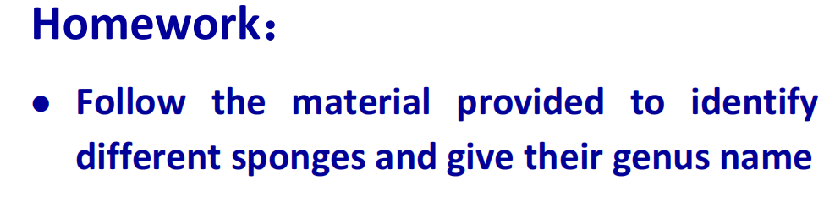
作业中使用到的网站：
World Porifera Database - Species - Porifera (marinespecies.org)
https://en.wikipedia.org/wiki
https://panamabiota.org/stri/taxa/index.php?taxauthid=1&taxon=30546&clid=35

Picture 1
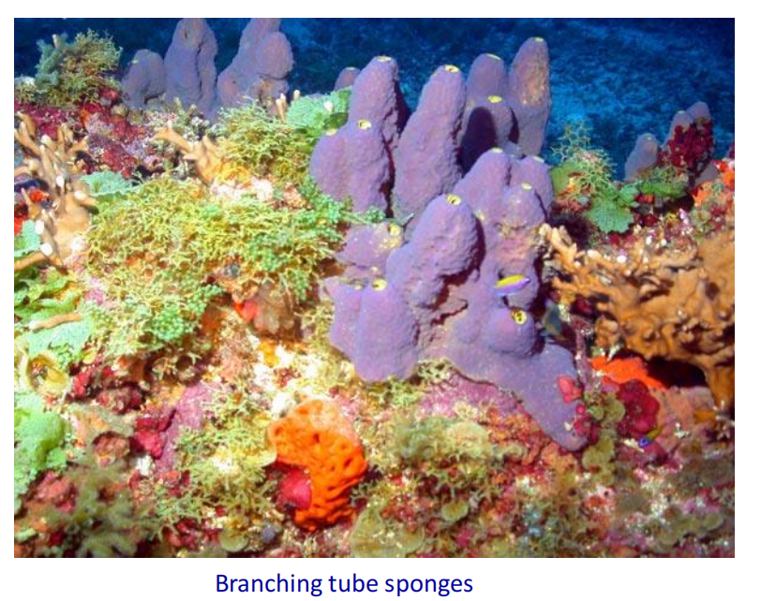
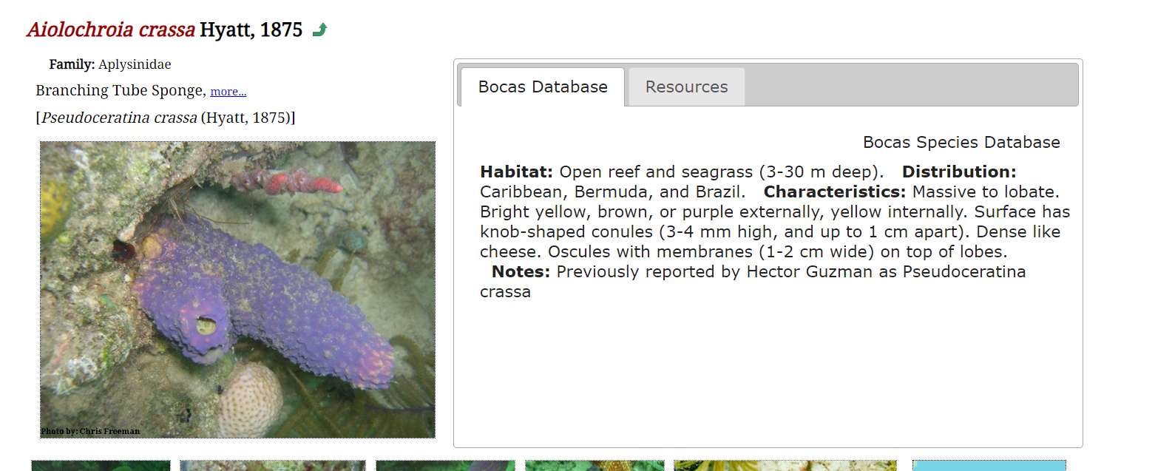

Picture 2
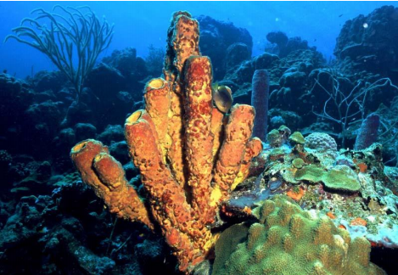

Domain: | Eukaryota
Kingdom: | Animalia
Phylum: | Porifera
Class: | Demospongiae
Order: | Verongiida
Family: | Aplysinidae  Carter, 1875[1]

Picture 3

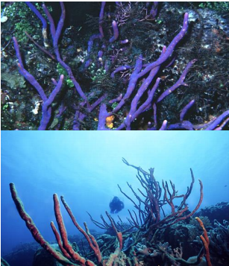
Domain: | Eukaryota
Kingdom: | Animalia
Phylum: | Porifera
Class: | Demospongiae
Order: | Haplosclerida
Family: | Niphatidae
Genus: | Amphimedon

Picture 4
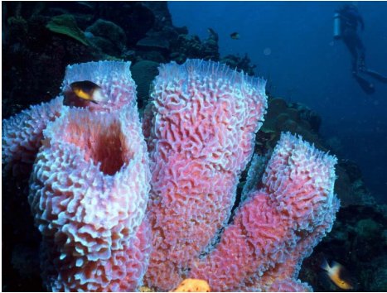
Domain: | Eukaryota
Kingdom: | Animalia
Phylum: | Porifera
Class: | Demospongiae
Order: | Haplosclerida
Family: | Callyspongiidae
Genus: | Callyspongia

Picture 5

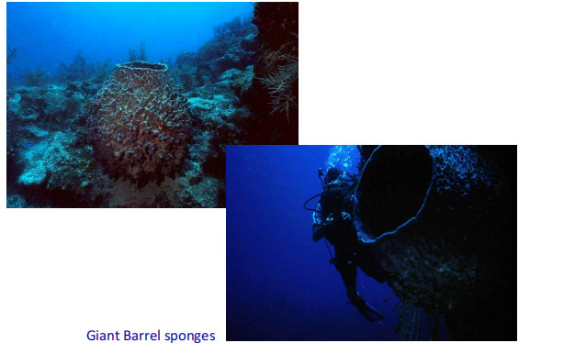
Domain: | Eukaryota
Kingdom: | Animalia
Phylum: | Porifera
Class: | Demospongiae
Order: | Haplosclerida
Family: | Petrosiidae
Genus: | Xestospongia

Picture 6
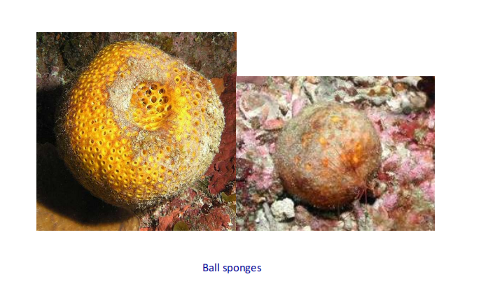
界：动物界 Animalia门：多孔动物门 Porifera纲：寻常海绵纲 Demospongiae目：多鞭海绵目 Polymastiida科：多鞭海绵科 Polymastiidae属：多鞭海绵属 PolymastiaBowerbank, 1863

Picture 7
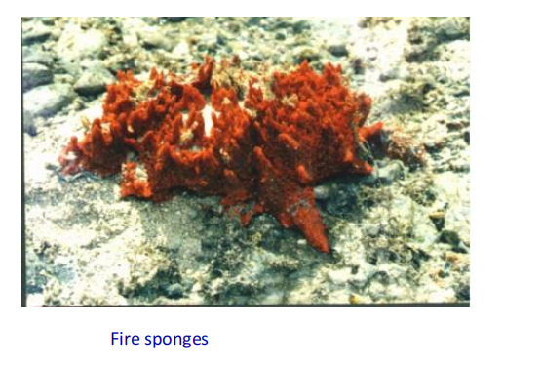
Domain: | Eukaryota
Kingdom: | Animalia
Phylum: | Porifera
Class: | Demospongiae
Order: | Poecilosclerida
Family: | Tedaniidae
Genus: | Tedania

Picture 8
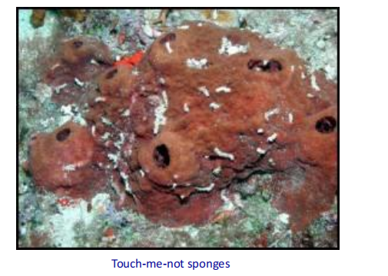

Domain: | Eukaryota
Kingdom: | Animalia
Phylum: | Porifera
Class: | Demospongiae
Order: | Biemnida
Family: | Biemnidae
Genus: | Neofibularia

Picture 9
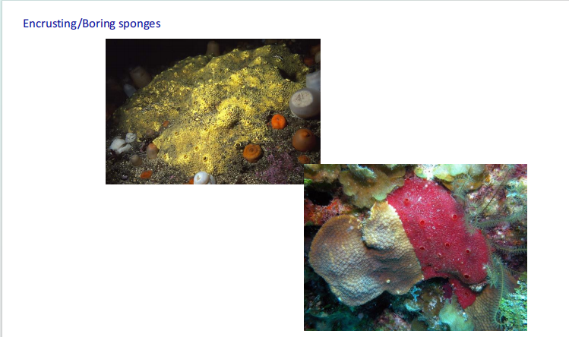
Domain: | Eukaryota
Kingdom: | Animalia
Phylum: | Porifera
Class: | Demospongiae
Order: | Clionaida
Family: | Clionaidae
Genus: | Cliona  Grant, 1826

