REPORT for Experiment 15
Experiment Title：Genomic DNA extraction and purification

Instructor(s)：Pinmei Wang

Lab Location：海工楼

Date Performed：2024.11.30

- Introduction
DNA carries the genetic information needed for cell development and behavior. In this experiment, we will isolate and extract DNA.
The basic step of DNA extraction is to disrupt the cellular structure to produce a lysate, isolating soluble DNA.
- Experimental Purpose
- Be able to extract genomic DNA samples from bacterial cells
- Be able to set up DNA electrophoresis
- Understand the principle of DNA extraction and electrophoresis
- Equipment and Materials
EXP15A
- My strain culture
- 25 mL LB
- Loop
EXP15B
(1)Genomic DNA extraction kit (Code No.9763, Takara) (see Appendix G)
(2)TAE buffer (see Appendix G)
(3)DNA-dye (see Appendix G)
(4)DNA loading buffer (see Appendix G)
(5)DNA electrophoresis system and gel imaging analysis system
(6)DNA ladder DL5000 (Takara) (see Appendix G)
(7)Agarose
(8)Microwave oven
(9)1.5 mL tube
(10)Pipettes and tips
(11)Water bath
(12)Centrifuge
4. Experimental Procedure
EXP15A
(1)Label flasks
(2)Inoculate each fals with strain from the stock or glycerol stock using a sterile loop
(3)Incubate the cultures
EXP15B
Cells lysis steps
- Transfer 500 μL 0.5-5.0 x 10’ of bacterial cells grown in the medium (Exp 1 5A) into a l.5mL tube
- Centrifuge at 10,000 rpm for 2 minutes. Discard the supernatant.
- Add 1 ml ddHzO to wash the cell precipitates, centrifuge at 10,000 rpm for 2minutes. Discard the supernatant.
- Add 180 μL of Buffer GL, 20 μL of Proteinase K and 10 uL of RNase A into the1.5 ml tube with the cell precipitates. Mix well by pipetting up and down until no cell clumps remain, and then incubate it in the 56 'C water bath for 10 min. The lysis mixture should be clarified and transparent. If not, incubate the tube at 56 °C for 30 min and mix by pipetting up and down every 5 min.
- Add 200 μL of Buffer GB and 200 μL of 100% ethanol. Mix it completely by
pipetting up and down
Dna extraction steps
(1)Place a Spin Column into a Collection Tube. Transfer the mixture to the Spin Column by l mL pipette. Centrifuge at 10,000 rpm for 2 min. Discard the flow-through.
(2)Add 500 μL of Buffer WA into Spin Column. Centrifuge at 10,000 rpm for 1 min.Discard the flow-through.
(3)Add 700 μL of Buffer WB into Spin Column. Centrifuge at 10,000 rpm for 1 min.Discard the flow-through.
(4)Add 700 uL of Buffer WB into Spin Column. Centrifuge at 10,000 rpm for 1 min.Discard the flow-through.
(5)Centrifuge the empty Spin Column with Collection Tube at 10,000 rpm for 2 min to reduce liquid.
(6)Place Spin Column into a new 1.5 mL tube. Preheat Elution Buffer to 65 °C and6.add 50 μL of Elution Buffer to the center of the Spin Column membrane. Let it stand at room temperature for 5 min.
(7)Centrifuge at 10,000 rpm for 2 min to elute the DNA.

Detection steps for extracted DNA
- .Prepare 50 mL 0.8% agarose gel with TAE (including DNA.dye)(see Appendix F)in a 200 ml flask, boil it in the microwave oven until theliquid is completely transparent without any lumps, cool, and pour it into an agarosgel mould with a narrow well comb.After gel solidification(about 20-30 min), transfer gel into gel tank
- Mix 5 μL (50-500 ng) DNA sample with 2 μL DNA loading buffer on a piece of clean plastic paper using a 10 uL pipette, and transfer it into a well by 10 μL pipette.
(3)Add 5 uL DNA ladder DL5000 into another well.
(4)Run gel for 20-30 min at ~200V, Remove gel from gel tank, image and save photo.Keep the remaining genomic DNA sample at -20 or -80 °C until analysis. Frozen DNA samples are stable for more than one year without frequent freezing and thawing.
5. Record and Results
Label the bands in your gel picture, print and stick the picture here:
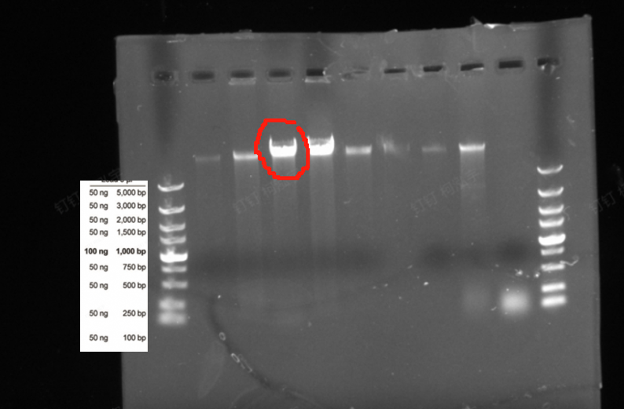
Label one is our sample.
Did you see the bands of genomic DNA by DNA electrophoresis? What sizes were expected?
Yes 1000bp
6. Discussion
1) Describe the function of each reagent in the kit used for DNA extraction.
Reagent | Purpose
BS | Cell lysis
GL | Cell lysis
K | Digest proteins
RNase A | Digest DNA
GB | promote DNA bingding
WA | Washing
WB | Washing

- Supposing no bands were seen in your gels, discuss the possible reasons
①The electrodes are reversed
②There was a mistake in the DNA extraction process

