REPORT for Experiment 1
Experiment Title：Observing microorganism

Instructor(s)：王品美

Lab Location：海工楼239

Date Performed：9.11

1. Introduction
In your own words, describe the theory and principle of the experiment.
Different microorganisms have its unique characteristics of colonies.For bacteria,each colony means an individual bacterial which have been totally separated.For Yeast,it’s colonies look similar to bacterial ones,but Molds are appear whitish gray, with fuzzy edges.
Observe the characteristics of colonies

2. Experimental Purpose

3. Equipment and Materials
Provide a list of materials and equipment used in the experiment.
70%EtOH in spray bottle
Plates of microorganisms （微生物平板）
A. Escherichia coli （大肠杆菌）
B. Bacillus subtilis （枯草芽孢杆菌）
C. Staphylococcus epidermidis （表皮葡萄球菌）
D. Staphylococcus aureus （金黄色葡萄球菌）
E. Pseudomonas aeruginosa （铜绿假单胞菌）
F. Actinobacillus （放线菌）
G. Saccharomyces cerevisiae （酿酒酵母）
H. Aspergillus （曲霉）

4. Experimental Procedure
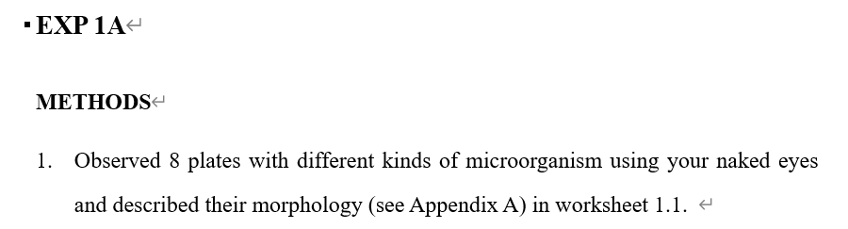

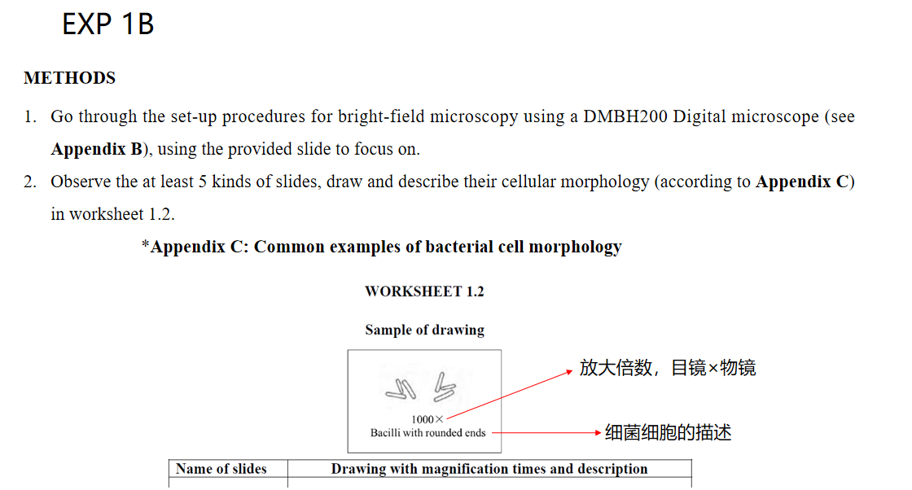

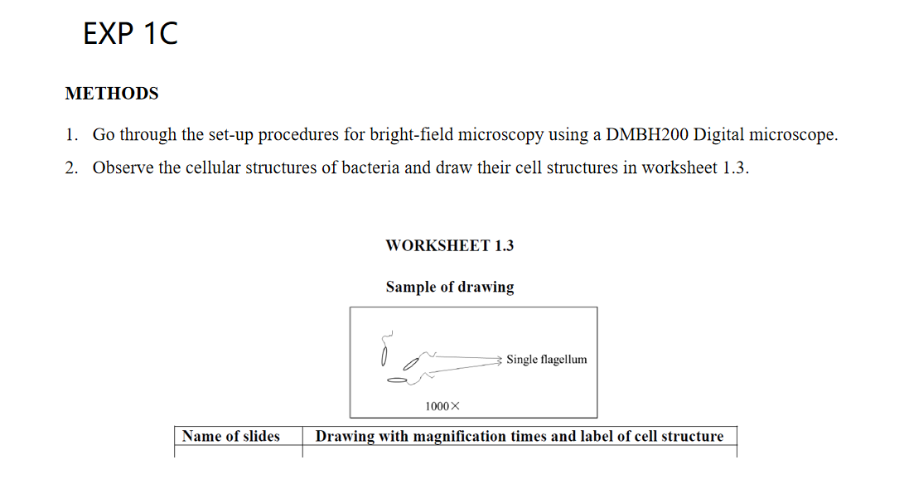

5. Record and Results
WORKSHEET 1.1
Descriptive features of colonies grown on solid media according to Appendix A.
Strains | Morphology description (Size, Form, Side view, etc.)
A.  Escherichia coli | Size：1.5mm Form:circular Side view:flat
B.  Bacillus subtilis | Size：2mm Form:circular Side view:raised
C.  Staphylococcus epidermidis | Size：0.2mm Form:circular Side view:raised
D.  Staphylococcus aureus | Size：0.8mm Form:circular Side view:raised
E.  Pseudomonas aeruginosa | Size：2.5mm Form:circular Side view:flat
F.  Actinobacillus | Size：3mm Form:circular Side view:raised
G.  Saccharomyces cerevisiae | Size：1mm Form:circular Side view:convex
H.  Aspergillus | Size：17mm Form:circular Side view:flat
WORKSHEET 1.2
Sample of drawing
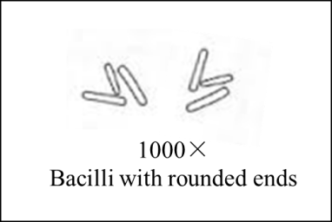
Name of slides | Drawing with magnification times and description
青霉菌 | 40*10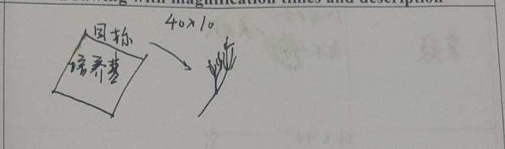  Broom-shaped
匍枝霉菌 | 10*10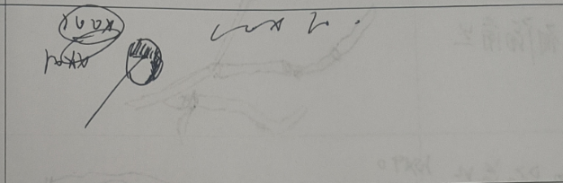  Mushroom-shaped
放线菌 | 10*100  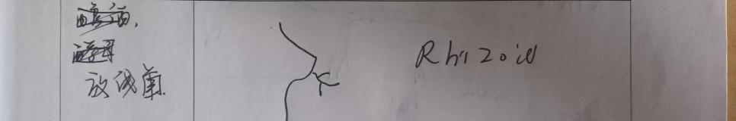  Rhizoid
曲霉菌 | 10*10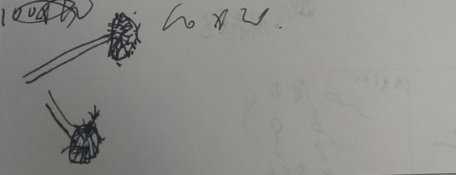  Mushroom-shaped
霍乱弧菌 | 10*100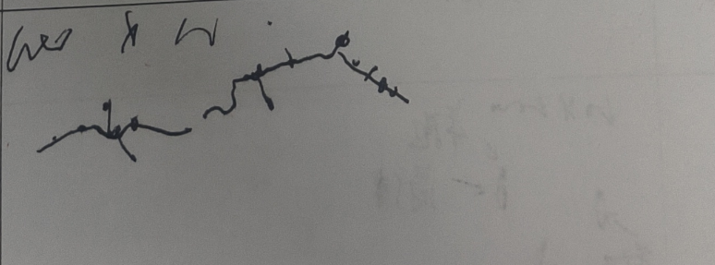  Spirochete
WORKSHEET 1.3
Sample of drawing
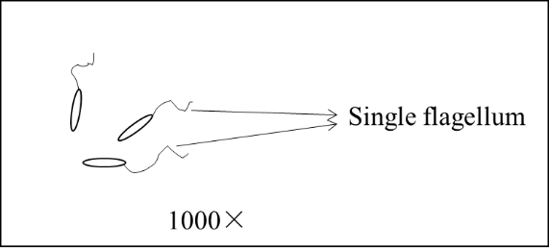
Name of slides | Drawing with magnification times and label of cell structure
荚膜 | 10*100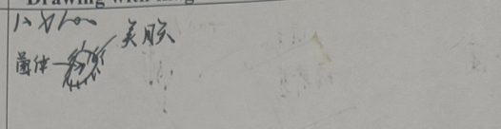
有隔菌丝 | 10*10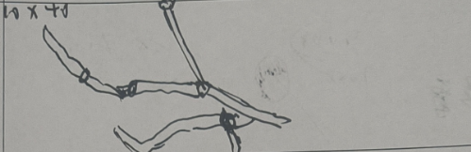  有隔膜
无隔菌丝 | 10*10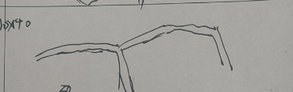  没有隔膜
周鞭毛 | 10*100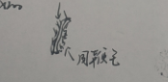
丛鞭毛 | 10*100  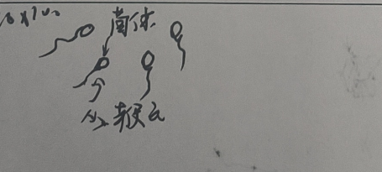
芽孢 | 10*100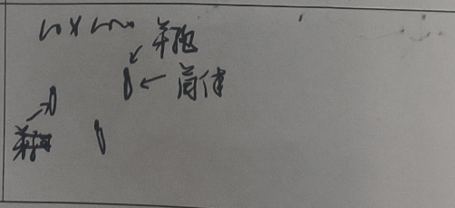
6. Discussion
Describe the function of oil when you use microscopes.
When using a microscope, especially for high-magnification observations, oil serves a crucial function in improving the quality and clarity of the image. This technique is commonly used with compound light microscopes and is referred to as oil immersion.
The primary purpose of using oil, typically a special type called immersion oil, is to eliminate the air gap between the glass slide and the objective lens. Air has a different refractive index compared to glass, which can cause light to scatter and reduce the resolution of the image. Immersion oil has a refractive index that closely matches that of the glass, reducing this scattering effect and allowing more light to pass directly through the specimen to the lens. As a result, the contrast and resolution are significantly enhanced, enabling the observer to see finer details of the specimen.

