REPORT for Experiment 2
Experiment Title：Contamination and aseptic techniques

Instructor(s)： 王品美

Lab Location： 海工楼

Date Performed： 9.11 9.18

1. Introduction
In Experiment 2, we focused on contamination and aseptic techniques.Contamination by bacteria, fungi, mycoplasma, etc., can greatly affect the results of microbiological experiments.Therefore, aseptic technique is particularly important. Specifically, aseptic technique is a set of tools used in experiments to avoid contamination.For example,laminar flow hood.

2. Experimental Purpose
1.Know that microorganisms are ubiquitous
2.Know why aseptic technique is essential in the laboratory
3.Know how to use a laminar flow hood
4,Be able to describe bacterial colonies on the surface of agar media

3. Equipment and Materials
Provide a list of materials and equipment used in the experiment.
A laminar flow hood
Loop
Parafilm
LB agar plates
Sterile cotton swabs
70% EtOH in a spray bottle

4. Experimental Procedure

A
1.Label all plates on the base (agar side) around the edge in small letters. Divide a LB plate into 3 sections. (Fig.2.1)
2.Inoculate each section of the plate with the appropriate swab.
3.Divide another LB plate into 2 sections.
4.Open the 3rd LB plate opened in the hood after UV for 20 mins. (at least 30 mins)
5.Open the 4th LB plate and one blood plate near to window. (at least 30 mins)
B
1.Examine the plates exposed to contamination in the previous laboratory period.
2.Record all the results from your group in Worksheet 2, and describe colonies. Descriptive features of colonies grown on solid media can be found in Appendix A.
3.Describe a maximum of three colony types per section (A-D).

5. Record and Results
WORKSHEET 2
Procedure |  | LB Plate
 |  | No. colonies | No. colony types | Description
A | 1.surface of bench | 1 | 1 | 1.5mm circular flat
 | 2. clothing/shoes | 2 | 2 | 3mm circular flat
 | 3. saline control | 无单菌落 | 1 | 5mm circular flat
Procedure |  | LB Plate
 |  | No. colonies | No. colony types | Description
B | 1. fingers on plate | 4 | 2 | 19mm circular raised 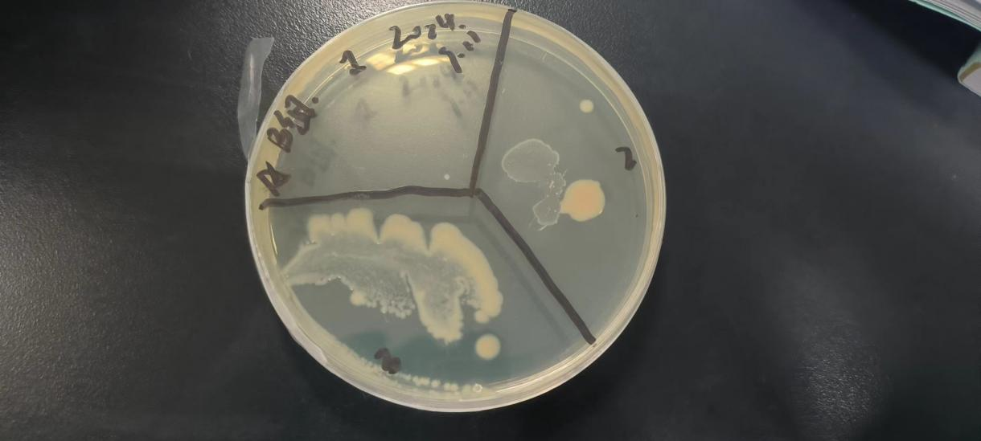 the around of colony is white and centre is yellow
 | 2. fingers after 70% EtOH | 4 | 1 | 10mm circular flat black  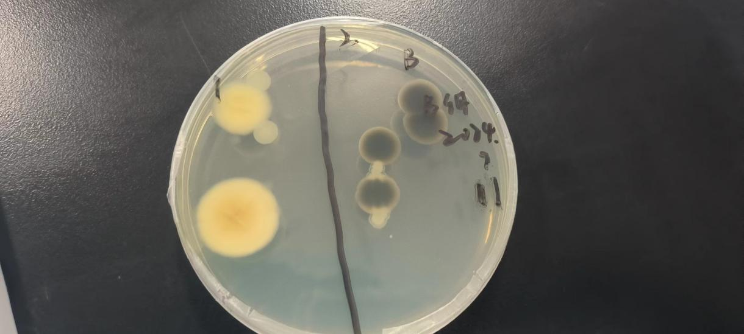
C | Plate open in the hood after UV sterilization | 5 | 3 | 18mm circular raise the around of colony is white and centre is yellow
4mm irrugular raise yellow

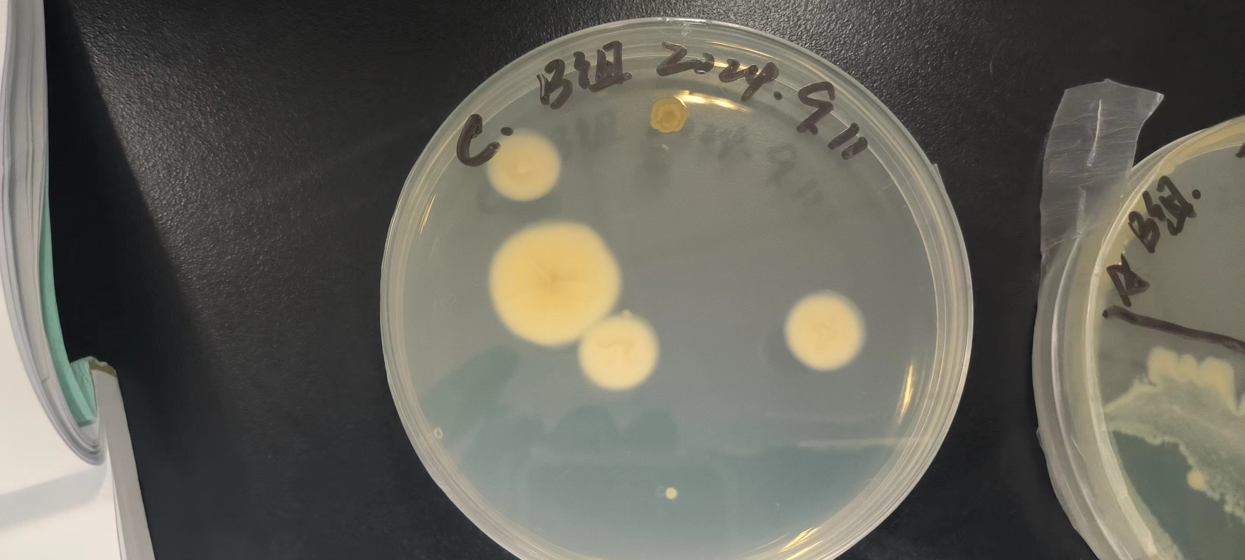

D | Plate open near to window | 15 | 7 | 15mm circular raised the around of colony is white and centre is yellow
 |  |  |  | 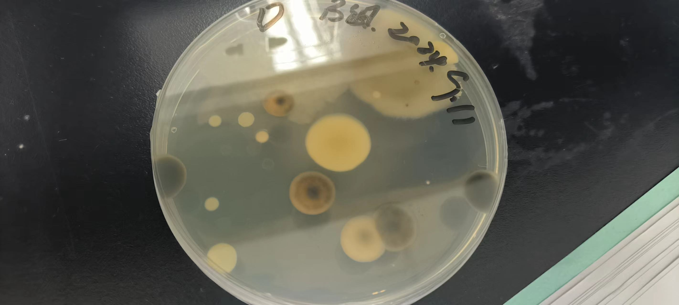

6. Discussion
According to the differences in colony number and type for the different procedures tested, discuss the necessity for aseptic techniques in the laboratory?

In the experimental results of the three groups of A,B,C, the number of colonies obtained from the medium treated with sterility was relatively small, and the species were monotonous.This proves the importance of aseptic operation to eliminate bacterial interference in microbiological experiments

