REPORT for Experiment 4
Experiment Title：
Sterilization by Millipore filtration
Instructor(s)：
王品美
Lab Location：
海工楼239
Date Performed：
2024.10.16
1. Introduction
Filtration is an effective technique in microbial isolation experiments, which can make microorganisms stay in the filter material with small pore size.They are usually made by mixed cellulose ester or PES which have some incredible peculiarity.For bacterial isolation experiments, we typically use pore sizes of 0.45 micron or 0.22 micron.It is worth noting that such protocols cannot be used for viruses and bacteriophages.
Besides,In microbiological experiments, any supplies must be sterilized by autoclaving and other aseptic treatment, and the experiment must be in a clean bench.
Some filters can be mounted on syringes, which facilitates fast and effective filtration, but attention needs to be paid to the integrity of the syringe before use.
- Experimental Purpose
- Be familiar with liquid sterilization by Millipore filtration.
- Know when we use sterilization by Millipore filtration instead of autoclaving
- Know how to streak out for single colonies by streak-plate method form liquid.
3. Equipment and Materials
(1)A laminar flow hood
(2)Incubator
(3)pipette tips
(4)parafilm
(5)1 x Millipore syringe filter (0.45 micron) and a 2.5ml syringe
(6)2 x LB agar plates
(7)1 x sterile tube
- Contaminated enzyme solution
4. Experimental Procedure
(1)Use a pencil to mark the group, date, time, filtered or not, and other information on the edge of the medium .
(2)According to the method in Appendix E,take contaminated enzyme solution and streak out for single colonies onto Before-labeled plate.
(3) Attach one filter to one syringe,and add 1-2 ml contaminated enzyme solution into syringe.Pass the liquid through a Millipore filter into a sterile,labeled tube.
(4)As in step (2), streak the the filtered solution out for single colonies on another LB plate.
(5)Incubate both plates at 37 celsius for 24 hours(one week in this experiment).
(6)Examine the LB plates streak with contaminated enzyme solution before and after filtration, for the presence of microbial growth.
5. Record and Results
WORKSHEET 4
 | Without filtration |  | With filtration
 | Growth+ or - | Colony description | Growth + or - | Colony description
Contaminated enzyme solution  (E) | + | Circular and raised  yellow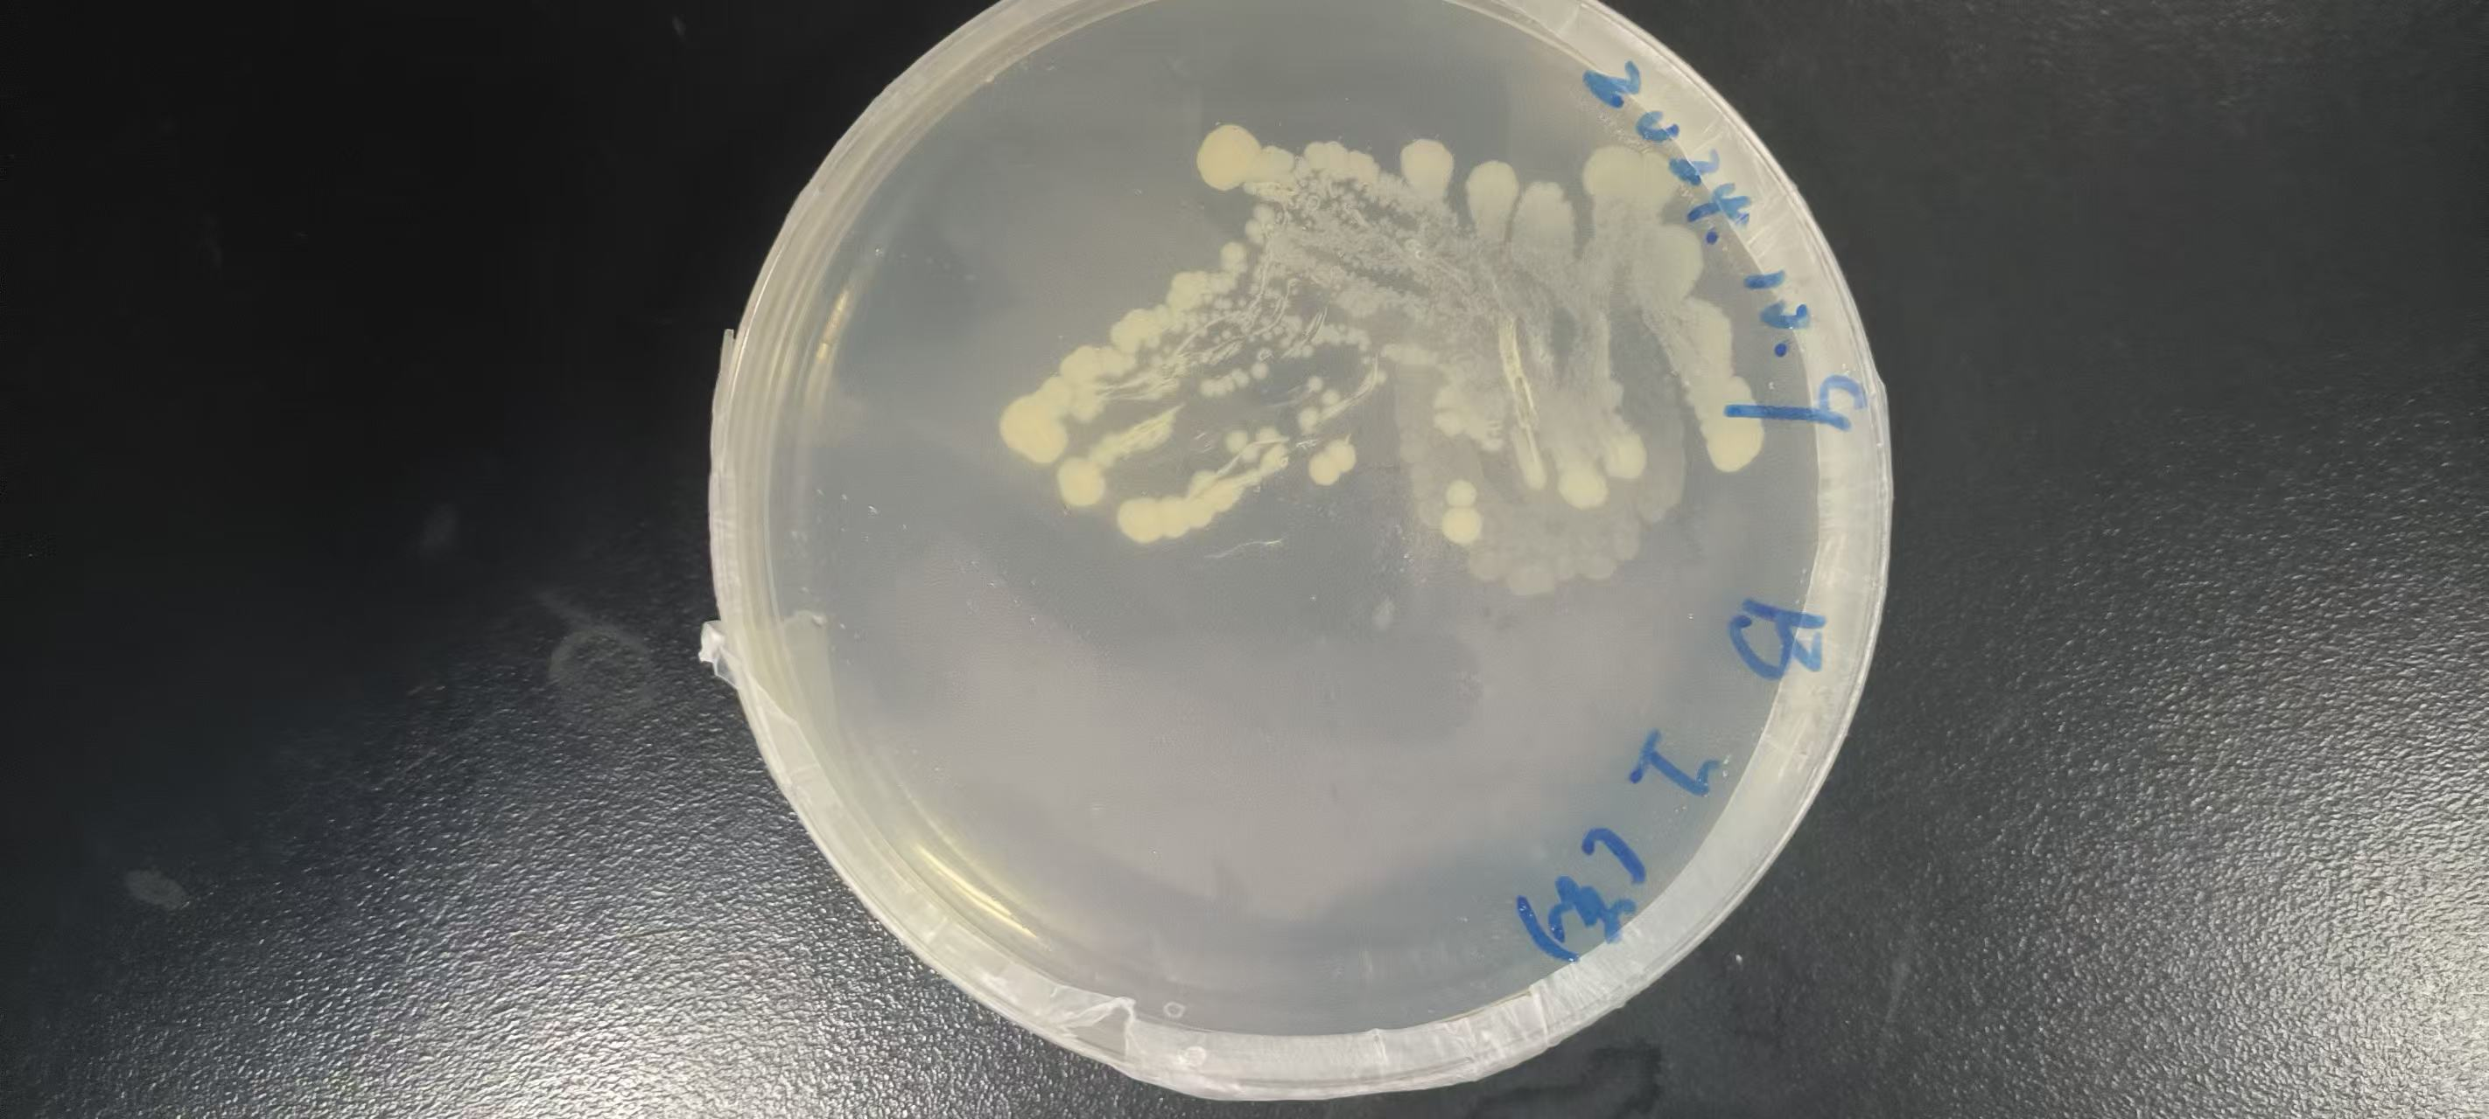 | - | Circular and raised  orange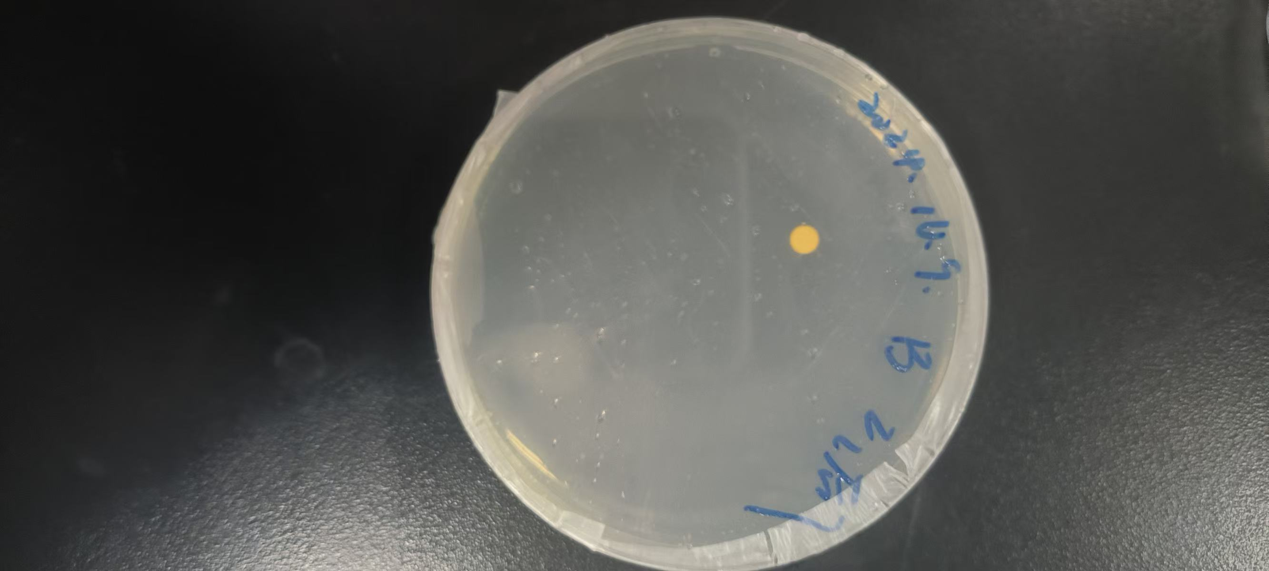

6. Discussion
What are other common methods for sterilizing liquids? Why was this type of sterilization (membrane filtration) used for the different solutions?
Common Methods for Sterilizing Liquids
1. Heat Sterilization:
Autoclaving: Uses high-pressure steam to kill microorganisms. Effective for heat-stable liquids.
Dry Heat: Involves heating at high temperatures (e.g., 160-170°C) for extended periods. Suitable for heat-stable materials.
2. Filtration:
Membrane Filtration: Uses filters with pore sizes small enough to remove bacteria and other microorganisms. Commonly used for heat-sensitive liquids.
Depth Filtration: Involves passing the liquid through a thick layer of filter media to trap particles and microorganisms.
3. Chemical Sterilization:
Ethylene Oxide (EtO): Gas that can penetrate packaging and kill microorganisms. Used for heat-sensitive and moisture-sensitive items.
Hydrogen Peroxide Vapor (HPV): Effective for sterilizing surfaces and equipment.
4. Irradiation:
Gamma Irradiation: Uses gamma rays to kill microorganisms. Suitable for heat-sensitive and moisture-sensitive materials.
Electron Beam (E-beam): Uses high-energy electrons to sterilize materials.
5. Ultraviolet (UV) Light:
UV-C Light: Effective for surface sterilization and can be used to treat liquids in specific applications.
Why Membrane Filtration Was Used for Different Solutions
By using membrane filtration, you can ensure that the solutions remain sterile without compromising their integrity, making it a preferred method in many applications.

