REPORT for Experiment 5
Experiment Title：
Isolation and purification of marine microoragnism
Instructor(s)：
Pinmei Wang
Lab Location：
海工楼
Date Performed：
2024.11.5
1. Introduction
In natural environments such as oceans, there are often many types of microorganisms, and in order to obtain a single colony, we need to purify and culture to obtain a single colony.
Serial dilution is a commonly used means of obtaining highly accurate dilution solutions. Often, we take multiple ten-fold dilutions to get the target dilution concentration.Once sufficient dilution concentrations have been obtained to isolate single colonies, the solution is applied to the Petri dish using the coating separation method.
If you want to preserve bacteria for a longer period of time, consider glycerol preservation, which stabilizes the freezing of bacteria and prevents damage to their cell membranes.
- Experimental Purpose
1. Be able to isolate microorganism from a certain environment
2. Know the basic traits of marine microorganism
3.Know the differences between halotolerance bacterial and halophiles
4. Know how to streak a single colony from cultured plates
5. Know how to do the long-term preservation of microorganisms
3. Equipment and Materials
EXP5A
Clean Bench
Pipettes and tips
Parafilm
Water samples from ocean
Sterile Spreader
3 x MBA plates (from Exp.3)
50 mL sterile tubes
EXP5B
Clean Bench
Loop
3XMBA plates
3X25 ml MBE+YE liquid medium in a 100ml flask
EXP5C
Clean Bench
Pipettes and tips
2 ml screw top tube
Sterile 50% glycerol
5. Record and Results
WORKSHEET 5.1
Dilution factor | Colony number | Single colony from  (√) | Growth in liquid medium  （Yes/No）
10^-4 | 0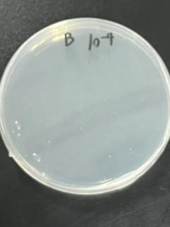 | x | No
10^-5 | 0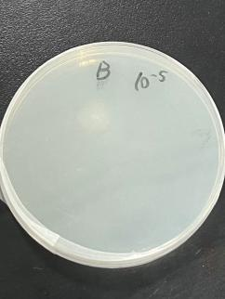 | x | No
10^-6 | 0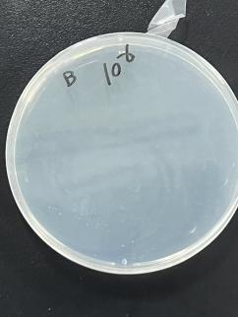 | x | No
WORKSHEET 5.2
Colony name on glycerol tube | Preserved by | Date
YHY | Haoyu You | 2024.10.30
KHY | Hongyu Ke | 2024.10.30
KHY | Hongyu Ke | 2024.10.30
6. Discussion
What is the function of glycerol in the long-term preservation of microorganisms?
Cryoprotectant: Glycerol acts as a cryoprotectant, which means it helps protect cells from damage during the freezing and thawing processes. It reduces the formation of ice crystals within the cells, which can cause mechanical damage and disrupt cellular structures.
Osmotic Balance: Glycerol helps maintain osmotic balance by preventing excessive dehydration of the cells. This is important because dehydration can lead to cell shrinkage and damage to cellular components.
Reduction of Freezing Point: Glycerol lowers the freezing point of the solution, allowing the microorganisms to be stored at lower temperatures without forming harmful ice crystals. This is particularly useful for long-term storage in liquid nitrogen or ultra-low freezers.
Stabilization of Cellular Membranes: Glycerol can stabilize cell membranes by interacting with the lipid bilayer, reducing the risk of membrane rupture during freezing and thawing.
Prevention of Protein Denaturation: Glycerol can help prevent the denaturation of proteins, which can occur due to the stress of freezing and thawing. This ensures that the microorganisms remain viable and functional after being thawed.

