STAT665 Lab1

Bo Song

This algorithm uses category encoding for both variable ‘hour’ and variable ‘neighborhood’. The mapping pattern of neighborhood code is demonstrated in following table.

|  |  |  |
| --- | --- | --- |
| NTACode | Name | Index |
| MN01 | Marble | 0 |
| MN03 | Central Harlem North-Polo Grounds | 1 |
| MN04 | Hamilton Heights | 2 |
| MN06 | Manhattanville | 3 |
| MN09 | Morningside Heights | 4 |
| MN11 | Central Harlem Sourth | 5 |
| MN12 | Upper West Side | 6 |
| MN13 | Hudson Yards-Chelsea-Flatiron-Union | 7 |
| MN14 | Lincoln Square | 8 |
| MN15 | Clinton | 9 |
| MN17 | Midtown-Midtown South | 10 |
| MN19 | Turtle Bay-East Midtown | 11 |
| MN20 | Murray Hill-Kips Bay | 12 |
| MN21 | Gramercy | 13 |
| MN22 | East Village | 14 |
| MN23 | West Village | 15 |
| MN24 | SoHo-TriBeCa-Civic Center-Little Italy | 16 |
| MN25 | Battery Park City-Lower Manhattan | 17 |
| MN27 | Chinatown | 18 |
| MN28 | Lower East Side | 19 |
| MN31 | Lenox Hill-Roosevelt Island | 20 |
| MN32 | Yorkville | 21 |
| MN33 | East Harlem South | 22 |
| MN34 | East Harlem North | 23 |
| MN35 | Washington Heights North | 24 |
| MN36 | Washington Heights South | 25 |
| MN40 | Upper East Side-Carnegie Hill | 26 |
| MN50 | Stuyvesant Town-Cooper Village | 27 |
| MN99 | Park-cemetery-etc-Manhattan | 28 |

Based on the linear regression model we built in question 2, we get the following prediction graph.

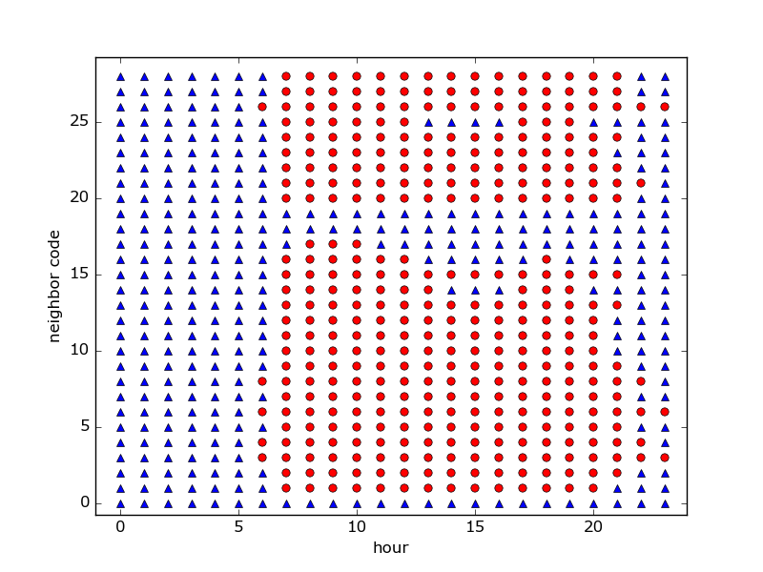

The red dot indicates the 1, the cab remains in Manhattan. The blue triangle indicates 0, the cab will leave Manhattan.