《面向对象Java编程》上机作业4
学号：
姓名：
班级：
日期：

*样例见附1

1. Define an interface, called VolumeArea, within which there’re:
- a static and final variable PI (with the value 3.14159), and
- two abstract methods volume(double radius) and area(double radius).
Write another class MyCircle which implements the interface VolumeArea. Overriding the two methods:
- volume(double radius) to return a value zero (as the volume of a circle is 0), and
- area(double radius) to return the area of the circle.
Write the third class MySphere, also implements VolumeArea. Overriding the two methods:
- volume(double radius) to calculate and return the volume of the sphere (using (4π*r*r*r)/3);
- area(double radius) to calculate and return the surface area of the sphere (using 4π*r*r).
Write a main class with the main method to test the methods in MyCircle and MySphere, set the radius of the circle and sphere both to 3.5. And display the results.

- 问题分析

- 代码实现

- 运行结果

- 思考及总结

2. Define an abstract class named Employee. Define following classes to inherit the abstract class,
a) Boss class, indicate the boss who get paid with a fixed salary without considering working hours;
b) CommissionWork class, indicate the workers who some basic salary and floating wages according to sales;
c) PieceWorker class, indicate those who are paid according to the numbers of products;
d) HourlyWorker class, indicate those get paid according to their working hours.
Define above four classes, to implement the abstract methods declared in the abstract class:
- getPaid() method without any parameter but have a return value for total salary, and,
- display() method for output the information about the employee.
And define another class with main method (also called test class or driven class), to test the methods defined.

- 问题分析

- 代码实现

- 运行结果

- 思考及总结

3. 请根据以下UML图，编写相关的三个类：
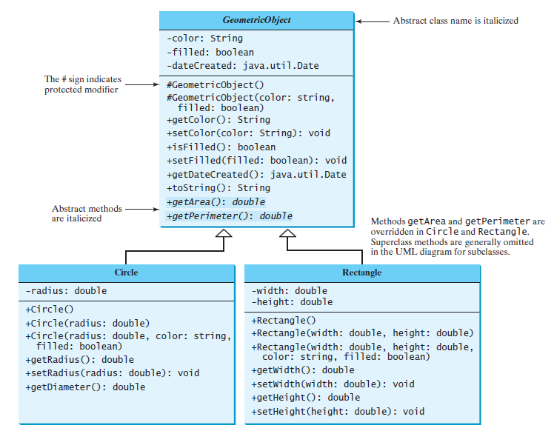
另外定义一个主类，main方法中对上图中设计的各个方法进行测试。
TIPs: ’+’符号表示public修饰的属性/方法；’-‘表示private修饰；’#’表示protected修饰；斜体表示abstract修饰的类/方法。
- 问题分析

- 代码实现

- 运行结果

- 思考及总结

4. (Math: The Complex class) A complex number is a number of the form where a and b are real numbers and i is The numbers a and b are known as the real part and imaginary part of the complex number, respectively. You can perform addition, subtraction, multiplication, and division for complex numbers using the following formula:
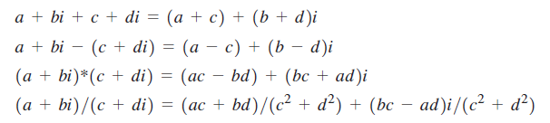
You can also obtain the absolute value for a complex number using the following formula:
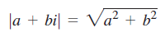
Design a class named Complex for representing complex numbers and the methods add, subtract, multiply, divide, and abs for performing complex-number operations, and override the toString method for returning a string representation for a complex number. The toString method returns a + bi as a string. If b is 0, it simply returns a.
Provide three constructors Complex(a, b), Complex(a), and Complex(). Complex() creates a Complex object for number 0 and Complex(a) creates a Complex object with 0 for b. Also provide the getRealPart() and getImaginaryPart() methods for returning the real and imaginary part of the complex number, respectively.
Write a test program that prompts the user to enter two complex numbers and display the result of their addition, subtraction, multiplication, and division. Here is a sample run:
Enter the first complex number: 3.5 5.5
Enter the second complex number: -3.5 1
3.5 + 5.5i + -3.5 + 1.0i = 0.0 + 6.5i
3.5 + 5.5i - -3.5 + 1.0i = 7.0 + 4.5i
3.5 + 5.5i * -3.5 + 1.0i = -17.75 + -15.75i
3.5 + 5.5i / -3.5 + 1.0i = -0.5094 + -1.7i
|3.5 + 5.5i| = 6.519202405202649

- 问题分析

- 代码实现

- 运行结果

- 思考及总结

注1：
- 独立完成！切勿抄袭！
- 提交的文档请重命名为“学号_姓名_上机n”命名，如“202112340001_徐利锋_上机n.doc”).
- 截止日期：4月17日 20:00

注2：作业样例（见后）
附1.作业样例：
编写一个程序，打印100～200之间的素数，要求每行按10个数(数与数之间有一个空格间隔)的形式对其输出。
(以下为本题的解题样例，后续题目请参考样例解答)
- 问题分析
用循环遍历101-200之间的数，通过筛选法判断每个数是否为素数，如是则按题目要求格式输出。
筛选法求素数的大致思路：一个数n分别除以2、3…根号n，若全部不能整除，则为素数；反之则不是素数。
题目要求格式的满足：每行10个数，需要对每次输出进行计数，逢10换行。不换行的时候则输出空格。
根号运算需要调用Math类里的sqrt方法，如：Math.sqrt(n)表示n的平方根。
- 代码实现
public class Prime {
public static void main(String[] args) {
int counter = 0;
for(int i=101; i<=200; i++) {
if(isPrime(i)) {
System.out.print(i);
counter++;
if(counter % 10 == 0) {
System.out.println();
} else {
System.out.print(" ");
}
}
}
}
public static boolean isPrime(int num) {
boolean result = true;
for(int i=2; i<=Math.sqrt(num); i++) {
if(num % i == 0) {
result = false;
break;
}
}
return result;
}
}

- 运行结果

运行结果如图1-1所示。
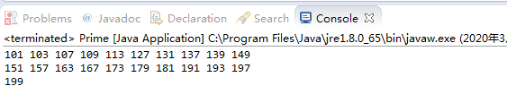
图1-1 问题1程序运行结果
- 思考及总结
学习到了以下几个用法。（以上述代码为例）
1、其他方法的定义： public static boolean isPrime(int num)
表示声明一个在main方法中可以直接调用的方法（因有static修饰，表示静态方法），需要一个int类型的参数，返回值为boolean类型。
2、for循环的使用: for(int i=101; i<=200; i++)
循环时注意循环变量的取值边界及累进值
break;
表示退出当前循环。
3、Math类中开根方法的调用：Math.sqrt(n)
4、输出：换行及空格的输出：
System.out.println();
System.out.print(" ");

