《面向对象Java编程》上机作业5
学号：
姓名：
班级：
日期：

- Write a Java program called ArithmeticT1 that takes three command-line arguments: two integers and in between an arithmetic operator (+, ‐, *, /). The program shall perform the corresponding operation on the two integers and display the result, and the arithmetic equations together with the results shall be also saved in a file called “calculation.txt” (one line per equation).
Note that you need to deal with the nonnumeric input as operands (one of the two integers) using exception handler (try-catch statements) - the program terminates if any operand is nonnumeric, and it should display a message with the wrong operand input before exiting. Besides, the program should also handle the wrong input for operator.
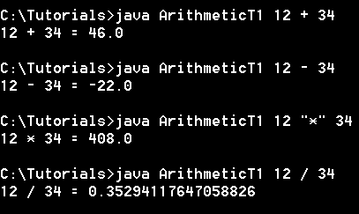
Example run of wrong input:
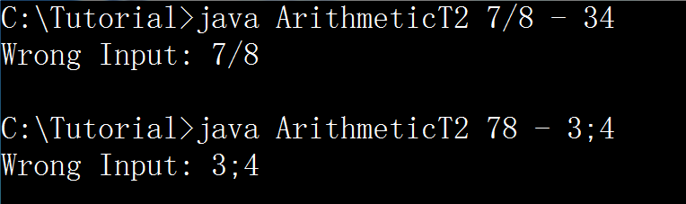

- 问题分析与解答

- 代码实现

- 运行结果

- 思考及总结

- (ArrayIndexOutBoundsException) Write a program that meets the following requirements:
■ Create an array with 100 randomly chosen integers. (Note: method nextInt() in class Random can be used.)
■ Prompt the user to enter an int value as the index of the array, and then display the corresponding element from the array. If the specified index is out of bounds, display the message Out of Bounds.

- 问题分析

- 代码实现

- 运行结果

- 思考及总结

- 自定义一个异常类，叫做负年龄异常: MinusAgeException。再定义类Person，包含姓名name，年龄age等属性，在Person类中有一个方法setAge()，若年龄为负，则抛出MinusAgeException异常。
另外编写驱动类，对上述方法进行测试。

- 问题分析

- 代码实现

- 运行结果

- 思考及总结

- 编写一个程序，类名为WordCount，统计任意单词（如“hello”，由用户输入）在一篇英文文章（内容保存在当前文件夹下的article.txt）中出现的次数。要求统计时忽略单词的大小写，统计完毕后再显示器输出统计结果，格式为“单词hello在文章中出现的次数为： 10”。
提示：String类中的indexOf(String str)可以返回指定子字符串在此字符串中第一次出现处的索引；indexOf(String str, int fromIndex)可以从指定的索引开始返回指定子字符串在此字符串中第一次出现的索引。

- 问题分析

- 代码实现

- 运行结果

- 思考及总结

- Create a file named “scores.txt”, within which there are five lines of texts as following,
NAMEs CPP JAVA OS DB CAD
Zhangsan 85 89.5 78 90.5 85
Lisi 67 89 78.5 85 77
Wangwu 78.5 81 67 88 67
Zhaoliu 90 95 87 78 89.5
Write a program to read the data from the file, and then change (mainly transposition) the format and output to another file named “courses.txt”. The content should be as following,
COURSEs Zhangsan Lisi Wangwu Zhaoliu
CPP 85 67 78.5 90
JAVA 89.5 89 81 95
OS 78 78.5 67 87
DB 90.5 85 88 78
CAD 85 77 67 89.5
The program should also be able to output (to console) the average scores for each course and for each person.
Tips:
- The input and output streams should be closed after reading/writing finished.
- The separators used in the two files are both blank spaces, you can change it into tabs (‘\t’) if you like.
- There is no need to handle the exceptions in this question, but if you do, it will be better. (Use “throws Exception” at the method header, in which the possible exception would occur and handling of it is required.)
The methods of transforming strings into numerical values are: strings to int - Integer.parseInt(str); string to double - Double.parseDouble(str);
The methods from String to separate one whole string with certain separator:
str.split(separator); note that the return value is an array of string… find more in APIs.

- 问题分析

- 代码实现

- 运行结果

- 思考及总结

