中餐变形记：那些漂洋过海的中国菜
The Transformation of Chinese Cuisine: Chinese Dishes That Crossed the Oceans
中国菜，以其丰富的食谱和精湛的烹调技术闻名于世。经过数千年的传承与发展，它不
Chinese cuisine is world-renowned for its diversity and culinary mastery. After millennia of evolution, it has
仅在国内广受喜爱，还漂洋过海，成为世界各地餐桌上的常客。然而，当中国菜踏上异国他
become not only a national favorite but also a global culinary staple. However, when Chinese cuisine lands in
乡的土地，为了适应当地人的口味和饮食习惯，往往会经历一番“变形”。这些“变形”后的中
foreign countries, it often undergoes a transformation to adapt to the local tastes and eating habits. These
国菜，既保留了部分中国菜的特色，又融入了当地的饮食文化，形成了独特的风味，也成为
"transformed" Chinese dishes blend traditional traits with local flavors, creating unique tastes and fostering
中外文化交流的桥梁。
cross-cultural exchange.
美式中餐：从“杂碎”到“左宗棠鸡”
American Chinese Cuisine: From "Chop Suey" to "General Tso's Chicken"
1.1 “杂碎”的诞生与流行
The Birth and Popularity of "Chop Suey"
19世纪中期，大批中国劳工远渡重洋来到美国，参与太平洋铁路工程等建设。身处异
In the mid-19th century, Chinese laborers migrated to the U.S. for projects like the Transcontinental
国他乡，他们渴望能吃到家乡的味道，但由于当地食材有限，他们用现有的食材和厨艺，创
Railroad. Craving hometown flavors but constrained by local ingredients, they adapted their cooking, creating the
造出了一些既带有家乡风味，又适应当地环境的菜肴。这些便是美式中餐的雏形。
dishes with hometown flavors with local adaptations. These are the prototypes of American Chinese cuisine.
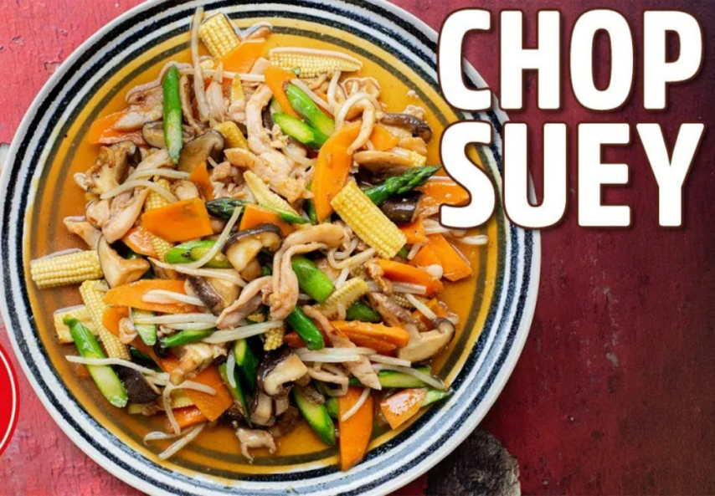
当时，“杂碎”成为一大风靡一时的菜品。它将各种肉类、蔬菜混合炒制，食材丰富，
At that time, "Chop Suey" became a popular dish. This affordable stir-fry combines assorted meats and
价格实惠，迅速受到美国民众的喜爱。据说，1896年李鸿章访美时，纽约一家报纸报道称
vegetables, quickly winning American hearts with its rich flavors. Legend has it that Li Hongzhang's 1896 "Chop
他在宴会上食用了“杂碎”，这一消息进一步推动了“杂碎”在美国的流行。从此以后，许许多
Suey" banquet in the U.S., reported by The New York Times, boosted the dish's popularity nationwide. Since then,
多的中餐馆如雨后的春笋般在美国各地涌现。
Chinese restaurants have sprung up across the United States.
1.2 “左宗棠鸡”的崛起
The Rise of "General Tso's Chicken"
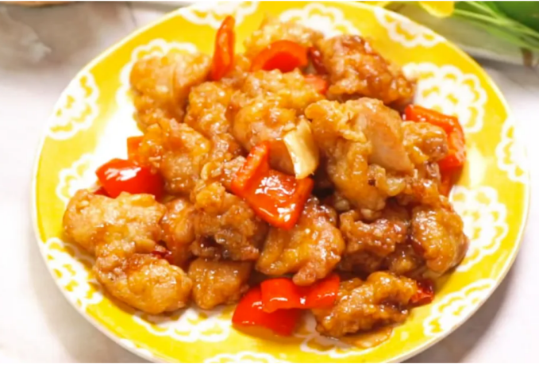
随着时间的推移，美式中餐不断发展演变，许多菜肴逐渐融入了美国人喜爱的口味元素。
Over time, American Chinese cuisine has evolved, incorporating flavors favored by local palates. Among
其中，“左宗棠鸡”成为了美国人最爱点的外卖菜之一。这道菜以鸡肉为主料，切成小块后
them, "General Tso's Chicken" has become one of the most popular take-out dishes among Americans. This dish 裹上面粉或淀粉炸至金黄，再淋上由醋、糖、酱油、辣椒等调料调制而成的酱汁，口味酸甜
features bite-sized chicken, fried until golden and coated in a sweet-sour-spicy sauce of vinegar, sugar, soy sauce,
微辣。
and chili.
美式“左宗棠鸡”与中国传统左宗棠鸡在口味和做法上有很大不同。中国版本的左宗棠
American "General Tso's Chicken" differs from the traditional one in both flavor and preparation.While the
鸡以咸鲜香辣为主，而美式则更强调酸甜口味，并加入油炸工艺，使鸡肉更加酥脆。这种改
Chinese original features savory spiciness, the American adaptation emphasizes sweet-sour flavors and crispy fried
良迎合了美国人的饮食习惯，也让这道菜在美国家喻户晓。
texture—catering to local tastes and boosting its U.S. great popularity.
此外，像西兰花牛肉、甜酸鸡等菜品也在美式中餐馆中十分受欢迎。西兰花牛肉结合了
Additionally, dishes like Broccoli Beef and Sweet-and-Sour Chicken are also very popular in American
西兰花的爽脆和牛肉的鲜嫩，口味较为清淡；甜酸鸡则是将炸鸡块浇上酸甜酱，与中国粤菜
Chinese restaurants. Broccoli Beef pairs crisp broccoli with tender beef in a light sauce, while Sweet-and-Sour
中的咕咾肉有相似之处，但在食材与调味上更加本土化。这些菜品虽然在中国本土并不常见，
Chicken features fried chicken glazed with a tangy sauce—a localized twist on Cantonese Sweet-and-Sour Pork.
但是他们在今天成为了美国人眼中最具标志意义的中国菜的代名词。
Though uncommon in China, these dishes now symbolize Chinese cuisine for Americans.
1.3 签语饼的趣味文化
The Fun Culture of Fortune Cookies
在美式中餐中，结账时赠送签语饼是一个独特的传统。签语饼是一种空心的小饼干，里
In American Chinese cuisine, it is a unique tradition to give out fortune cookies when settling the bill. A
面夹着一张印有预言、格言或幸运号码的纸条。尽管它并非源自中国，却已成为美式中餐文
fortune cookie—a hollow crisp containing prophetic notes—though non-Chinese in origin, became iconic in
化不可或缺的一部分。一种说法认为它由早期日本移民在加州发明，后来被中餐馆借鉴并推
American Chinese dining. One theory attributes its invention to early Japanese immigrants in California, later
广开来；另一种说法是，签语饼是由中国移民在美国创造出来的，用于吸引顾客。无论它的
adopted by Chinese restaurants; another credits Chinese immigrants with creating it as a customer attraction.
起源如何，签语饼都为美式中餐的顾客带来了趣味横生的用餐体验。
Regardless of origin, fortune cookies deliver uniquely entertaining dining moments.
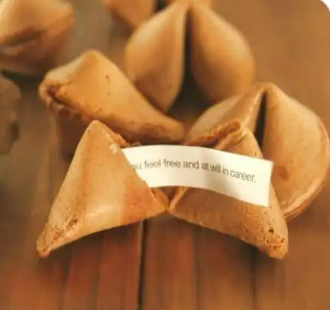

日式中餐：改良的中华料理
Japanese Chinese Cuisine: The Modified Chinese Cuisine
2.1 麻婆豆腐的清淡变奏
The Light Variation of Mapo Tofu
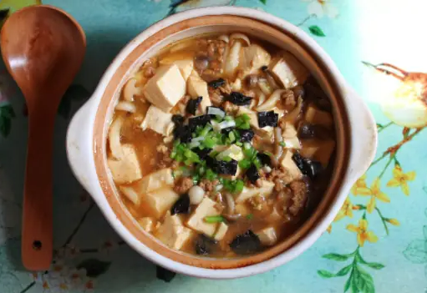
在日本，中餐馆随处可见，许多中国菜品已经融入了日本的饮食文化，成为日本人日常
In Japan, Chinese restaurants can be seen everywhere, and many dishes have integrated into Japanese food
饮食生活中的一部分。其中，麻婆豆腐是在日本最受欢迎的中式菜肴之一，但其味道与中国
Culture, becoming part of the daily lives of Japanese people. Mapo Tofu ranks among the top Chinese dishes,
传统的麻婆豆腐的风味有较大的差异。
though differing from the traditional version.
为了迎合日本人的口味，日本版麻婆豆腐通常减少了辣椒和花椒的用量，使辣度降低；
The Japanese version of Mapo Tofu typically tones down the heat by reducing chili and Sichuan pepper, while
同时增加了糖和酱油的比例，使口味更加甘甜、浓郁。此外，还可能加入一些日本特色食材，
boosting sweetness with more sugar and soy sauce. In addition, some Japanese - style ingredients such as konjac
如魔芋丝，进一步丰富口感。在烹饪上，日本的中餐馆更加注重对菜品的摆盘与菜品本身的
noodles may be added to further enrich the texture. In cooking, Japanese Chinese restaurants emphasize artistic
卖相，以更好地满足日本人对食物“色、香、味、形”的追求。
plating to achieve the perfect balance of color, aroma, taste, and presentation.
2.2 创意季节性菜品
Creative Seasonal Dishes
日本的中餐馆还会根据四季推出特色菜品。春季会使用樱花作为装饰或食材，夏季则推
Japanese Chinese restaurants craft seasonal specialties: sakura-adorned dishes in spring and chilled Chinese
出清凉解暑的中式甜品，将中国饮食文化与日本的四季美学巧妙结合。这种创新既保留了中
desserts in summer, marrying authentic Chinese flavors with Japan's refined shiki aesthetics. This innovation
餐的核心，又融入了日本饮食文化本身的细腻之美。
preserves culinary authenticity while embracing wabi-sabi subtlety.
墨西哥式中餐：独特的边境风味
Mexican - Style Chinese Cuisine: Unique Border Flavors
在墨西哥边境城市墨西卡利，中餐也发展出了独特的风味，被称为“墨西卡利中餐”。
In Mexicali, a border city in Mexico, Chinese cuisine has also developed a unique flavor, known as
这里的中餐融入了大量墨西哥当地的饮食元素，例如柠檬块、辣椒酱和玉米片等，成为餐桌
"Mexicali Chinese Cuisine". Chinese cuisine blends Mexican flavors—lemon wedges, chili sauce, tortilla chips—
上的一种常见的搭配。
now standard accompaniments.
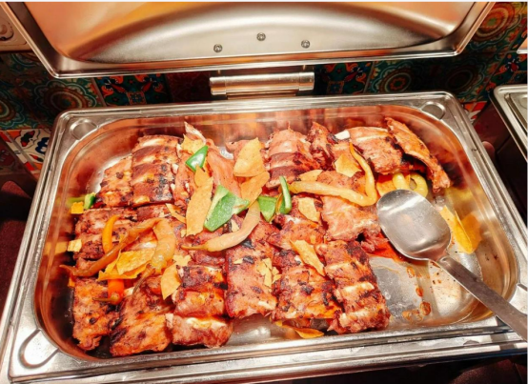
炸排骨是墨西卡利中餐的招牌菜之一。墨西哥食客会在炸排骨上挤上柠檬汁，再淋上一
Fried Spare Ribs is one of the signature dishes of Mexicali Chinese Cuisine. Mexican diners zest up fried ribs
勺酸甜酱，吃得津津有味。这种独特的风味背后，是历史的交融。1882年美国颁布《排华
with lime wedges and sweet-sour glaze—a flavor steeped in history. After the 1882 Chinese Exclusion Act in the
法案》后，许多华人南迁至墨西哥，在这里扎根，中餐也随之与墨西哥饮食文化相互融合，
U.S., many Chinese migrants resettled in Mexico, where their culinary traditions intertwined with local flavors, 形成了别具一格的“变形”中国菜品。
giving rise to a distinctive fusion cuisine.
英式中餐：改良的宫保鸡丁
British Chinese Cuisine: The Modified Kung Pao Chicken
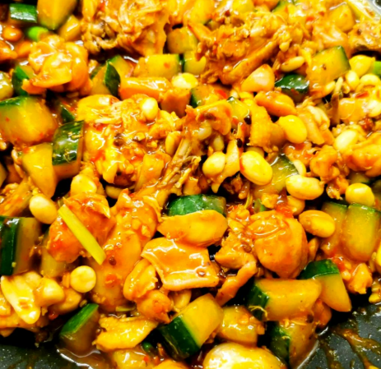
在英国，中餐菜品如宫保鸡丁也发生了明显的变化。在英国中餐厅，外卖版的宫保鸡丁
In the UK, Chinese dishes like Kung Pao Chicken have undergone distinct adaptations. Takeaway versions in
常常根据当地的食材供应和口味习惯进行调整。例如，辣椒用量有所减少，调味上更加清淡，
British Chinese restaurants often modify spice levels and ingredients to suit local preferences—reducing chili heat
以适应英国人普遍不太能吃辣的饮食需求。同时，菜品的摆盘和包装更为简洁，更符合英国
for milder British palates. And the plating and packaging of the dishes are more concise, which is more in line with
消费者的外卖习惯。
their take-out habits.
中餐海外变形的原因与影响
Reasons and Influences of the Transformation of Chinese Cuisine Overseas
中国菜在海外传播的过程中常常会发生“变形”，其原因有以下几个方面：
The reasons for the "transformation" of Chinese cuisine overseas are as follows:
- 适应当地口味：
Adaptation to Local Tastes:
不同国家和地区的人对口味有着不同的偏好。为了吸引更多顾客，中餐馆不得不对菜品
People in different countries and regions have different taste preferences. To attract more customers, Chinese
进行改良。例如，美国人偏爱酸甜口味，日本人喜欢清淡细腻的风味，这都直接影响了当地
restaurants modify their dishes. For example, American sweet-sour and Japanese delicate tastes reshape Chinese
中国菜的制作方式。
culinary methods.
- 食材的获取限制：
Restrictions on Ingredient Acquisition:
许多中国传统菜肴的原材料在海外并不容易获得。因此，厨师们会用当地的食材进行替
Many materials for traditional Chinese dishes are not easily available overseas. Therefore, chefs use local
代，这也导致了当地菜品在味道和形式上与传统的差异。
ingredients as substitutes, leading to changes in the taste and form of the dishes.
- 文化差异的融合：
The Integration of Cultural Differences:
中餐在不同国家的变化，往往融入了当地的饮食文化和用餐习惯。例如，在墨西哥，中
Global Chinese cuisine blends local food cultures and eating habits. For example, Mexican-Chinese cuisine
餐融入了墨式调料和独特的香料搭配；在日本，中餐融入了季节性美学和摆盘设计。
blends local spices and flavors, while Japanese-Chinese embraces seasonal aesthetics and plating design.
在影响上，中餐海外变形是一把双刃剑，既带来了文化融合的机遇，也面临着传统流
In terms of impact, The overseas adaptation of Chinese cuisine presents both opportunities for cultural
失的挑战。在积极方面，本土化改良让中餐更容易被外国消费者接受，像"左宗棠鸡"这样的
integration and challenges to traditional authenticity. On the positive side, Local adaptations like "General Tso's
创新菜品不仅成为文化符号，更带动了整个海外中餐市场的繁荣，促进了中外饮食文化的交
Chicken" have popularized Chinese food abroad, fostering the popularity of Chinese cuisine and cultural exchange
流。然而，过度本土化也导致了一些问题，比如为迎合当地口味而过度调整的"宫保鸡丁"
through cuisine. However, excessive localization has created issues.For example, over-modified dishes like
失去了川菜的本真风味，一些快餐化的改良甚至强化了西方对中餐的刻板印象。更值得关注
"Kung Pao Chicken" lose their authentic Sichuan essence, while some fast-food adaptations reinforce Western
的是，这种变形可能挤压传统中餐馆的生存空间，使得刀工、火候等传统烹饪技艺面临失传
stereotypes of Chinese cuisine. More importantly, It also threatens authentic restaurants and traditional cooking
的风险。如何在保持中餐精髓的同时进行适度创新，成为海外中餐发展必须面对的课题。
Techniques. Balancing innovation with heritage preservation remains key to develop the foreign Chinese food.
结语：漂洋过海的中国菜
Conclusion: Chinese Cuisine That Crossed the Oceans
中餐漂洋过海后，经历了各种“变形”，在异国他乡焕发了新的生命力。这些“变形”
Chinese cuisine has undergone various transformations overseas, gaining new vitality there. These
后的中国菜，不仅是一道道美食，也是中外文化交流的桥梁。它们以独特的方式展现了中国
"transformed" Chinese dishes are not just culinary delights, but also bridges for cross-cultural exchange. They
饮食文化的包容性与适应性，为全球美食舞台增添了亮丽的色彩。
demonstrate Chinese cuisine's cultural flexibility, enriching global food diversity.
无论是美式“左宗棠鸡”、日式麻婆豆腐，还是墨西卡利的炸排骨，它们都传递着中国
Whether American "General Tso's Chicken", Japanese Mapo Tofu, or Mexicali Fried Spare Ribs, these dishes饮食文化的独特魅力，同时也在全球范围内促进着中外文化的交融与传播。
showcase Chinese unique culinary culture's charm while promoting global cultural integration.

