中国文化与国际传播
- 修读情况：2024-2025学年春夏学期，骆蓉老师
- records
  - communication and culture theory
    - intercultural communication
      - the ingrendts of communication
      - the types of communication
        - written communication :
        - group communication: presentation
        - verbal communication: face-to-
        - feedback communication
        - synchronous async
      - features: is not statci; cannot be retracted; mutiple means of communication ; contestual composing of numbers occasion purpose time adn environment
      - cross
    - power of culture
      - transend borders and endure through ages
      - allow hostility to dissolve
      - entangle in sordid environments
      - soft power, hard power, smart power
      - 文化六维度 文化中心论 文化相对主义 文化刻板印象 文化认同理论 文化适应理论 文化冰山理论 如何提高文化软实力
  - beautiful China and case analysis
    - karst typography/features Mount Everest/Qomolangma SAR Mogao Caves
    - cultural Forbidden City the Great Wall Jiuzhaigou Sceni and Historic Interest Area,Ancient city of Ping Yao, Old town of Lijiang ,Mount Summer Resort, Dazu Rock carvings, Fujian Tulou, Classical Gardens of Suzhou , Grand canal ， Historic Center of Macao
    - 短语翻译
      - 港珠澳大桥
        - the Hang Kong-Zhuhai-Macau Bridge
      - 青藏高原
        - The Tibetan Plateau
      - 内蒙古高原
        - The Mongolian Plateau
      - 塔里木盆地
        - The Tarim Basin
      - 戈壁沙漠
        - the Gobi Desert
      - 丹霞地貌
        - The Danxia landforms
      - 喀斯特地形
        - karst features
      - 珠穆朗玛峰
        - Mount Qomolangma
      - 特别行政区
        - Special Administrative Region
      - 莫高窟
        - The Mogao caves
      - 兵马俑
        - Terroacotta Warriors and Horses

      - 少数民族
        - minor ethnic groups
      - 儒家思想/道/释
        - Confucianism
        - Taoism
        - Buddhism
      - 中庸之道
        - the golden mean
      - 特别经济区
        - Special economic zones
      - 拙政园
        - the humble administrator' s garden
      - 沧浪亭
        - the Canglang Pavilion
      - 大都会博物馆
        - Metropolitan Museum of Art
      - 狮子林
        - Lion Grove Garden
      - 留园
        - The Lingering Garden
      - 良渚遗址
        - Archaeological ruins of Liangzhu City
      - 九寨沟国家公园/风景名胜区
        - Jiuzhaigou national park
        - Jiuzhaigou Valley scenic and historic interest area
      - 乐山大佛
        - Leshan Giant Buddha Sculpture
      - 都江堰水利工程
        - Dujiangyan Irrigation System
    - 句子翻译
      - 五岳归来不看山，黄山归来不看岳
      - 黄山以秀美的景色、日落、松树、温泉、云海闻名

      - 澳门回归
        - The return of the sovereignty of Macao to China is a significant historical event, marking the end of European colonialism in China and Asia.
      - 深圳硅谷
        - In the past 4 decades, Shenzhen has floushed and become a leading gobal technological hub in China , dubbed by the media as the next Silicon Valley and China' s Silicon Valley.
      - 北京魅力
        - The city' s hi-tech infrastructure and super-modern buildings such as the "Bird' s Nest" National Stadium, the Water Cube and the CCTV headquarters offer you a valuable chance to appreciate the charms of modern Beijing.
      - 西安，十朝古都
        - Xi'an, also known as Chang'an, served as the capital of more than 10 dynasties, is called the birthplace of Chinese civilization.
      - 苏杭
        - "In the heaven there is paradise and on earth there is Suzhou and Hangzhou." The first pair of twin cities are Suzhou and Hangzhou. The two cities are both renowed for enchanting natural scenery and rich cultrual heritages.
      - 马可波罗称赞杭州精致
        - Marco Polo, the famous traveler in the 13th century , admired Hangzhou for its exquisiteness and described it as "the City of Heaven, the most beautiful and magnficent in the world"
      - 杭州领先数字经济
        - As the birthplace of China' s e-commerce, the first city to propose smart city brains and the first cashless city in China, Hangzhou has taken the lead in digital economy in China.
    - cultural knowledge
      - Kangzhou' s world heritage
        - Grand Canal
        - Liangzhu Archeological Ruins
        - The West Lake
    - this is beijing rednote
      - 文化元素cultrual elements 京剧 建筑文化和美食，京话便民，自然，奥运，政治外交
      - 吸引点 Beijing practices a lot of actions to boost living levels of forigners, can eliminate culture shock and foster culture identity. And it also mentions Beijing envoronment is imporveing. . Audience, narrtive, cultrue, emotion
      - 数字技术visual sound rhythm
      - 交互性 deepen
    - case analysis : content design ,communication strategy, technique execution and improvement strategy
      - this is Beijing
        - content design and cultural elements
          - offer a comprehensive portrayal of Beijing by showcasing its historical landmarks, natural scenery, daily life and modern architecture
          - blend aesthetics and philosophy and cultural identity
          - convey Chinese traditional values
        - audience
          - target the gobal audience interested in Chinese history and Chinese culture and urban development
          - Enhance Interactivity 增加交互性: Adding interactive elements, such as QR codes linking to more travel information or virtual reality (VR) experiences, could allow viewer to explore "Beijing" more vitrually.
        - narrative approach
          - employ a virtual tour guide to lead viewers through Beijing, creating a sense of immersion and interaction
        - emotional appeal
          - evoke the emotinal connections with audience by featuring ordinary Beijing residents
        - cross-cultural communication theory
          - the use of English narration and avoidance of overly complex cultural terms makes the content more accessible to international viewers
          - add cultural notes
          - Adding English subtitles makes the video more accessible to international viewers
          - In addition to English, producing versions in other languages (e.g., French, Spanish) could expand the video’s global reach
          - For certain cultural symbols (e.g., the sacrificial rituals of the Temple of Heaven), brief text explanations or animated illustrations could help international audiences better understand their significance
        - economy
          - The video is concise, delivering rich and effective information within a limited time, with a tight and efficient narrative.
        - digital techniques
          - visual presentation
            - High-definition cinematography, aerial shots, and time-lapse techniques are used to capture Beijing’s grandeur and intricate details. For example, aerial views of the Forbidden City highlight its symmetrical layout and majestic scale.
            - CCTV's Every Treasure Tells a Story uses macro shots to reveal bronze patterns, with colloquial narration bridging ancient artifacts and modern viewers.
            - drone
            - close-up
            - the video uses various shot types and camera movements to effectively enhance visual storytelling
          - sound design/effects
            - blends traditional Chinese instruments with modern electronic elements, creating a harmonious fusion of past and present
            - uses the Hakka dialect to authentically convey the customs of southern Chinese communities
          - editing rhythm
            - The video’s editing is smooth and well-paced,alternating between bustling cityscapes and tranquil life scenes, providing a balanced viewing experience
  - art China
    - 艺韵中国语言知识点
      - 词汇
        - connotation
          - n. 内涵
        - aesthetics
          - n. 美学
        - 刺绣
          - embroidery
        - 中国戏剧脸谱
          - facial makeup in Chinese Opera
        - 颜料
          - pigment
        - dye
          - n. 染料
          - v. 染色
        - 山水画
          - painting of landscape
        - 天然宝石
          - natural gems
        - 蓝绿色 ；青丝
          - cyan cyan silk
        - 调色板
          - palette
        - 夕阳余晖
          - afterglow of sunset
        - gorgeous
          - adj. 灿烂华丽
        - melancholy
          - n. sadness
          - A mood of melancholy descended on us
        - hue
          - n. 色调色度
        - 色彩渐变
          - color gradation
        - distill
          - v. 提取蒸馏
        - 古朴
          - primitive simplicity
        - 皇权
          - imperial power
        - chromatography
          - n. 色谱分析法
        - 雨过天青云破处
          - the sky is clearing up after the rain
        - 徽派建筑的门楼和马头墙
          - the gatehouse and the horse-head wall of Hui-style building
        - 五行
          - the Five Elements
        - 五位
          - the Five Positions
        - 五色
          - core colors
        - mellow
          - adj. 圆润的，柔和的
        - condense
          - v. 使浓缩使压缩
        - 象形文字
          - hieroglyphics
        - 写意;工笔
          - freehand；fine painting
        - 快雪时晴帖
          - Clearing after Snowfall
        - 五墨
          - five types of ink
        - 芙蓉花
          - hibiscus flowers
        - 葫芦
          - calabash
          - gourd
        - 金元宝
          - boat-shaped gold ingots
        - 镂空艺术
          - hollowing-out art
        - 吉祥谐音的图案
          - auspicious homophonic patterns
        - 克拉克号
          - Clark Porcelain
        - 上釉瓷器
        - ingenuity
          - n. skillful at inventing
        - 文人
          - literati
        - synonym
          - n. 同义词
        - Danqing hand
          - 丹青手
        - 川剧变脸
          - the Face Changing of Sichuan Opera
        - ruthless
          - adj. cruel
        - epitome
          - n. 典范
        - treacherous
          - adj. 不可信
          - adj. dangerous
        - divination
          - n. 占卜
        - limpid
          - adj. 清澈的 limpid eyes
        - carp
          - n. 鲤鱼
        - lifelike
          - adj. 栩栩如生的
        - 没骨
          - boneless technique
        - 砚
          - inkstone
        - 界画
          - architectural painting
        - 留白
          - negative space
        - 虚实
          - void and soild
      - 句子
        - 剪纸图案丰富
          - Images of paper-cutting vary from opear figures, birds and flowers to grass, insects, fish and beasts as well as many auspicious homophonic patterns.
        - 青花瓷工艺
          - Blue and white porcelain applies the technology of painting on the body of hard and white porcelain and then the body is coated with a transparent glaze and is fired at a high temperature to produce the final work.
        - 东西结合
          - When the delicate eastern elements conveying ancient Chinese styles meet with simple western fashion styles, the combination can send forth unmatched glamour with the help of the ornament of embroidery.
        - 宝库比喻
          - What a treasure house! Calligraphy and ink painting are pearls; paper-cutting is ruby; blue and white procelain is jade sapphire; facial make-ups and embroidery are glittering diamonds.
  - 烟火中国和case analysis
    - knowledge of language
      - 史记
        - Historical Records
      - 民以食为天
        - Food is the first necessity of people
      - 重庆小面
        - small noodle
      - elastic
        - adj. 富有弹性的
      - crystallization
        - v. Our ideas gradually crystallize into a practical plan.
      - pungent
        - adj. having a strong taste
        - a pungent smell of burning rubber
        - pungent criticism
      - 腌白菜/酸菜
        - pickled cabbage
      - 中庸
        - moderation and balance
        - the Golden mean
      - replicate
        - v. copy
      - brew
        - v. 烹茶 brew beer/tea/ coffee
        - n. beer local brew
        - n. an amount of tea have a brew
        - n. a mixture a heady brew of heavy metal and punk
      - aroma
        - n. 芬芳 the aroma of fresh coffee
      - detoxify
        - v. 解毒
      - 茶艺表演
        - tea art performance
      - intoxicate
        - adj. drunk
        - v make you drunk
      - 兰亭集序
        - the Orchid Pavilion
      - 流觞曲水
        - Floating wine cups along winding water
      - compass
        - n. 指南针
      - 豆腐脑
        - bean curd jelly
      - 饮食习俗
        - meal custom
      - 三餐制
        - three meal custom
      - 色香味俱全
        - the perfect combination of color,aroma, taste and appearance
      - 四大菜系
        - four major Chinese cuisines
      - 饮食结构
        - nutrition structure
      - 面食
        - wheaten food

      - 翻译句子
        - 饮食文化承载价值观
          - Chinese cuisine culture is blessed with unique values. Their respect and admiration for food serve as a manifesation of their reserved and simple attitudies to life
        - 开门七件事
          - Fuel, rice, oil, salt, voy, vingear and tea are regarded as seven daily necessities for Chinese people.
        - 渴望团圆饭
          - From north to south, west to east, all Chinese families are craving for a reunion family meal
        - 锅碗瓢盆折射伦理观
          - The everyday utensils manifest the true life of Chinese people as well as the morals of their life.
        - 一方水土养一方人
          - Every place has its unique way to support its inhabitants. For a long time, various tastes have come into being in different regions in China.
        - 辣椒魅力
          - Peppers have given full play in the hands of Sichuan people. The hot pot, spicy hot pot and chuanchuan which grow out of Sichuan food stepped out of Sichuan and become popular food all over the country.
    - Chinese cusine
      - 川 鲁 淮 粤/徽湘浙闽
      - fry 炸 煎pan-fry plain quick爆 deep干炸 stir-fry 炒
      - roast 烘 烤
      - stew 炖
      - steam 蒸
      - simmer 煨
      - smoke 熏
      - 拌mix
      - boil煮 quick-boil入水 涮instant boil
      - braise 烧
      - chop 剁
      - 去骨boning
      - 去皮skinning
      - mash捣碎
  - harmonious China
    - 语言
      - 民族区域自治
        - the system of regional enthnic autonomy
      - 促进民族交流交往
        - foster exchanges and integration among ethnic groups
      - 中华民族共同体
        - Chinese national community
      - 民族平等团结互助
        - ethnic equality, unity and mutual assistance
      - 义务教育
        - complusory education
  - green China
    - language
      - essential for survival and development of mankind
      - bloodline and foundation of a shared future for all life on earth
      - respect and follow its laws and protect it
      - A sound ecosystem is essential for the prosperity of civilization
      - 生态保护
        - ecological conservation
      - 生态补偿
        - ecological compensation
      - 大自然的搬运工
        - porters of nature
      - 退耕还林
        - reserving deforestation
      - 植树造林
        - afforestation
      - 治霾
        - haze fighting
      - 治沙
        - sandstorm source control
      - 地球卫士奖
        - Champions of the earth Award
      - 碳达峰
        - carbon emission peaking
      - 碳中和
        - carbon neutrality
  - tech China
    - 词汇
      - 拱形桥
        - arch bridge
      - 超级工程项目
        - super engineering projects
        - mega-projects
      - 基础设施
        - infrastructure
      - 纵横交错的桥梁网络
        - a crisscross network of bridges
      - 西气东输
        - West to East natural gas transmission project
      - 南水北调
        - South to North Water Diversion
      - 珠江三角洲
        - the Pearl River Delta
      - 大数据时代
        - the era of big data
      - 5G牌照
        - 5G license plate
    - 句子
      - 中国制造质量不好
        - In the past, "maed in China" was always associated with things of low prices and poor qualities, which drew people' s attention to quantities rather than qualities.
      - 同时，中国也已经成为全球人工智能专利数量最多的国家
        - At the same time, China has become the country with the largest number of AI patents in the world and with the second largest number of AI technical personnel in the world.
      - 中国是手机制造大国
        - Mobile phones accompany us around our lives all the time.
        - China is a well-derserved mobile phone manufacturing country with an annual output of nearly 2 billion smartphones.
      - 航天探索成就显著
        - In the history, the lengend of Chang'e running to the moon reflects people' s yearning for the distant universe.
        - In the past 50 years, Chinese have made unremitting exploration in the field of space and maed important contributes
      - 一桥飞架南北
        - Many bridges fly to span the south and north, changing a deep chasm into a thoroughfare.
      - 工程奇迹
        - All the super engineering projects not only manifest the Chinese wisdom with a history of more than thousands of years but also show a miracle of China in the new era.
      - 中国援助项目使世界更美好
        - The China-aid projects are also helping build a better future for our families around the world.
      - 尊重自然顺应自然是骨子里的哲学
        - Showing respect to nature and being adpative to the environment is philosophy hidden in Chinese people' s life.
      - 融合加工数据
        - We should not noly master the blowout growth data, but also integrate them into processing , which is the significance and value of big data technology.
    - culture knowledge
      - bridges
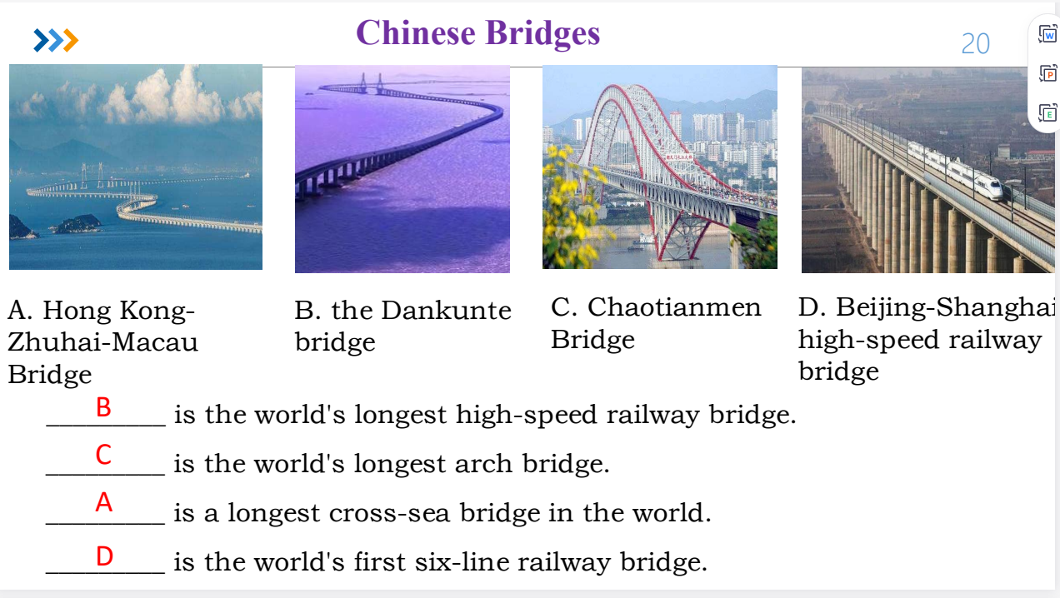
      - ports
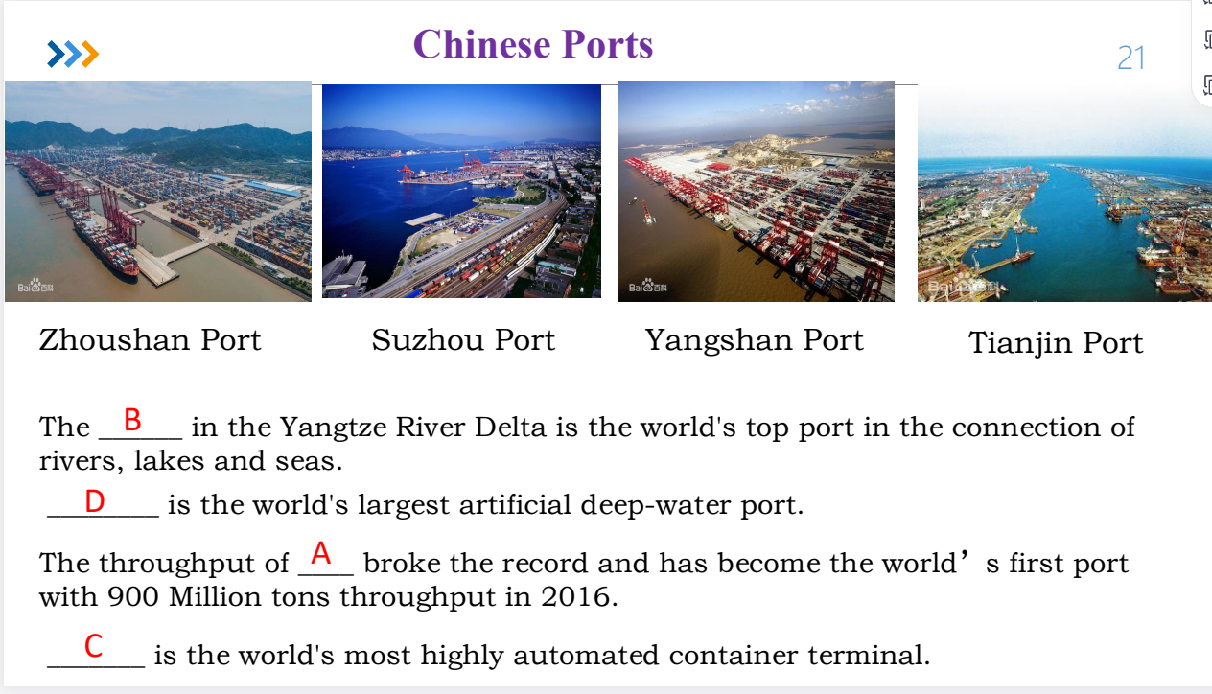
  - video script
    - digital design
      - target audience
      - content elements
        - concept
        - theme and idea
        - emotion
      - creative ideas
        - animation
        - voiceover narration
        - AIGV
        - English subtitle
        - muti-language
        - QR code and VR to enhance interactivity
        - hook
      - video structure
        - 镜号
        - 时间
        - summary
        - image
        - subtitle
        - music
        - shot types
          - long shot
          - medium shot
          - close-up
          - extreme close-up
- assessment
  - 30online+30平时分（考勤+小作业+大作业+口语测评）+40期末考（24分Chinese culture and case analysis , design a culture product ）
  - final exam
    - 1. 单项选择 10*1.5=15； 前三个单元
    - 2. 判断题：5*1.5=7.5
    - 3. 填空题：5*1.5=7.5
    - 4. 翻译题： 1）词汇和短语 5 * 3=15分；2）句子 3*5=15 （2道汉译英，1道英译汉）
    - 5. 传播案例分析，需要使用数字叙事框架，20分
    - 6. 数字作业设计，20分。
    - 课件、语言点、视频 美丽、艺韵、烟火、和谐、绿色、科创
- quiz
  - What is a key characteristic of traditional Italian pasta?It emphasizes diverse shapes for different sauces (e.g., spaghetti, penne).
  - Which type of alcoholic beverage is traditionally associated with ancient Chinese culture and often referenced in classical Chinese poetry and literature?Baijiu
  - What is the typical alcohol content range for Chinese Baijiu, making it one of the strongest traditional spirits globally?35-60%
  - Which traditional Chinese craft, known for its intricate designs and vibrant colors, is considered an Intangible Cultural Heritage?Paper cutting

- project
  - 静音仓 东家学生文化长廊 云峰楼下 主图4楼 录音。熟悉发音和
  - 背景音保留
  - 原字幕音删去
  - 后来的字幕音加上
  - 说明信息
  - 熟悉材料，看着字幕录音，去掉旧字幕加上新字幕，分离人声
- 课程感想
  - 课程我那年是新开的，骆老师在查老师上也无信息。本课程上课主要讲中国文化，以及传播中国文化的相关案例，并对此加以分析。
  - 考核有小组作业、个人作业和最后的期末考。小组作业和个人作业工作量不大，分析传播中国文化的案例为主，ai+稍稍修改，难度不大。期末考主要考中国文化的常识，和现场看一个视频赏析，以及设计一个视频来传播中国文化。由于新开课程，大概率之后考核会改，还在调整中。
  - 老师人很好，给分不错，相比于大英还是好的。每节课点名，最后得分是90.

