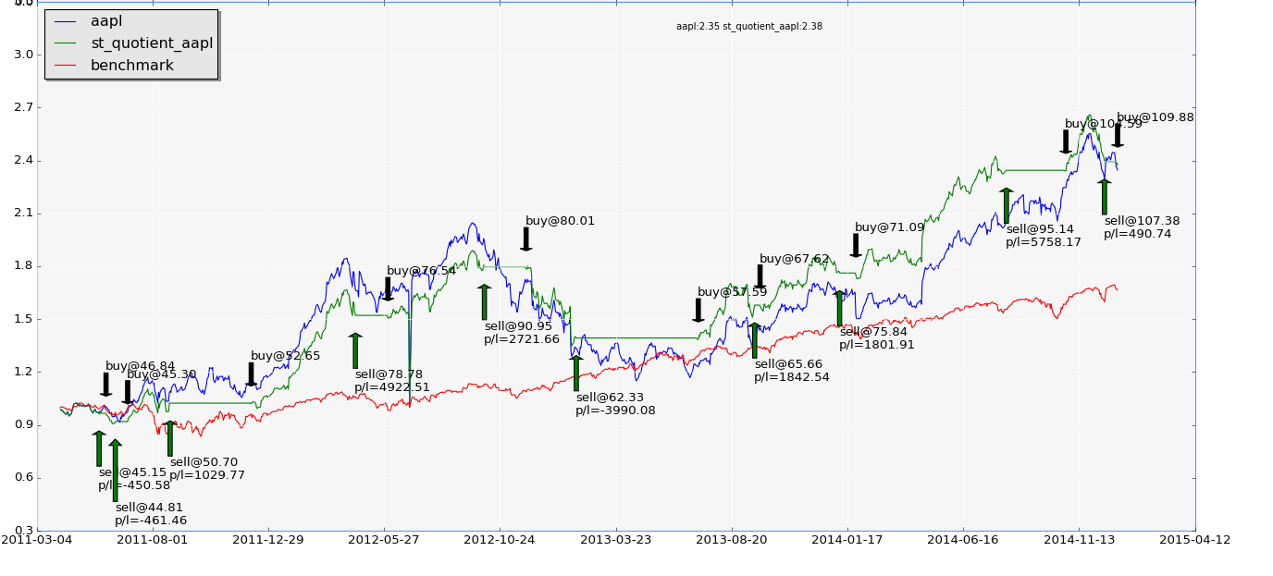

**C O N V I C T I O N B U Y**

S T O C K

B A C K T E S T

and

A N A L Y S I S

S Y S T E M

# Quick Start

## Requirement

##### Install numpy, pandas, matplotlib yourself, or

* Install an integrated development environment such as canopy

$CBROOT = /path/to/convictionbuy/

## Prepare portfolio file

* cd $CBROOT/data
* Create new file portfolio2015.txt
* Input equity symbol. E.g.

NYSE:DOW NYSE:PEP NYSE:CVX NYSE:WMT NYSE:MMM NYSE:CAT NYSE:XOM NYSE:COP NYSE:KO NYSE:CL NYSE:KMB NYSE:MCD NYSE:GE NYSE:BA NYSE:NOC NYSE:MRK NYSE:GSK NYSE:NVS NYSE:PG NYSE:JNJ NYSE:MJN NYSE:ABT NYSE:LLY NYSE:PFE NYSE:BMY NYSE:SNY NASDAQ:BIIB NYSE:AZN NASDAQ:GILD NYSE:BLK NYSE:AXP NYSE:MA NYSE:V NYSE:C NYSE:BAC NYSE:JPM NYSE:WFC NYSE:GM NYSE:F NYSE:MS NASDAQ:ERIC NYSE:NOK NASDAQ:NTES NASDAQ:BBRY NYSE:QIHU NASDAQ:SOHU NASDAQ:CYOU NYSE:VIPS NYSE:LITB NYSE:BABA NASDAQ:WB NASDAQ:YY NYSE:VMW NASDAQ:NFLX NASDAQ:AMZN NASDAQ:GOOGL NASDAQ:GOOG NYSE:LMT NYSE:A NYSE:GS NASDAQ:BIDU NYSE:ORCL NASDAQ:FB NYSE:TWTR NYSE:EMC NASDAQ:AAPL NASDAQ:JDSU NASDAQ:CSCO NYSE:T NYSE:VZ NASDAQ:MSFT NYSE:SAP NASDAQ:INTC NYSE:IBM NASDAQ:QCOM NASDAQ:TSLA NYSE:COH NYSE:RTN NYSE:CBI NYSE:HD NYSE:DIS NASDAQ:FOXA

* Save and close file

### Assign portfolio id for one stock

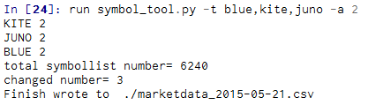

### See stock’s portfolio id

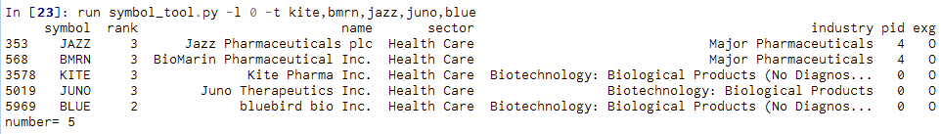

## Run optimization on strategy “st_aeoas”

* cd $CBROOT/src
* run backtest.py -f ..\data\portfolio2015.txt -p 'chart=0&mode=1' -g st_aeoas -s 2013-12-20 -e 2015-01-13
* a file “st_aeoas_best_2015-01-14.csv” will be created in $CBROOT/result:

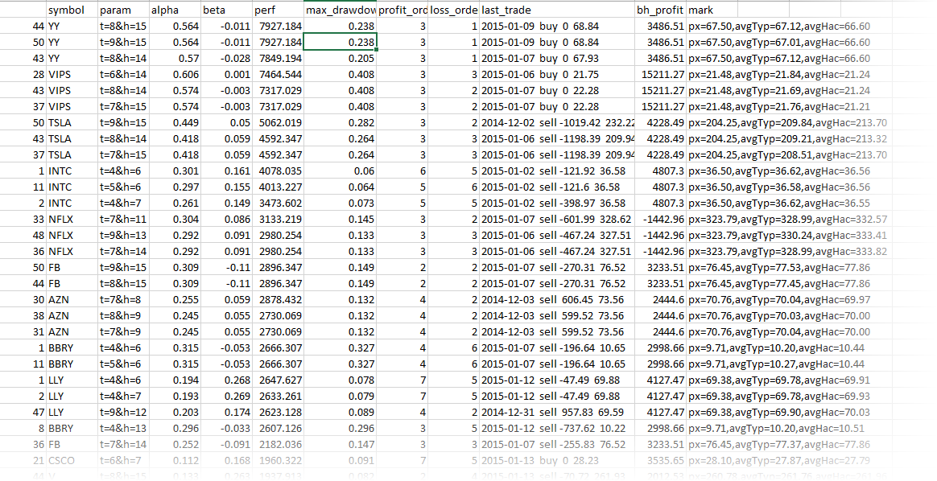

Noted:

* bh_profit = buy & hold profit (from first trade)
* param = strategy parameter
* mark = additional strategy info, e.g px=67.50(last close price=67.5);avgTyp and avgHac is strategy indicator

## About strategy

The strategy is implemented according to the article “An Expert Of A System” by Sylvain Vervoort, technical analysis of stock & commodities 2013 Oct issue.

please refer to <http://www.traders.com/Documentation/FEEDbk_docs/2013/10/Vervoort.html>

# Market Data