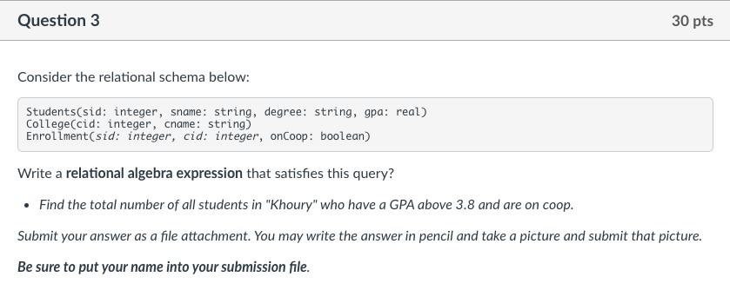

Name: Jinwei Zhang

Answer:

