CS162 Lecture 2 Detailed Notes
Four Fundamental OS Concepts: Thread, Address Space, Process, Dual Mode Operation

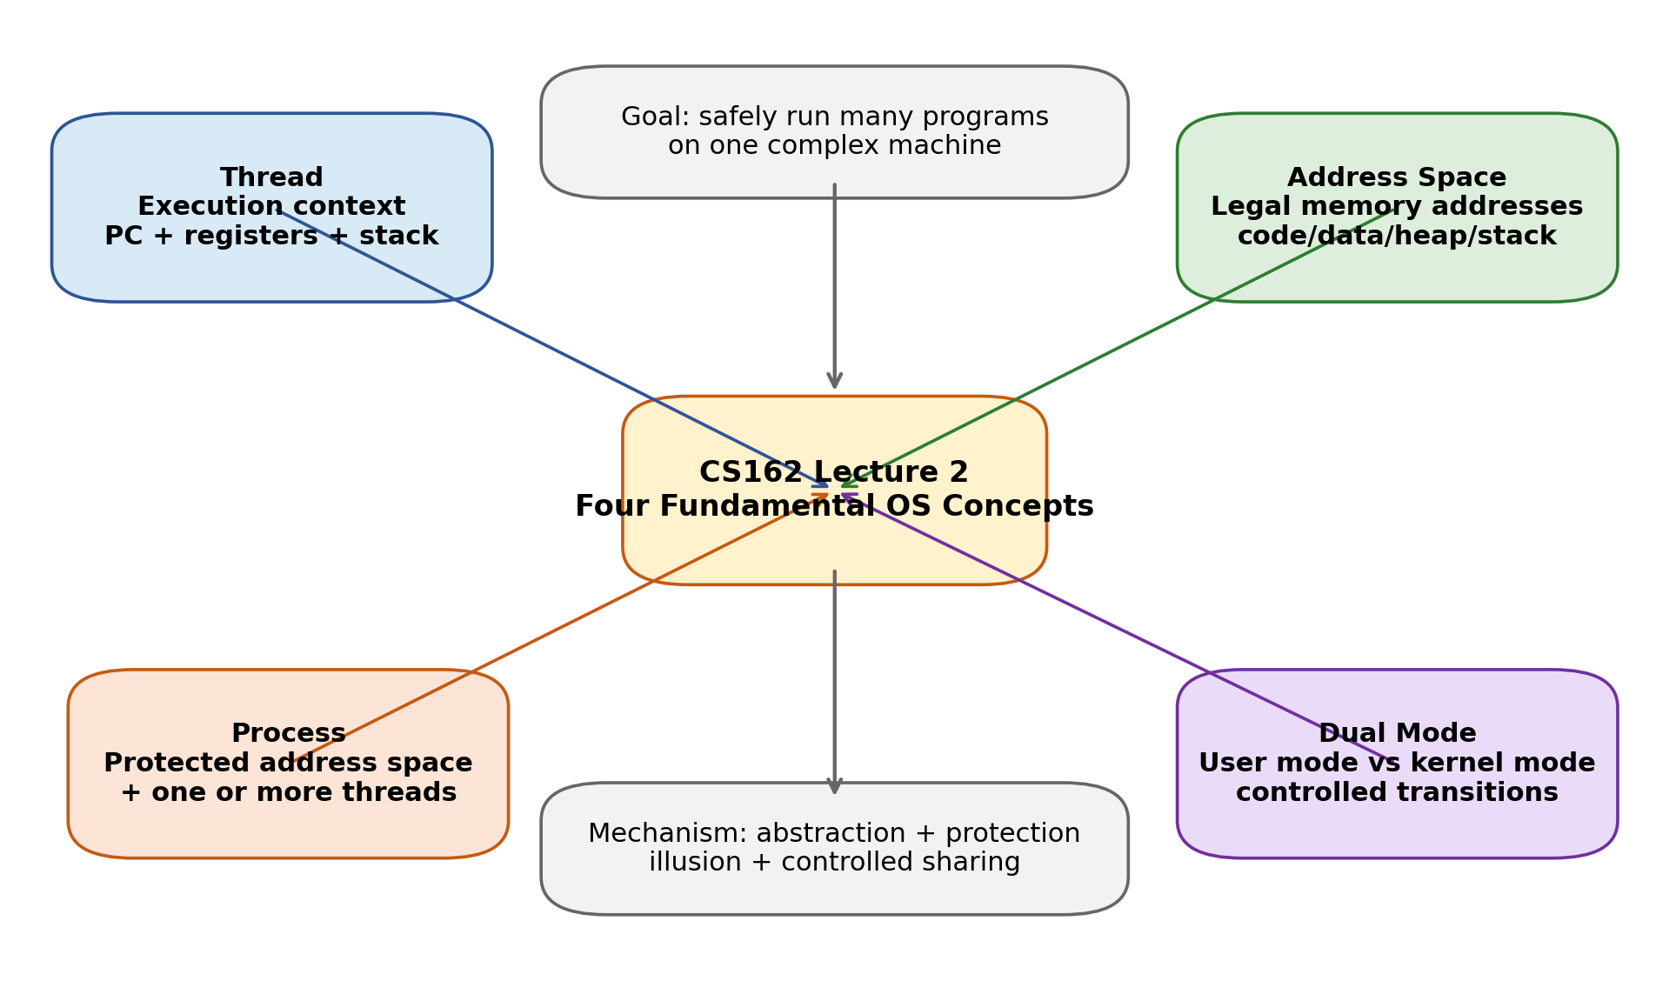
Figure 1. Lecture 2 overview map.
How to use this note
Read the overview first, then study each concept with the picture beside it. For every concept, ask: (1) what hardware reality is being hidden? (2) what software abstraction does the OS provide? (3) what protection problem is solved?

Source used | How it is used in this note
02.en.srt | Lecture transcript: used to capture instructor emphasis and the spoken explanation order.
2.pdf | Lecture 2 slides: used as the main structure and slide/page topic sequence.
1.pdf | OSPP textbook notes: used to deepen process, kernel, protection, and mode-transfer explanations.

Table of Contents
- 1. Big Picture: Why OS Concepts Exist
- 2. From C Program to Running Process
- 3. Concept 1: Thread = Execution Context
- 4. Concept 2: Address Space = Protected Memory View
- 5. Concept 3: Process = Protected Container + Threads
- 6. Concept 4: Dual Mode Operation = Hardware Protection Gate
- 7. Mode Transfers: System Calls, Interrupts, Exceptions
- 8. Putting It Together: Context Switch, PCB, Scheduler
- 9. Common Confusions and Exam-Style Answers
- 10. Review Sheet and Self-Test

1. Big Picture: Why OS Concepts Exist
Lecture 2 begins by reminding us that the operating system is not just a program launcher. It is the layer that turns a messy, shared, failure-prone machine into a safer and easier programming environment.
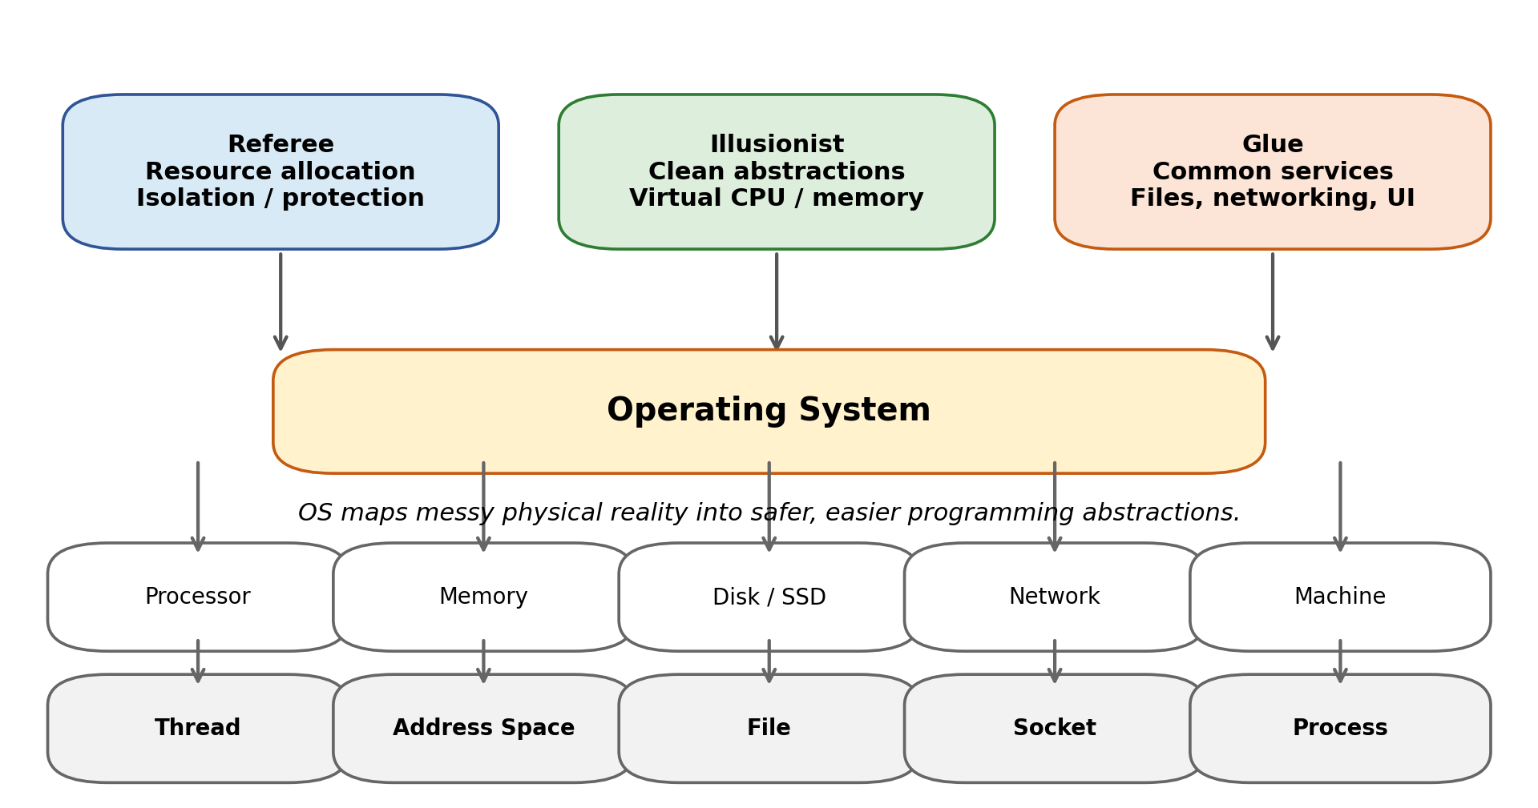
Figure 2. OS roles and the abstractions built on top of raw hardware.
OS role | Beginner meaning | Lecture 2 connection
Referee | The OS decides who may use CPU, memory, disk, network, and when. | Needed because multiple programs compete for finite resources.
Illusionist | The OS gives a nicer virtual world than the physical machine. | A processor becomes threads; memory becomes address spaces; disks become files.
Glue | The OS gives common services so programs can cooperate. | Files, sockets, window systems, authorization, shared libraries.

Core problem of the lecture
How can one machine run many programs at the same time, while preventing a buggy or malicious program from destroying the OS or another program?

1.1 Complexity is the reason we need clean abstractions
- Modern hardware has many cores, caches, memory channels, I/O devices, and hardware-specific quirks.
- Modern software has millions of lines of code, many libraries, third-party modules, and many possible failure modes.
- Because we cannot test every possible hardware/software combination, the OS must design strong boundaries and simple abstractions.
Mental model
An OS is a “complexity shield.” It hides unnecessary hardware details from applications while enforcing rules so applications cannot damage each other.

2. From C Program to Running Process
A common confusion is: “I compiled my C file into machine language stored in memory. Where did the process and thread come from?” The answer is: a program file is passive; a process and thread are created by the OS when the program is executed.
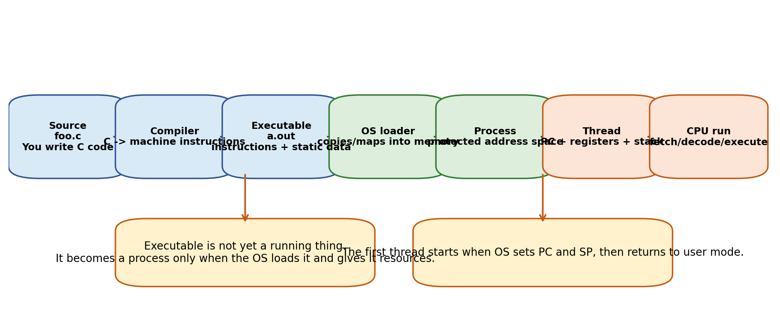
Figure 3. From source code to a running process/thread.
- You write source code such as foo.c.
- The compiler and linker translate it into an executable file. This file contains machine instructions plus metadata and initial static data.
- When you run the program, the OS creates a process object and a process control block (PCB).
- The OS loader maps or copies the program code and data into the process address space.
- The OS creates memory regions for the heap and the initial stack.
- The OS creates at least one thread and initializes the thread state: program counter (PC), stack pointer (SP), registers, and flags.
- The OS transfers control to user mode. The CPU starts fetching instructions at the thread PC.
Key distinction
Program = passive file on disk. Process = running instance with resources and protection. Thread = active execution context inside the process.

2.1 Minimal C example: what happens at runtime?
int main() {
int x = 10; // local variable: usually on stack
int *p = malloc(sizeof(int)); // dynamic object: heap
*p = x + 1; // CPU executes load/compute/store instructions
printf("%d\n", *p); // library call eventually uses system call to write output
return 0;
}
Runtime object | Where it is | Why it matters
Machine instructions | Code segment | CPU fetches instructions from here using PC.
Global/static variables | Static data segment | Exist for the whole program lifetime.
Local variable x | Stack | Exists during the function call; removed when function returns.
malloc object | Heap | Exists until freed; grows dynamically.
printf output | Usually via library + syscall | User code asks kernel to write to terminal/file/device.

3. Concept 1: Thread = Execution Context
A thread is the OS abstraction for “a sequence of execution.” It fully describes the current state needed to continue running some code.
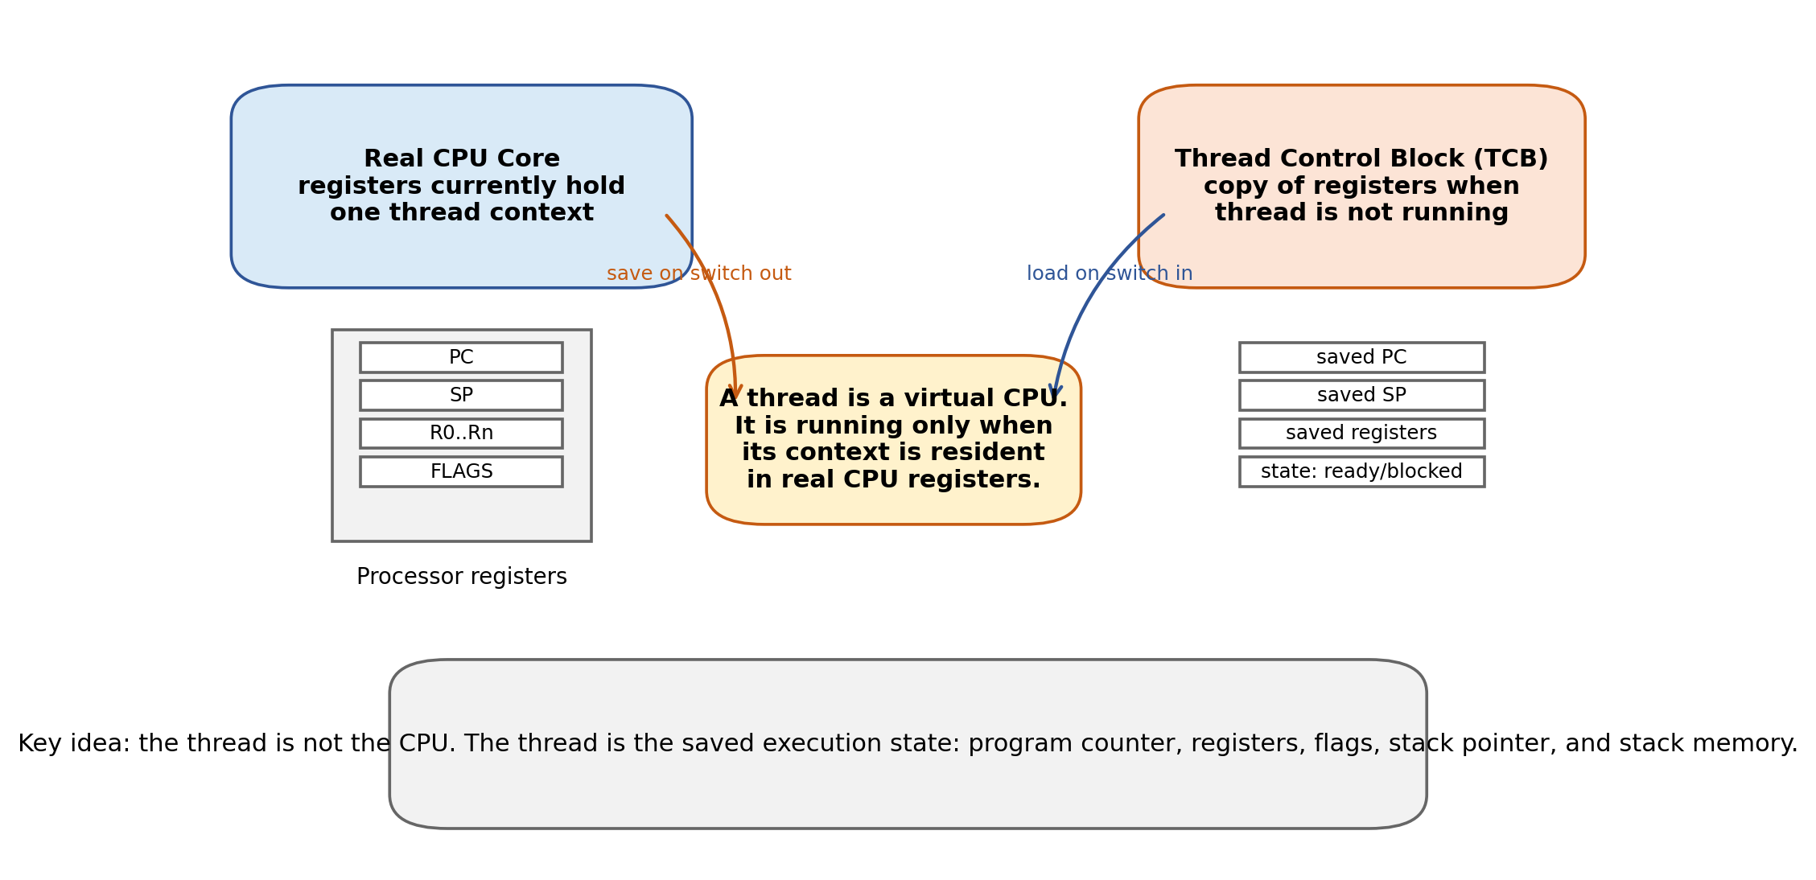
Figure 4. Thread as a virtual CPU and its saved Thread Control Block (TCB).
Part of thread state | Meaning | Beginner explanation
Program Counter (PC) | Address of the next instruction | The CPU asks: “what instruction should I fetch next?”
Registers | Small fast storage inside CPU | Temporary values, pointers, function arguments, return values.
Execution flags | Condition/status bits | Record results like zero/negative/carry; used by branches.
Stack pointer (SP) | Address of top of current stack | Shows where function-call state is stored.
Stack memory | Function calls and local variables | Each thread normally has its own stack.

Very important
A thread is not always running. If it is not running, its PC/SP/registers are saved in memory, usually inside a Thread Control Block. When it runs again, the OS reloads those values into the real CPU registers.

3.1 What does “resident in the processor registers” mean?
The lecture uses the word resident to mean the thread state is currently loaded into the physical CPU registers. If Thread A is running, the PC register points to Thread A’s next instruction. If the OS switches to Thread B, the CPU registers no longer represent Thread A; Thread A’s state is saved in its TCB.
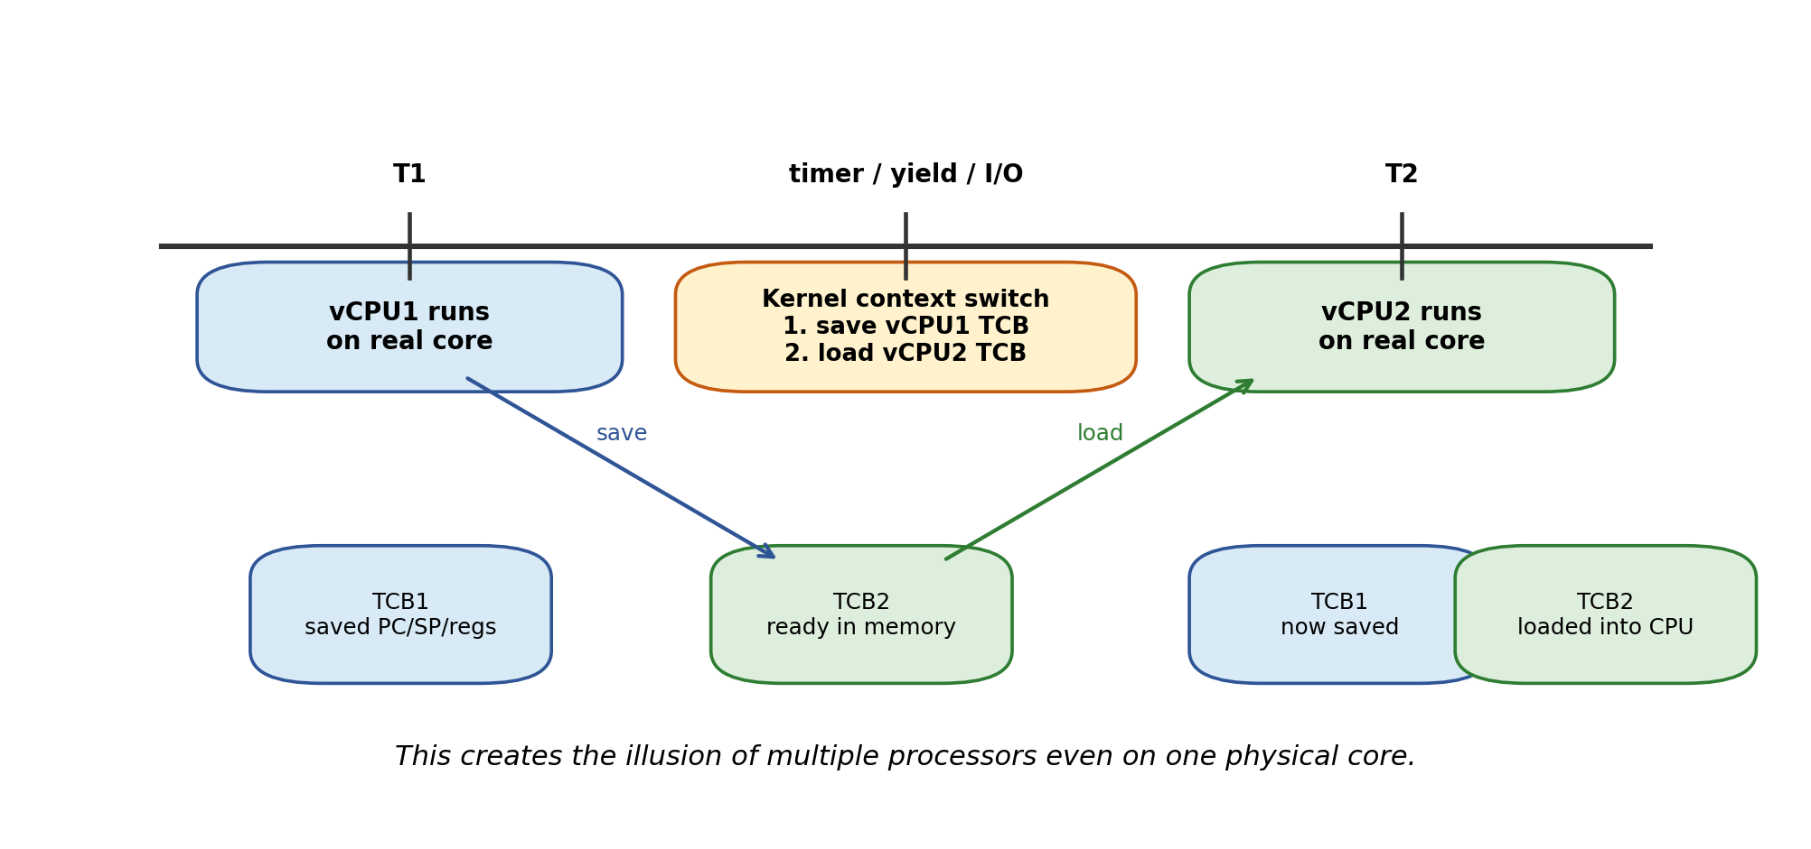
Figure 5. Time multiplexing creates the illusion of multiple CPUs.

3.2 Why threads let the world look parallel
- On one physical core, the OS rapidly switches between threads over time.
- On many physical cores, multiple threads may truly run at the same time.
- Either way, programmers think in terms of virtual CPUs/threads rather than raw cores.
- A timer interrupt, voluntary yield, blocking I/O, or scheduler decision can trigger a switch.
Analogy
A single teacher can talk to student A for a short time, then student B, then student C. Each student feels they are making progress, even though the teacher is shared. A CPU core is like the teacher; threads are like students waiting for attention.

4. Concept 2: Address Space = Protected Memory View
An address space is the set of memory addresses a program is allowed to use, plus the state associated with those addresses. Modern programs usually operate on virtual addresses, not raw physical addresses.
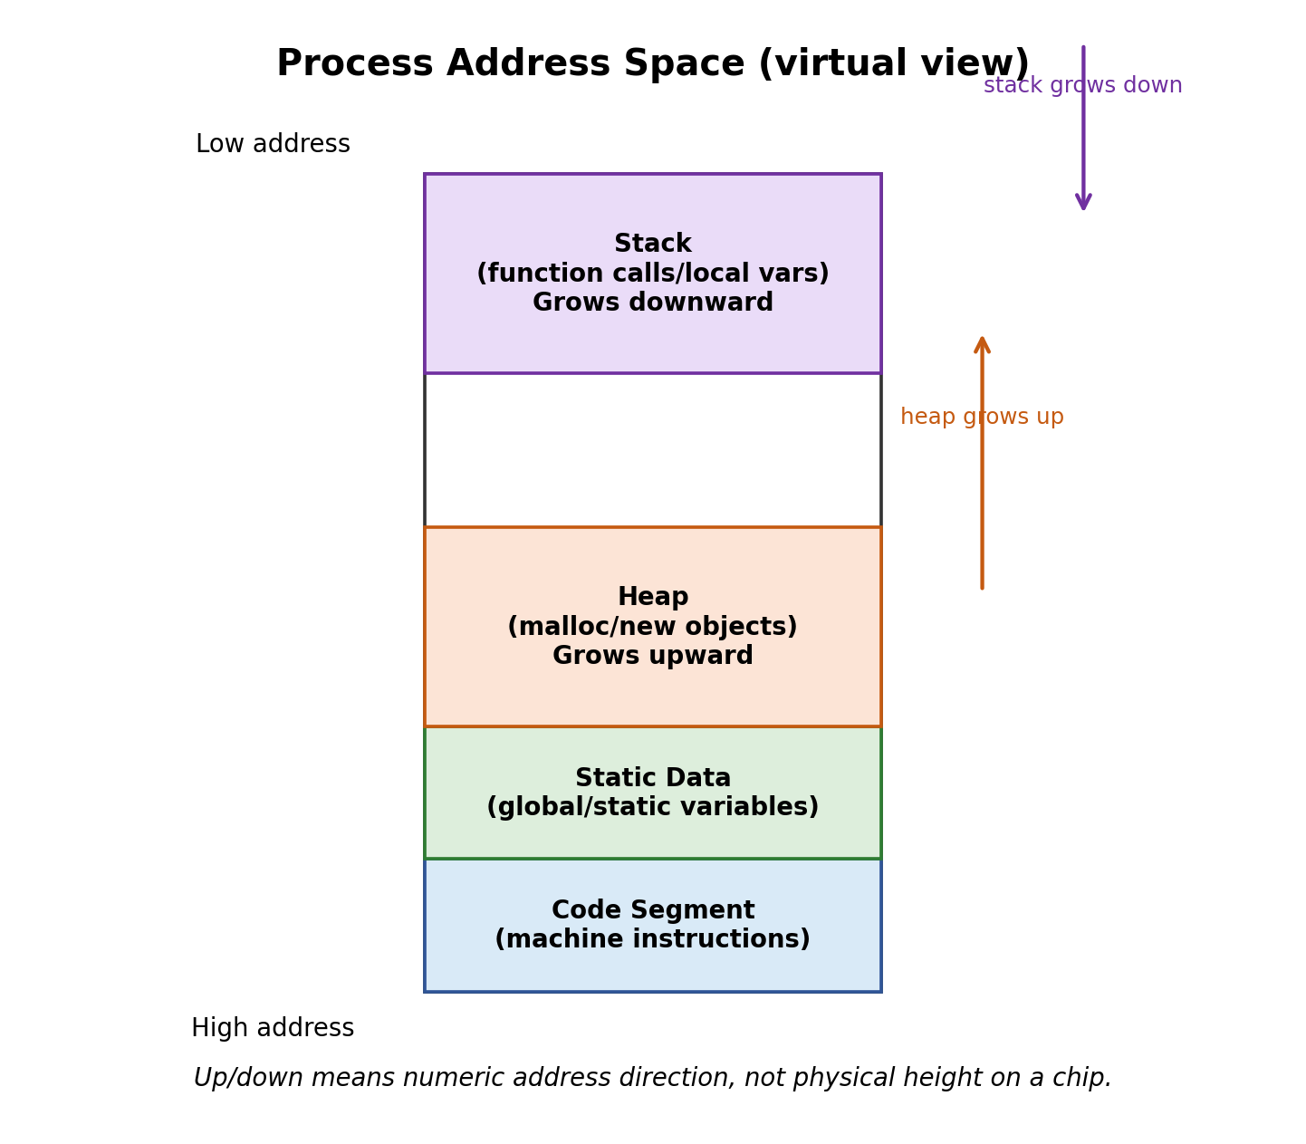
Figure 6. Typical process address space layout.
Segment | Contains | Growth / lifetime | Why it matters
Code segment | Machine instructions | Mostly fixed; often read-only | Prevents accidental modification of program code.
Static data | Global/static variables | Whole program lifetime | Initialized before main; exists until process exits.
Heap | Dynamically allocated objects | Can grow upward | malloc/new use heap; programmer must manage lifetime in C/C++.
Stack | Call frames, local variables, return addresses | Often grows downward | Each thread needs its own stack.

What does “stack grows downward” mean?
It means the numeric addresses used by newer stack frames usually become smaller. It does not mean that memory physically moves downward. It is only a convention in the virtual address map.

4.1 Why not “heap becomes smaller but stack becomes bigger”?
Heap and stack are two different regions. The heap grows when the program asks for dynamic memory; the stack grows when function calls need more call frames. In the common layout, heap growth moves toward higher addresses and stack growth moves toward lower addresses. The free gap between them becomes smaller if both grow. So the heap itself is not becoming smaller; the unused space between heap and stack is becoming smaller.

4.2 Segmentation fault and “valid memory”
A memory address is valid only if the process address space contains that address with the required permission: read, write, or execute. If a C pointer points to nothing valid and the program writes through it, the hardware/OS detects an illegal memory access and raises an exception. The OS usually kills the process and reports a segmentation fault.
int *p = NULL;
*p = 42; // invalid write: address 0 is not a writable user address
Valid does not mean “looks like a number”
A pointer value is just a number, but the OS decides whether that number is inside your process address space and whether the requested operation is allowed.

4.3 Simple protection: Base and Bound
Base-and-bound is a simple hardware mechanism for memory protection. The base register says where the process memory begins; the bound says where it ends. Every user-mode memory reference is checked.
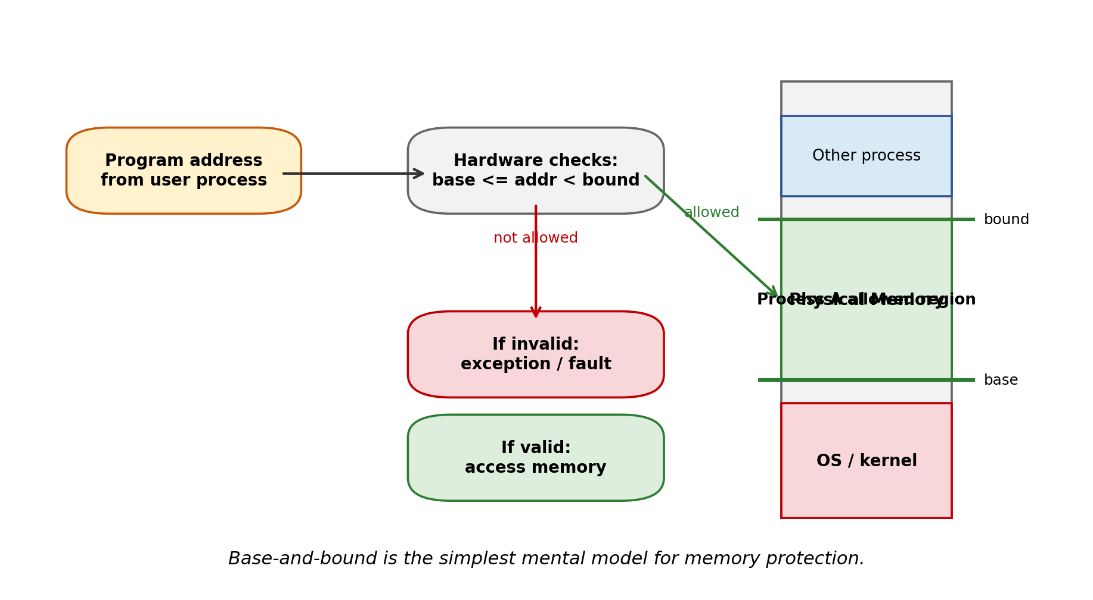
Figure 7. Base-and-bound protection checks every address.
- The program generates an address.
- Hardware checks whether base <= address < bound.
- If yes, the memory access continues.
- If no, the hardware raises an exception and enters the kernel.
- The kernel usually terminates the offending process or reports an error.
Why this matters
Without memory protection, one program could overwrite OS memory or another process’s memory. One bug could crash the whole machine.

4.4 Virtual addresses and page tables
Modern systems usually use page-based virtual memory. The program uses virtual addresses; hardware translates them through a page table into physical memory frames. Each process can have its own page table, so the same virtual address in two processes can map to different physical frames.
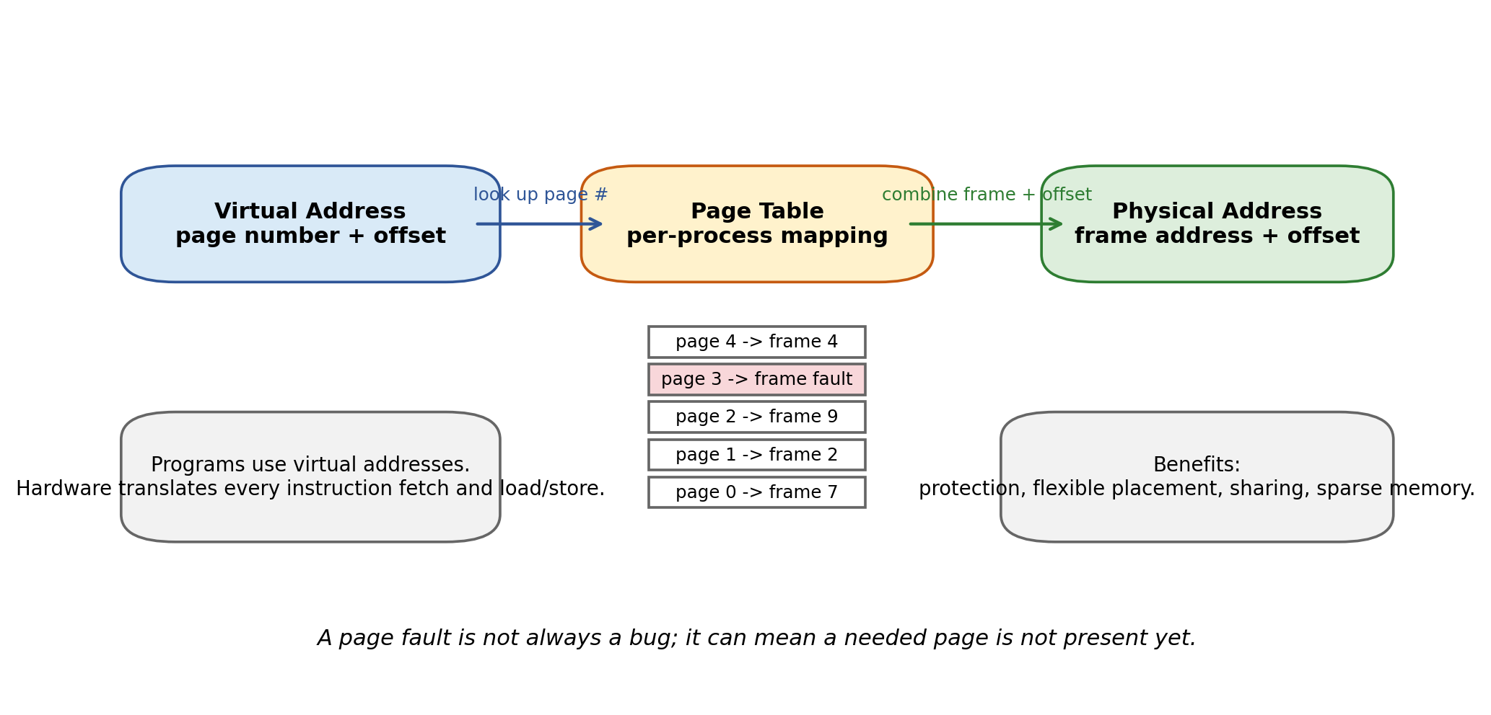
Figure 8. Page-table translation from virtual address to physical address.
Term | Meaning | Why it helps
Virtual address | Address seen by the program | Every process can appear to start from address 0.
Physical address | Actual RAM location | Managed by OS/hardware.
Page | Fixed-size chunk of virtual address space | Easy to map, protect, share, or mark not present.
Frame | Fixed-size chunk of physical memory | A page can be placed in any free frame.
Page fault | Exception when translation fails or permission is wrong | Can signal invalid access or demand loading from disk.

5. Concept 3: Process = Protected Container + Threads
A process is an instance of a running program with restricted rights. In this lecture, the clean definition is:
Definition
Process = protected address space + one or more threads + OS-managed resources such as file descriptors, identity, permissions, and accounting.

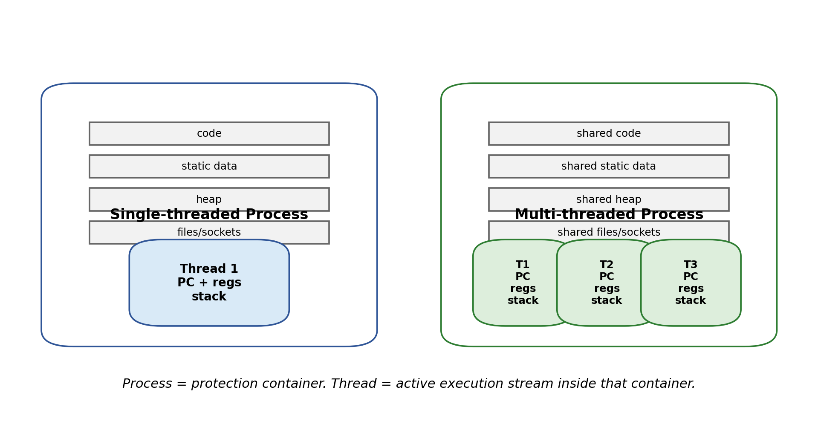
Figure 9. Single-threaded and multi-threaded processes.
Concept | What it owns / represents | Example
Program | File containing executable instructions and data | a.out on disk
Process | Protected execution environment | One running instance of a.out
Thread | Execution stream inside a process | The main thread executing main()
Address space | Memory view of a process | Code/data/heap/stack virtual addresses
PCB | Kernel record for a process | PID, status, register state, memory info
TCB | Kernel record for a thread | Saved PC/SP/registers when not running

5.1 Why multiple threads inside one process?
- Parallelism: on multiple cores, several threads can run truly at the same time.
- Concurrency: even on one core, threads can handle I/O, UI, networking, and computation without freezing the application.
- Shared memory: threads in the same process can communicate through shared heap/global data more easily than separate processes.
- Tradeoff: sharing memory is fast but dangerous; it can cause race conditions. Later lectures cover synchronization.
Active vs passive
Threads are the active component: they execute. Address spaces are the passive protection component: they contain what memory can be accessed.

6. Concept 4: Dual Mode Operation = Hardware Protection Gate
Memory protection is not enough by itself. A process must also be prevented from changing the page table pointer, disabling interrupts, or directly controlling devices. Dual-mode operation provides this foundation.
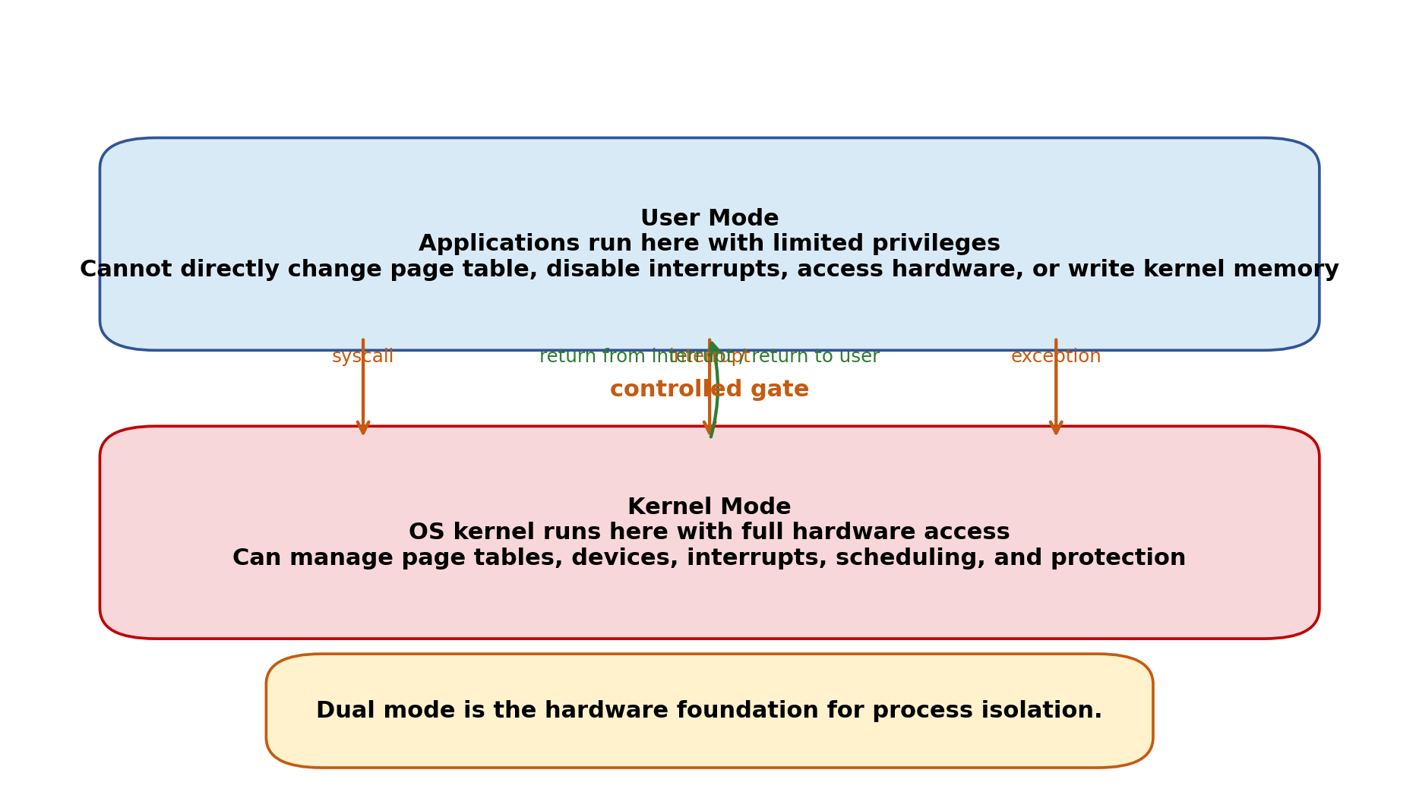
Figure 10. User mode and kernel mode.
Mode | Who runs here? | Allowed operations | Danger if user code had this power
User mode | Applications | Normal computation and allowed memory accesses | Safe because dangerous operations are blocked.
Kernel mode | OS kernel | Privileged instructions, page tables, devices, interrupts | If arbitrary user code entered here, it could control the whole machine.

6.1 Privileged instructions
Privileged instructions are instructions that only kernel-mode code may execute. Examples include changing page-table registers, disabling interrupts, and controlling device hardware. If a user program tries to execute them, the processor raises an exception.
Principle of least privilege
Code should have exactly the privileges needed to do its job, and no more. This reduces the damage from bugs and attacks.

7. Mode Transfers: System Calls, Interrupts, Exceptions
The user program cannot jump to any random kernel address. Instead, hardware provides controlled gates from user mode into kernel mode.
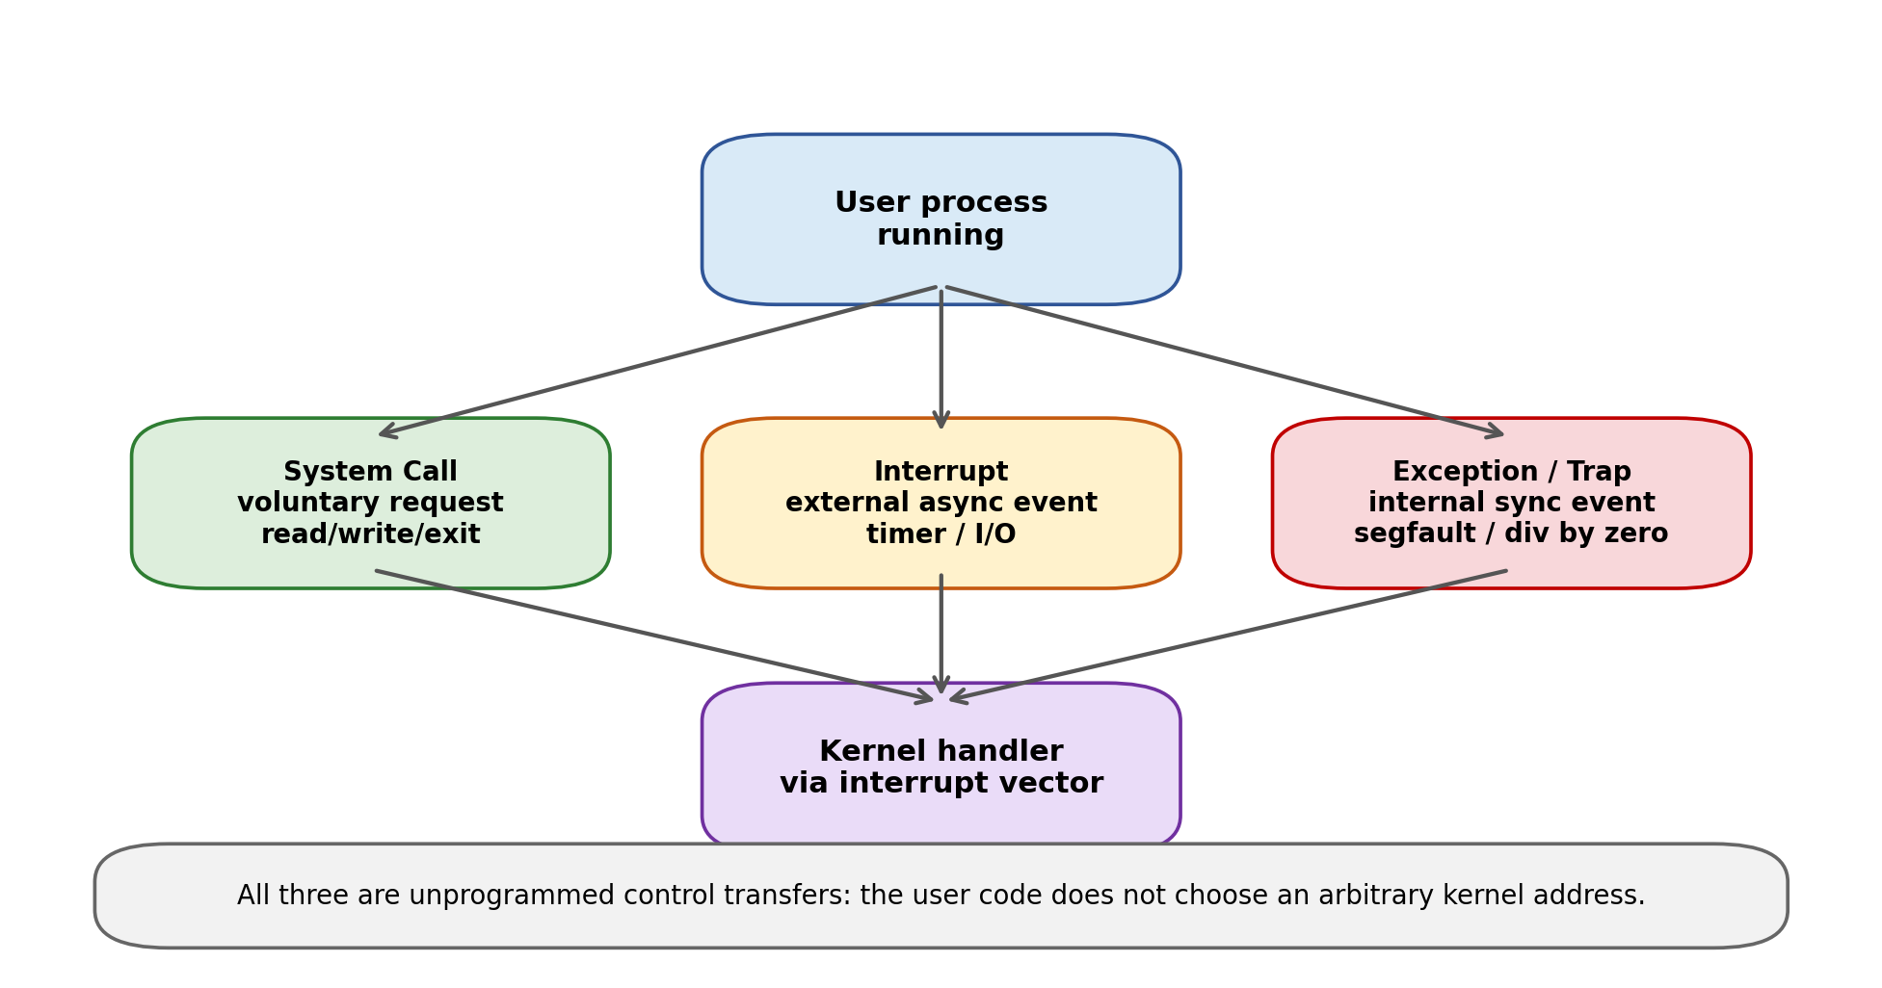
Figure 11. Three types of user-to-kernel transfer.
Transfer type | Triggered by | Synchronous or asynchronous? | Example | Typical kernel response
System call | Program asks for OS service | Synchronous | read(), write(), exit() | Validate args, perform service, return value.
Interrupt | External event | Asynchronous | Timer, keyboard, disk done, network packet | Handle event; maybe schedule another thread.
Exception / trap | Current instruction causes problem or special condition | Synchronous | Segmentation fault, divide by zero, page fault | Fix if possible or kill/report process.

7.1 Interrupt vector table
When an interrupt, exception, or system call occurs, hardware needs to know which kernel handler to run. It uses a protected interrupt vector table: an array of handler addresses in kernel memory.
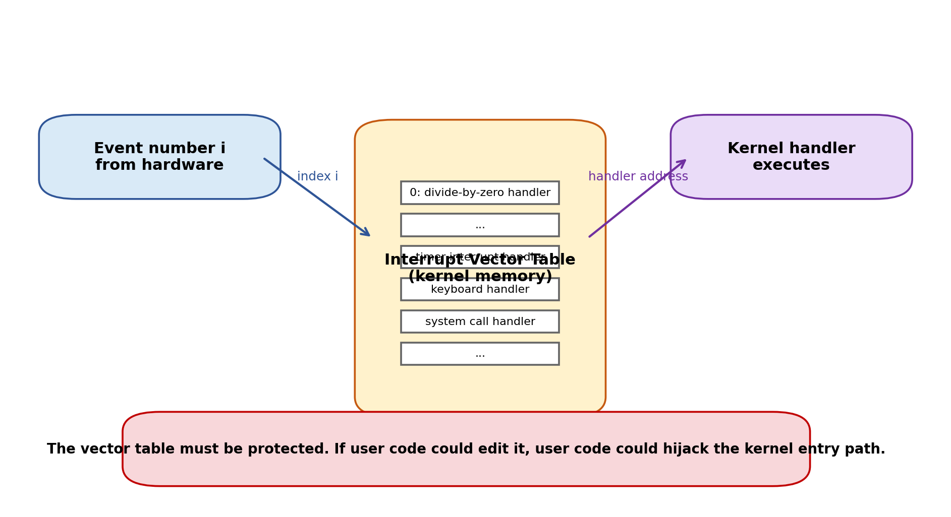
Figure 12. Interrupt vector table selects the correct kernel handler.
Why user code must not edit the interrupt vector
If user code could change the vector table, it could redirect timer, network, or system-call entries to its own code and effectively hijack the machine.

7.2 Kernel stack and user stack
A process usually has a user stack for running application code and a kernel stack for handling system calls, interrupts, and exceptions on behalf of that process. The kernel cannot safely use the user stack because the user stack might be invalid or maliciously modified.
Stack | Used when | Stores
User stack | Process is running application code | Application call frames, local variables, return addresses.
Kernel stack | Kernel is handling event for that process/thread | Saved user registers, kernel call frames, handler state.

Beginner summary
A mode transfer is not just “jumping to another function.” The hardware must atomically change privilege, switch to a safe kernel entry point, save enough user state, and use a trusted kernel stack.

8. Putting It Together: Context Switch, PCB, Scheduler
Once the kernel regains control, it may return to the same process or switch to a different one. To do this, the kernel needs persistent records of processes and threads.
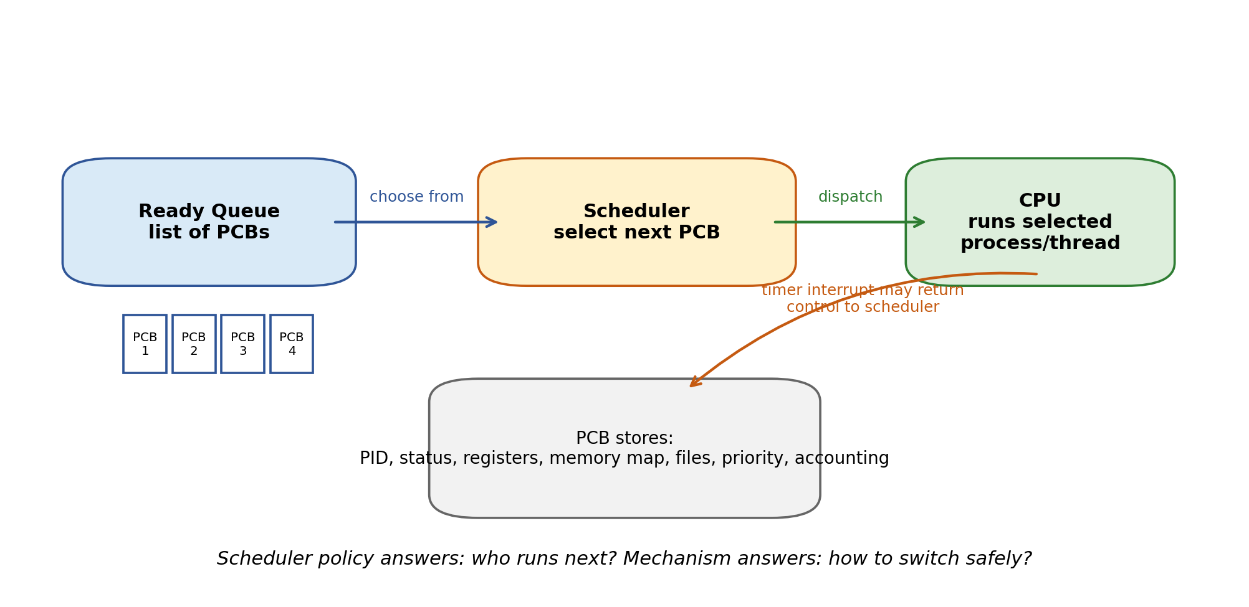
Figure 13. PCB, scheduler, and dispatch to CPU.
PCB field | Purpose
Status | running, ready, blocked, zombie, etc.
Register state | Where to resume if the process/thread is not currently running.
PID / user / executable | Identity and ownership.
Priority / accounting | Scheduling and fairness decisions.
Memory translation info | Page table or base/bound state.
Open files / sockets | Resources owned by the process.

8.1 What a context switch does
- An interrupt, syscall, or exception brings control into the kernel.
- The kernel saves the current thread state: PC, SP, registers, flags, memory-translation state if needed.
- The scheduler chooses another ready thread/process.
- The kernel loads the new thread state from its TCB/PCB.
- The kernel returns to user mode at the new thread’s saved PC.
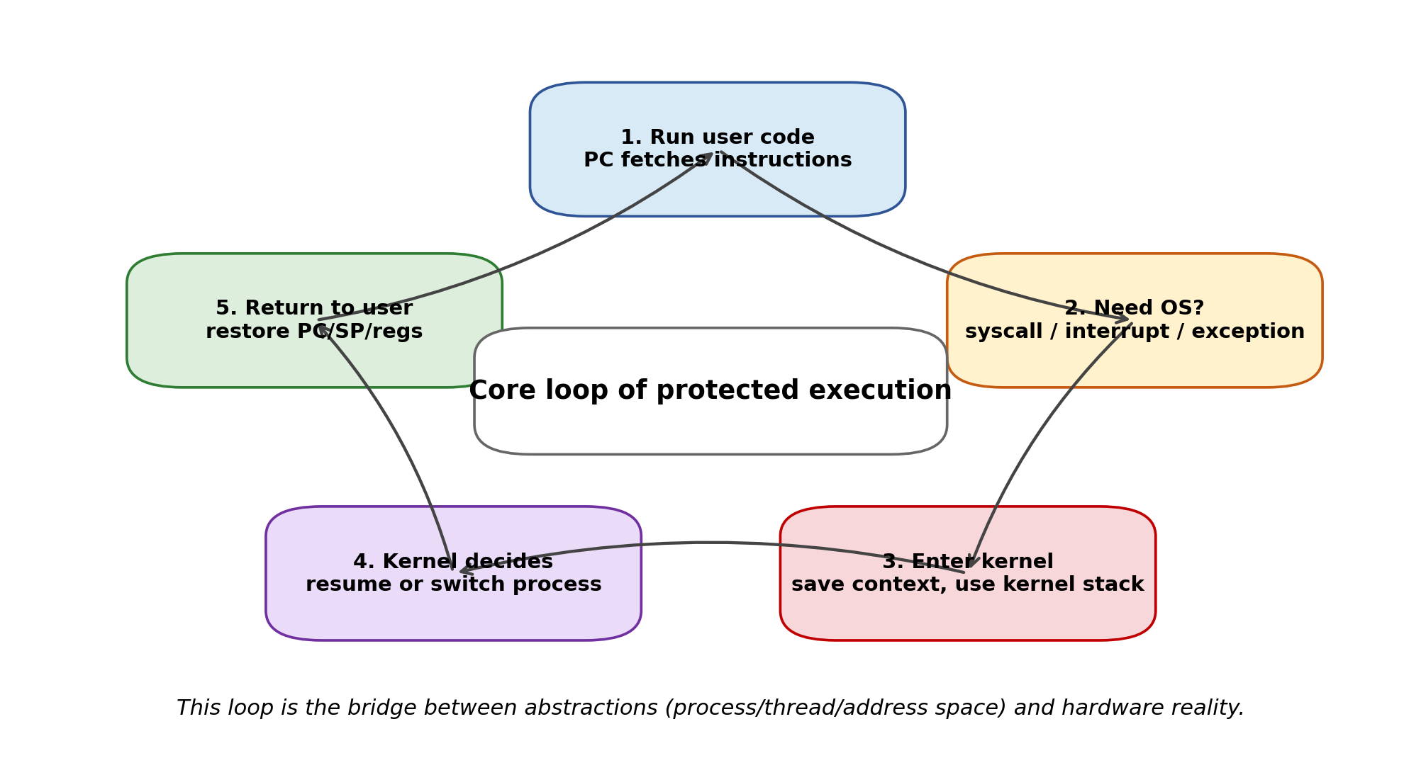
Figure 14. Protected execution cycle.
Mechanism vs policy
Mechanism: how the OS can safely switch, protect memory, and enter/exit the kernel. Policy: which process should run next and how much CPU time it gets.

9. Common Confusions and Exam-Style Answers
Confusion | Clear answer
Register vs memory | Registers are tiny, very fast storage inside the CPU. Memory is much larger and slower. A running thread’s “root state” is in registers; most data is in memory.
Register vs cache | A register is directly named by instructions and holds current computation state. A cache is hidden hardware that stores recently used memory blocks to speed up memory access.
Program counter vs instruction | An instruction is a command stored in memory. The PC is a register holding the address of the next instruction.
Thread vs process | A process is the protection container. A thread is an execution path inside the process. One process can contain many threads.
Process vs executable file | The executable is passive on disk. The process is a running instance with memory, resources, and kernel bookkeeping.
Why PC/SP/registers saved? | Because after a context switch the CPU registers will be reused by another thread. To resume later, the old values must be preserved.
Why segmentation fault? | The process touched an address that is not valid for that process or not allowed for that operation.
Why not let user code access hardware? | Then one program could corrupt disks, steal data, disable interrupts, or take over the OS.

9.1 “A C program is compiled to memory; where do thread/process come from?”
A compiled C program is an executable file. It does not automatically become a process. When you run it, the OS creates the process and initializes the first thread. The first thread begins at a start routine that eventually calls main(). If the program later calls a thread library or system API to create more threads, the OS/library creates additional thread contexts.
One-sentence answer
A process/thread is not produced directly by the compiler; it is produced by the OS loader and kernel when an executable is started.

9.2 How to understand invalid pointer writes
Suppose p points to nothing valid and the program writes *p = 1. The CPU issues a store to the numeric address in p. The memory-protection hardware checks the address against the process address space. If the address is outside the allowed range or lacks write permission, the hardware raises an exception. The kernel sees a protection violation and usually terminates the process with “Segmentation fault.”

9.3 Why stack and heap grow toward each other
The OS often places heap near the low part of the user address space and stack near the high part. The heap grows upward as dynamic allocations increase. The stack grows downward as nested function calls need more frames. This arrangement lets both regions expand into a shared free gap, instead of choosing fixed sizes too early.

10. Review Sheet and Self-Test
Concept | Must-remember definition
Thread | Execution context: PC + registers + flags + stack; a virtual CPU.
Address Space | Set of addresses a program can access; often virtual and translated to physical memory.
Process | Running program instance with restricted rights: protected address space + one or more threads.
Dual Mode | Hardware support for user mode and kernel mode; protects privileged operations.
System Call | User program voluntarily asks kernel for a service.
Interrupt | External asynchronous event that transfers control to the kernel.
Exception | Synchronous event caused by current instruction; may be an error or page fault.
PCB | Kernel data structure representing a process.
TCB | Kernel data structure representing a thread’s saved execution state.

10.1 Self-test questions
- Explain why a process needs both an address space and at least one thread.
- Why does a timer interrupt make preemptive scheduling possible?
- Why can a user program call write() but cannot directly write to a disk controller?
- What exact state must be saved to suspend a thread and resume it later?
- Why does page-table translation help process isolation?
- What is the difference between a system call and an exception?
- Why must the interrupt vector table be in protected kernel memory?
- Describe the full path from running a.out to the CPU executing the first instruction of main().

10.2 Model answers in compact form
Process = protection, thread = execution
The address space defines what memory/resources can be accessed; the thread provides the PC/register/stack state needed to execute instructions inside that space.

Timer interrupt
It lets the kernel regain control even if the program never voluntarily yields, enabling fairness and responsiveness.

write() vs disk controller
write() enters the kernel through a controlled system-call gate. Direct device access is privileged and blocked in user mode.

Saved state
At least PC, SP, general registers, flags, and enough address-space / kernel bookkeeping to restart correctly.

Page tables
They map each process’s virtual addresses to permitted physical frames and permissions; illegal access triggers a fault.

Appendix A: Key Vocabulary (English / Chinese)
English term | 中文提示 | Simple meaning
Operating System | 操作系统 | Software layer that manages hardware resources and provides abstractions.
Thread | 线程 | One execution context / virtual CPU.
Process | 进程 | Protected running instance of a program.
Program Counter (PC) | 程序计数器 | Register storing address of next instruction.
Register | 寄存器 | Tiny fast CPU storage for current computation.
Address Space | 地址空间 | Set of addresses a process can access.
Virtual Address | 虚拟地址 | Address used by the program.
Physical Address | 物理地址 | Actual RAM location.
Page Table | 页表 | Mapping from virtual pages to physical frames.
System Call | 系统调用 | Controlled request from user program to kernel.
Interrupt | 中断 | External event that makes CPU enter kernel.
Exception / Trap | 异常/陷入 | Event caused by current instruction.
Kernel Mode | 内核态 | Privileged mode with full hardware access.
User Mode | 用户态 | Restricted mode for applications.
PCB | 进程控制块 | Kernel record for a process.
TCB | 线程控制块 | Kernel record for a thread.

Appendix B: One-page narrative summary
The OS provides the illusion that each program has its own processor and its own memory, even though all programs share the same physical machine. A thread is the virtual processor: it stores where execution is and what temporary values are in progress. An address space is the virtual memory world the program is allowed to access. A process combines a protected address space with one or more threads, plus resources such as open files. Dual-mode operation gives hardware support for protection: applications run in user mode, while the kernel runs in kernel mode. When user code needs OS help or when hardware needs attention, controlled transfers such as system calls, interrupts, and exceptions move execution into the kernel. The kernel saves state, handles the event, possibly chooses another thread/process, restores state, and returns to user mode. This is how one machine can safely and efficiently run many programs.
Final mental model
OS = a careful manager of illusions. Threads create the illusion of many CPUs. Address spaces create the illusion of private memory. Processes package protection. Dual mode makes the boundary enforceable.

