CS162 Lecture 2: Four Fundamental OS Concepts
Page-by-page explanation according to the SRT transcript and slide PDF
Source note: This Word note follows the uploaded Lecture 2 slide PDF. Each PDF handout page contains four lecture slides. The explanations are written from the SRT transcript when the transcript covers that material. Slides 2.45-2.55 are marked as preview because the SRT reaches the topic only briefly and says the next lecture will discuss kernel-mode transfers in more detail.
Big picture
Mental model: A program becomes useful only when the OS can run it safely.
Source code -> executable -> OS loads code/data -> creates stack/heap -> creates thread context -> runs in a protected process.
The protection story is:
1. Thread = the active CPU state.
2. Address space = the memory box the program can see.
3. Process = protected address space plus one or more threads.
4. Dual mode = hardware rule that only the kernel can use dangerous powers.

Manual table of contents
- PDF Page 1: This page reviews the OS roles and protection. The SRT explains that processes are virtual containers and segmentation fault is the result of invalid access.
- PDF Page 2: This page motivates why OS design is hard: modern hardware and software are very complex and bugs are unavoidable.
- PDF Page 3: This page moves from complexity to the OS abstraction role, then introduces the four fundamental concepts and the program loading story.
- PDF Page 4: This page connects CPU execution mechanics to the first OS concept: a thread as execution context.
- PDF Page 5: This page explains time multiplexing and context switching, then includes course setup logistics.
- PDF Page 6: This page includes course collaboration policy and then begins the second technical concept: address space.
- PDF Page 7: This page explains why simple multiprogramming without protection is dangerous and introduces base and bound.
- PDF Page 8: This page develops base-and-bound protection, relocation, hardware translation, and x86 segmentation ideas.
- PDF Page 9: This page introduces paging and defines the process abstraction.
- PDF Page 10: This page explains single vs multithreaded processes, protection/isolation, and dual-mode operation.
- PDF Page 11: This page shows user/kernel transitions, VMs/containers, and a concrete B&B process-start example.
- PDF Page 12: This page previews user-to-kernel transfer mechanisms: syscall, interrupt, exception, and interrupt vectors.
- PDF Page 13: This page continues the B&B story through interrupt, switching to another process, and resume.
- PDF Page 14: This page wraps up with PCB, scheduler, and the final four-concept summary.

PDF Page 1
Page summary: This page reviews the OS roles and protection. The SRT explains that processes are virtual containers and segmentation fault is the result of invalid access.

Slide 2.1: Title: Four Fundamental OS Concepts
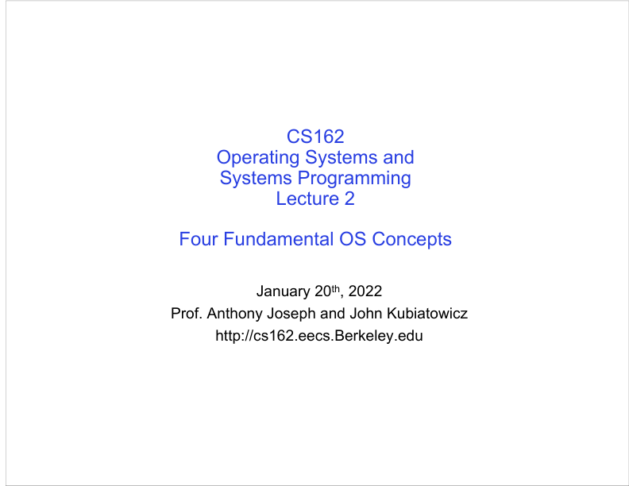
Figure: PDF page 1, quadrant 1, lecture slide 2.1.
SRT anchor: 00:00:04-00:00:15
What this slide means: The lecture opens by saying this is Lecture 2 and it will finish ideas introduced last time, then introduce four core OS concepts.
- The title tells you the main goal: build the vocabulary used throughout CS162.
- The four concepts are not isolated facts. They connect together: threads need CPU state, address spaces protect memory, processes combine both, and dual-mode hardware lets the OS enforce protection.
- Think of this lecture as the first map of the OS world. Later lectures fill in each region in more detail.
Graphic mental model: Lecture 2 roadmap: Thread -> Address Space -> Process -> Dual Mode Protection

Slide 2.2: Recall: What is an Operating System?
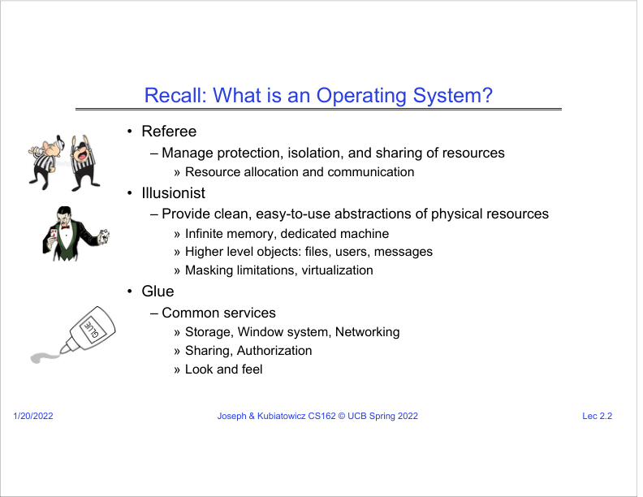
Figure: PDF page 1, quadrant 2, lecture slide 2.2.
SRT anchor: 00:00:18-00:01:08
What this slide means: The lecturer reviews the three roles of an OS: referee, illusionist, and glue.
- Referee means the OS manages shared resources and prevents programs from damaging each other.
- Illusionist means the OS hides ugly hardware details and presents clean abstractions, such as "each program has its own machine" or "memory looks huge".
- Glue means the OS provides common services, such as files, windows, networking, sharing, authorization, and a common look and feel.
- The SRT emphasizes that different OS definitions exist, but these three roles appear across many real systems.
Graphic mental model: Hardware reality -> OS abstractions -> Easier application programming

Slide 2.3: Recall: OS Protection
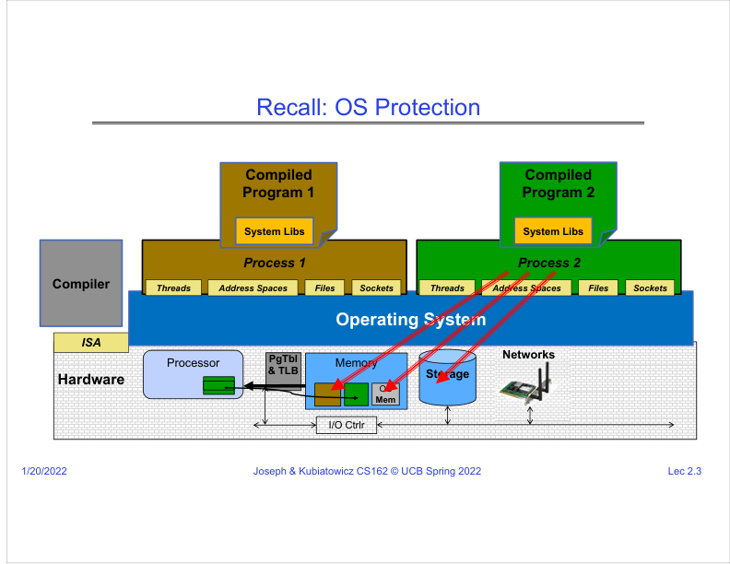
Figure: PDF page 1, quadrant 3, lecture slide 2.3.
SRT anchor: 00:01:11-00:02:05
What this slide means: Processes are shown as virtual containers above the OS. Each process believes it owns threads, address space, files, and sockets.
- The hardware is at the bottom. The OS sits above the hardware and creates a virtual-machine-like view for each process.
- In the diagram, the brown process and green process each think they have their own memory, files, sockets, and threads.
- This is an illusion created by the OS. In reality, physical CPU, memory, disks, and network devices are shared.
- The OS must both share resources and isolate programs, which is why protection is a central theme.
Graphic mental model: Physical machine shared by all -> OS -> separate process views

Slide 2.4: Recall: Segmentation Fault
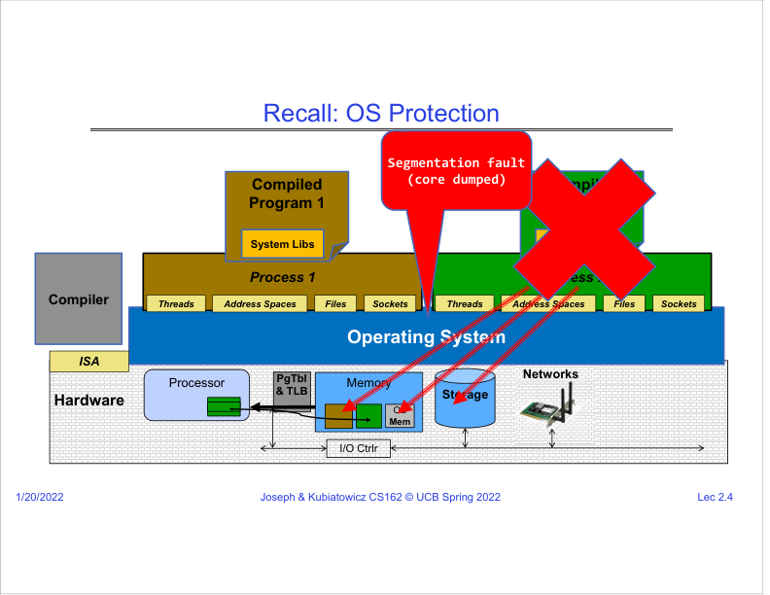
Figure: PDF page 1, quadrant 4, lecture slide 2.4.
SRT anchor: 00:02:05-00:02:53
What this slide means: If one process tries to access memory or storage it is not allowed to access, the OS stops it.
- The SRT example says the green process might try to access the brown process memory, OS memory, or unauthorized storage.
- The OS blocks that access. If the violation is memory-related, the common result is a segmentation fault.
- A segmentation fault is not random. It is protection working: the OS is killing or stopping an invalid action to protect the system.
- This lecture later introduces simple hardware mechanisms that make this kind of protection possible.
Graphic mental model: Invalid memory access -> hardware/OS detects violation -> exception -> process stopped

PDF Page 2
Page summary: This page motivates why OS design is hard: modern hardware and software are very complex and bugs are unavoidable.

Slide 2.5: Challenge: Complexity
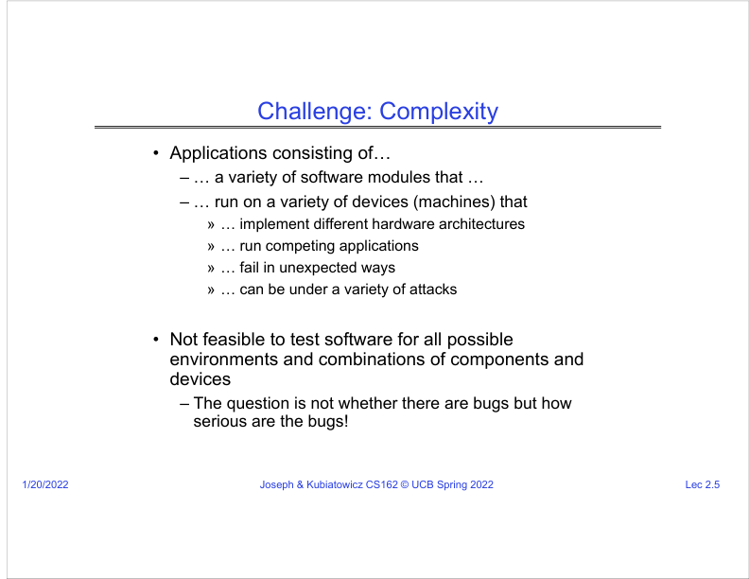
Figure: PDF page 2, quadrant 1, lecture slide 2.5.
SRT anchor: 00:03:00-00:04:20
What this slide means: Modern systems are complex because applications, devices, failures, and attacks all interact.
- Applications are not single simple programs. They contain many modules and run on many kinds of devices.
- Devices differ in hardware architecture and behavior. Multiple applications also compete at the same time.
- The lecturer says it is not realistic to test every possible combination. Therefore, bugs are inevitable.
- The real OS design question is not "are there bugs?" but "how serious are the bugs, and can the OS contain them?"
Graphic mental model: Complex world + inevitable bugs -> need OS abstractions and protection

Slide 2.6: The World Is Parallel: Intel Skylake
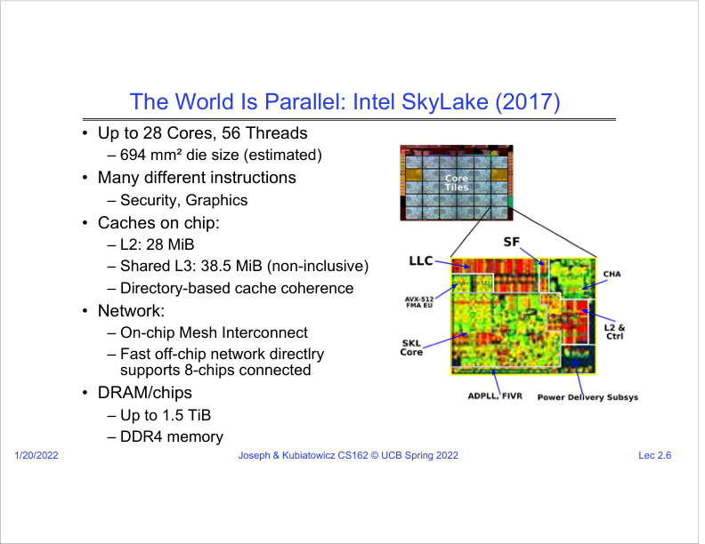
Figure: PDF page 2, quadrant 2, lecture slide 2.6.
SRT anchor: 00:04:20-00:05:45
What this slide means: A modern CPU is already a parallel system, with many cores, threads, caches, networks, and memory channels.
- The SRT uses Intel Skylake as an example of hardware complexity: many cores, many hardware threads, many instruction types, and multiple cache levels.
- Parallelism matters because the OS must schedule work across cores and keep shared data consistent.
- Caches and coherence matter because multiple cores may access related data; the hardware and OS must maintain a consistent view.
- This motivates later CS162 topics such as scheduling, synchronization, and concurrency.
Graphic mental model: Many cores + shared memory + caches -> OS must coordinate parallel execution

Slide 2.7: Hardware Functionality Comes with Great Complexity
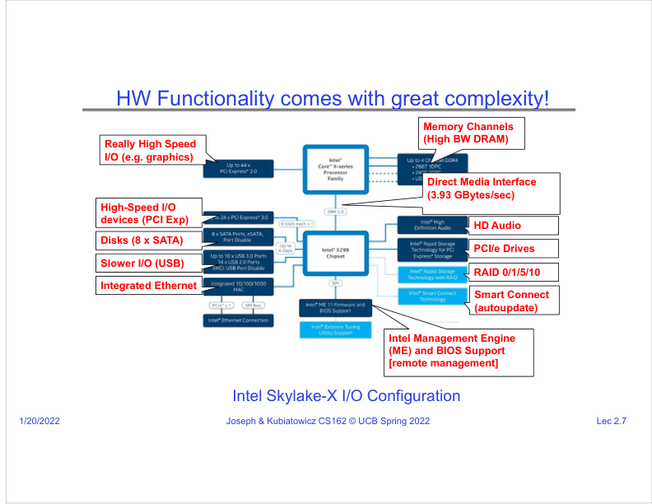
Figure: PDF page 2, quadrant 3, lecture slide 2.7.
SRT anchor: 00:05:45-00:06:45
What this slide means: The CPU is connected to many subsystems: memory, PCIe, disks, USB, Ethernet, audio, RAID, and management engines.
- The lecturer describes the CPU plus chipset as a web of high-speed and slower I/O connections.
- Each device has different protocols, speeds, failure modes, and security implications.
- The OS hides most of this complexity behind simple APIs: read a file, send bytes, draw a window, receive input.
- Device drivers are where the OS meets messy hardware, and later the lecture notes that drivers are a common source of crashes.
Graphic mental model: Many hardware interfaces -> drivers + OS services -> simple application calls

Slide 2.8: Recall: Increasing Software Complexity
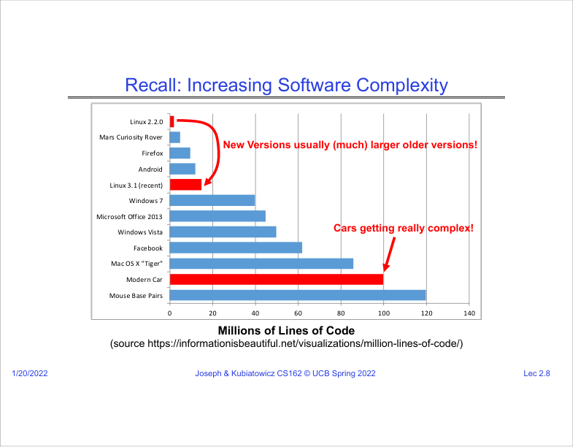
Figure: PDF page 2, quadrant 4, lecture slide 2.8.
SRT anchor: 00:06:45-00:07:45
What this slide means: Software systems are growing larger, and larger codebases usually create more opportunities for bugs.
- The chart compares millions of lines of code across systems such as cars, Linux, Android, Firefox, and Windows.
- The SRT emphasizes that newer versions are usually bigger than older versions.
- More code can mean more features, but also more possible bugs and interactions.
- The OS must provide structures that contain bugs rather than allowing one bug to destroy the whole machine.
Graphic mental model: More code -> more interactions -> more bugs -> stronger OS boundaries needed

PDF Page 3
Page summary: This page moves from complexity to the OS abstraction role, then introduces the four fundamental concepts and the program loading story.

Slide 2.9: Complexity Leaks into the OS
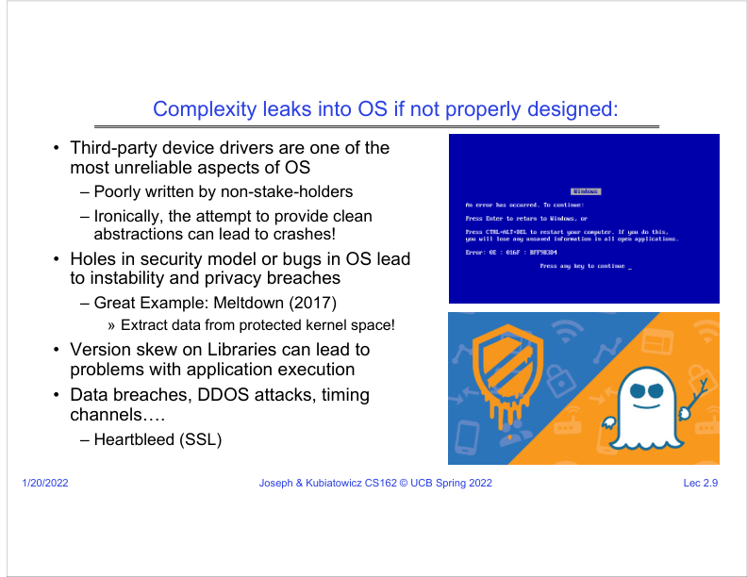
Figure: PDF page 3, quadrant 1, lecture slide 2.9.
SRT anchor: 00:07:45-00:10:05
What this slide means: If the OS is not well designed, hardware and software complexity can cause crashes and security failures.
- The lecturer points out that third-party device drivers are often unreliable because they are written quickly by hardware vendors rather than OS designers.
- Even clean driver interfaces can ironically lead to crashes if the driver behind the interface is buggy.
- Security holes also appear in complex systems. The SRT names Meltdown as an example where protected kernel data could be leaked by exploiting hardware behavior.
- Other examples include library version mismatch, data breaches, DDoS attacks, timing channels, and Heartbleed.
Graphic mental model: Complexity leak -> driver bugs / security holes / version mismatch -> OS instability

Slide 2.10: OS Abstracts Underlying Hardware
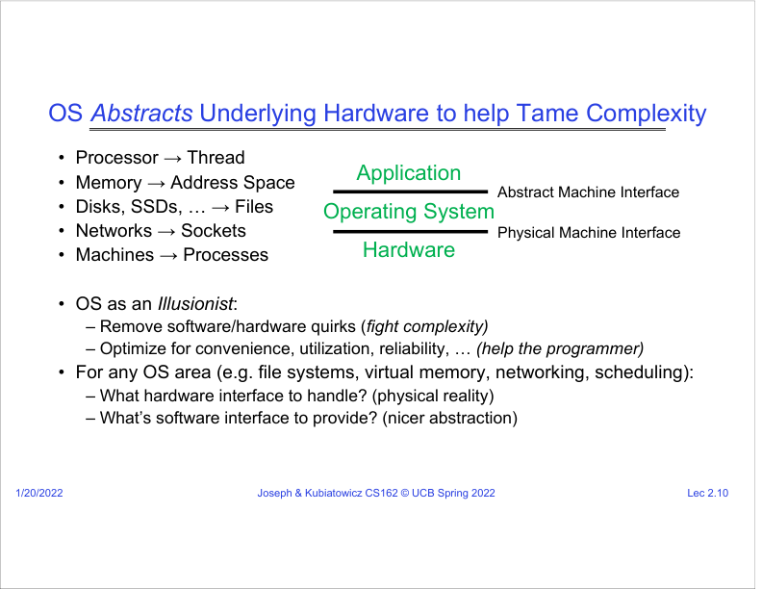
Figure: PDF page 3, quadrant 2, lecture slide 2.10.
SRT anchor: 00:10:05-00:12:18
What this slide means: The OS converts messy physical hardware interfaces into cleaner abstract machine interfaces.
- The SRT says the OS is trying to "tame" the hardware and provide a clean virtual machine abstraction.
- Processor becomes thread; memory becomes address space; disks/SSDs become files; networks become sockets; machines become processes.
- For each OS area, ask two questions: what is the hardware interface, and what nicer software interface should be provided?
- This is the OS as illusionist: remove hardware quirks and optimize for convenience, utilization, and reliability.
Graphic mental model: Processor -> thread | memory -> address space | disk -> files | network -> sockets

Slide 2.11: Today: Four Fundamental OS Concepts
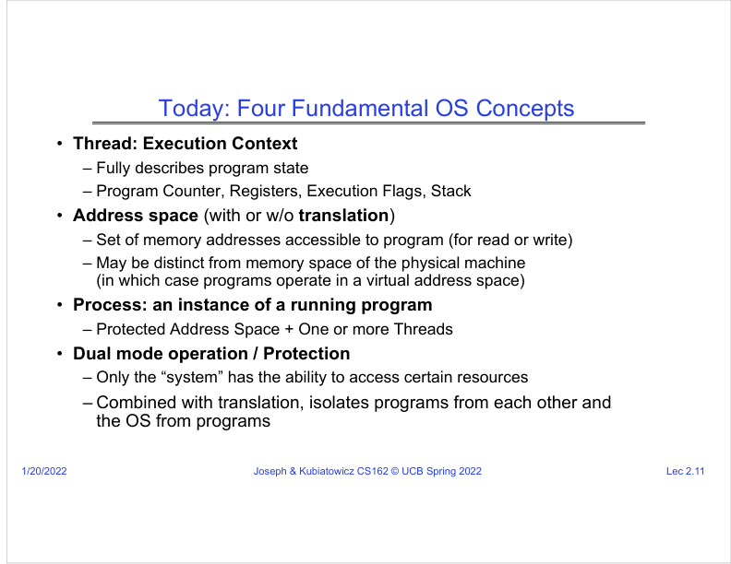
Figure: PDF page 3, quadrant 3, lecture slide 2.11.
SRT anchor: 00:12:18-00:14:15
What this slide means: The four core concepts are thread, address space, process, and dual-mode operation/protection.
- A thread is an execution context: program counter, registers, flags, stack, and memory state.
- An address space is the set of memory addresses a program may access. It may be virtual rather than physical.
- A process is a running program instance: protected address space plus one or more threads.
- Dual-mode operation means hardware distinguishes user mode from kernel/system mode so only the OS can perform certain privileged actions.
Graphic mental model: Thread (CPU state) + Address Space (memory box) = Process; Dual Mode enforces safety

Slide 2.12: OS Bottom Line: Run Programs
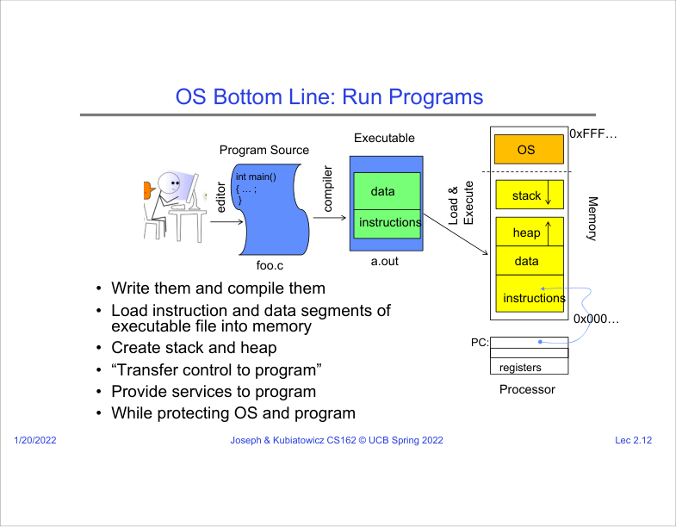
Figure: PDF page 3, quadrant 4, lecture slide 2.12.
SRT anchor: 00:14:15-00:20:20
What this slide means: The OS turns source code and an executable file into a running program while protecting itself and other programs.
- The SRT walks through writing source code, compiling it into an executable, loading instructions and data into memory, and then transferring control to the program.
- The OS creates stack and heap regions, sets the program counter to the starting instruction, and lets the processor execute.
- System calls let the running program request OS services, such as I/O, while the OS remains protected.
- Beginner view: the compiler creates the executable file; the OS creates the process and starts a thread inside it.
Graphic mental model: foo.c -> compiler -> a.out -> OS loads memory -> PC points to first instruction -> program runs

PDF Page 4
Page summary: This page connects CPU execution mechanics to the first OS concept: a thread as execution context.

Slide 2.13: Instruction Fetch / Decode / Execute
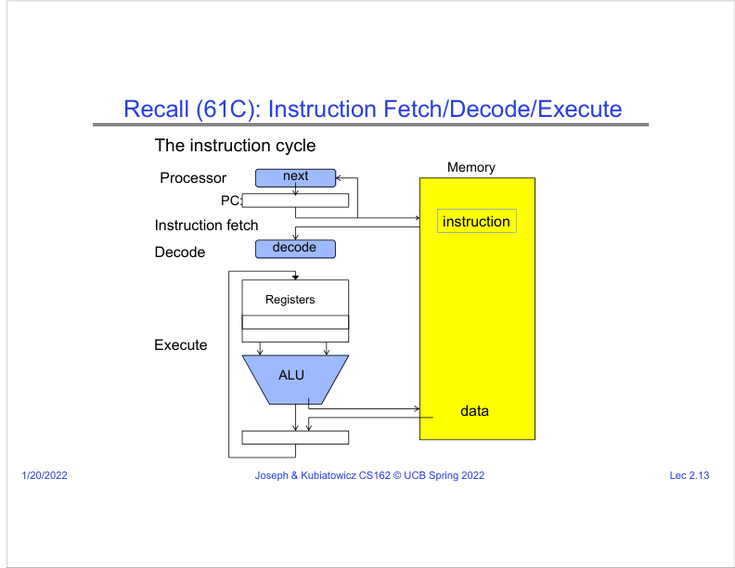
Figure: PDF page 4, quadrant 1, lecture slide 2.13.
SRT anchor: 00:20:20-00:22:00
What this slide means: A CPU repeatedly fetches an instruction, decodes it, executes it, and moves the program counter forward.
- The program counter (PC) points to the next instruction in memory.
- The CPU fetches that instruction, decodes what operation it represents, executes using registers/ALU/memory, then updates the PC.
- This simple cycle is the base mechanism behind every running thread.
- The OS can interrupt or switch this cycle by saving and restoring CPU state.
Graphic mental model: PC -> fetch instruction -> decode -> execute -> update PC -> repeat

Slide 2.14: First OS Concept: Thread of Control
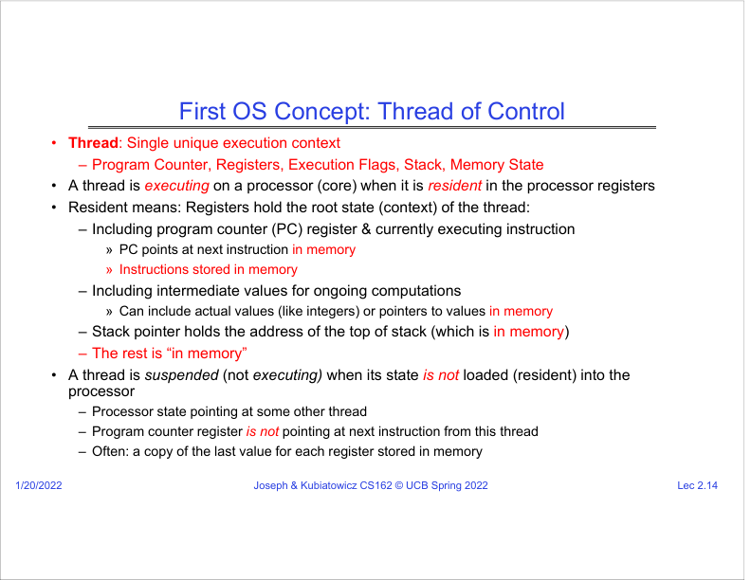
Figure: PDF page 4, quadrant 2, lecture slide 2.14.
SRT anchor: 00:22:00-00:28:10
What this slide means: A thread is the complete execution context needed to continue a computation.
- The SRT emphasizes that a thread is resident on a core when its state is loaded into the processor registers.
- Important state includes PC, general registers, execution flags, and stack pointer.
- The stack itself is in memory; the stack pointer register only stores the address of the top of that stack.
- A suspended thread is not on the CPU. Its last register values are saved in memory so it can resume later.
Graphic mental model: Running thread = register state loaded in CPU; suspended thread = register state saved in memory

Slide 2.15: What Happens During Program Execution?
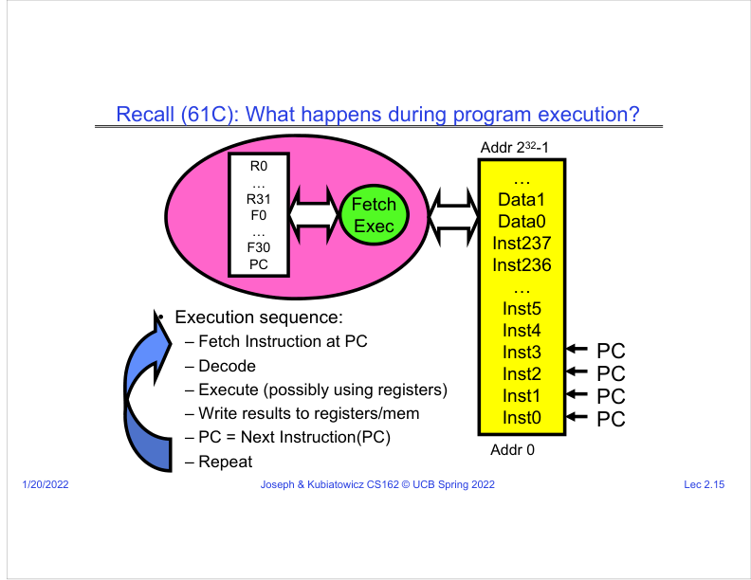
Figure: PDF page 4, quadrant 3, lecture slide 2.15.
SRT anchor: 00:22:00-00:28:10
What this slide means: The slide visualizes repeated PC movement through instructions while data and registers change.
- The PC points at instruction 0, then instruction 1, then instruction 2, and so on unless a branch changes it.
- Registers hold temporary values. Memory holds instructions and data.
- To resume a thread after stopping it, the OS must restore the same PC and register contents.
- This is why PC and registers are central to context switching.
Graphic mental model: Instruction stream + register values + stack = enough to continue the same execution

Slide 2.16: Registers: RISC-V to x86
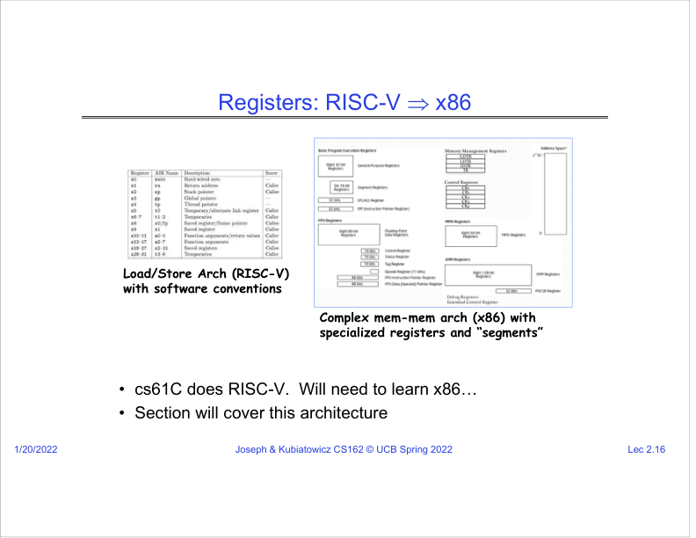
Figure: PDF page 4, quadrant 4, lecture slide 2.16.
SRT anchor: 00:28:10-00:29:20
What this slide means: The course moves from CS61C-style RISC-V concepts toward x86 details used in OS implementation.
- RISC-V is a load/store architecture with simpler conventions, while x86 has specialized registers and segmentation history.
- The OS must know the exact register set because it saves and restores those registers during context switches.
- Even if different architectures look different, the OS idea is the same: save the old execution context and load a new one.
- Later project and section material may use architecture-specific files and assembly.
Graphic mental model: Architecture details differ; context-switch principle stays the same

PDF Page 5
Page summary: This page explains time multiplexing and context switching, then includes course setup logistics.

Slide 2.17: Illusion of Multiple Processors
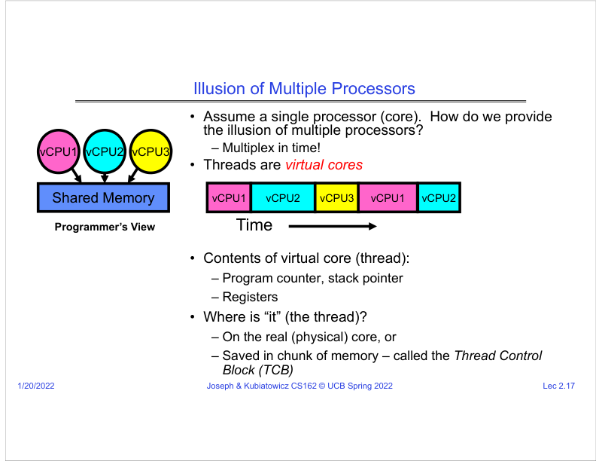
Figure: PDF page 5, quadrant 1, lecture slide 2.17.
SRT anchor: 00:29:20-00:31:30
What this slide means: On one physical core, the OS can create the illusion of many virtual CPUs by multiplexing time.
- The SRT says to think of threads as virtual cores.
- The OS runs vCPU1 for a short time, then vCPU2, then vCPU3, and so on.
- To the programmer, it looks as if several activities are progressing together.
- In reality, on a single core only one thread is executing at one instant; the illusion comes from fast switching.
Graphic mental model: Time slice: [vCPU1][vCPU2][vCPU3][vCPU1]...

Slide 2.18: Illusion of Multiple Processors: Context Switch
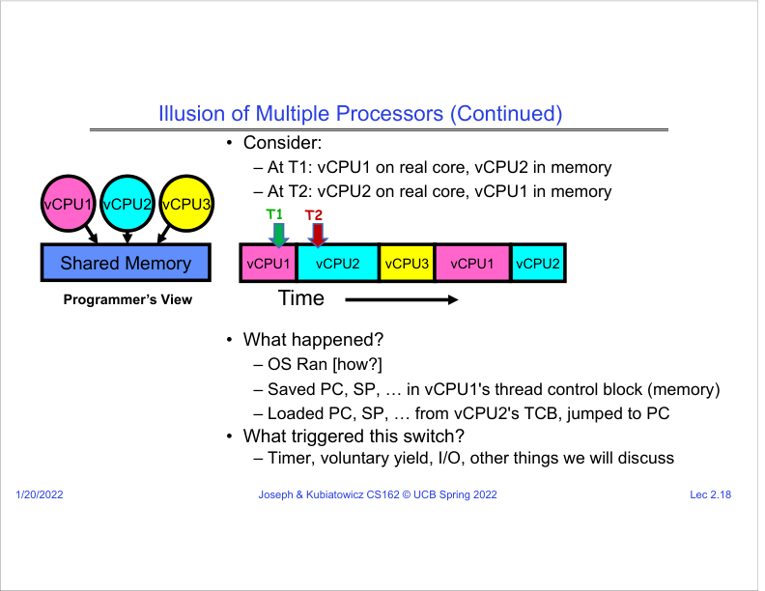
Figure: PDF page 5, quadrant 2, lecture slide 2.18.
SRT anchor: 00:31:30-00:35:30
What this slide means: A context switch saves the old thread state and loads another thread state.
- At T1, vCPU1 is on the real core and vCPU2 is saved in memory.
- At T2, the OS saves vCPU1 PC, stack pointer, and registers into its Thread Control Block, then loads vCPU2 state from its TCB.
- The switch can be triggered by a timer interrupt, voluntary yield, I/O wait, or other events.
- This is the mechanical basis of multitasking.
Graphic mental model: Save old TCB -> load new TCB -> jump to new PC

Slide 2.19: Multiprogramming: Multiple Threads of Control
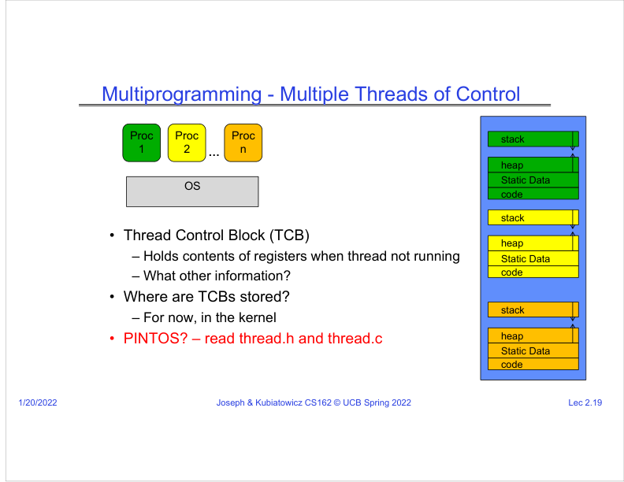
Figure: PDF page 5, quadrant 3, lecture slide 2.19.
SRT anchor: 00:35:30-00:38:50
What this slide means: The Thread Control Block stores the saved CPU state for a thread that is not currently running.
- A TCB holds the register contents when a thread is not running.
- The lecture notes say, for now, TCBs are stored in the kernel.
- In systems like Pintos, thread.h and thread.c define the data structures and code that represent kernel threads.
- This slide also hints that each process has its own code, static data, heap, and stack.
Graphic mental model: TCB = "save file" for a thread CPU context

Slide 2.20: Administrivia: Getting Started
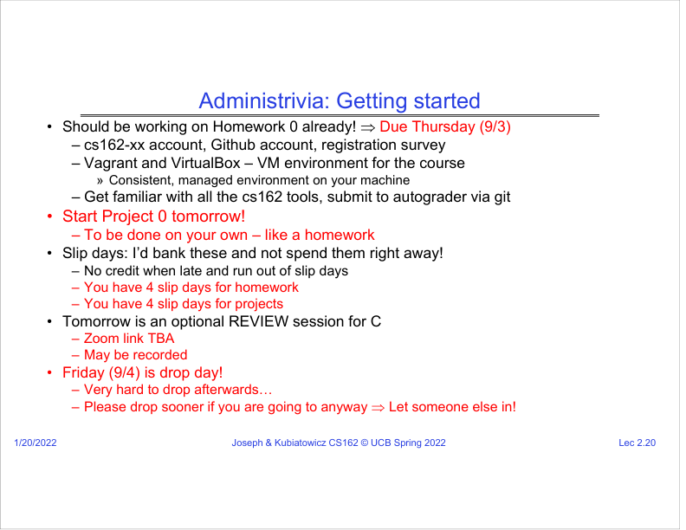
Figure: PDF page 5, quadrant 4, lecture slide 2.20.
SRT anchor: 00:38:50-00:40:40
What this slide means: This is course logistics rather than OS theory: setup accounts, VM tools, project 0, slip days, and C review.
- The SRT reminds students to complete Homework 0 and set up GitHub, Vagrant, VirtualBox, and course tools.
- The technical importance is that OS courses require a controlled environment so everyone runs the same toolchain.
- Project 0 and C review prepare students for low-level systems programming.
- For your learning notes, treat this slide as "course setup requirements," not a core OS concept.
Graphic mental model: Course tools -> reproducible environment -> fewer setup bugs in projects

PDF Page 6
Page summary: This page includes course collaboration policy and then begins the second technical concept: address space.

Slide 2.21: Review: Coping with COVID-19
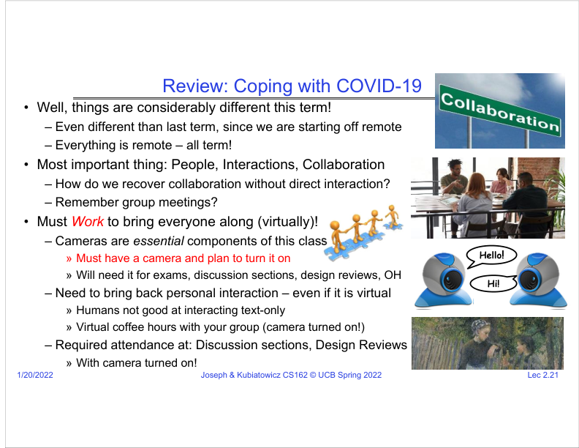
Figure: PDF page 6, quadrant 1, lecture slide 2.21.
SRT anchor: 00:40:40-00:43:10
What this slide means: This slide is about remote collaboration expectations, not a core technical concept.
- The lecture stresses that operating systems projects require people, interaction, and collaboration.
- Cameras, group meetings, office hours, design reviews, and discussion attendance are listed because the course is team/project heavy.
- For a technical learner, the hidden message is: systems debugging is collaborative, and communication quality matters.
- You can mark this as course policy/admin in your notes.
Graphic mental model: Remote class -> deliberate collaboration -> better project success

Slide 2.22: CS162 Collaboration Policy
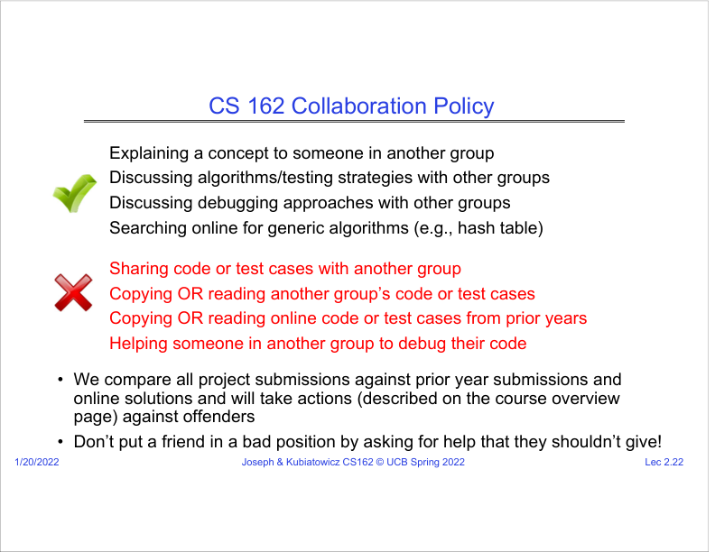
Figure: PDF page 6, quadrant 2, lecture slide 2.22.
SRT anchor: 00:43:10-00:45:40
What this slide means: The policy distinguishes allowed conceptual help from forbidden code/test sharing.
- Allowed: explaining concepts, discussing algorithms and testing strategies, discussing debugging approaches, and searching generic algorithms online.
- Forbidden: sharing code or tests, reading another group code/tests, and copying online prior-year solutions.
- The OS learning connection: you may discuss ideas, but implementation must be your own.
- This matters because CS162 compares submissions against previous years and online solutions.
Graphic mental model: Share ideas, not code

Slide 2.23: Second OS Concept: Address Space
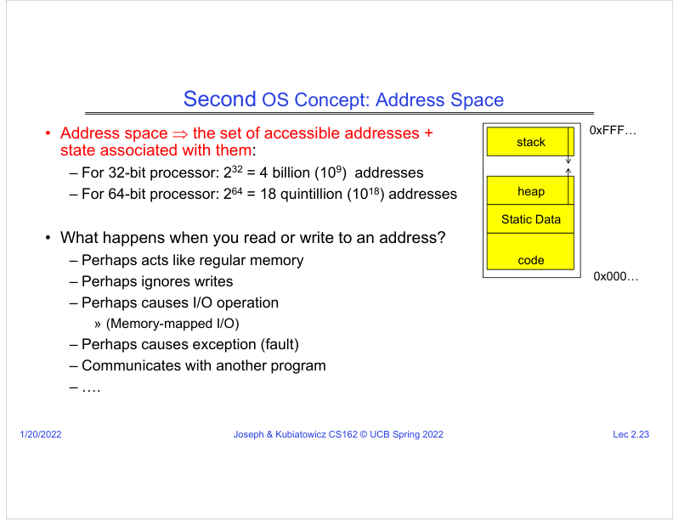
Figure: PDF page 6, quadrant 3, lecture slide 2.23.
SRT anchor: 00:45:40-00:49:40
What this slide means: An address space is the set of addresses and states a program can access.
- The SRT explains 32-bit address spaces as around 4 billion addresses and 64-bit address spaces as enormously larger.
- Reading or writing an address may act like normal memory, trigger I/O, cause an exception, communicate with another program, or do something special.
- The key idea: an address is not just a number; it has meaning defined by hardware and OS translation/protection.
- Address spaces become the main protection boundary for processes.
Graphic mental model: Address number -> OS/hardware interpretation -> memory, I/O, fault, or communication

Slide 2.24: Address Space in a Picture
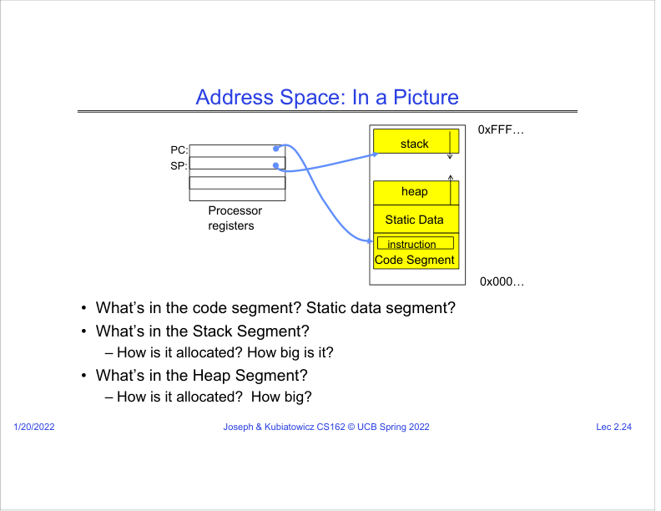
Figure: PDF page 6, quadrant 4, lecture slide 2.24.
SRT anchor: 00:47:40-00:50:30
What this slide means: A process address space usually contains code, static data, heap, and stack.
- Code segment stores machine instructions. Static data stores global/static variables.
- Heap stores dynamically allocated objects, such as malloc memory.
- Stack stores procedure call frames and local variables. The stack pointer points to the top of the current stack.
- The SRT says stack/heap behavior will be revisited later, especially when memory is missing and a page fault occurs.
Graphic mental model: Low addresses: code/data/heap ... High addresses: stack

PDF Page 7
Page summary: This page explains why simple multiprogramming without protection is dangerous and introduces base and bound.

Slide 2.25: Very Simple Multiprogramming
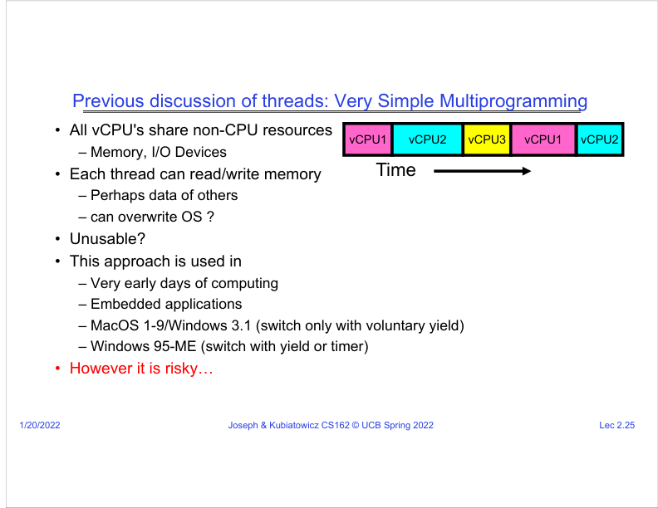
Figure: PDF page 7, quadrant 1, lecture slide 2.25.
SRT anchor: 00:50:30-00:53:00
What this slide means: If multiple virtual CPUs share memory and I/O without protection, each thread can read or write everything.
- This early/simple model lets each thread use shared memory and devices directly.
- The problem is that one thread can accidentally or maliciously overwrite another thread or even the OS.
- The slide lists historical systems where weaker protection or voluntary yielding existed.
- This motivates hardware protection mechanisms.
Graphic mental model: Shared memory with no walls -> one bug can damage everyone

Slide 2.26: Simple Multiplexing Has No Protection
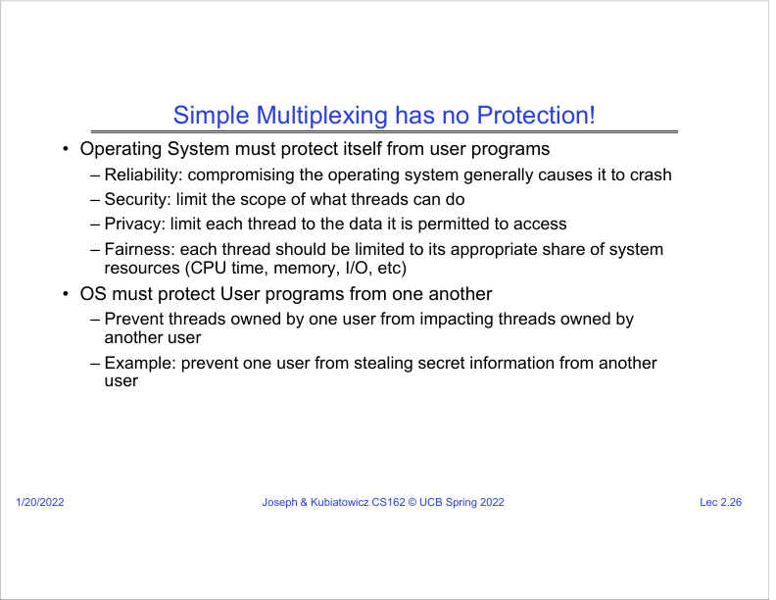
Figure: PDF page 7, quadrant 2, lecture slide 2.26.
SRT anchor: 00:53:00-00:55:10
What this slide means: The OS must protect itself and protect user programs from each other.
- Reliability: if a user program compromises the OS, the whole system may crash.
- Security and privacy: one program should not steal another program data.
- Fairness: one thread should not consume all CPU, memory, or I/O resources.
- Protection is not optional in modern systems; it is required for usable multi-program computing.
Graphic mental model: Protection goals = reliability + security + privacy + fairness

Slide 2.27: What Can Hardware Do to Help?
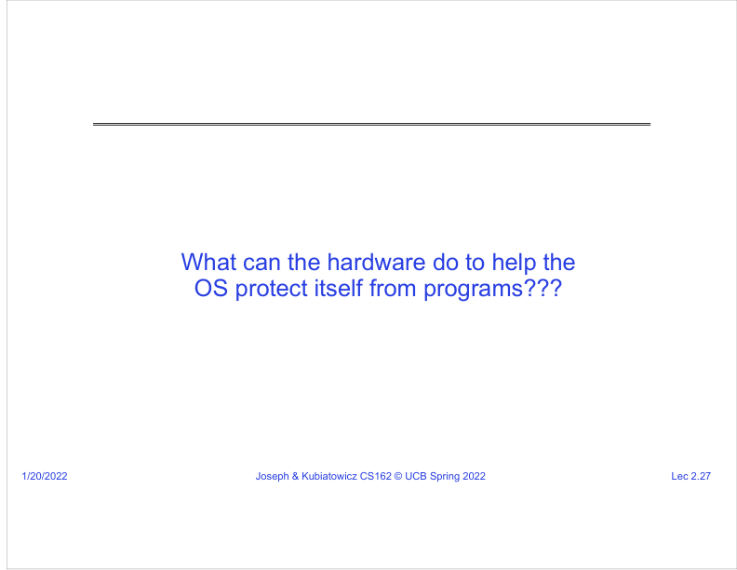
Figure: PDF page 7, quadrant 3, lecture slide 2.27.
SRT anchor: 00:55:10-00:56:00
What this slide means: The lecture asks what hardware support is needed so the OS can protect itself from programs.
- Software alone is not enough if user programs can execute every instruction and access every address.
- The OS needs hardware mechanisms that user programs cannot bypass.
- The next slides introduce one simple protection mechanism: base and bound.
- This question is the bridge from OS concept to actual hardware enforcement.
Graphic mental model: Policy in OS + enforcement in hardware = real protection

Slide 2.28: Simple Protection: Base and Bound
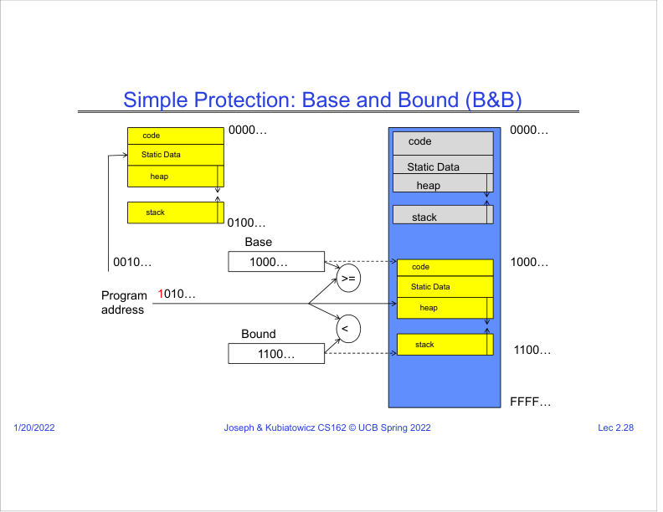
Figure: PDF page 7, quadrant 4, lecture slide 2.28.
SRT anchor: 00:56:00-00:56:50
What this slide means: Base and bound protect memory by checking whether a program address falls inside an allowed range.
- Base is the start of the allowed memory region. Bound is the end or size limit.
- Before a program address is used, hardware checks whether it is within the legal range.
- If the address is outside the range, the access is blocked and an exception/fault occurs.
- This is a simple first model for isolation.
Graphic mental model: Legal if: base <= address < bound

PDF Page 8
Page summary: This page develops base-and-bound protection, relocation, hardware translation, and x86 segmentation ideas.

Slide 2.29: Base and Bound: Load-Time Translation
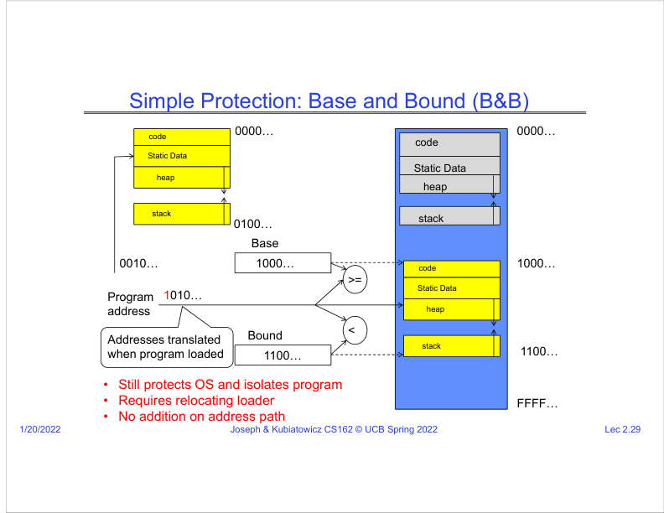
Figure: PDF page 8, quadrant 1, lecture slide 2.29.
SRT anchor: 00:56:50-00:57:30
What this slide means: One version translates addresses when the program is loaded into memory.
- The slide says this still protects the OS and isolates programs.
- However, it requires a relocating loader: when loading the program, addresses must be adjusted for where the program is placed.
- The advantage is that there is no extra addition on every memory access because translation already happened.
- The limitation is flexibility: moving or growing programs later is harder.
Graphic mental model: Load program -> adjust addresses once -> run with checked range

Slide 2.30: 61C Review: Relocation
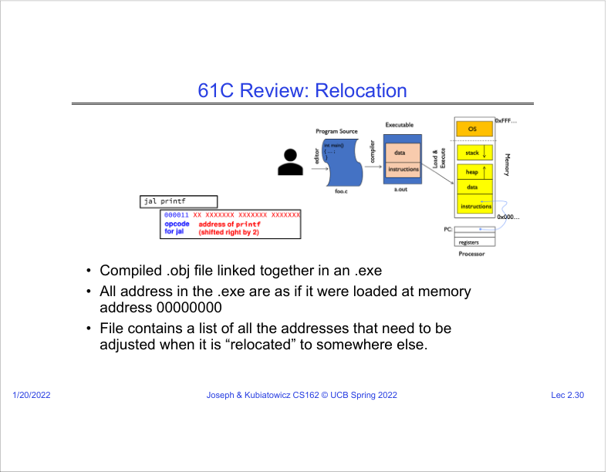
Figure: PDF page 8, quadrant 2, lecture slide 2.30.
SRT anchor: 00:57:30-00:59:30
What this slide means: Relocation means changing addresses in an executable when it is loaded somewhere other than address 0.
- The SRT explains that compiled object files are linked into an executable, and addresses often assume a start address such as 0.
- If the program is loaded at a different physical address, some addresses must be adjusted.
- The executable contains relocation information listing which address references must change.
- This is why loading a program is more than copying bytes; the OS/loader may need to fix addresses.
Graphic mental model: Executable assumes address 0 -> loader places at 1000 -> adjust references by +1000

Slide 2.31: Base and Bound: Hardware Relocation
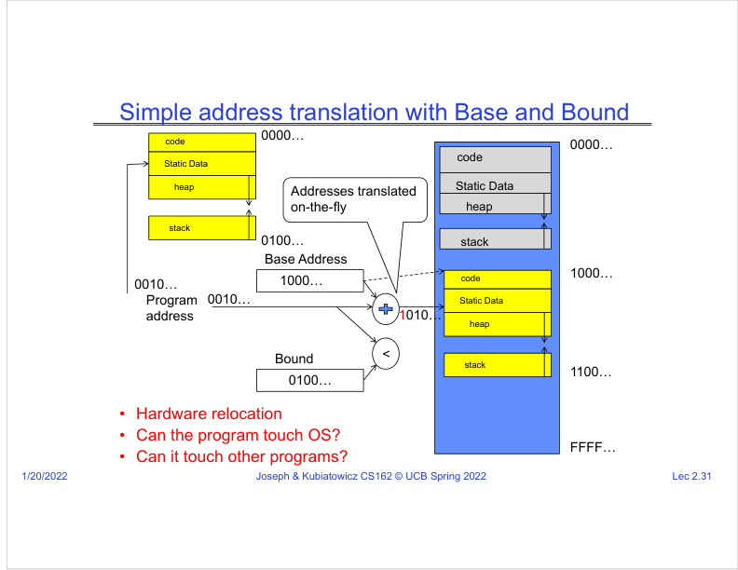
Figure: PDF page 8, quadrant 3, lecture slide 2.31.
SRT anchor: 00:59:30-01:02:10
What this slide means: Another version translates addresses on the fly by adding the base address during execution.
- The program uses its own program addresses, but hardware translates them into physical addresses.
- Example: program address 0010 plus base 1000 becomes physical address 1010.
- The bound still prevents access outside the allowed region.
- This raises the central protection question: can the program touch the OS or other programs? With correct base/bound enforcement, no.
Graphic mental model: virtual/program address + base -> physical address, if within bound

Slide 2.32: x86 Segments and Stacks
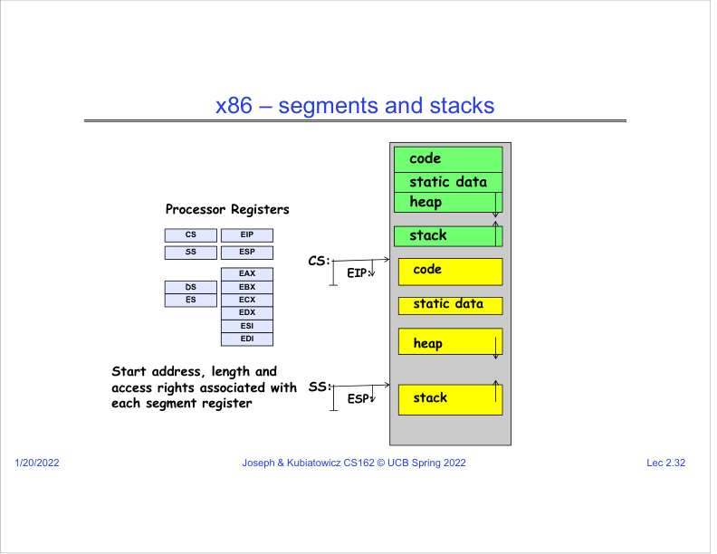
Figure: PDF page 8, quadrant 4, lecture slide 2.32.
SRT anchor: 01:02:10-01:03:20
What this slide means: x86 historically uses segment registers to describe code, stack, and data regions with start, length, and access rights.
- CS, SS, DS, and ES are segment-related registers; EIP and ESP are instruction and stack pointers.
- A segment can carry a start address, length, and access permissions.
- This is another way hardware can help separate code, data, heap, and stack regions.
- Do not get lost in register names yet. The concept is: the CPU needs protected metadata describing where execution and stack are allowed.
Graphic mental model: CS:EIP points to instruction; SS:ESP points to stack top

PDF Page 9
Page summary: This page introduces paging and defines the process abstraction.

Slide 2.33: Another Idea: Address Space Translation
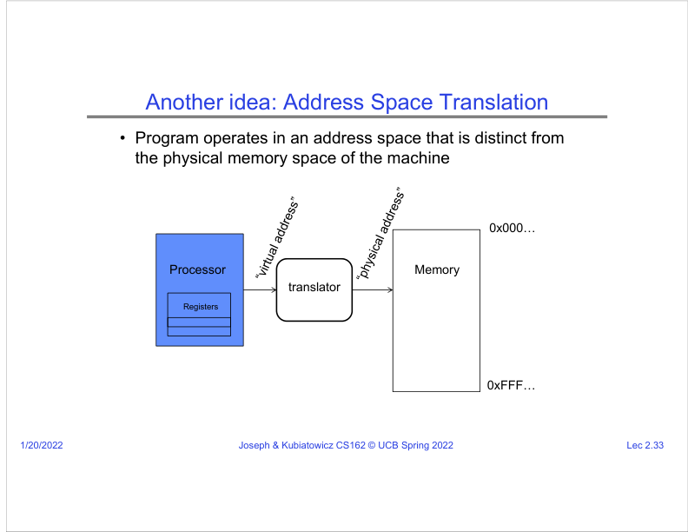
Figure: PDF page 9, quadrant 1, lecture slide 2.33.
SRT anchor: 01:03:20-01:04:20
What this slide means: A program can operate in an address space distinct from physical memory.
- Instead of using physical addresses directly, the program uses virtual addresses.
- A translator, controlled by the OS and hardware, maps virtual addresses to physical memory locations.
- This gives the OS much more flexibility than one contiguous base/bound range.
- This is the idea behind modern virtual memory.
Graphic mental model: Program virtual address -> translator -> physical memory address

Slide 2.34: Paged Virtual Address Space
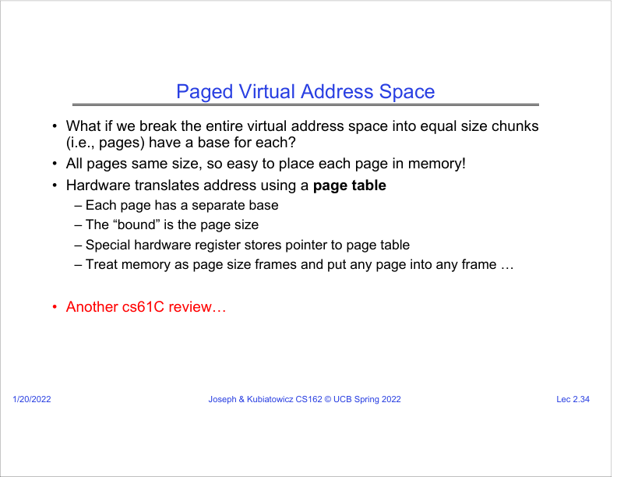
Figure: PDF page 9, quadrant 2, lecture slide 2.34.
SRT anchor: 01:04:20-01:06:25
What this slide means: Paging divides virtual address space into equal-size chunks called pages.
- The SRT says all pages are the same size, making them easy to place into memory frames.
- Hardware translates addresses using a page table.
- Each page can have a separate base/frame mapping; the page size acts like a natural bound.
- A special hardware register points to the current process page table.
Graphic mental model: Virtual memory split into pages; physical memory split into frames

Slide 2.35: Paged Virtual Address
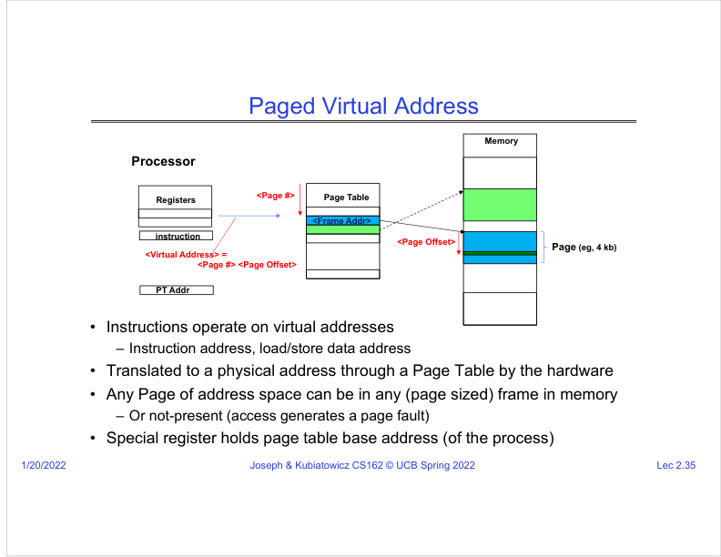
Figure: PDF page 9, quadrant 3, lecture slide 2.35.
SRT anchor: 01:06:25-01:08:40
What this slide means: A virtual address is split into a page number and page offset; the page table maps page number to frame address.
- Instructions use virtual addresses for instruction fetches and data load/store operations.
- Hardware uses the page table to translate virtual page number to physical frame address.
- The offset stays the same inside the page/frame.
- If a page is not present, the access generates a page fault, letting the OS handle missing memory or illegal access.
Graphic mental model: Virtual address = [page # | offset] -> page table -> [frame address | offset]

Slide 2.36: Third OS Concept: Process
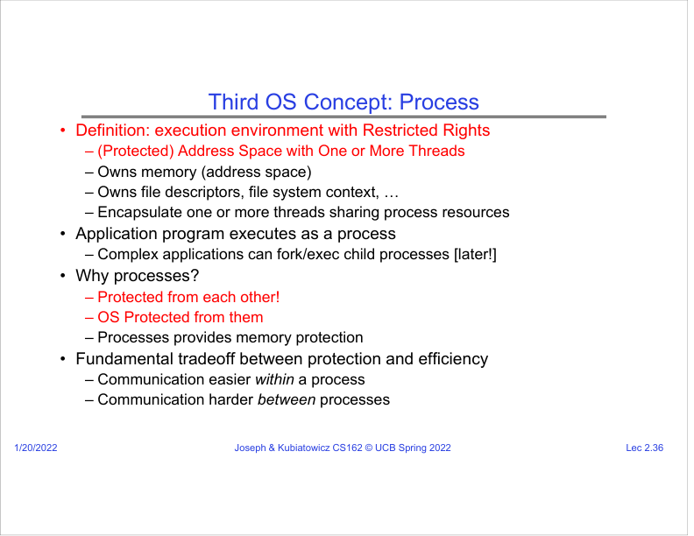
Figure: PDF page 9, quadrant 4, lecture slide 2.36.
SRT anchor: 01:08:40-01:14:15
What this slide means: A process is an execution environment with restricted rights: a protected address space plus one or more threads.
- The SRT explains that the OS loads an application, sets up code/data/heap/stack, and creates the environment for it to run.
- A process owns memory/address space, file descriptors, and file-system context.
- Threads inside one process share process resources.
- Protection/efficiency tradeoff: communication inside one process is easier, but communication between processes is harder because protection boundaries exist.
Graphic mental model: Process = protected box of resources + active thread(s)

PDF Page 10
Page summary: This page explains single vs multithreaded processes, protection/isolation, and dual-mode operation.

Slide 2.37: Single and Multithreaded Processes
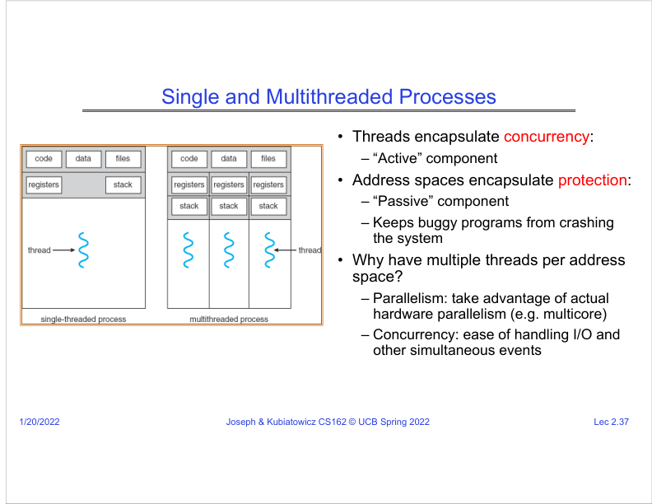
Figure: PDF page 10, quadrant 1, lecture slide 2.37.
SRT anchor: 01:10:40-01:16:50
What this slide means: Threads are the active execution part; address spaces are the passive protection part.
- Threads encapsulate concurrency: they are the active lines of execution.
- Address spaces encapsulate protection: they keep buggy programs from crashing the whole system.
- Multiple threads in one address space help with parallelism on multicore hardware and concurrency when dealing with I/O and simultaneous events.
- The SRT answers a question: even on a single core, multithreading is useful because one thread can wait for I/O while another can continue.
Graphic mental model: One process, many threads: shared memory/resources, separate PC/registers/stacks

Slide 2.38: Protection and Isolation
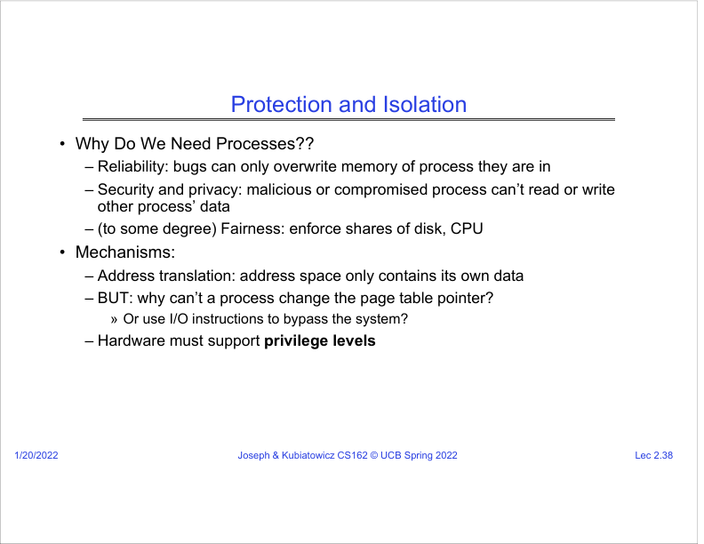
Figure: PDF page 10, quadrant 2, lecture slide 2.38.
SRT anchor: 01:14:15-01:17:20
What this slide means: Processes are needed for reliability, security, privacy, and fairness.
- Reliability: bugs can overwrite only the memory inside their own process.
- Security/privacy: malicious or compromised processes cannot directly read/write other process data.
- Fairness: with OS scheduling and resource control, one process cannot simply steal everything.
- The SRT asks why a process cannot change its own page table pointer. If it could, it could map itself to OS memory or another process memory.
Graphic mental model: Do not let user process edit the map that defines its own prison walls

Slide 2.39: Fourth OS Concept: Dual Mode Operation
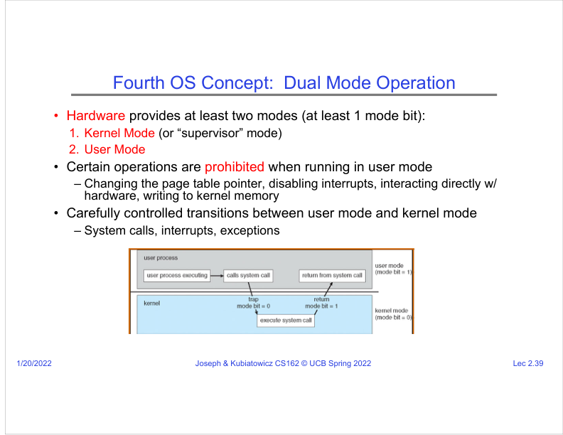
Figure: PDF page 10, quadrant 3, lecture slide 2.39.
SRT anchor: 01:17:20-01:19:40
What this slide means: Hardware must provide at least user mode and kernel/supervisor mode.
- In user mode, dangerous operations are prohibited: changing the page table pointer, disabling interrupts, direct hardware I/O, and writing kernel memory.
- In kernel mode, the OS can perform privileged operations needed to manage the machine.
- Transitions must be carefully controlled. User code cannot simply jump anywhere into kernel code.
- The allowed paths into the kernel include system calls, interrupts, and exceptions.
Graphic mental model: User mode = restricted; kernel mode = privileged; transitions = guarded gates

Slide 2.40: Example: UNIX System Structure
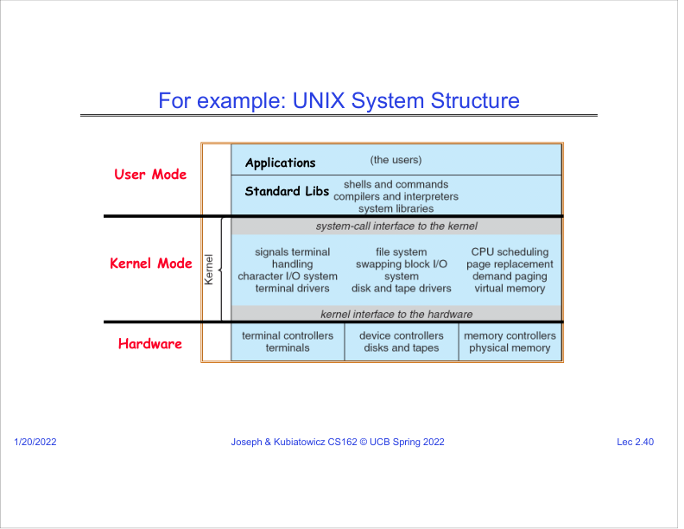
Figure: PDF page 10, quadrant 4, lecture slide 2.40.
SRT anchor: 01:19:40-01:21:30
What this slide means: UNIX-like systems place applications and standard libraries in user mode, while core OS services run in kernel mode.
- Applications and many standard libraries run with limited privileges.
- The kernel implements protected services such as file systems, networking, scheduling, and device control.
- Hardware is below the kernel and is normally accessed through privileged kernel code.
- This division reduces damage: ordinary application bugs should not corrupt hardware or kernel state.
Graphic mental model: Apps/libs (user) -> system-call interface -> kernel -> hardware

PDF Page 11
Page summary: This page shows user/kernel transitions, VMs/containers, and a concrete B&B process-start example.

Slide 2.41: User/Kernel Privileged Mode
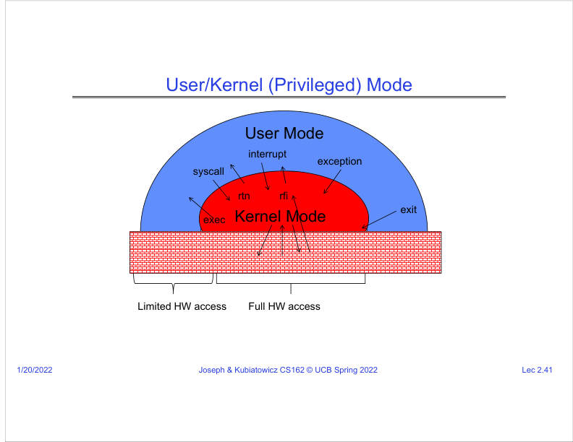
Figure: PDF page 11, quadrant 1, lecture slide 2.41.
SRT anchor: 01:21:30-01:22:40
What this slide means: The diagram shows paths between user mode and kernel mode: exec, syscall, interrupt, exception, return, and exit.
- User mode has limited hardware access; kernel mode has full hardware access.
- A syscall is a controlled request from user code to kernel code.
- An interrupt is an external event, such as a timer or device event, that transfers control to the kernel.
- An exception is caused by current execution, such as divide-by-zero or invalid memory access.
Graphic mental model: User -> kernel: syscall/interrupt/exception; kernel -> user: return/resume

Slide 2.42: Additional Protection: Virtual Machines and Containers
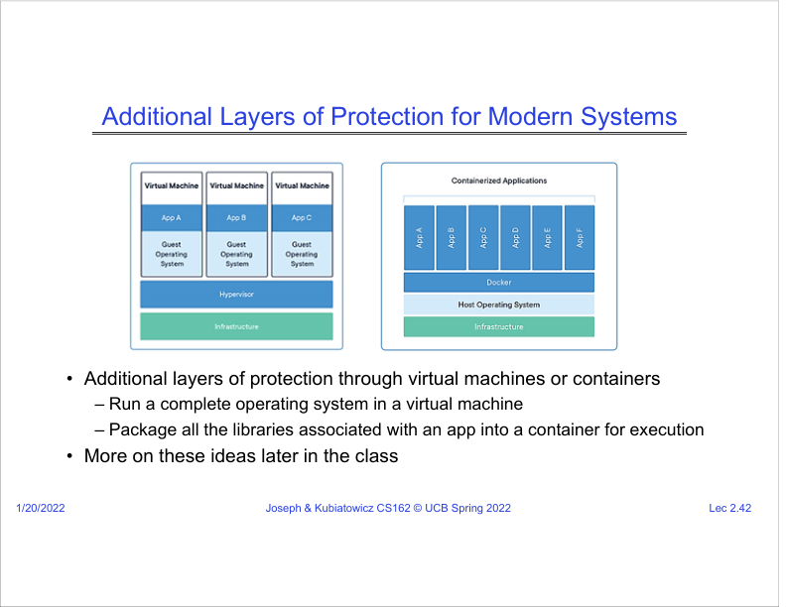
Figure: PDF page 11, quadrant 2, lecture slide 2.42.
SRT anchor: 01:22:40-01:24:00
What this slide means: Modern systems add protection layers such as hypervisors, virtual machines, and containers.
- The SRT names the hypervisor as a layer even more privileged than a guest operating system.
- A virtual machine lets an OS run as if it controls the whole machine, while the hypervisor multiplexes real hardware underneath.
- A container packages an application with its libraries and isolates execution at a lighter level than a full VM.
- This extends the same OS theme: create controlled illusions and boundaries.
Graphic mental model: Hardware -> hypervisor -> guest OS -> apps; or OS -> containers -> apps

Slide 2.43: Tying It Together: OS Loads Process
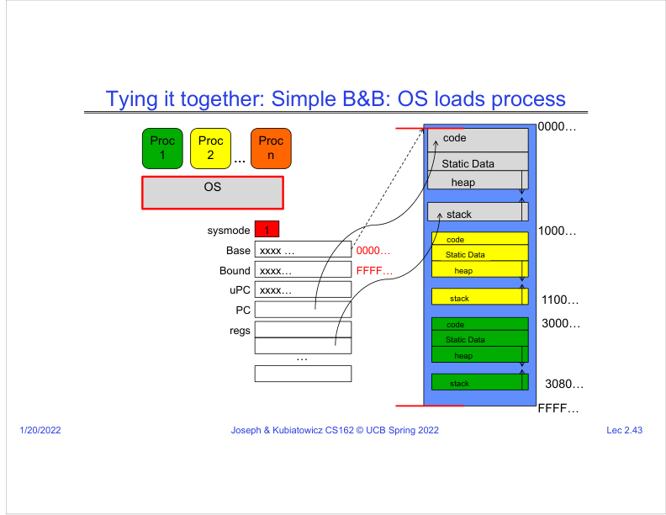
Figure: PDF page 11, quadrant 3, lecture slide 2.43.
SRT anchor: 01:24:00-01:24:50
What this slide means: When the OS is running in system/kernel mode, it can prepare the special registers and memory needed for a process.
- The OS is active, so sysmode is 1 and the PC points into OS code.
- The process memory regions are already placed in memory, but the special registers are not yet set to run that process.
- The OS controls base, bound, user PC, registers, and stack state.
- This diagram connects process loading with base-and-bound protection.
Graphic mental model: Kernel prepares process state while still privileged

Slide 2.44: Simple B&B: OS Gets Ready to Execute Process
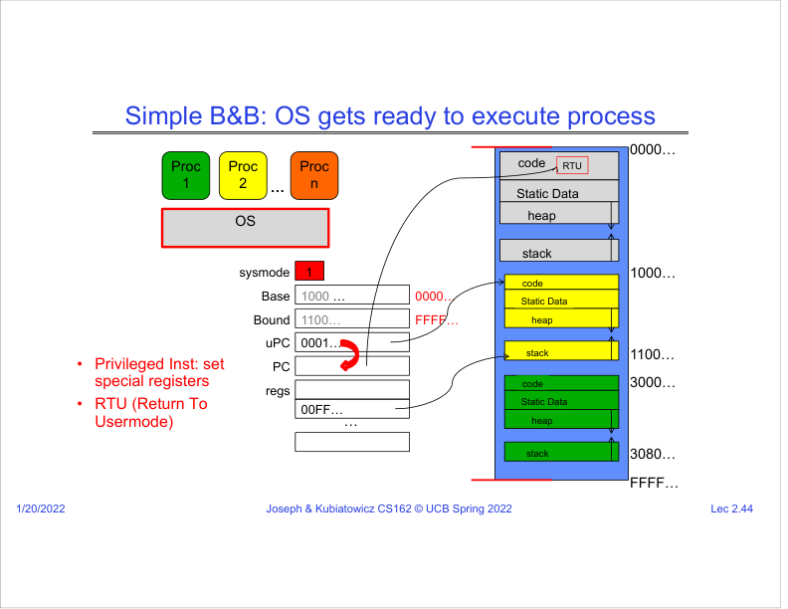
Figure: PDF page 11, quadrant 4, lecture slide 2.44.
SRT anchor: 01:24:50-01:25:30
What this slide means: The OS sets base/bound and user PC, then uses Return To Usermode to start user execution.
- The SRT says the OS sets up pointers to the yellow code in special registers.
- Return To Usermode changes the PC to the user code and switches out of system mode.
- Once in user mode, base and bound are enforced, so the user program cannot access outside its allowed range.
- This is how the OS gives a process the CPU while still retaining protection.
Graphic mental model: Set base/bound + user PC -> RTU -> user code runs with checks enabled

PDF Page 12
Page summary: This page previews user-to-kernel transfer mechanisms: syscall, interrupt, exception, and interrupt vectors.

Slide 2.45: Simple B&B: User Code Running
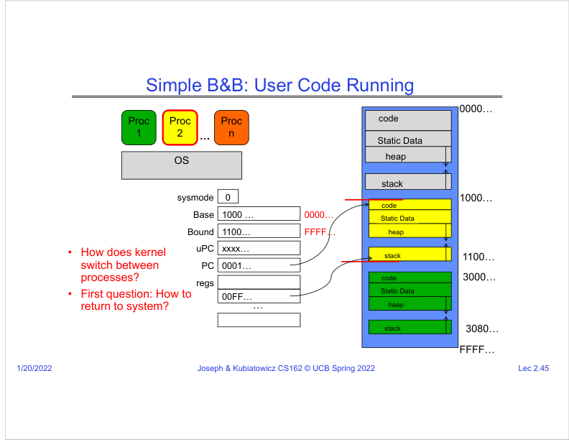
Figure: PDF page 12, quadrant 1, lecture slide 2.45.
SRT anchor: SRT coverage: preview only
What this slide means: The process is now running in user mode with base and bound enforced.
- Sysmode is now 0, meaning user mode. The PC points inside the process memory region.
- The process can execute normal instructions but cannot directly change protected registers or access outside its memory range.
- The slide asks the next question: how does the kernel regain control and switch between processes?
- The SRT reaches this point near the end and says the next lecture will discuss kernel-mode transfers in more detail.
Graphic mental model: User code running safely inside base/bound box

Slide 2.46: Three Types of User-to-Kernel Mode Transfer
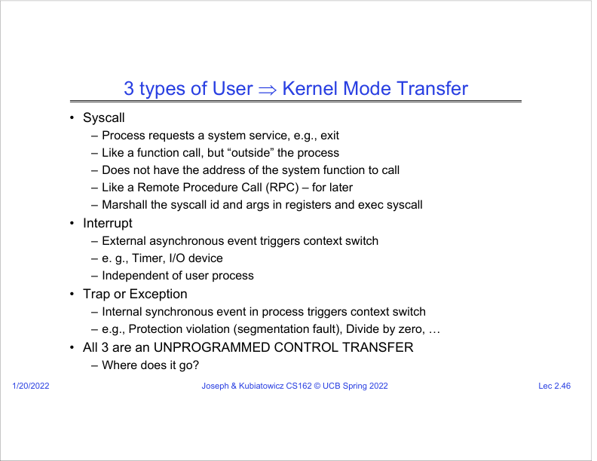
Figure: PDF page 12, quadrant 2, lecture slide 2.46.
SRT anchor: SRT coverage: next-lecture preview
What this slide means: There are three main ways control moves from user mode to kernel mode: syscall, interrupt, and trap/exception.
- Syscall: the process intentionally requests a service, such as exit, read, write, or open.
- Interrupt: an external asynchronous event occurs, such as a timer tick or I/O device event.
- Trap/exception: the running program causes an internal synchronous event, such as segmentation fault or divide-by-zero.
- All three are "unprogrammed control transfers" because normal user code does not choose an arbitrary target address.
Graphic mental model: User -> kernel because of request, device/timer event, or fault

Slide 2.47: Where Does an Unprogrammed Control Transfer Go?
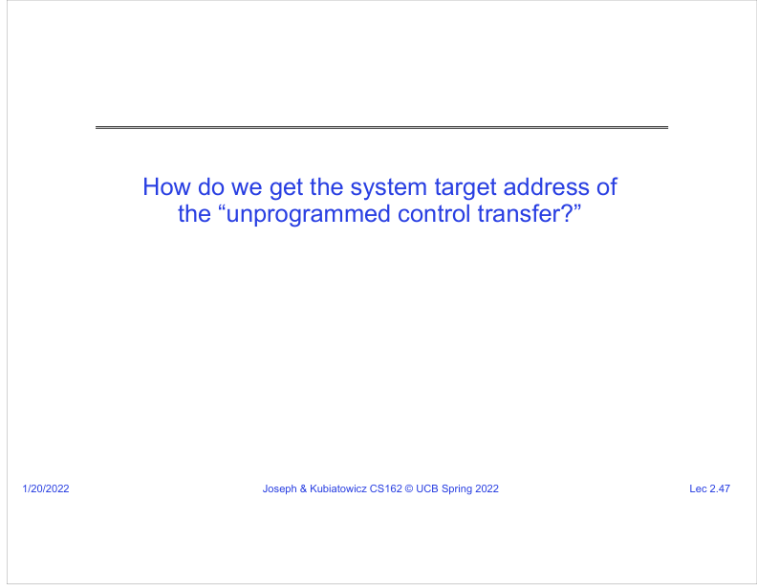
Figure: PDF page 12, quadrant 3, lecture slide 2.47.
SRT anchor: SRT coverage: next-lecture preview
What this slide means: The CPU must know which kernel address should handle a syscall, interrupt, or exception.
- User code must not choose the kernel target address, otherwise it could jump past security checks.
- The hardware and OS provide predefined entry points for each event type.
- This ensures that every kernel entry starts at safe, vetted handler code.
- The next slide introduces the interrupt vector as the dispatch table.
Graphic mental model: Event type -> safe kernel entry point

Slide 2.48: Interrupt Vector
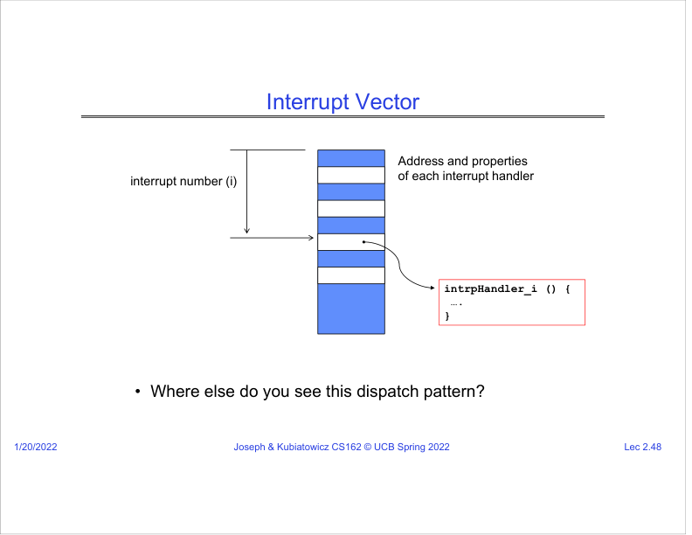
Figure: PDF page 12, quadrant 4, lecture slide 2.48.
SRT anchor: SRT coverage: next-lecture preview
What this slide means: The interrupt vector maps an interrupt/trap number to the address of its handler.
- Think of it like an array or table: interrupt number i points to intrpHandler_i().
- The table stores handler addresses and properties.
- This pattern is similar to dispatch tables used in programming: index -> function to call.
- Because it controls kernel entry, the interrupt vector must be protected from user modification.
Graphic mental model: interrupt number -> vector table -> handler address

PDF Page 13
Page summary: This page continues the B&B story through interrupt, switching to another process, and resume.

Slide 2.49: Simple B&B: User to Kernel
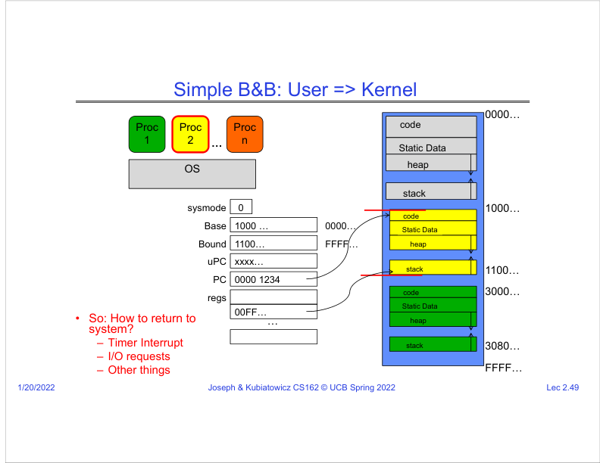
Figure: PDF page 13, quadrant 1, lecture slide 2.49.
SRT anchor: SRT coverage: next-lecture preview
What this slide means: A timer interrupt or I/O request can transfer control from user mode back to the kernel.
- The process is running in user mode, with base and bound set for its memory.
- An event occurs, such as a timer interrupt or I/O request/completion.
- The hardware switches into kernel mode and jumps to the proper handler.
- The key challenge is preserving the user state so the process can later resume correctly.
Graphic mental model: User PC/state -> interrupt event -> kernel entry

Slide 2.50: Simple B&B: Interrupt
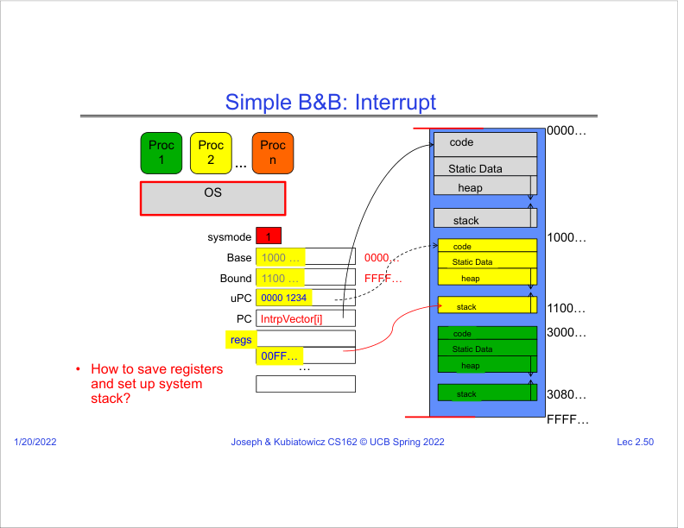
Figure: PDF page 13, quadrant 2, lecture slide 2.50.
SRT anchor: SRT coverage: next-lecture preview
What this slide means: During an interrupt, the system saves the user PC and state and begins running the interrupt handler.
- Sysmode becomes 1, meaning kernel mode.
- The PC now points to IntrpVector[i], the selected kernel handler.
- The old user PC is saved as uPC so execution can resume later.
- The slide asks how registers and the system stack are saved, which is the core mechanics of safe context switching.
Graphic mental model: Save user PC/registers -> switch to kernel handler

Slide 2.51: Simple B&B: Switch User Process
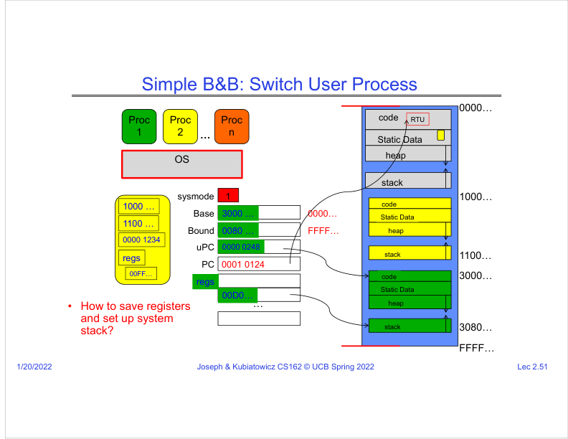
Figure: PDF page 13, quadrant 3, lecture slide 2.51.
SRT anchor: SRT coverage: next-lecture preview
What this slide means: The kernel may choose to run a different process after handling an interrupt.
- The kernel saves the old process state, including base, bound, user PC, and registers.
- It loads the next process state, here shown by switching from one process memory region to another.
- Then it uses Return To Usermode to enter the new process.
- This is the process-level version of context switching.
Graphic mental model: Save Process A state -> load Process B state -> RTU into B

Slide 2.52: Simple B&B: Resume
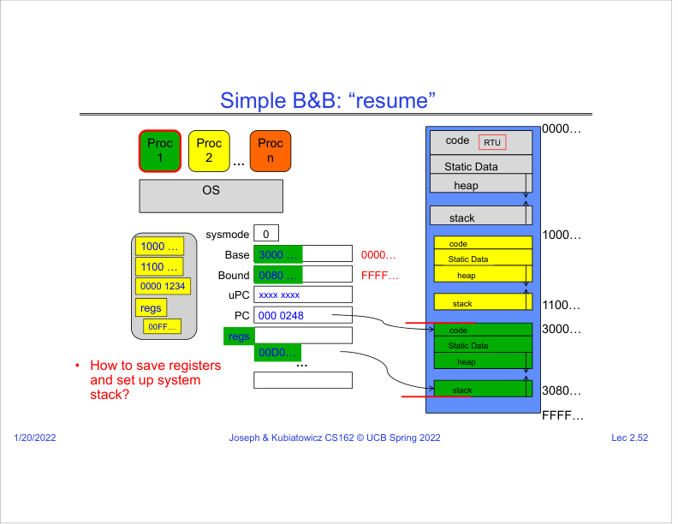
Figure: PDF page 13, quadrant 4, lecture slide 2.52.
SRT anchor: SRT coverage: next-lecture preview
What this slide means: After switching, the new process runs in user mode with its own base/bound protection.
- Sysmode becomes 0 again, so base/bound checks are active for the selected process.
- The PC points to the selected process saved user PC.
- The old process remains saved and can be resumed later.
- This explains how many programs can appear to run on one machine while remaining isolated.
Graphic mental model: RTU -> Process B continues exactly where it left off

PDF Page 14
Page summary: This page wraps up with PCB, scheduler, and the final four-concept summary.

Slide 2.53: Running Many Programs?
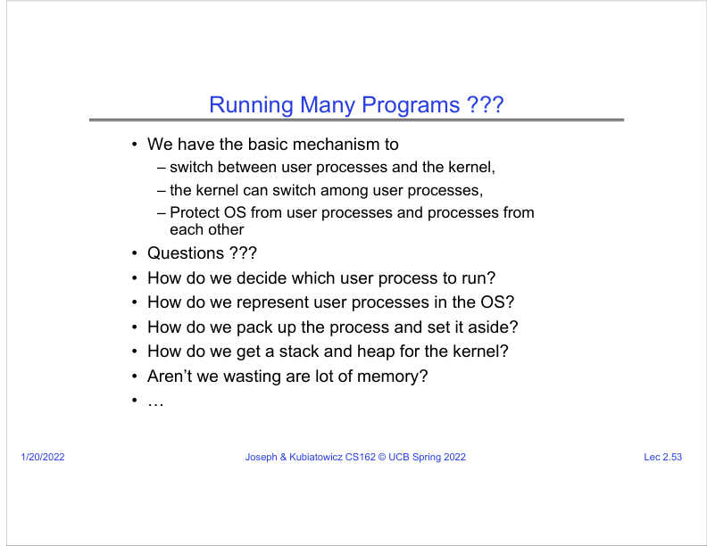
Figure: PDF page 14, quadrant 1, lecture slide 2.53.
SRT anchor: SRT coverage: mostly preview
What this slide means: Now that basic mechanisms exist, the lecture lists the next unanswered questions.
- We can switch between user processes and the kernel, and the kernel can switch among processes.
- We can protect the OS from processes and processes from each other.
- Remaining questions: which process should run next, how processes are represented, how to save process state, and how to manage kernel stack/heap and memory waste.
- These questions lead to PCB, scheduler, and later virtual memory topics.
Graphic mental model: Mechanism exists -> now need policy and data structures

Slide 2.54: Process Control Block
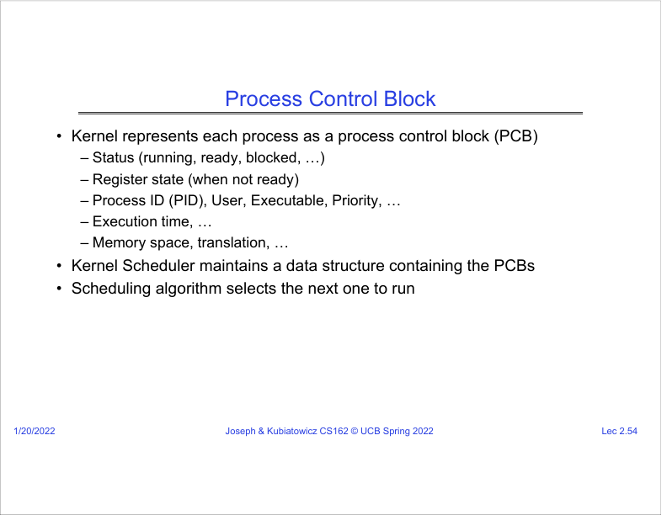
Figure: PDF page 14, quadrant 2, lecture slide 2.54.
SRT anchor: SRT coverage: preview + conclusion context
What this slide means: The kernel represents each process using a Process Control Block (PCB).
- A PCB stores status such as running, ready, or blocked.
- It stores register state when the process is not currently running.
- It also stores process ID, user, executable, priority, execution time, memory/translation information, and other metadata.
- The scheduler uses PCB data structures to choose which process to run.
Graphic mental model: PCB = kernel record describing one process

Slide 2.55: Scheduler
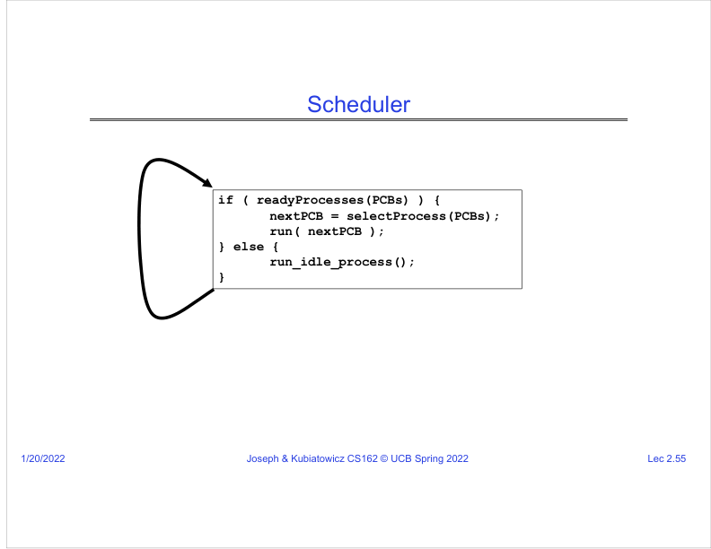
Figure: PDF page 14, quadrant 3, lecture slide 2.55.
SRT anchor: SRT coverage: preview + conclusion context
What this slide means: The scheduler selects the next process to run from the ready processes.
- The pseudocode says: if there are ready PCBs, select one and run it; otherwise run the idle process.
- A scheduling algorithm decides which ready process is best according to some policy.
- Earlier in the SRT, the lecturer says schedulers can vary time slices based on priority or real-time requirements.
- This topic becomes a major unit later in the course.
Graphic mental model: Ready queue -> selectProcess() -> run next process

Slide 2.56: Conclusion: Four Fundamental OS Concepts
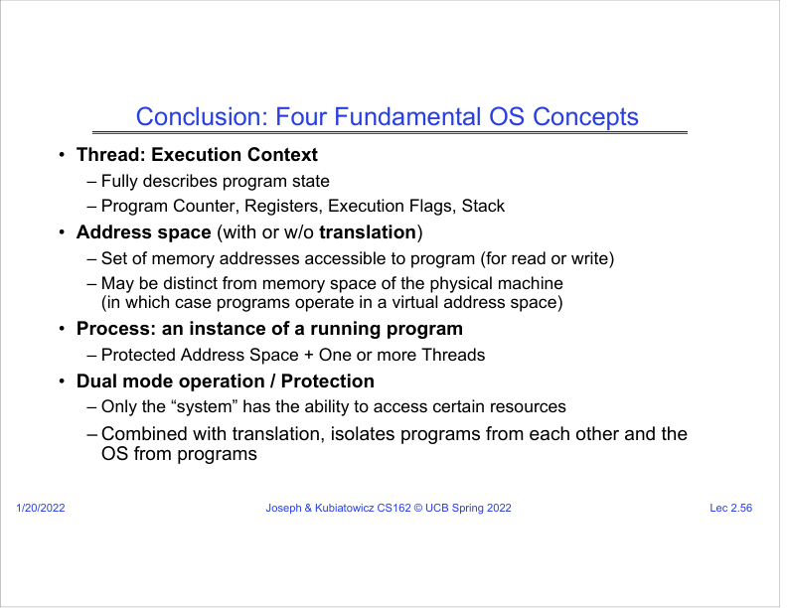
Figure: PDF page 14, quadrant 4, lecture slide 2.56.
SRT anchor: 01:25:42-01:26:58
What this slide means: The lecture concludes by summarizing thread, address space, process, and dual-mode protection.
- Thread: virtualized CPU / execution context with PC, registers, flags, and stack.
- Address space: protected set of addresses the program can read or write, possibly virtual rather than physical.
- Process: protected address space plus one or more threads.
- Dual-mode operation/protection: hardware distinguishes system/kernel mode from user mode so user programs cannot touch privileged resources directly.
Graphic mental model: Thread + Address Space -> Process; Dual Mode + Translation -> Protection

Final Synthesis for Lecture 2
One-sentence summary: The OS creates safe illusions: it lets each program feel like it owns a CPU and memory, while hardware and the kernel secretly multiplex resources and enforce protection.
- Thread: The running line of execution. It is the PC, registers, flags, stack pointer, and stack/memory state needed to continue computation.
- Address Space: The set of addresses visible to a program. It protects memory and can be virtual, translated to real physical memory by hardware and page tables.
- Process: A protected execution environment: address space plus one or more threads and resources such as file descriptors.
- Dual Mode: The hardware distinction between user mode and kernel mode. User code is restricted; kernel code can perform privileged operations.
- Context Switch: The OS saves one execution context, loads another, and resumes at the saved PC. This creates the illusion of many CPUs.
- Base and Bound: A simple protection idea: allow memory access only within an address range.
- Paging: A modern translation idea: split virtual memory into pages and map them to physical frames using page tables.
- PCB/TCB: Kernel data structures for saved process/thread state. A PCB represents a process; a TCB represents a thread execution context.

