CS162 Lecture 2
Four Fundamental OS Concepts
Step 1 - Overview Knowledge Structure Notes
Source materials: lecture slides PDF and English subtitle SRT
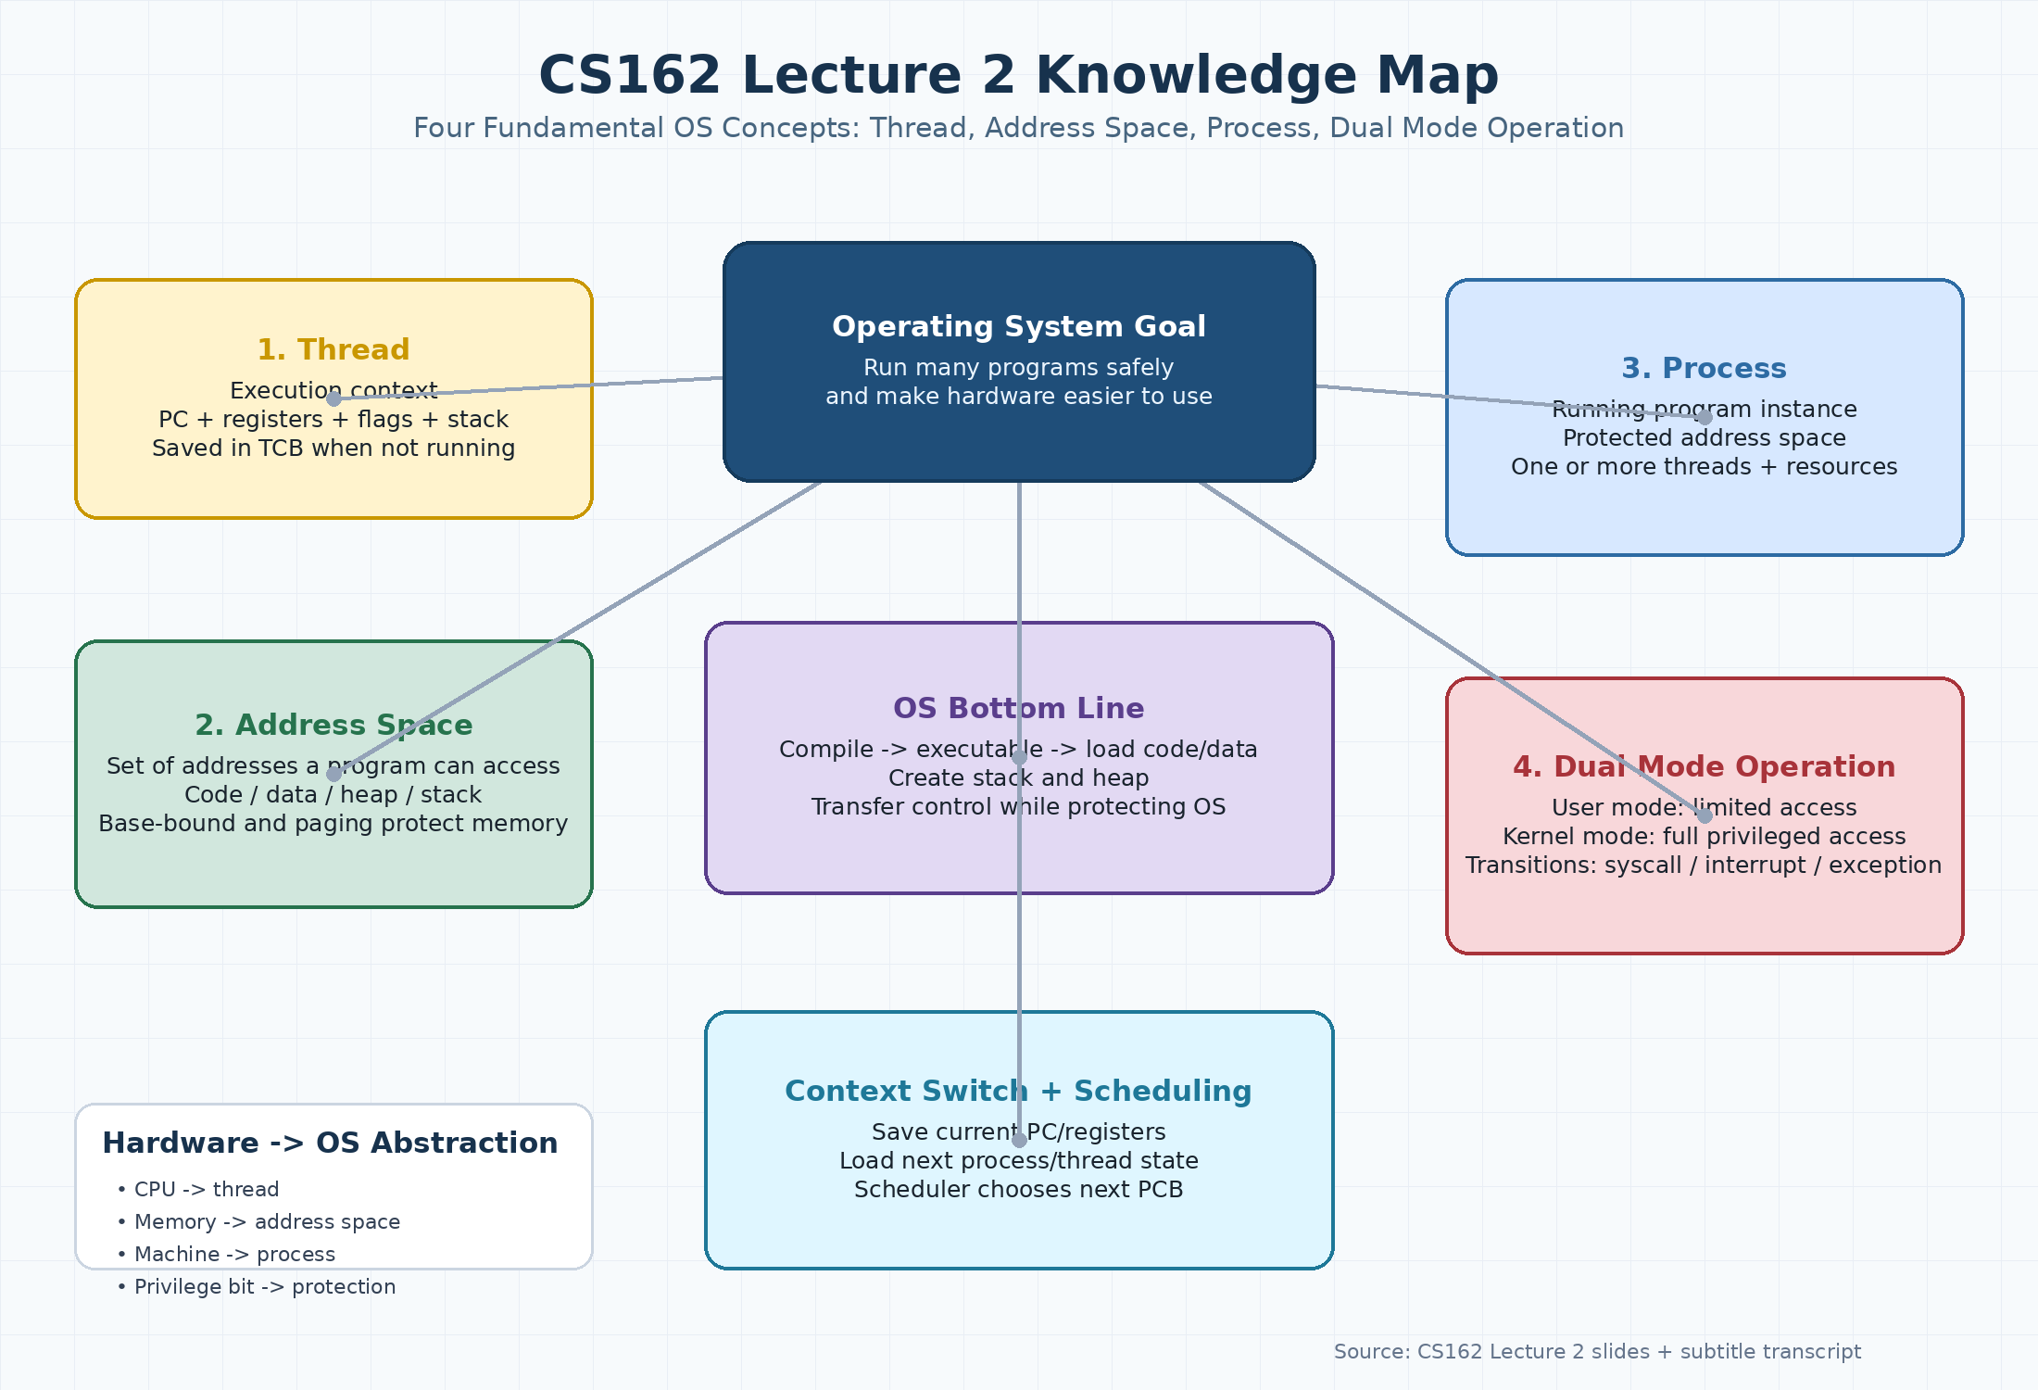
Figure 1. Lecture 2 overview knowledge map.
What this document does: It builds an overview structure for Lecture 2. The lecture starts from the complexity/protection problems introduced in Lecture 1, then introduces four OS concepts: thread, address space, process, and dual mode operation. The subtitle transcript was also checked; it contains about 13,885 words and reinforces the same lecture flow.

1. Learning Goals
- Understand why OS design is difficult: hardware complexity, software complexity, parallelism, bugs, and security risks.
- Understand the four fundamental OS concepts: thread, address space, process, and dual mode operation.
- Explain how a program becomes a running process: compile, load, create stack/heap, transfer control, and provide OS services.
- Explain how the OS creates the illusion of multiple processors using threads and context switching.
- Understand why protection requires both address translation and hardware privilege levels.

2. Big Picture of Lecture 2
Lecture 2 answers one main question: How can the OS safely run many programs on complicated hardware?
- The OS must run programs, but it must also prevent programs from damaging each other or the OS.
- The OS gives clean abstractions over messy hardware: CPU becomes threads, memory becomes address spaces, machines become processes.
- The OS must switch between user code and kernel code in a controlled way.
- The OS needs data structures such as TCBs and PCBs to remember the state of threads and processes.

3. Lecture Flow
Part | Core Idea | Why It Matters
Review from Lecture 1 | OS as referee, illusionist, and glue; protection stops illegal memory access. | This prepares the need for protected processes and kernel/user separation.
Complexity challenge | Modern hardware and software are large, parallel, and failure-prone. | OS must hide complexity while still providing performance and safety.
Thread | A thread is an execution context: PC, registers, flags, stack. | The OS can save/restore thread state to create the illusion of many CPUs.
Address space | A set of addresses that a program can access; may be virtual. | It protects memory and organizes code, data, heap, and stack.
Process | A running program with protected address space and one or more threads. | It is the OS container for protection, resources, and execution.
Dual mode operation | Hardware has user mode and kernel mode. | This prevents user programs from changing privileged resources directly.
Control transfers | Syscalls, interrupts, and exceptions move execution from user to kernel. | They allow services, preemption, and fault handling.
Scheduling | Kernel uses PCBs and a scheduler to choose the next process. | This is the basis for running many programs.

4. The Four Fundamental OS Concepts

4.1 Thread: Execution Context
Definition: A thread is a single flow of execution. It describes where the program is and what it is currently doing.
- Important state: Program Counter (PC), registers, execution flags, stack, and memory state.
- The PC points to the next instruction to run.
- Registers hold the immediate values or pointers the CPU is using right now.
- The stack stores function calls, return addresses, and local variables.
- When a thread is not running, the OS saves its state in memory, often in a Thread Control Block (TCB).
Simple understanding: Beginner analogy: a thread is like a bookmark plus your current scratch paper while reading a book. If you stop reading, you save the bookmark and notes so you can continue later.

4.2 Address Space: The Program's Memory World
Definition: An address space is the set of memory addresses a program is allowed to access.
- It usually contains a code segment, static data segment, heap, and stack.
- For a 32-bit machine, an address can theoretically name 2^32 locations; for 64-bit, 2^64 locations.
- A program may use virtual addresses that are translated to physical memory by hardware and OS data structures.
- Invalid access may cause a fault, such as a segmentation fault or page fault.
- Address translation helps isolate one program from another.
Simple understanding: Beginner analogy: an address space is like one student's assigned desk area. The student can use that area, but cannot write on another student's desk.

4.3 Process: Running Program with Protection
Definition: A process is an instance of a running program with restricted rights.
- A process = protected address space + one or more threads.
- It owns resources such as memory, file descriptors, file-system context, and other OS-managed state.
- Different processes are protected from each other.
- Communication is easier inside one process and harder between processes; this is a protection-efficiency tradeoff.
- The kernel represents each process with a Process Control Block (PCB).
Simple understanding: Beginner analogy: a process is like a protected room. Threads are workers inside the room. The room has its own tools, desk, and permissions.

4.4 Dual Mode Operation: User Mode and Kernel Mode
Definition: Dual mode operation means the CPU has at least two privilege levels: user mode and kernel mode.
- User mode has limited hardware access and is used by normal applications.
- Kernel mode has full privileged access and is used by the OS kernel.
- User programs cannot directly change page table pointers, disable interrupts, access hardware directly, or write kernel memory.
- Controlled transitions from user to kernel happen through system calls, interrupts, and exceptions.
- This mechanism protects the OS and isolates programs from each other.
Simple understanding: Beginner analogy: user mode is like a normal student account; kernel mode is like the administrator account. Normal users must request privileged actions through official procedures.

5. OS Bottom Line: Run Programs
The slides show the path from source code to a running program:
Step | Action | Meaning
1 | Write source code | For example, a file such as foo.c contains program source.
2 | Compile and link | The compiler/linker create an executable such as a.out.
3 | Load executable into memory | The OS loads instruction and data segments into memory.
4 | Create stack and heap | The stack supports function calls; the heap supports dynamic allocation.
5 | Transfer control to the program | The CPU starts executing at the program entry point.
6 | Provide services while protecting the system | The OS handles system calls, I/O, memory protection, and scheduling.

6. Context Switching: How One CPU Looks Like Many CPUs
Core idea: On one physical core, only one thread runs at one exact moment. The OS switches quickly between threads, saving one thread's state and loading another thread's state.
- Before switch: vCPU1/thread 1 is running on the real core.
- OS gets control by a timer interrupt, voluntary yield, I/O, syscall, or exception.
- OS saves PC, SP, registers, and other state into thread 1's TCB.
- OS loads thread 2's saved PC, SP, and registers from its TCB.
- CPU resumes from thread 2's PC.

7. Protection Mechanisms

7.1 Base and Bound
Base and bound is a simple memory protection method. The base says where the program's memory region starts. The bound says how large or how far the region is. The hardware checks every address to see whether it is inside the allowed range.
- If address is inside the allowed range, access is allowed.
- If address is outside the allowed range, hardware raises an exception.
- This protects the OS and other programs from illegal memory access.
- It is simple but less flexible than modern paging.

7.2 Paging and Page Tables
Paging breaks the virtual address space into equal-size pages. Physical memory is also divided into frames. A page table maps each virtual page to a physical frame, or marks it as not present.
- CPU instructions use virtual addresses.
- Hardware translates virtual addresses to physical addresses using the page table.
- Different pages of one process can be placed anywhere in physical memory.
- If a page is not present, access can generate a page fault.

7.3 System Calls, Interrupts, and Exceptions
Type | Source | When it Happens | Example
System call | Program request | The process asks the kernel for a service. | exit, read, write, open
Interrupt | External event | Hardware interrupts the CPU asynchronously. | timer interrupt, disk I/O finished
Exception / trap | Internal event | The running program causes a synchronous event. | segmentation fault, divide by zero

8. Key Vocabulary
Term | Simple Definition
Program Counter (PC) | A CPU register that points to the next instruction to execute.
Register | Very fast storage inside the CPU for current computation state.
Stack Pointer (SP) | A register that points to the top of the current stack.
Thread Control Block (TCB) | Kernel data structure that stores a thread's saved state when it is not running.
Process Control Block (PCB) | Kernel data structure that represents a process, including status, PID, registers, priority, and memory information.
Scheduler | Kernel component that chooses the next ready process or thread to run.
Virtual address | Address used by a program before translation.
Physical address | Real address in physical memory after translation.
Page table | Data structure used by hardware/OS to translate virtual addresses to physical addresses.
Kernel mode | Privileged CPU mode used by the OS kernel.
User mode | Limited CPU mode used by normal applications.

9. Common Confusions to Avoid
Confusion | Correct Understanding
Thread vs Process | A thread is an execution context. A process is a protected container that may contain one or more threads.
Address space vs physical memory | Address space is what the program can see. Physical memory is the real RAM hardware.
System call vs normal function call | A normal function call stays in the process. A system call crosses into the kernel through a controlled mechanism.
Interrupt vs exception | An interrupt comes from outside the running program. An exception is caused by the running program itself.
Protection vs performance | Stronger protection often makes communication harder; weaker protection can be faster but riskier.

10. Self-Check Questions
1. What state must be saved when switching from one thread to another?
2. Why does a thread need a stack?
3. Why is an address space important for protection?
4. What is the difference between a virtual address and a physical address?
5. Why is a process defined as a protected address space plus one or more threads?
6. Why can a user program not directly change the page table pointer?
7. What is the difference between a syscall, an interrupt, and an exception?
8. What information does a PCB contain?
9. How does a scheduler decide what to run next?
10. Why do we need both address translation and dual mode operation for protection?

11. Short Learning Log Preview
For the final GitHub update later, the core summary could be:
Today I studied CS162 Lecture 2, which introduces four fundamental OS concepts: thread, address space, process, and dual mode operation. I learned that a thread is an execution context, an address space defines accessible memory, a process combines protection with execution, and dual mode operation separates user programs from the privileged kernel. I also learned how context switching, TCBs, PCBs, system calls, interrupts, exceptions, base-bound protection, and paging help the OS run many programs safely.

