CS162 Lecture 1 Overview Notes
What is an Operating System?
Step 1 Deliverable: Knowledge Structure + Overview Picture
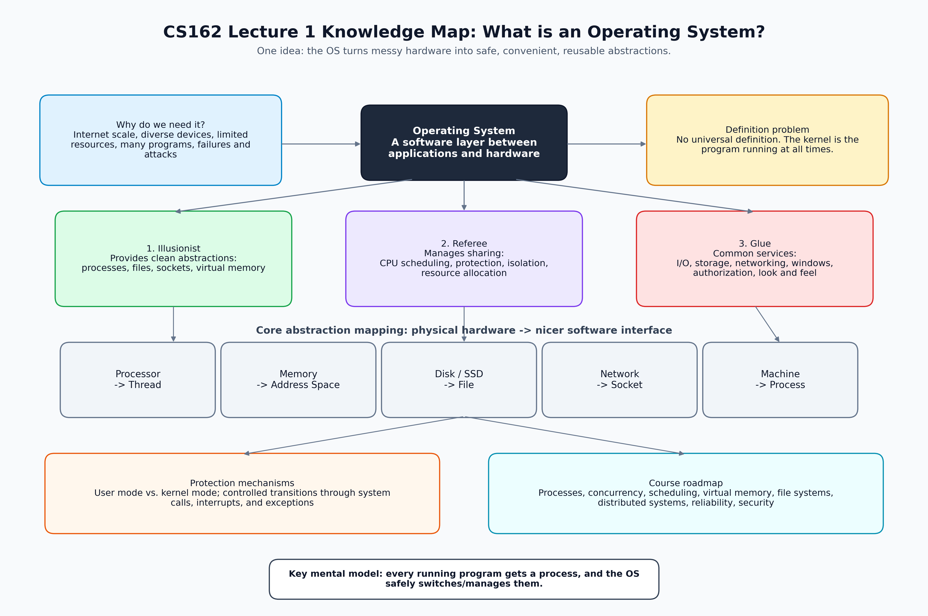
Course | CS162 - Operating Systems and Systems Programming
Lecture | Lecture 1 - What is an Operating System?
Source files | Lecture slides PDF + English SRT transcript (2057 subtitle blocks, approx. 01:20:34)
Purpose | Build a beginner-friendly structure before detailed Q&A and GitHub notes

0. Corrected Standard Workflow
Your original idea, corrected in natural English:
- Step 1: I will upload the SRT subtitle file and the PDF lecture slides. You should create a Word document and a picture that help me build an overview structure of all the knowledge.
- Step 2: I will publish my notes, including knowledge points and questions. You should answer them in detail.
- Step 3: You should create a Word document of questions and answers to help me master the knowledge.
- Step 4: We will summarize everything and create a .md file to update on GitHub.

1. One-Minute Overview
The central idea: an operating system is the software layer that turns complex physical hardware into safer and easier software interfaces for applications.
- It hides hardware complexity by giving programs abstractions such as processes, address spaces, files, and sockets.
- It manages shared resources such as CPU time, memory, storage, networks, and devices.
- It protects programs from each other and protects the kernel from user programs.
- It provides common services so every application does not need to reinvent low-level hardware control.

2. Knowledge Structure
Use this structure as your mental map when reviewing the lesson.
Layer | Main Idea | Important Keywords
Motivation | Modern systems run at Internet scale across many devices and timescales. | Internet scale, diversity, IoT, latency, complexity
Definition | There is no single perfect definition, but the kernel is always running. | kernel, system program, application program
Role 1 | OS as illusionist: provide clean abstractions. | virtualization, process, address space, file, socket
Role 2 | OS as referee: coordinate sharing and protection. | scheduling, isolation, resource allocation, protection
Role 3 | OS as glue: provide common services. | I/O, storage, networking, authorization, window system
Mechanisms | The OS uses hardware support to enforce boundaries. | user mode, kernel mode, system call, interrupt, exception
Challenge | OS work is hard because hardware/software are complex and parallel. | manycore, concurrency, failure, security, reliability

3. Core Concepts

3.1 What does an operating system do?
- Memory management: gives each process a controlled view of memory.
- I/O management: lets programs use storage, displays, keyboards, networks, and other devices.
- CPU scheduling: decides which thread or process runs next.
- Communication: helps programs exchange information locally or over networks.
- Multitasking and multiprogramming: lets many programs appear to run at the same time.

3.2 OS as Illusionist
Meaning: The OS creates useful illusions. A program feels like it has its own machine, even though many programs share the same physical hardware.
- The program sees a process abstraction instead of raw CPU, memory, storage, and network devices.
- Files hide the details of disks and SSDs.
- Sockets hide the details of network cards and packet transmission.
- Virtual memory can make memory look simpler and larger than physical memory.

3.3 OS as Referee
Meaning: The OS makes sure multiple programs can share one machine without destroying each other.
- It isolates processes from each other.
- It isolates the kernel from user programs.
- It allocates shared resources fairly or according to policy.
- It prevents user programs from directly doing dangerous operations.

3.4 OS as Glue
Meaning: The OS provides common services that many applications need.
- Storage and file systems
- Network services
- I/O interfaces
- Authorization and sharing
- Window system and look-and-feel services
- Background managers, such as power and network managers

4. Process: The First Big Abstraction
Simple definition: A process is a running program with restricted rights provided by the OS.
- A program is code stored on disk.
- A process is what that program becomes when it is running.
- Each running program normally runs inside its own process.
- The process is the application’s view of the machine.

What is inside a process?
Part | Meaning
Address space | The process's private memory world.
One or more threads | The actual execution paths running inside the process.
Open files | Files the process is currently using.
Open sockets | Network connections the process is currently using.
Other system state | Extra information the OS tracks for this process.

5. Hardware to OS Abstraction Mapping
Physical Reality | OS Abstraction | Beginner Meaning
Processor / CPU | Thread | A stream of execution.
Memory | Address Space | The memory world seen by a process.
Disk / SSD | File | A simple named object for persistent data.
Network | Socket | A communication endpoint.
Machine | Process | A safe execution environment for a program.

6. Protection: Why User Mode and Kernel Mode Matter
The OS must stop unsafe programs from damaging the system. For this reason, hardware provides at least two modes.
Mode / Mechanism | Who uses it? | What it means
User mode | Normal applications | Restricted mode. Dangerous operations are prohibited.
Kernel mode | Operating system kernel | Privileged mode. The kernel can manage hardware and memory.
System call | Application -> kernel | A controlled way for user programs to request OS service.
Interrupt | Hardware -> kernel | A signal that hardware needs attention.
Exception | Program/hardware -> kernel | A controlled reaction to unusual events, such as illegal memory access.

7. Why Operating Systems Are Challenging
- Hardware is complex: processors, caches, memory, I/O controllers, networks, disks, displays, keyboards, and more.
- Software is complex: modern systems contain millions of lines of code.
- The world is parallel: many cores, many threads, many devices, and many distributed services.
- Systems fail in unexpected ways and may be attacked.
- A robust OS needs careful engineering, error handling, protection, recovery, and security.

8. Course Roadmap from This Lecture
Topic | What to focus on later
Processes and I/O | How programs run and interact with the outside world.
Concurrency | Threads, scheduling, locks, deadlock, fairness, scalability.
Address Spaces | Virtual memory, translation, protection, sharing.
File Systems | Files, storage, naming, caching, performance, transactions.
Distributed Systems | Protocols, RPC, NFS, DHTs, consistency, scalability.
Reliability and Security | Fault tolerance, protection, security.

9. Feynman Review Questions
Use these questions before Step 2. Try to answer them in simple English, as if explaining to a 10-year-old.
- What is an operating system in one simple sentence?
- Why is the OS placed between applications and hardware?
- What does it mean to say the OS is an illusionist?
- What does it mean to say the OS is a referee?
- What does it mean to say the OS is glue?
- What is the difference between a program and a process?
- What things are inside a process?
- Why does each process need an address space?
- What is the difference between user mode and kernel mode?
- Why can’t a normal application directly change page tables or access hardware?
- What is a system call?
- Why are modern operating systems difficult to build correctly?

10. Today’s GitHub Update Checklist
☐ Upload this overview note to my learning repository.
☐ Add the knowledge map picture to the repository, for example under images/ or assets/.
☐ Write a short README update: today I learned the three roles of an OS: illusionist, referee, and glue.
☐ Prepare personal questions for Step 2.
☐ Use the Feynman questions to test whether I really understand the lesson.

11. Short README Update Draft
## 2026-04-26 CS162 Learning Update
Today I studied CS162 Lecture 1: **What is an Operating System?**
The most important idea is that an operating system is a software layer between applications and hardware. It gives programs clean abstractions, manages shared resources, and protects programs from each other.
My current mental model:
- **Illusionist**: the OS hides hardware complexity and provides abstractions such as processes, address spaces, files, and sockets.
- **Referee**: the OS manages CPU, memory, storage, and devices while enforcing protection and isolation.
- **Glue**: the OS provides common services such as I/O, storage, networking, authorization, and background management.
Next, I will review processes, threads, address spaces, user mode, kernel mode, and system calls in more detail.

12. Source Notes
- Lecture slides: CS162 Operating Systems and Systems Programming, Lecture 1, What is an Operating System?
- SRT transcript: English subtitle file with 2057 subtitle blocks, approx. 01:20:34 total duration.
- This document is a learning aid, not an official replacement for the course materials.

