Information

Weld Number: | 1
Weld Status: | 好
Company: | 教一128

Customer: |  | BatchNumber: | 0 | RecordNumber: | 0
BatchName: | 0-1 | Location: |  | Local D&T:
Product: | QQQQ | Thickness: | 8.7 | ControlSpec:
OperatorID: |  | Material: | WW | Temp.(℃): | 30°C
OperatorName: |  |  |  | By:

UT Zone

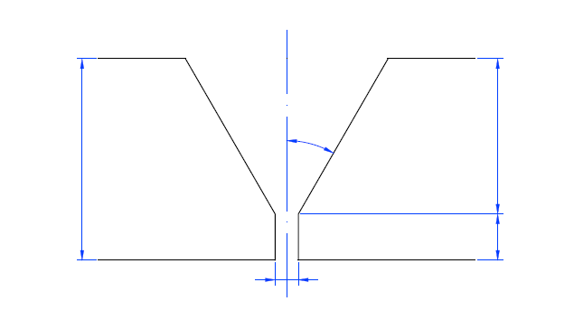
2mm
6.7mm
30°C
1mm
8.7mm

Approval Signature

Comments:

Interpreter: | Client:
Sign: | Sign:
Date: | Date:
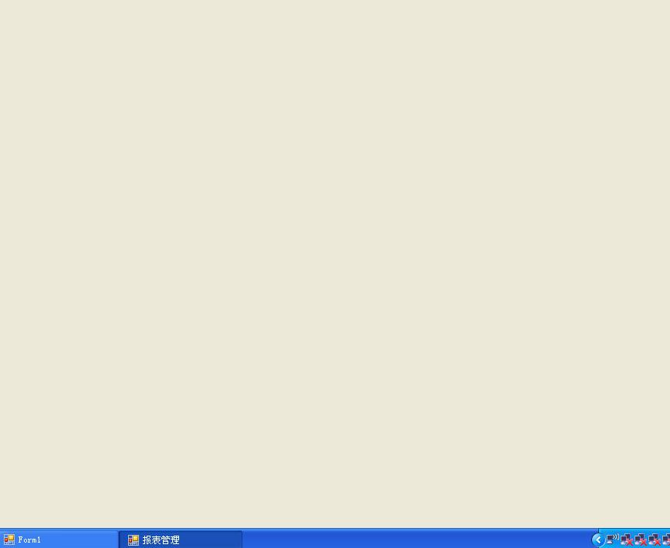

# | Type | Channels | Height(mm) | Start(mm) | Length(mm)

