Supplementary Data

Table S1. XRD Rietveld refinement parameter data of Li₆PS₅Cl_{0.95}I_{0.05} sample.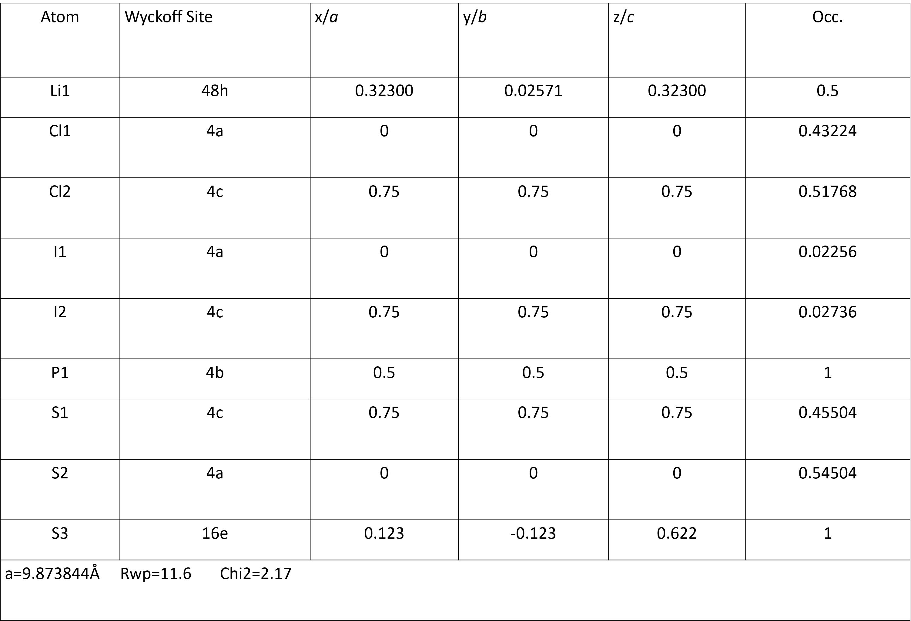
Figure S1. XRD pattern of and the corresponding Rietveld refinement of Li₆PS₅Cl sample.

Table S2. XRD Rietveld refinement parameter data of Li₆PS₅Cl sample.
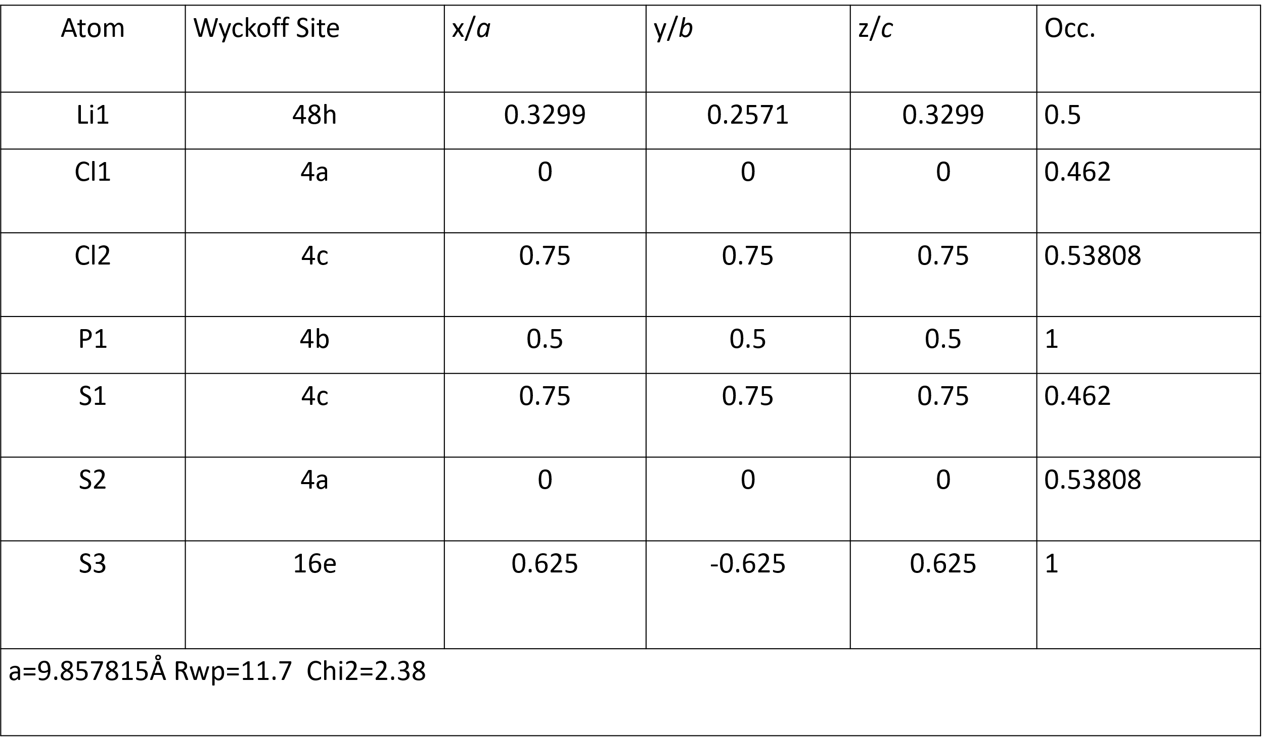

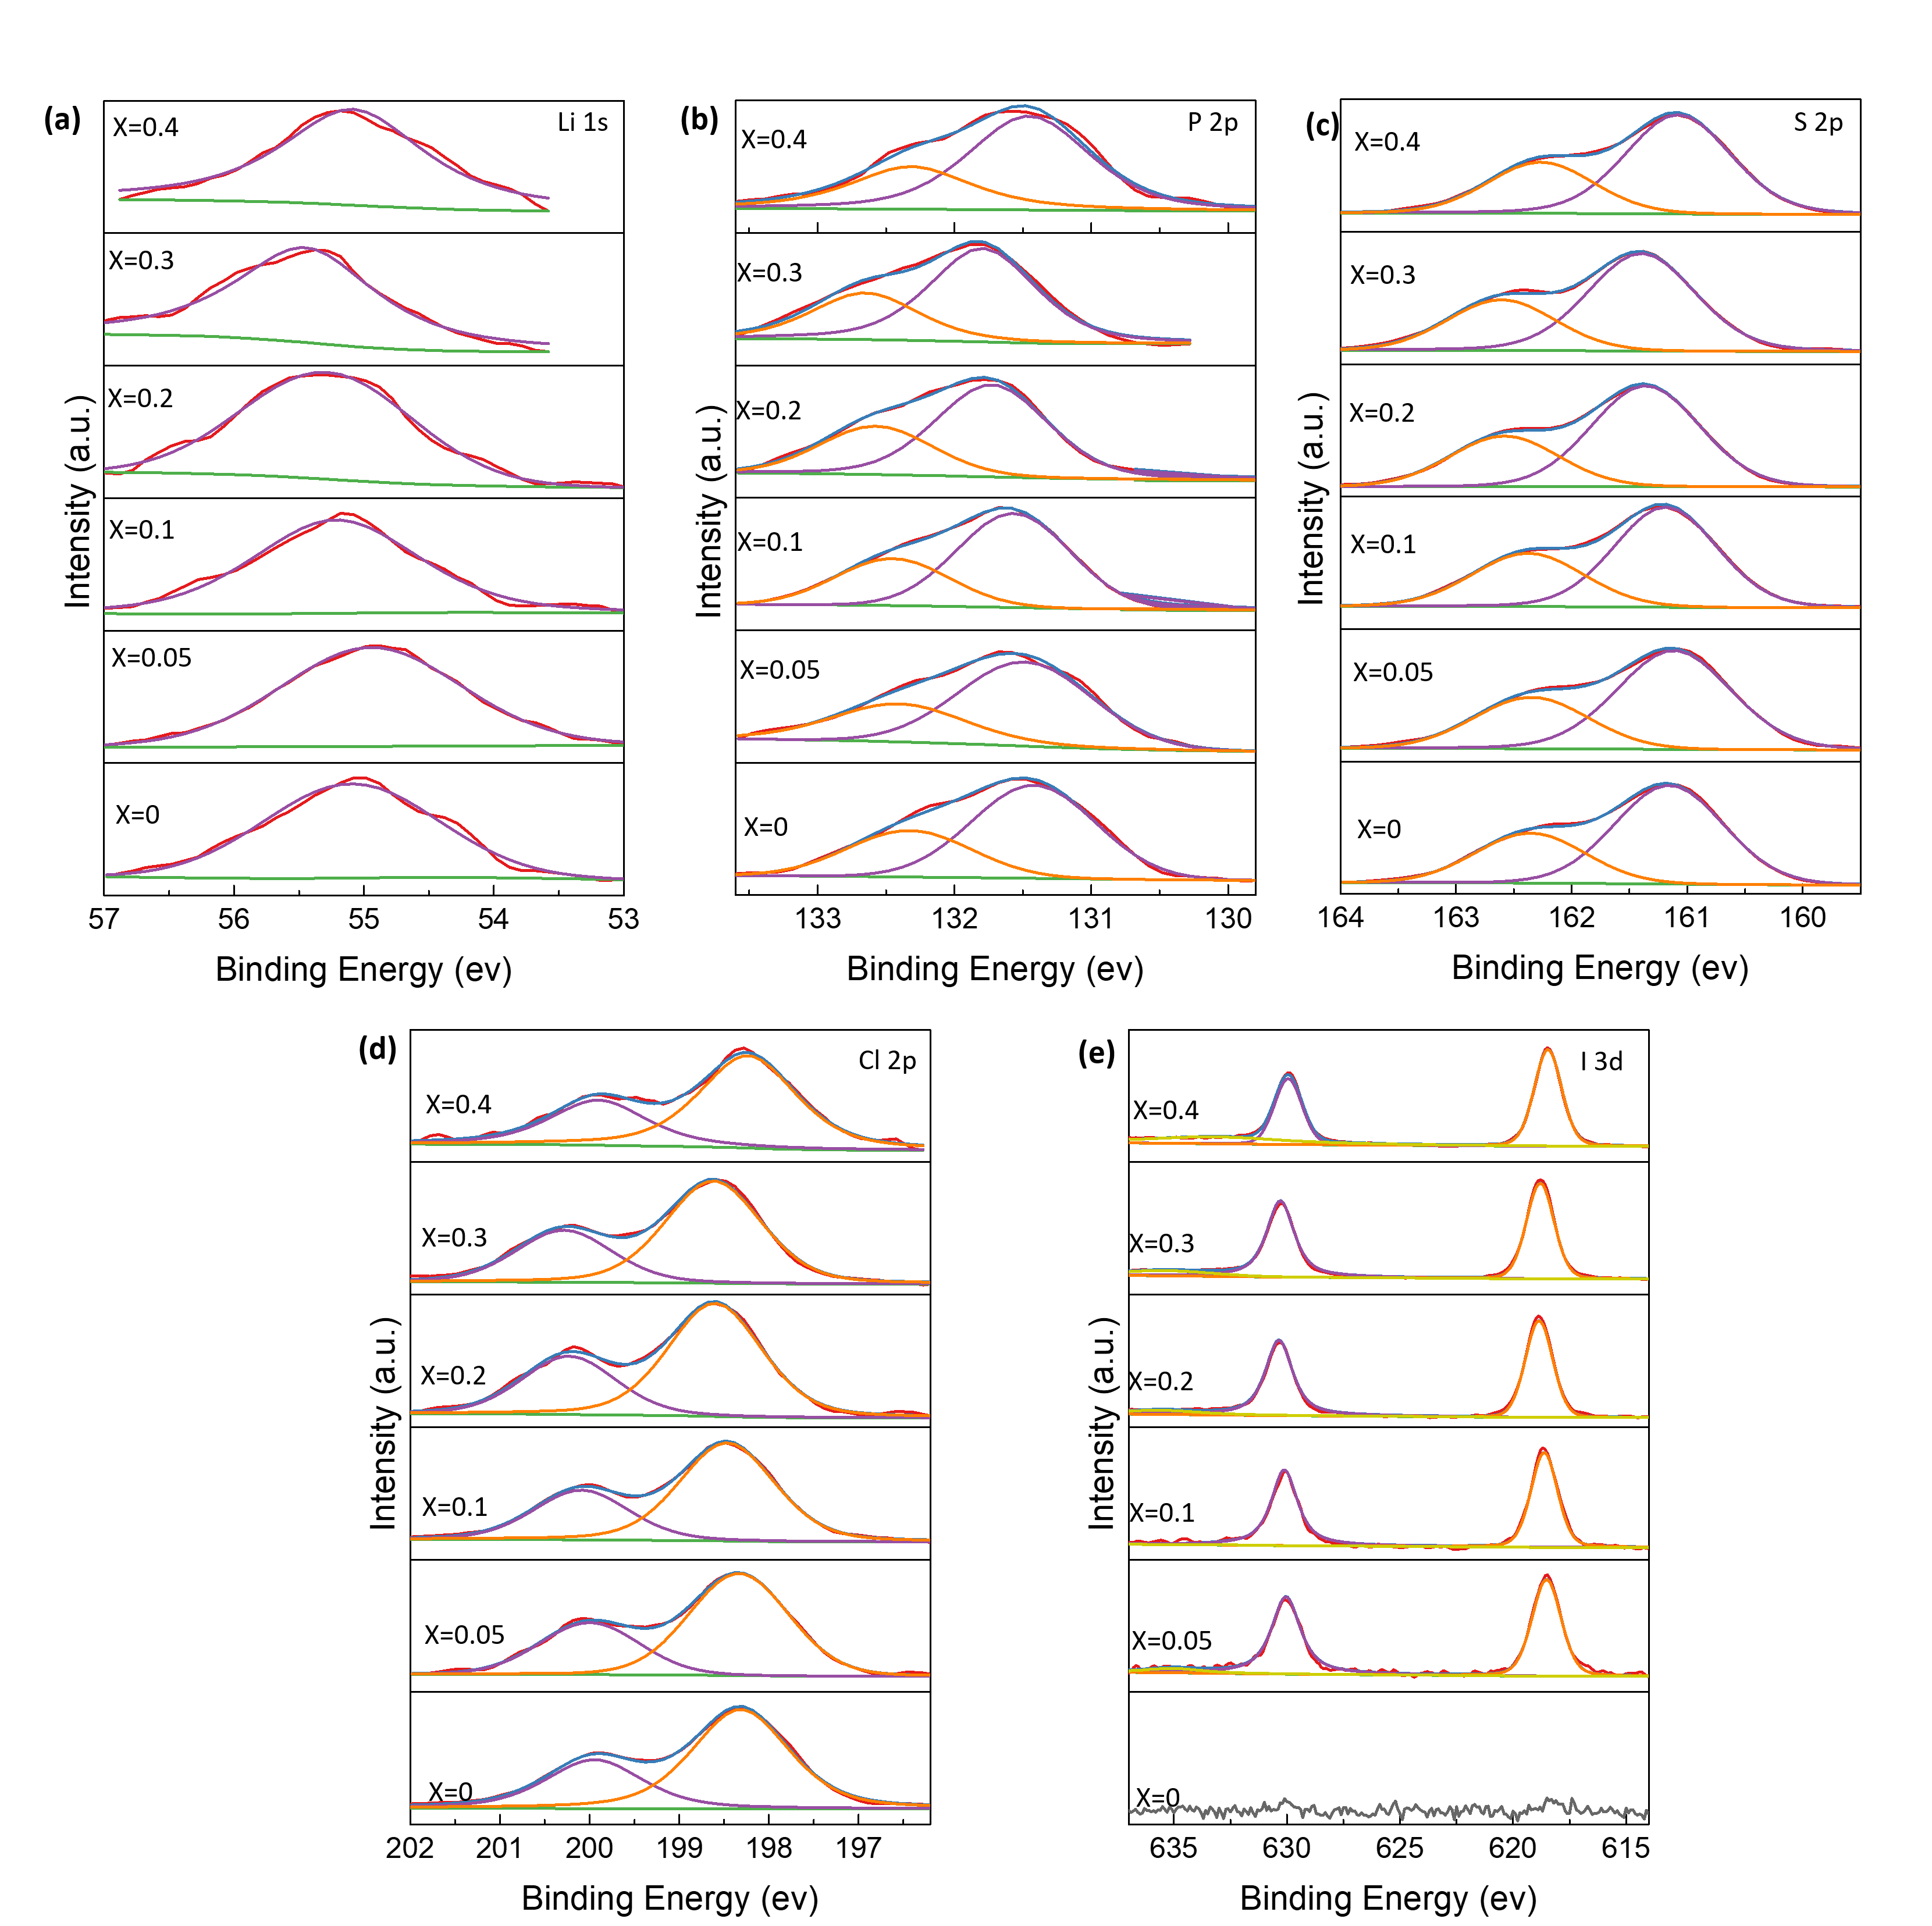
Figure S2. Measured X-ray photoelectron spectroscopy (XPS) spectra of Li₆PS₅Cl_{1-x}I_{x} (x=0, 0.05, 0.1, 0.2, 0.3, 0.4) electrolyte samples. (a) Li 1s, (b) P 2p, (c) S 2p, (d) Cl 2p, (e) I 3d.

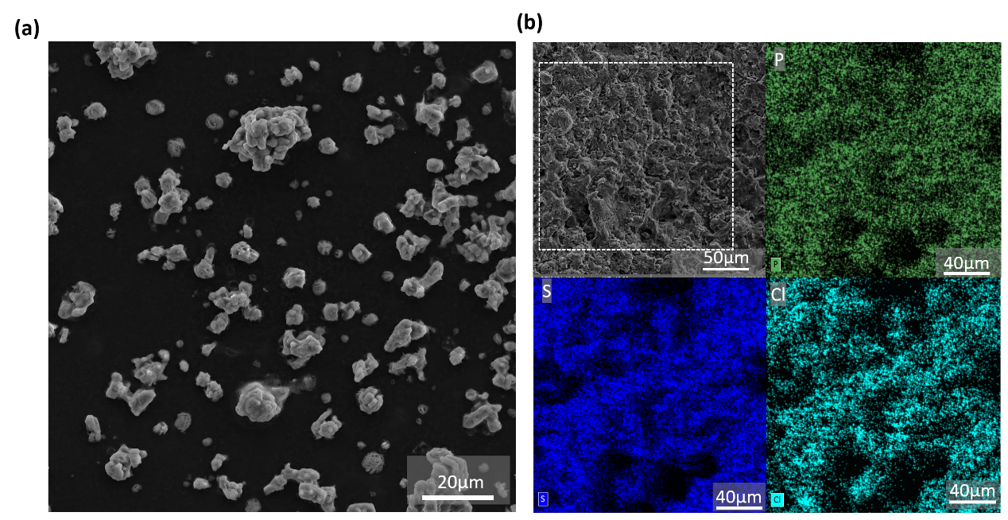
Figure S3. (a) SEM data of Li₆PS₅Cl_{0.95}I_{0.05} powder morphology. (b) EDS mapping of Li₆PS₅Cl electrolyte pellet.

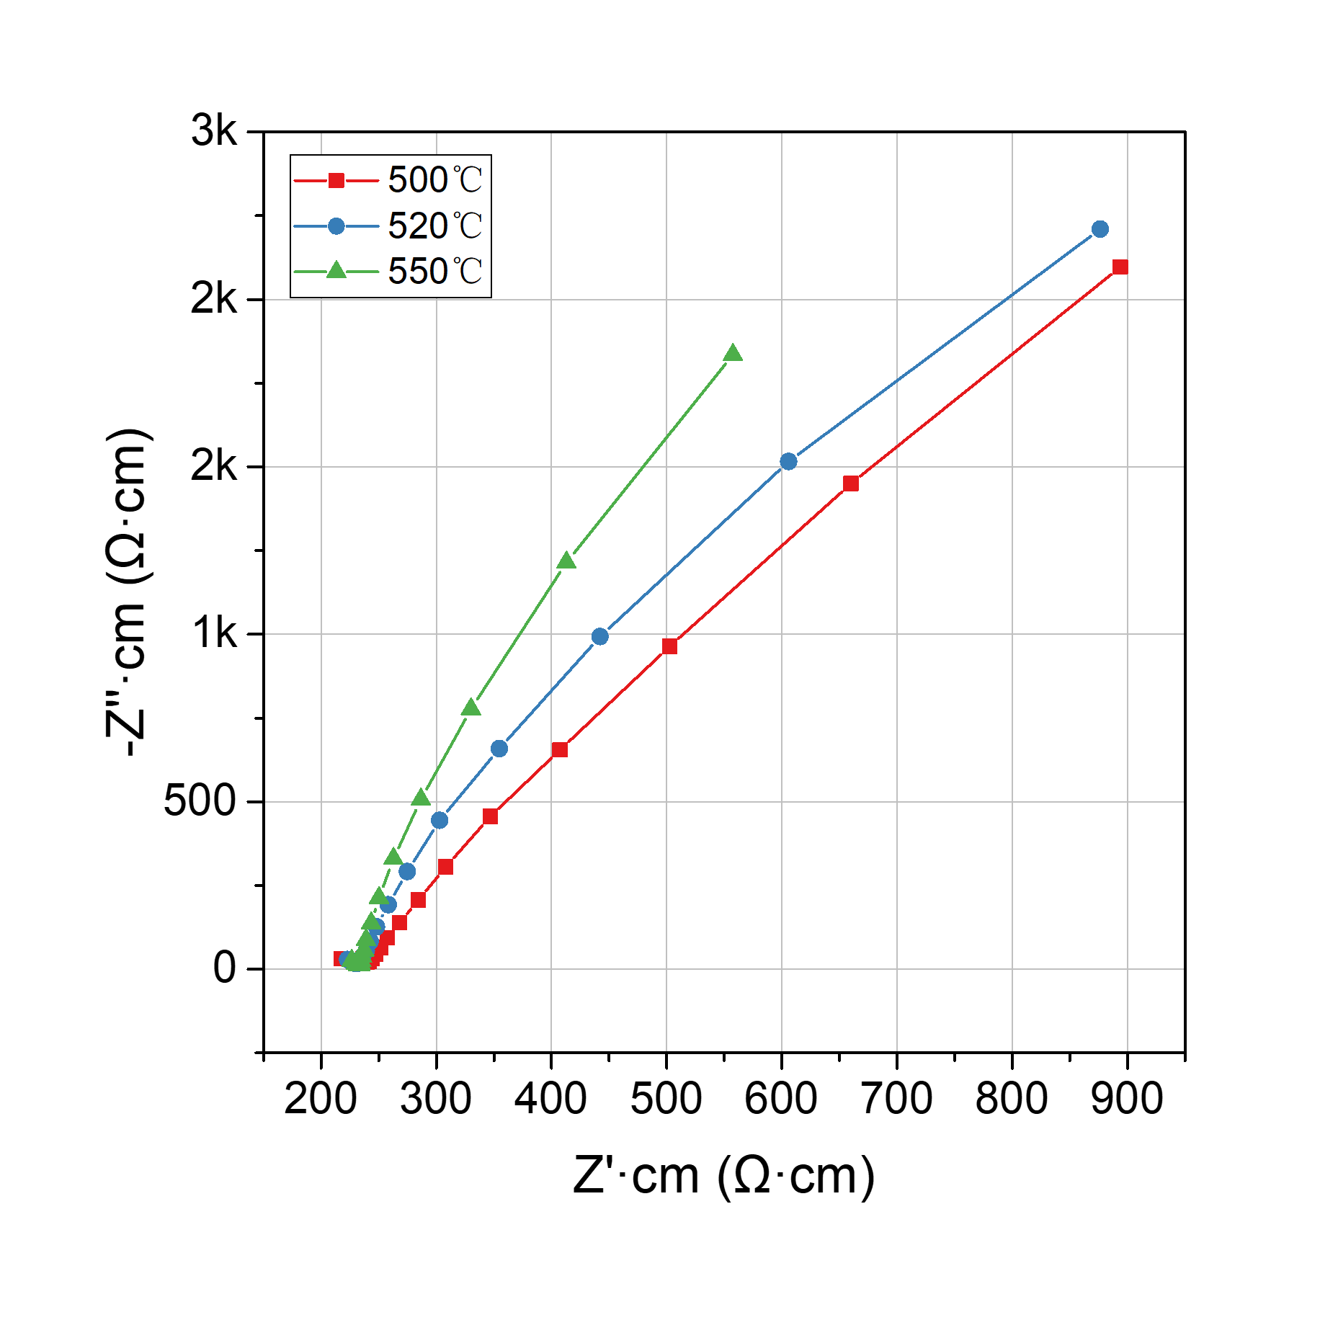
Figure S4. Impedance spectra of Li₆PS₅Cl sintering at different temperatures (500-550 ℃)

Table S3. Nyquist impedance fitting parameter data of Li₆PS₅Cl_{1-x}I_{x} (x=0, 0.05, 0.1, 0.2, 0.3, 0.4) electrolyte.
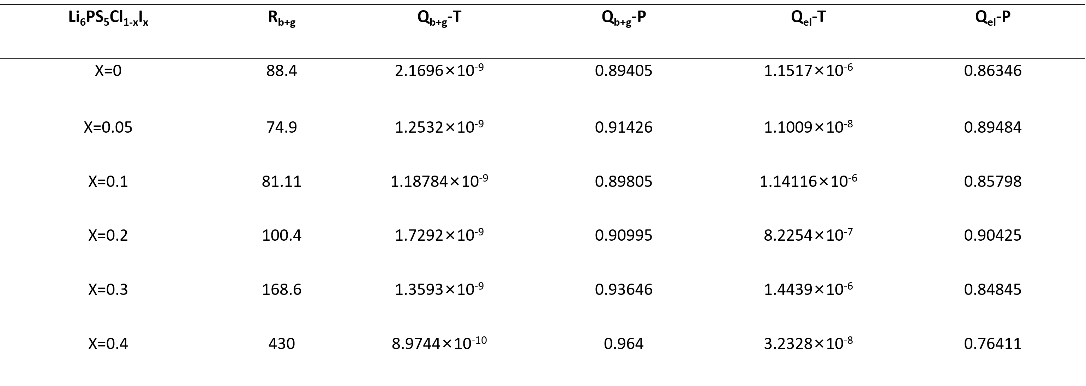

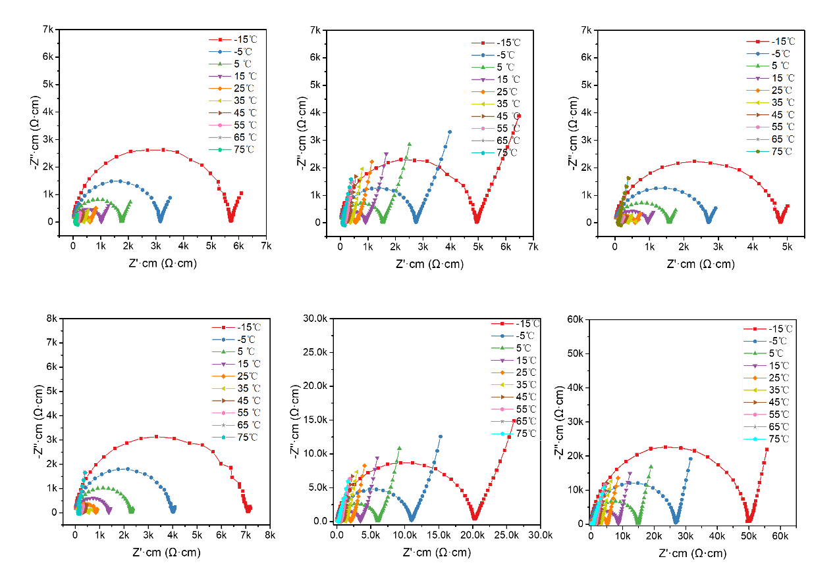
Figure S5. Different temperature (-15~75℃) impedance of Li₆PS₅Cl_{1-x}I_{x} (x=0, 0.05, 0.1, 0.2, 0.3, 0.4) electrolyte.

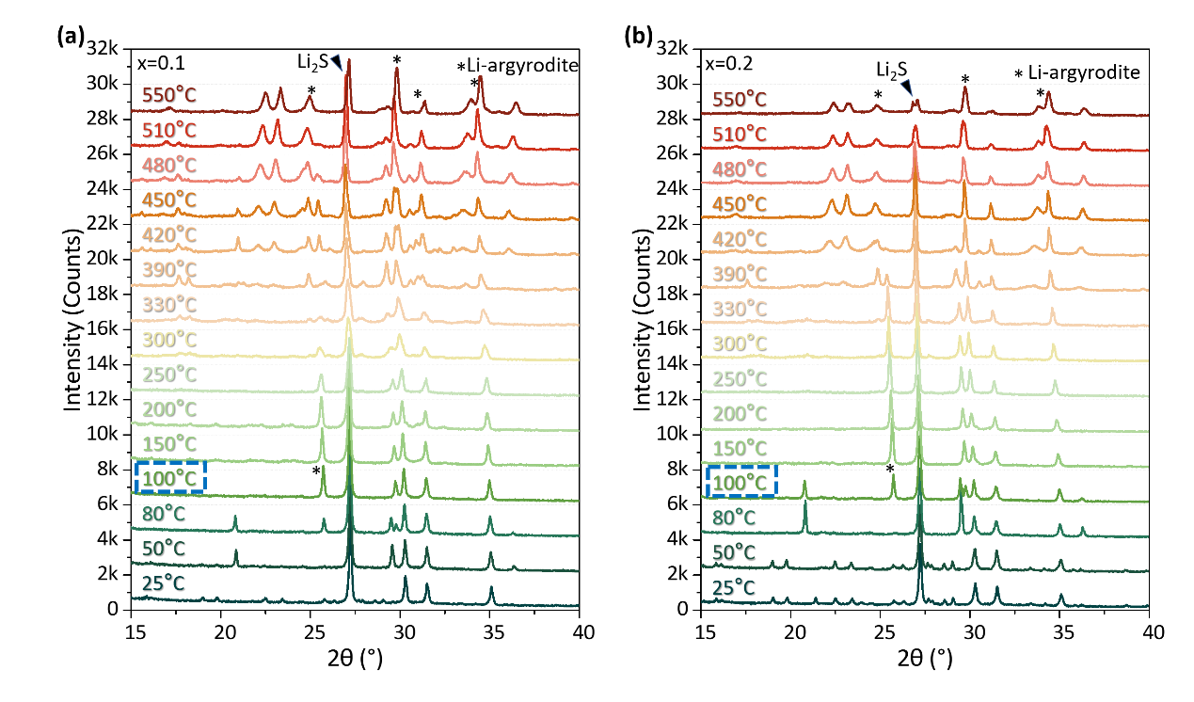 Figure S6. Details from in-situ XRD patterns at various temperatures for (a) Li₆PS₅Cl_{0.9}I_{0.1} and (b) Li₆PS₅Cl_{0.8}I_{0.2}.

