**Application and Implementation of different deep learning**

[Deep learning] is a part of machine learning that learns data representations. Many of the fundamental tasks (with appropriate reformulation) in deep learning are relevant to a much broader array of domains, and in particular, have tremendous potential in aiding the investigation of central scientific questions. There are many different Applications and Implementation of deep learning in different fields.

The Application and Implementation of deep learning in more and more wise fields is a hot topic in machine learning, neural networks, and deep learning. There have been many relevant studies on how to correctly select a deep learning approach. The proposal aims to propose a short story about the application and implementation of different deep learning. According to the author of the article "[A Survey of Deep Learning for Scientific Discovery](https://arxiv.org/pdf/2003.11755.pdf) ", numerous studies have been published resulting in various models in the field of deep learning (DL) has recently begun to receive Widely concerned, this is mainly due to its better performance than the classic model. In recent years, most of the fundamental breakthroughs in the core problems of machine learning have been driven by the progress of deep neural networks.

To supplement the information in this short story, other resources explaining the application and implementation of deep learning in different fields will be used. In addition, other sources will be used to compare the application of the deep learning (DL) field to other studies on similar topics. For example, the short story will include other papers in this field, such as the newest application and implementation of Meta-Learning, to compare with other existing studies.

The short story will begin with the introduction of Deep Learning, then briefly introduce existing research on application, implementation of DL that have been published for several years, and the emerging technologies for DL. While discussing the overall quality of the application and implementation, this short story will also explain the whole situation of DL application and the source papers have used for other research, as well as the critique of the paper, what can be done to improve and future directions and suggestions.

* Prediction Problems: the most straightforward way to apply deep learning
* From Predictions to Understanding : One fundamental difference between scientific questions and core machine learning problems.
* Complex Transformations of Input Data: In many scientific fields, the amount of generated data has increased dramatically, and deep learning can provide efficient analysis and automated processing.

In general, the more data you feed, the more accurate are the results in DL.

Coincidentally, there are huge datasets in scientific fields , such as petabytes of data in lab, patients, papers, reports.

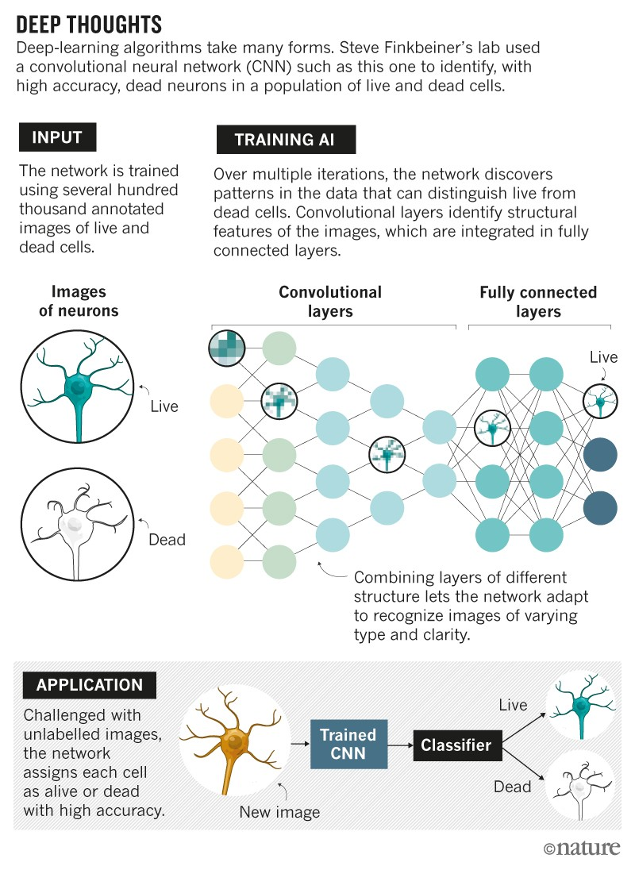

Source: Jeremy Linsley/Drew Linsley/Steve Finkbeiner/Thomas Serre

Bayers’ theorem

Deep Learning Libraries and Resources

Deep learning models

* Key Methods (Supervised Learning);
* Doing More with Less Data;
* Interpretability, Model Inspection and Representation Analysis

Deep Learning Libraries and Resources that the source papers have used for their research.

* Software Libraries for Deep Learning
* Research Overviews, Code, Discussion
* Models, Training Code and Pretrained Models:
* Data Collection, Curation and Labelling Resources
* Visualization, Analysis and Compute Resources

An overview of supervised learning, some core neural network models and the types of important tasks they can be used for. These topics involve a very wide range of research areas, so there are some areas, such as deep neural networks, which are used to set up structured data, model different invariances-apply the invariance of specific Lie groups to molecular property prediction. It is hoped that the materials and references provided can help inspire novel contributions to these very exciting and rapidly developing research directions.

The proposed deep learning models that the source

papers have used for their research.

* **Convolutional neural network(CNN)**
* **Recurrent Neural Networks（RNN)**
* **Long Short Term Memory (LSTM)**
* **Deep Belief Networks (DBNs)**

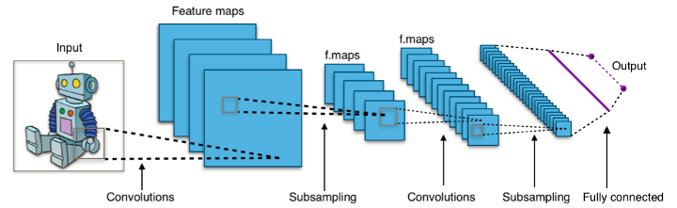

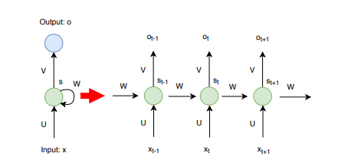

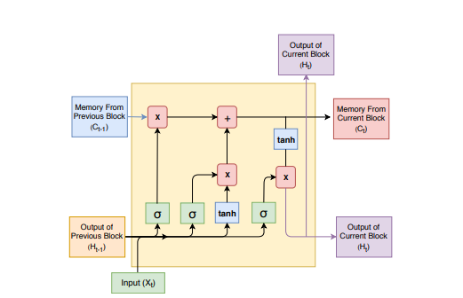

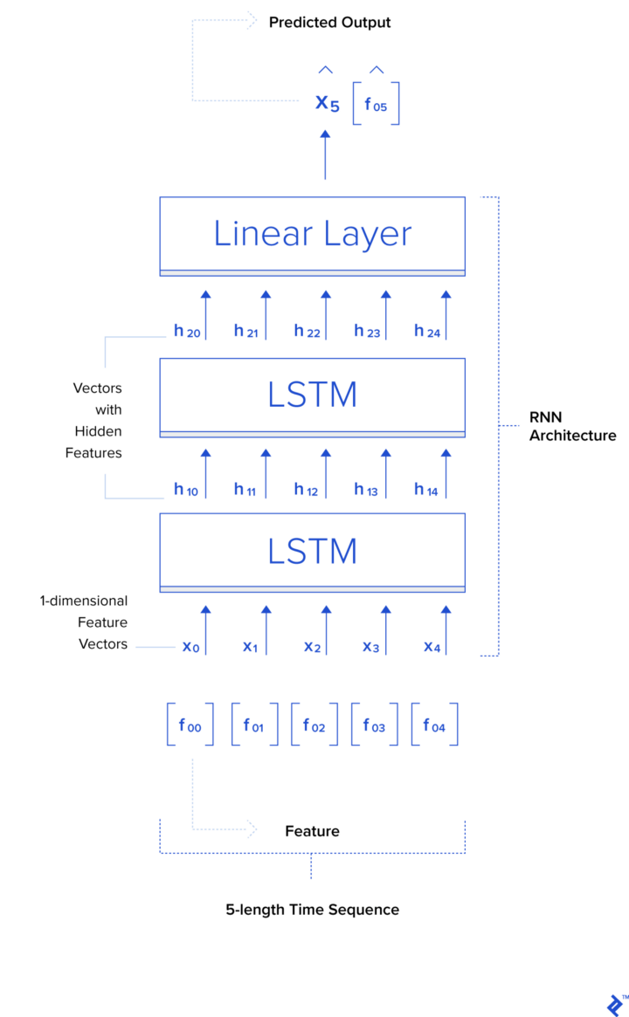

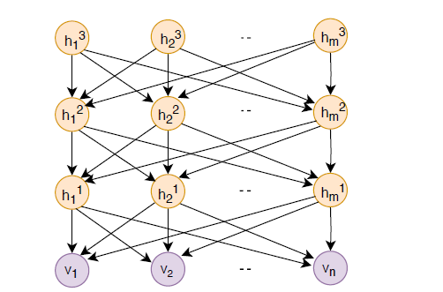

In this section, we have overviewed some of the central supervised learning based methodologies for developing deep learning models. This is just a sampling of the broad collection of existing methods, and again, we hope that the descriptions and references will help facilitate further exploration of other approaches. One method not covered that might be of particular interest is multimodal learning, where neural networks are simultaneously trained on data from different modalities, such as images and text [139, 238, 102]. Multimodal learning also provides a good example of the fact that it is often difficult to precisely categorize deep learning techniques as only being useful for a specific task or training regime. For example, we looked at language modelling for sequence tasks in this supervised learning section, but language modelling is also an example of self-supervision (Section 6) and generative models (Section 8.1). There are many rich combinations of the outlined methods in both this section and subsequent sections, which can prove very useful in the development

of an end to end system.

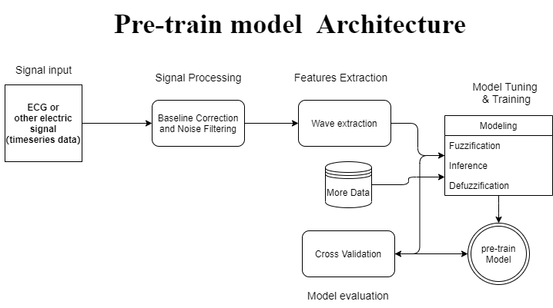

Transfer learning is a classic scientific research model using deep learning, and a similar model will be used in our master project (AI for healthcare).

Instead of randomly initializing parameters and directly training the target task, we first perform pre-training steps on some diversified general tasks. This leads to the neural network parameters converges to a set of values, called pre-training weights. If the pre-training tasks are sufficiently diverse, these pre-training weights will contain useful functions, which can be used to learn the target task more effectively. Starting with the pre-trained weights, we then train the network on the target task (called fine-tuning), which provides us with the final model.

**Meta-Learning:**

* Memory-based approach
* Method based on predicted gradient
* Method of using Attention attention mechanism
* Learn from the LSTM method
* Meta Learning Method for RL
* Through the method of training a good base model, and simultaneously applying to supervised learning and reinforcement learning
* Ways to use WaveNet
* Ways to predict Loss

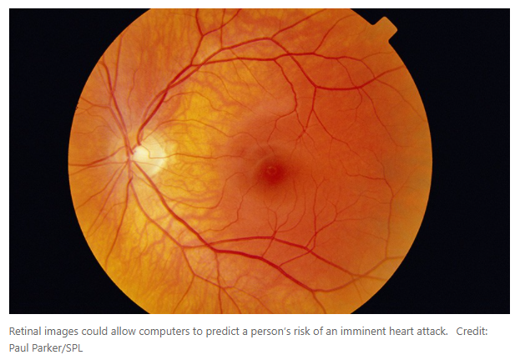

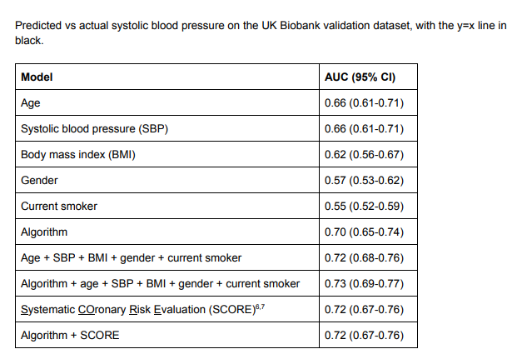

Although deep learning algorithms can evaluate data without human preconceptions and filters, this does not mean that they are unbiased. The training data may be skewed-for example, when using only genomic data from Northern Europeans. Deep learning algorithms trained on such data will obtain embedded biases and reflect them in predictions.

Then, it is challenging to understand exactly how these algorithms construct the features they use to classify the data. But the current system is still a black box.

The preceding sections contain many useful pointers to techniques and associated open sourced code references.

One additional reference of general interest may be https://christophm:github:io/interpretable-mlbook/

a fully open sourced book on interpretable machine learning. This focuses slightly more on more

traditional interpretability methods, but has useful overlap with some of the techniques presented above and

may suggest promising open directions.

[A Survey of Deep Learning for Scientific Discovery](https://arxiv.org/pdf/2003.11755.pdf) , https://arxiv.org/pdf/2003.11755.pdf

# Deep learning sharpens views of cells and genes

<https://www.nature.com/articles/d41586-018-00004-w>

# Predicting Cardiovascular Risk Factors from Retinal Fundus Photographs using Deep Learning

<https://arxiv.org/ftp/arxiv/papers/1708/1708.09843.pdf>

# Deep learning takes on synthetic biology

<https://www.sciencedaily.com/releases/2020/10/201007085615.htm>

# Recent Advances of Deep Learning in Bioinformatics and Computational Biology

https://www.frontiersin.org/articles/10.3389/fgene.2019.00214/full

# Deep learning for biology

<https://www.nature.com/articles/d41586-018-02174-z>

**Multiple Instance Learning with MNIST dataset using Pytorch**

<https://medium.com/swlh/multiple-instance-learning-c49bd21f5620>

**Review of Multi-Instance Learning and Its applications**

<https://www.cs.cmu.edu/~juny/MILL/review.htm>

[1] Santoro, Adam, Bartunov, Sergey, Botvinick, Matthew, Wierstra, Daan, and Lillicrap, Timothy. **Meta-learning with memory-augmented neural networks**. In Proceedings of The 33rd International Conference on Machine Learning, pp. 1842–1850, 2016.

[2] Munkhdalai T, Yu H. **Meta Networks**. arXiv preprint arXiv:1703.00837, 2017.

Andrychowicz, Marcin, Denil, Misha, Gomez, Sergio, Hoffman, Matthew W, Pfau, David, Schaul, Tom, and de Freitas, Nando. Learning to learn by gradient descent by gradient descent. In Advances in Neural Information Processing Systems, pp. 3981–3989, 2016

Ravi, Sachin and Larochelle, Hugo. Optimization as a model for few-shot learning. In International Conference on Learning Representations (ICLR), 2017.

**Andrychowicz, Marcin, Denil, Misha, Gomez, Sergio, Hoffman, Matthew W, Pfau, David, Schaul, Tom, and de Freitas, Nando. Learning to learn by gradient descent by gradient descent. In Advances in Neural Information Processing Systems, pp. 3981–3989, 2016**

[1] Wang J X, Kurth-Nelson Z, Tirumala D, et al. Learning to reinforcement learn. arXiv preprint arXiv:1611.05763, 2016.

[2] Y. Duan, J. Schulman, X. Chen, P. Bartlett, I. Sutskever, and P. Abbeel. Rl2: Fast reinforcement learning via slow reinforcement learning. Technical report, UC Berkeley and OpenAI, 2016.

[1] Finn, C., Abbeel, P., & Levine, S. (2017). Model-Agnostic Meta-Learning for Fast Adaptation of Deep Networks. arXiv preprint arXiv:1703.03400.

[1] Mishra N, Rohaninejad M, Chen X, et al. Meta-Learning with Temporal Convolutions. arXiv preprint arXiv:1707.03141, 2017.

[1] Flood Sung, Zhang L, Xiang T, Hospedales T, et al. Learning to Learn: Meta-Critic Networks for Sample Efficient Learning. arXiv preprint arXiv:1706.09529, 2017.<https://arxiv.org/pdf/1706.09529.pdf>

Ravi, Sachin and Larochelle, Hugo. Optimization as a model for few-shot learning. In International Conference on Learning Representations (ICLR), 2017.

Zheng, J., Zhang, J., Danioko, S. *et al.* A 12-lead electrocardiogram database for arrhythmia research covering more than 10,000 patients. *Sci Data* 7, 48 (2020).

Eduardo Jose da S. *et al*. ECG-based heartbeat classification for arrhythmia detection: A survey. *Computer Methods and Programs in Biomedicine*, Volume 127 (2016).

Sebastian D. Goodfellow. *et al*. Classification of Atrial Fibrillation Using Multidisciplinary Features and Gradient Boosting. *Computing in Cardiology conference*. (2017).

John Cristian Borges Gamboa. Deep Learning for time-series analysis (2017).

Shoaib Ahmed Siddiqui. *et al.* TSViz: Demystification of Deep Learning Models for the Time-series Analysis. *IEEE Access.* Volume PP (99) (2019).

Dong-wen Wu, Fen Wang. *et al*. How Long can we store blood samples: A systematic review and Meta-analysis *Ebiomedicine*. (2017).