Evaluation Framework (Grades 4–7):

Grade 4:
- Math:
  - RAG Classification:

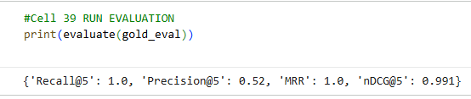
  - Rat Classification:

Traditional Rag:
Retriever quality evaluation matrix:

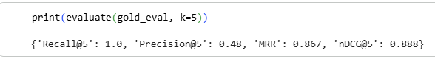
Llm answer generation:

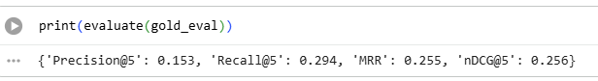
- Science:
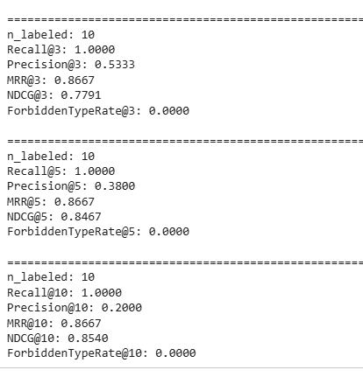

Traditional Rag:
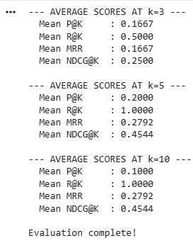

Grade 5:
- Science:

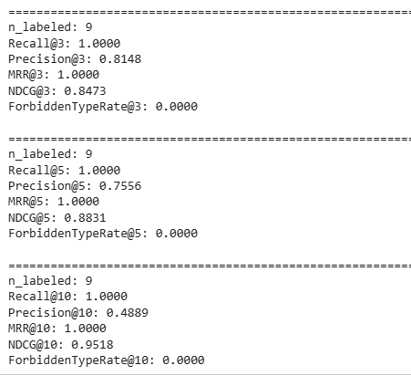

Traditional Rag:

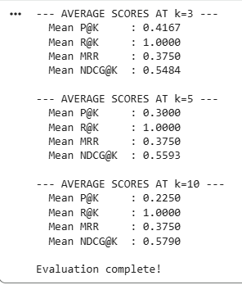

- Math:
  - Rag Classification:

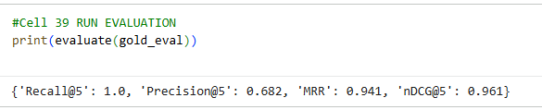
  - Rat Classification:

Traditional Rag:
Retriever quality evaluation matrix:

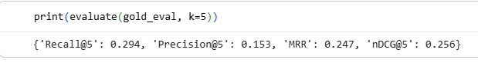
Llm answer generation:

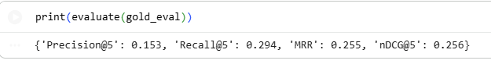

Grade 6:
- Science:
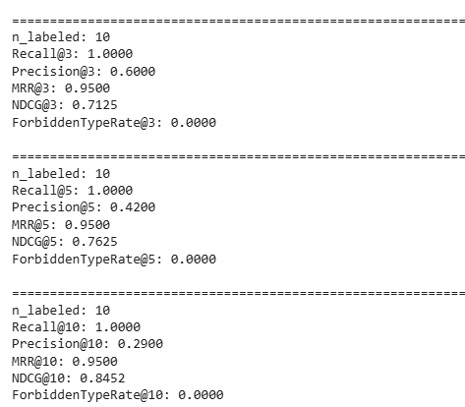

Traditional Rag:

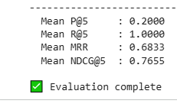

- Math:
  - Rag Classification:
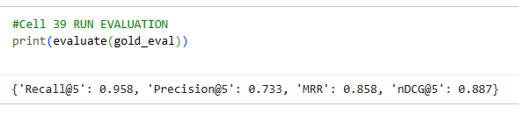

  - Rat Classification:

Traditional Rag:
Retriever quality evaluation matrix:

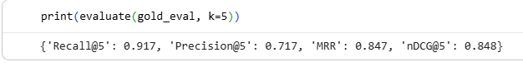
Llm answer generation:

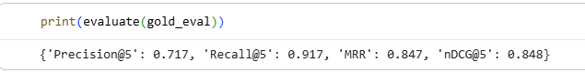

- Computer:
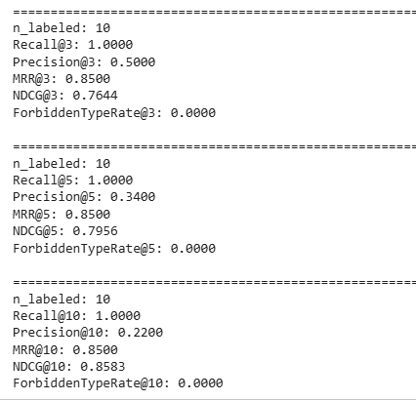

Traditional Rag:
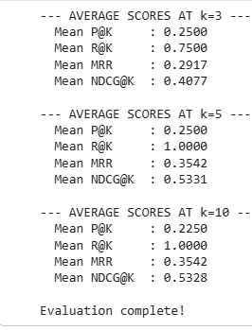

Grade 7:
- Science:
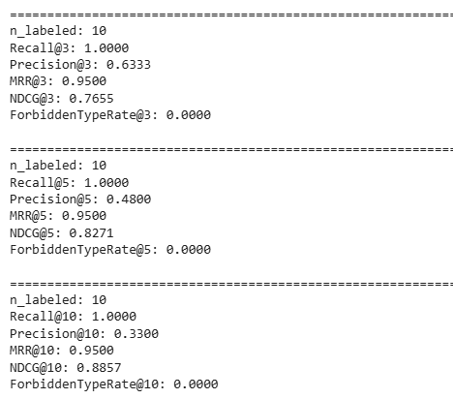

Traditional Rag:
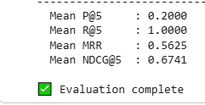

- Math:
  - Rag Classification:

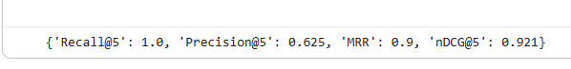
  - Rat Classification:

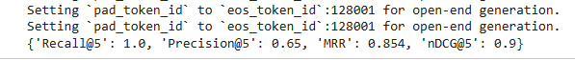

Traditional Rag:
Retriever quality evaluation matrix:

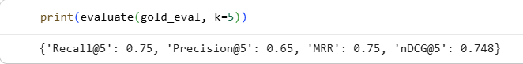
Llm answer generation:

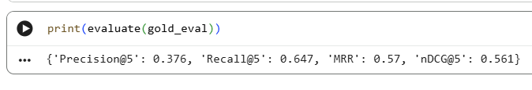

- Computer:
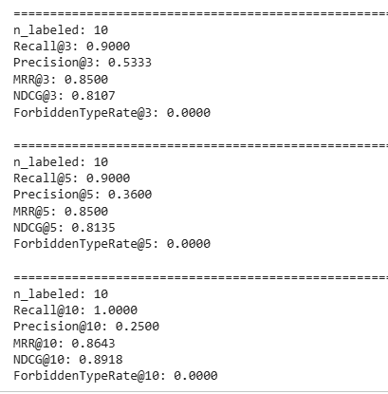

Traditional Rag:
