三大框架Spring+Mybatis+springMVC整合
置顶 2017-08-30 16:34:16 Augus胜 阅读数 459更多
分类专栏： 框架技术
版权声明：本文为博主原创文章，遵循 CC 4.0 BY-SA 版权协议，转载请附上原文出处链接和本声明。
本文链接：https://blog.csdn.net/KOBE_BPS/article/details/77718476
对于SSM框架学习使用已经快一年，现在打算从简单的整个框架搭建，再去整合一些其他的框架，例如shiro，springboot，dubbo，zookeeper等。那么今天呢，先简单的介绍一下SSM框架的整合，maven进行项目管理。首先你要去了解Spring，springMVC，mybatis，Maven是做什么的，有哪些好处，用处等等，这里就不多说了。现在进入正题。
1.新建MAVEN项目
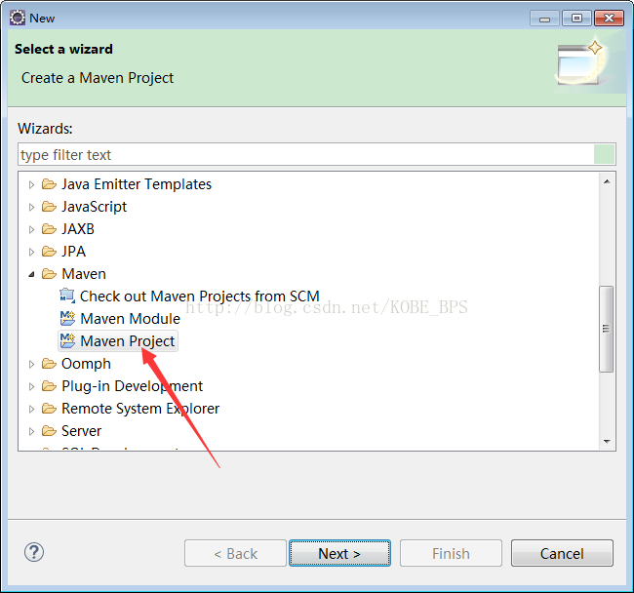
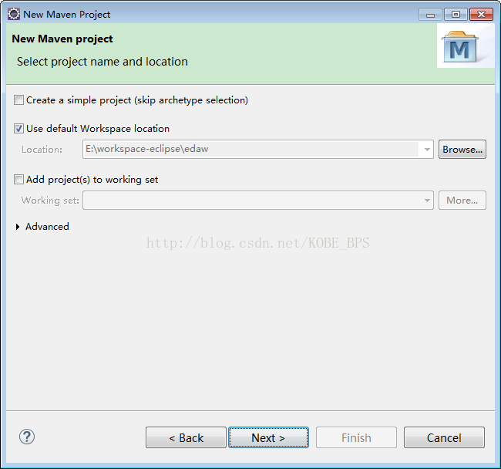
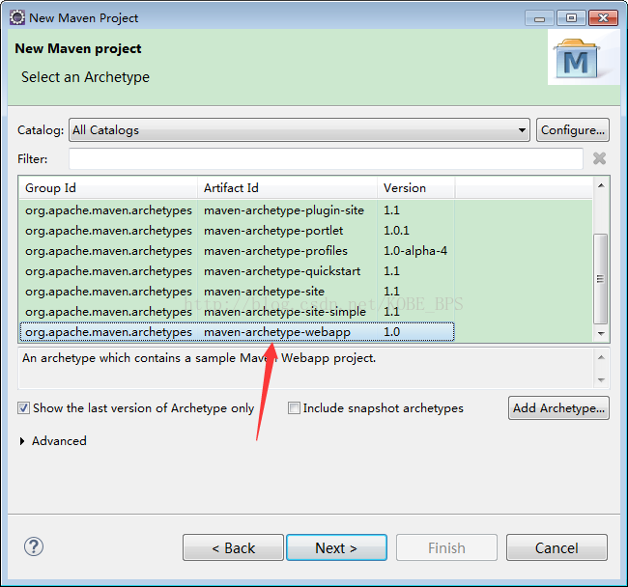
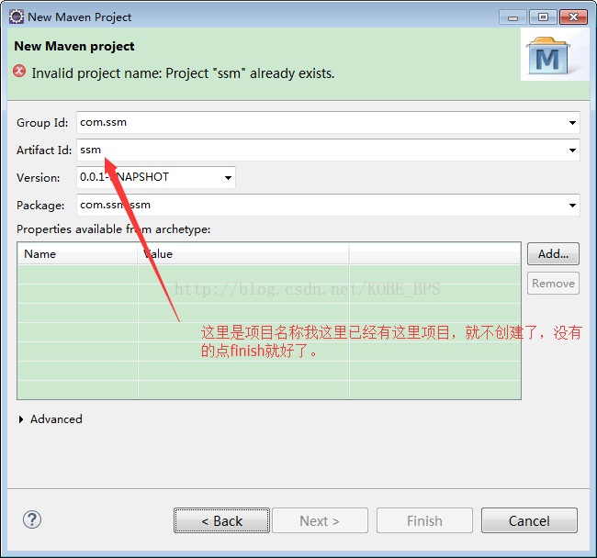

2.SSM框架的整合
首先先看下我项目的结构目录，如下图：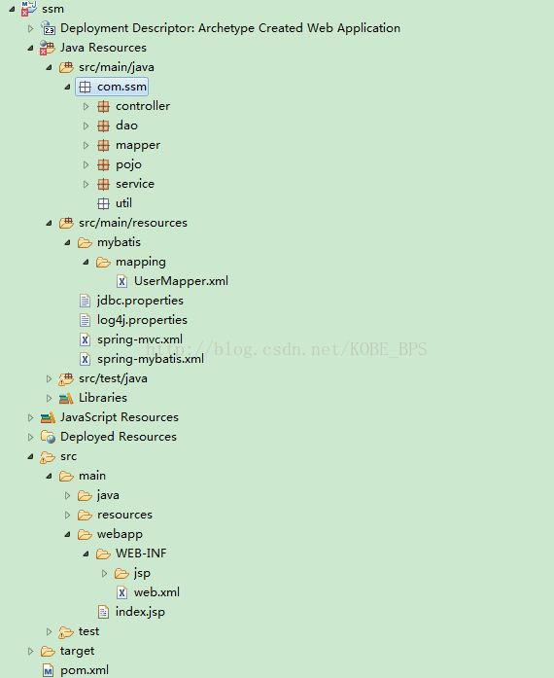.
接下来就是在pom.xml中配置相关的jar包文件

<project xmlns="http://maven.apache.org/POM/4.0.0" xmlns:xsi="http://www.w3.org/2001/XMLSchema-instance"
xsi:schemaLocation="http://maven.apache.org/POM/4.0.0 http://maven.apache.org/maven-v4_0_0.xsd">
<modelVersion>4.0.0</modelVersion>

<groupId>com.ssm</groupId>

<artifactId>ssm</artifactId>

<packaging>war</packaging>

<version>0.0.1-SNAPSHOT</version>

<name>ssm Maven Webapp</name>

<url>http://maven.apache.org</url>

<properties>

<!-- spring版本号 -->

<spring.version>4.3.10.RELEASE</spring.version>

<!-- mybatis版本号 -->

<mybatis.version>3.4.5</mybatis.version>

<!-- log4j日志文件管理包版本 -->

<slf4j.version>1.7.7</slf4j.version>

<log4j.version>1.2.17</log4j.version>

</properties>

<dependencies>

<dependency>

<groupId>junit</groupId>

<artifactId>junit</artifactId>

<version>4.12</version>

<!-- 表示开发的时候引入，发布的时候不会加载此包 -->

<scope>test</scope>

</dependency>

<!-- spring核心包 -->

<dependency>

<groupId>org.springframework</groupId>

<artifactId>spring-core</artifactId>

<version>${spring.version}</version>

</dependency>

<dependency>

<groupId>org.springframework</groupId>

<artifactId>spring-web</artifactId>

<version>${spring.version}</version>

</dependency>

<dependency>

<groupId>org.springframework</groupId>

<artifactId>spring-oxm</artifactId>

<version>${spring.version}</version>

</dependency>

<dependency>

<groupId>org.springframework</groupId>

<artifactId>spring-tx</artifactId>

<version>${spring.version}</version>

</dependency>

<dependency>

<groupId>org.springframework</groupId>

<artifactId>spring-jdbc</artifactId>

<version>${spring.version}</version>

</dependency>

<dependency>

<groupId>org.springframework</groupId>

<artifactId>spring-webmvc</artifactId>

<version>${spring.version}</version>

</dependency>

<dependency>

<groupId>org.springframework</groupId>

<artifactId>spring-aop</artifactId>

<version>${spring.version}</version>

</dependency>

<dependency>

<groupId>org.springframework</groupId>

<artifactId>spring-context-support</artifactId>

<version>${spring.version}</version>

</dependency>

<dependency>

<groupId>org.springframework</groupId>

<artifactId>spring-test</artifactId>

<version>${spring.version}</version>

</dependency>

<!-- mybatis核心包 -->

<dependency>

<groupId>org.mybatis</groupId>

<artifactId>mybatis</artifactId>

<version>${mybatis.version}</version>

</dependency>

<!-- mybatis/spring包 -->

<dependency>

<groupId>org.mybatis</groupId>

<artifactId>mybatis-spring</artifactId>

<version>1.3.1</version>

</dependency>

<!-- javaee jar包 -->

<dependency>

<groupId>javax</groupId>

<artifactId>javaee-api</artifactId>

<version>7.0</version>

</dependency>

<!-- Mysql数据库jar包 -->

<dependency>

<groupId>mysql</groupId>

<artifactId>mysql-connector-java</artifactId>

<version>5.1.30</version>

</dependency>

<!-- 导入dbcp的jar包，用来在applicationContext.xml中配置数据库 -->

<dependency>

<groupId>commons-dbcp</groupId>

<artifactId>commons-dbcp</artifactId>

<version>1.2.2</version>

</dependency>

<!-- JSTL标签类 -->

<dependency>

<groupId>jstl</groupId>

<artifactId>jstl</artifactId>

<version>1.2</version>

</dependency>

<!-- 日志文件管理包 -->

<!-- log start -->

<dependency>

<groupId>log4j</groupId>

<artifactId>log4j</artifactId>

<version>${log4j.version}</version>

</dependency>

<!-- 格式化对象，方便输出日志 -->

<dependency>

<groupId>com.alibaba</groupId>

<artifactId>fastjson</artifactId>

<version>1.1.41</version>

</dependency>

<dependency>

<groupId>org.slf4j</groupId>

<artifactId>slf4j-api</artifactId>

<version>${slf4j.version}</version>

</dependency>

<dependency>

<groupId>org.slf4j</groupId>

<artifactId>slf4j-log4j12</artifactId>

<version>${slf4j.version}</version>

</dependency>

<!-- log end -->

<!-- 映入JSON -->

<dependency>

<groupId>org.codehaus.jackson</groupId>

<artifactId>jackson-mapper-asl</artifactId>

<version>1.9.13</version>

</dependency>

<!-- 上传组件包 -->

<dependency>

<groupId>commons-fileupload</groupId>

<artifactId>commons-fileupload</artifactId>

<version>1.3.1</version>

</dependency>

<dependency>

<groupId>commons-io</groupId>

<artifactId>commons-io</artifactId>

<version>2.4</version>

</dependency>

<dependency>

<groupId>commons-codec</groupId>

<artifactId>commons-codec</artifactId>

<version>1.9</version>

</dependency>

<dependency>

<groupId>com.fasterxml.jackson.core</groupId>

<artifactId>jackson-core</artifactId>

<version>2.8.5</version>

</dependency>

<dependency>

<groupId>com.fasterxml.jackson.core</groupId>

<artifactId>jackson-databind</artifactId>

<version>2.8.5</version>

</dependency>

<dependency>

<groupId>com.fasterxml.jackson.core</groupId>

<artifactId>jackson-annotations</artifactId>

<version>2.8.5</version>

</dependency>

</dependencies>

<build>

<finalName>ssm</finalName>

</build>

</project>

然后，创建jdbc.properties 和log4j.properties文件。jdbc.properties的配置为：

jdbc.driver=com.mysql.jdbc.Driver

jdbc.url=jdbc:mysql://127.0.0.1:3306/db_bps

jdbc.username=root

jdbc.password=admin

#定义初始连接数

jdbc.initialSize=0

#定义最大连接数

jdbc.maxActive=20

#定义最大空闲

jdbc.maxIdle=20

#定义最小空闲

jdbc.minIdle=1

#定义最长等待时间

jdbc.maxWait=60000

log4j.properties的配置为：

log4j.rootLogger=INFO,console,File

#定义日志输出目的地为控制台

log4j.appender.console=org.apache.log4j.ConsoleAppender

log4j.appender.console.Target=System.out

#指定日志的输出方式

log4j.appender.console.layout = org.apache.log4j.PatternLayout

log4j.appender.console.layout.ConversionPattern=[%c] - %m%n

#文件大小到达指定大小会产生一个新文件

log4j.appender.File = org.apache.log4j.RollingFileAppender

#指定输出目录

log4j.appender.File.File = logs/ssm.log

#定义文件最大大小

log4j.appender.File.MaxFileSize = 1MB

# 输出所以日志，如果换成DEBUG表示输出DEBUG以上级别日志

log4j.appender.File.Threshold = ALL

log4j.appender.File.layout = org.apache.log4j.PatternLayout

log4j.appender.File.layout.ConversionPattern =[%p] [%d{yyyy-MM-dd HH\:mm\:ss}][%c]%m%n

接下来就是配置数据源spring-mybatis.xml 这里配置数据库连接，扫描，注入等

<?xml version="1.0" encoding="UTF-8"?>

<beans xmlns="http://www.springframework.org/schema/beans"

xmlns:xsi="http://www.w3.org/2001/XMLSchema-instance" xmlns:p="http://www.springframework.org/schema/p"

xmlns:context="http://www.springframework.org/schema/context"

xmlns:mvc="http://www.springframework.org/schema/mvc"

xsi:schemaLocation="http://www.springframework.org/schema/beans

http://www.springframework.org/schema/beans/spring-beans-4.0.xsd

http://www.springframework.org/schema/context

http://www.springframework.org/schema/context/spring-context-4.0.xsd

http://www.springframework.org/schema/mvc

http://www.springframework.org/schema/mvc/spring-mvc-4.0.xsd">

<!-- 自动扫描 -->

<context:component-scan base-package="com.ssm" />

<!-- 引入配置文件 -->

<bean id="propertyConfigurer"

class="org.springframework.beans.factory.config.PropertyPlaceholderConfigurer">

<property name="location" value="classpath:jdbc.properties" />

</bean>

<bean id="dataSource" class="org.apache.commons.dbcp.BasicDataSource"

destroy-method="close">

<property name="driverClassName" value="${jdbc.driver}" />

<property name="url" value="${jdbc.url}" />

<property name="username" value="${jdbc.username}" />

<property name="password" value="${jdbc.password}" />

<!-- 初始化连接大小 -->

<property name="initialSize" value="${jdbc.initialSize}"></property>

<!-- 连接池最大数量 -->

<property name="maxActive" value="${jdbc.maxActive}"></property>

<!-- 连接池最大空闲 -->

<property name="maxIdle" value="${jdbc.maxIdle}"></property>

<!-- 连接池最小空闲 -->

<property name="minIdle" value="${jdbc.minIdle}"></property>

<!-- 获取连接最大等待时间 -->

<property name="maxWait" value="${jdbc.maxWait}"></property>

</bean>

<!-- spring和MyBatis完美整合，不需要mybatis的配置映射文件 -->

<bean id="sqlSessionFactory" class="org.mybatis.spring.SqlSessionFactoryBean">

<property name="dataSource" ref="dataSource" />

<!-- 自动扫描mapping.xml文件 -->

<property name="mapperLocations" value="classpath:/mybatis/mapping/*.xml"></property>

</bean>

<!-- DAO接口所在包名，Spring会自动查找其下的类 -->

<bean class="org.mybatis.spring.mapper.MapperScannerConfigurer">

<property name="basePackage" value="com.ssm.dao" />

<property name="sqlSessionFactoryBeanName" value="sqlSessionFactory"></property>

</bean>

<!-- (事务管理)transaction manager, use JtaTransactionManager for global tx -->

<bean id="transactionManager"

class="org.springframework.jdbc.datasource.DataSourceTransactionManager">

<property name="dataSource" ref="dataSource" />

</bean>

</beans>

编写接口测试
我这里没有操作数据库，如果需要操作数据库的话也可以自己去做一下，但是没有操作数据库，像mapping里面的文件都要配完整，不然等下单元测试无法成功。
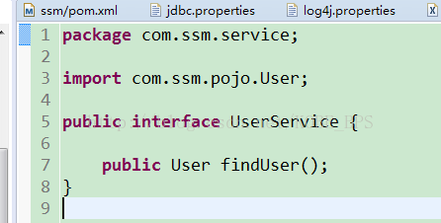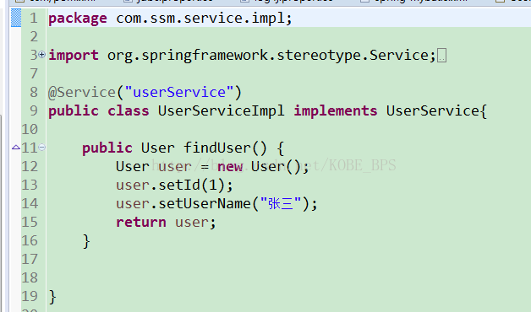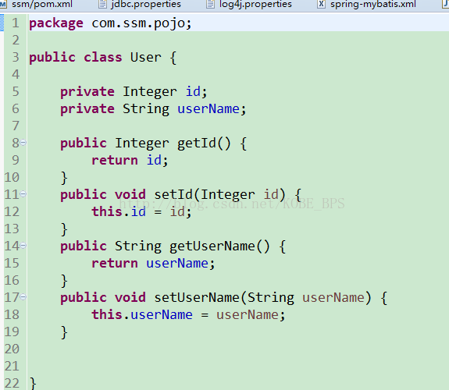
service，seviceImpl，pojo文件都创建好了之后，在这个test目录下面进行一个单元测试类
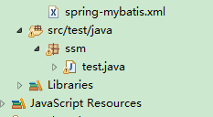

package ssm;

import org.apache.log4j.Logger;

import org.junit.Test;

import org.junit.runner.RunWith;

import org.springframework.beans.factory.annotation.Autowired;

import org.springframework.test.context.ContextConfiguration;

import org.springframework.test.context.junit4.SpringJUnit4ClassRunner;

import com.alibaba.fastjson.JSON;

import com.ssm.pojo.User;

import com.ssm.service.UserService;

@RunWith(SpringJUnit4ClassRunner.class)

@ContextConfiguration(locations = {"classpath:spring-mybatis.xml"})

public class test {

private final static Logger LOGGER = Logger.getLogger(test.class);

@Autowired

private UserService userService;

@Test

public void testOne(){

User user = userService.findUser();

System.out.println(JSON.toJSONString(user));

}

}

然后点击单元测试运行得出以下结果说明成功：
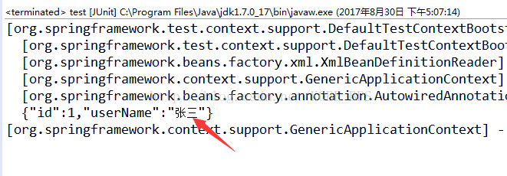

接着，配置spring-mvc.xml和web.xml
spring-mvc.xml配置为：

<?xml version="1.0" encoding="UTF-8"?>

<beans xmlns="http://www.springframework.org/schema/beans"

xmlns:xsi="http://www.w3.org/2001/XMLSchema-instance" xmlns:p="http://www.springframework.org/schema/p"

xmlns:context="http://www.springframework.org/schema/context"

xmlns:mvc="http://www.springframework.org/schema/mvc"

xsi:schemaLocation="http://www.springframework.org/schema/beans

http://www.springframework.org/schema/beans/spring-beans-3.1.xsd

http://www.springframework.org/schema/context

http://www.springframework.org/schema/context/spring-context-3.1.xsd

http://www.springframework.org/schema/mvc

http://www.springframework.org/schema/mvc/spring-mvc-4.0.xsd">

<!-- 自动扫描该包，使SpringMVC认为包下用了@controller注解的类是控制器 -->

<context:component-scan base-package="com.ssm.controller" />

<!--避免IE执行AJAX时，返回JSON出现下载文件 -->

<bean id="mappingJacksonHttpMessageConverter"

class="org.springframework.http.converter.json.MappingJackson2HttpMessageConverter">

<property name="supportedMediaTypes">

<list>

<value>text/html;charset=UTF-8</value>

</list>

</property>

</bean>

<!-- 启动SpringMVC的注解功能，完成请求和注解POJO的映射 -->

<bean

class="org.springframework.web.servlet.mvc.annotation.AnnotationMethodHandlerAdapter">

<property name="messageConverters">

<list>

<ref bean="mappingJacksonHttpMessageConverter" /> <!-- JSON转换器 -->

</list>

</property>

</bean>

<!-- 定义跳转的文件的前后缀 ，视图模式配置 -->

<bean

class="org.springframework.web.servlet.view.InternalResourceViewResolver">

<!-- 这里的配置我的理解是自动给后面action的方法return的字符串加上前缀和后缀，变成一个 可用的url地址 -->

<property name="prefix" value="/WEB-INF/jsp/" />

<property name="suffix" value=".jsp" />

</bean>

<!-- 配置文件上传，如果没有使用文件上传可以不用配置，当然如果不配，那么配置文件中也不必引入上传组件包 -->

<bean id="multipartResolver"

class="org.springframework.web.multipart.commons.CommonsMultipartResolver">

<!-- 默认编码 -->

<property name="defaultEncoding" value="utf-8" />

<!-- 文件大小最大值 -->

<property name="maxUploadSize" value="10485760000" />

<!-- 内存中的最大值 -->

<property name="maxInMemorySize" value="40960" />

</bean>

</beans>

web.xml配置如下：

<?xml version="1.0" encoding="UTF-8"?>

<web-app xmlns:xsi="http://www.w3.org/2001/XMLSchema-instance"

xmlns="http://java.sun.com/xml/ns/javaee"

xsi:schemaLocation="http://java.sun.com/xml/ns/javaee http://java.sun.com/xml/ns/javaee/web-app_3_0.xsd"

version="3.0">

<display-name>Archetype Created Web Application</display-name>

<!-- Spring和mybatis的配置文件 -->

<context-param>

<param-name>contextConfigLocation</param-name>

<param-value>classpath:spring-mybatis.xml</param-value>

</context-param>

<!-- 编码过滤器 -->

<filter>

<filter-name>encodingFilter</filter-name>

<filter-class>org.springframework.web.filter.CharacterEncodingFilter</filter-class>

<async-supported>true</async-supported>

<init-param>

<param-name>encoding</param-name>

<param-value>UTF-8</param-value>

</init-param>

</filter>

<filter-mapping>

<filter-name>encodingFilter</filter-name>

<url-pattern>/*</url-pattern>

</filter-mapping>

<!-- Spring监听器 -->

<listener>

<listener-class>org.springframework.web.context.ContextLoaderListener</listener-class>

</listener>

<!-- 防止Spring内存溢出监听器 -->

<listener>

<listener-class>org.springframework.web.util.IntrospectorCleanupListener</listener-class>

</listener>

<!-- Spring MVC servlet -->

<servlet>

<servlet-name>SpringMVC</servlet-name>

<servlet-class>org.springframework.web.servlet.DispatcherServlet</servlet-class>

<init-param>

<param-name>contextConfigLocation</param-name>

<param-value>classpath:spring-mvc.xml</param-value>

</init-param>

<load-on-startup>1</load-on-startup>

<async-supported>true</async-supported>

</servlet>

<servlet-mapping>

<servlet-name>SpringMVC</servlet-name>

<!-- 此处可以可以配置成*.do，对应开发者自身的习惯 -->

<url-pattern>/</url-pattern>

</servlet-mapping>

<welcome-file-list>

<welcome-file>/index.jsp</welcome-file>

</welcome-file-list>

</web-app>

现在就是在WEB-INF下面新建jsp文件夹，里面新建showUser.jsp,并且内容写上如图：
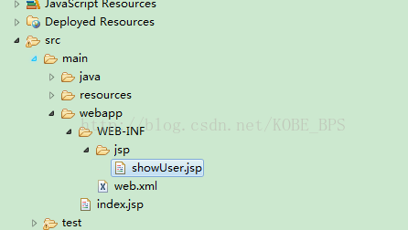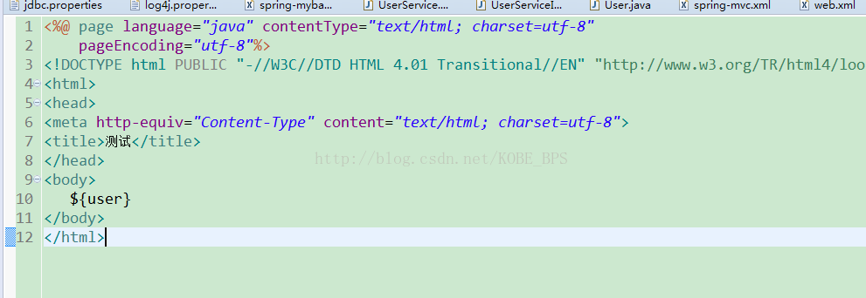
在index.jsp中内容写上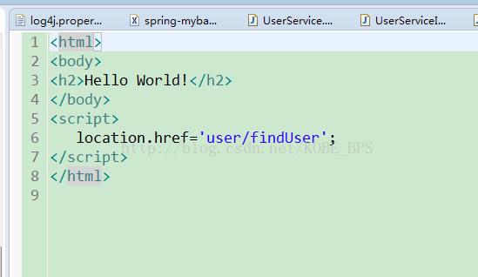
最后在controller目录中新建UserController.java，内容写上：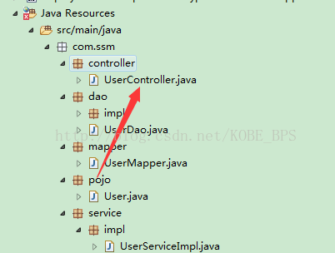

package com.ssm.controller;

import javax.servlet.http.HttpServletRequest;

import javax.servlet.http.HttpServletResponse;

import org.apache.log4j.Logger;

import org.springframework.beans.factory.annotation.Autowired;

import org.springframework.stereotype.Controller;

import org.springframework.web.bind.annotation.RequestMapping;

import org.springframework.web.servlet.ModelAndView;

import com.ssm.pojo.User;

import com.ssm.service.UserService;

/**

* User控制层

* @author BPS

* @time 2017年8月30日下午4:08:53

*

*/

@Controller

@RequestMapping("/user")

public class UserController {

private final static Logger LOGGER = Logger.getLogger(UserController.class);

@Autowired

private UserService userService;

/**

* 查找user

* @param response

* @param request

* @return

*/

@RequestMapping("/findUser")

public ModelAndView findUser(HttpServletResponse response,HttpServletRequest request){

LOGGER.info("进入查找User方法");

ModelAndView mv = new ModelAndView("showUser");

User user = userService.findUser();

mv.addObject("user", user);

return mv;

}

}

最后将项目用tomcat启动运行，在浏览器上输入localhost:8080/ssm 得出结果如下：
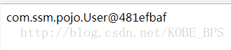
说明你的一个简单的SSM框架项目整合就圆满收工了。可以在此基础上添加新的功能哦！有什么缺陷各位请指出！
源码下载链接：http://download.csdn.net/download/kobe_bps/9957441
码云下载链接：http://git.oschina.net/xff520/SSM

