**Github Repo:** [**https://github.com/zk23aax/Applied-Data-Science-1_Assignment-1-Visualisation-20-**](https://github.com/zk23aax/Applied-Data-Science-1_Assignment-1-Visualisation-20-)

1. **Visualization using the lineplot**

A line plot serves as an ideal choice when the objective is to analyze trends over time, particularly regarding house prices concerning new constructions and renovations. This type of data visualization suits time series analysis and presents the changing price trends over time. It helps in understanding how house prices are affected by the year of construction and renovations. The line plot conveys these temporal patterns and is an insightful choice for interpreting the dataset.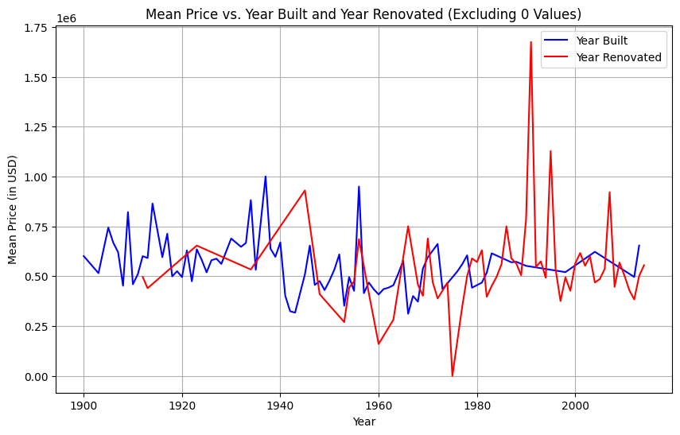

1. **Visualizing with Scatter Plot: Significant Features vs. Price**

The choice of a scatter plot is apt when dealing with house price data that exhibits a wide range, potentially including outliers such as high-end properties or mansions. In such cases, using a scatter plot allows for the visualization of individual data points, helping to identify patterns and potential outliers. It serves to reveal the distribution and relationships between significant features and house prices. This choice is pragmatic as it effectively deals with overplotting issues often encountered when prices vary considerably.

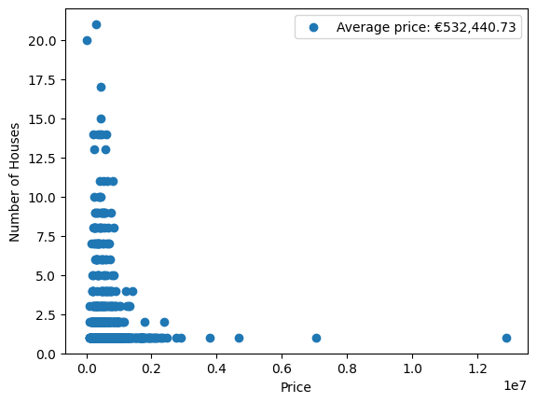

1. **Visualizing Data Distribution with Pie Charts**

The selected visualization type, which in this case is a pie chart, aligns with the specific data distribution being depicted. The choice reflects a logical decision to use a format that best conveys the intended insights from the dataset. This thoughtful selection contributes to the effectiveness of the visualizations, enhancing the audience's understanding of the data's composition and patterns.

