Task 2

1. Analyze the structure of the **/etc/passwd** and **/etc/group** file, what fields are present in it, what users exist on the system? Specify several pseudo-users, how to define them?

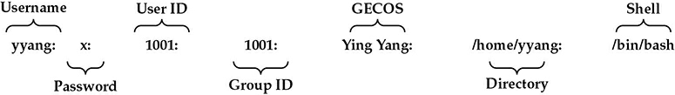

Password is encrypted.

UID ==0 – usually for user “root”. UID == 65534 in Ubuntu is user “nobody”.

GID – is main group ID, User can belong to other groups

GESOC – info about user

Directory – home dir

Shell – which shell which will be started first. All variants are in /etc/shells

1. What are the uid ranges? What is UID? How to define it?

UID 0 (zero) is reserved for the root.

UIDs 1–99 are reserved for other predefined accounts.

UID 100–999 are reserved by system for administrative and system accounts/groups.

UID 1000–10000 are occupied by applications account.

UID 10000+ are used for user accounts.

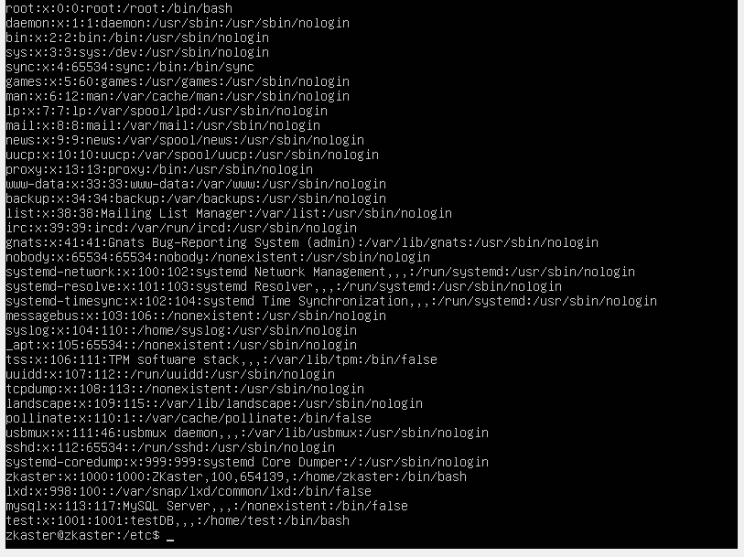

1. What is GID? How to define it?

Groups in Linux are defined by GIDs (group IDs).

GID 0 (zero) is reserved for the root group.

GID 1–99 are reserved for the system and application use.

GID 100+ allocated for the user’s group.

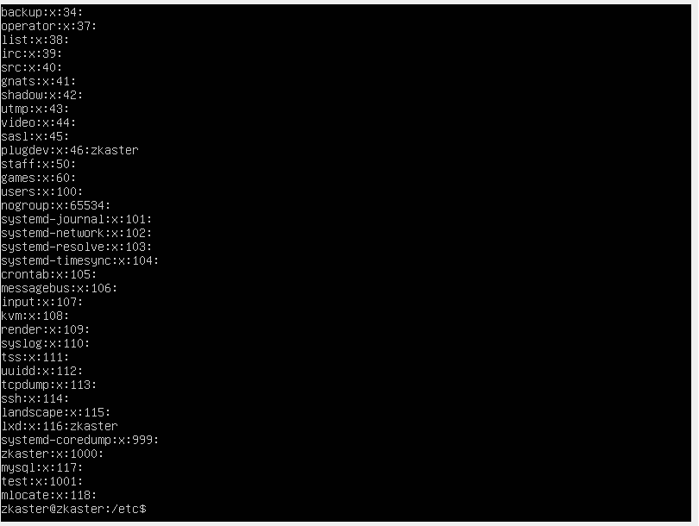

1. How to determine belonging of user to the specific group?

* We can see this info in the file etc/passwd
* All groups we can get with command “**groups** <username>”
* All groups we can get with command “**id** <username>”

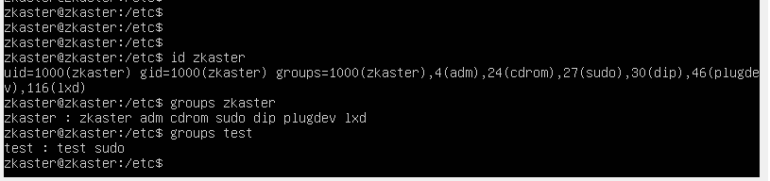

1. What are the commands for adding a user to the system? What are the basic parameters required to create a user?

**useradd** <name>



1. How do I change the name (account name) of an existing user?

**usermod**



1. What is skell_dir? What is its structure?

Directory /etc/skel/ (skel is derived from the “skeleton”) is used to initiate home directory when a user is first created. A sample layout of “skeleton” user files is as shown below:



In directory /etc/defualt/useradd file defined the skel directory. We can change the default location /etc/skel to any other location.

1. How to remove a user from the system (including his mailbox)?

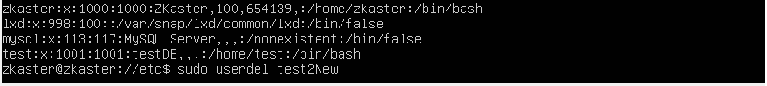

1. What commands and keys should be used to lock and unlock a user account?

>>#1<<

Run the passwd command with the -l switch, to lock the given user account.

**# passwd -l test**

Run the passwd command with the -u switch to unlock the given user account.

**# passwd -u test**

>>#2<<

Another command to lock user

**# usermod --lock daygeek**

or

**# usermod -L daygeek**

To unlock

**# usermod --unlock daygeek**

or

**# usermod -U daygeek**

>>#3<<

User can be disabled by changing the shell to /dev/null as shown below.

**# usermod -s /dev/null daygeek**  or **# usermod -s /bin/false daygeek**

It can be reversed by changing the shell back to the default shell of the user.

**# usermod -s /bin/bash daygeek**

>>#4<<

Set the expiration date to ‘0’ to lock user account with change command as shown below.

**# chage -E0 daygeek**

To reverse this change, run the following command.

**# chage -E -1 daygeek**

1. How to remove a user's password and provide him with a password-free login for subsequent password change?

To delete password can be done with command. **# passwd --delete username** OR **# passwd -d username**

Best way to force user change password: **# passwd --expire username**

Also can be used command **# chage -d 0 username**

1. Display the extended format of information about the directory, tell about the information columns displayed on the terminal.

The **-l** option signifies the long list format. This shows a lot more information presented to the user than the standard command. **-h** – the file size is displayed in a human-readable format.

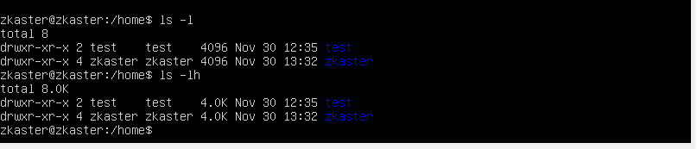

1. What access rights exist and for whom (i. e., describe the main roles)?

Briefly describe the acronym for access rights.

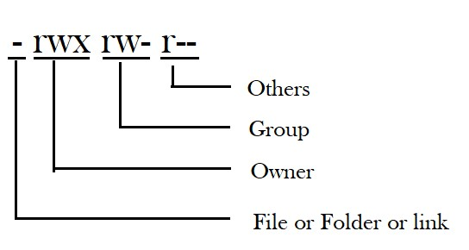

1. What is the sequence of defining the relationship between the file and the user?

Read-Wrire-Change

1. What commands are used to change the owner of a file (directory), as well as the mode of access to the file? Give examples, demonstrate on the terminal.

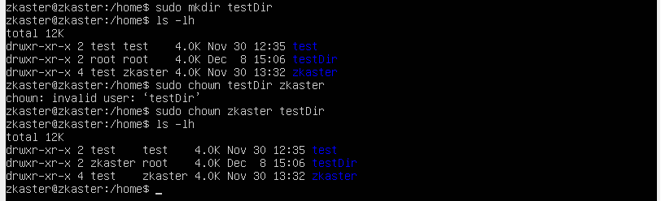

1. What is an example of octal representation of access rights? Describe the umask command.



1. Give definitions of sticky bits and mechanism of identifier substitution. Give an example of files and directories with these attributes.

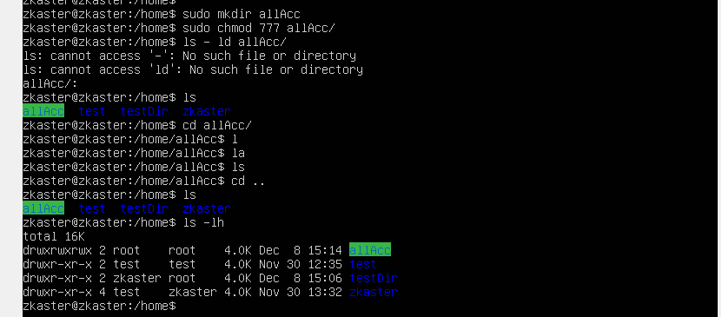

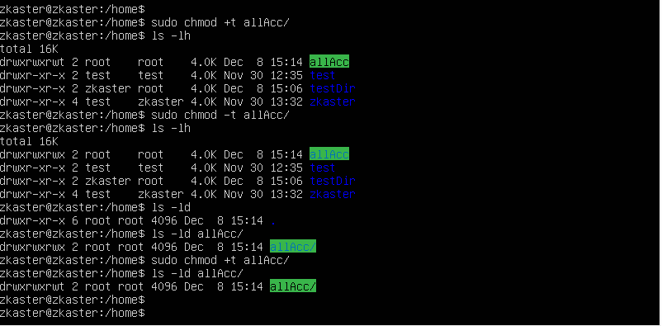

1. What file attributes should be present in the command script?

