To set IP address for enp0s8 (VM1) and enp0s3 (VM2) we use netplan

>>sudo nano /etc/netplan/00-installer-config.yaml

>>netplan try

VM1:

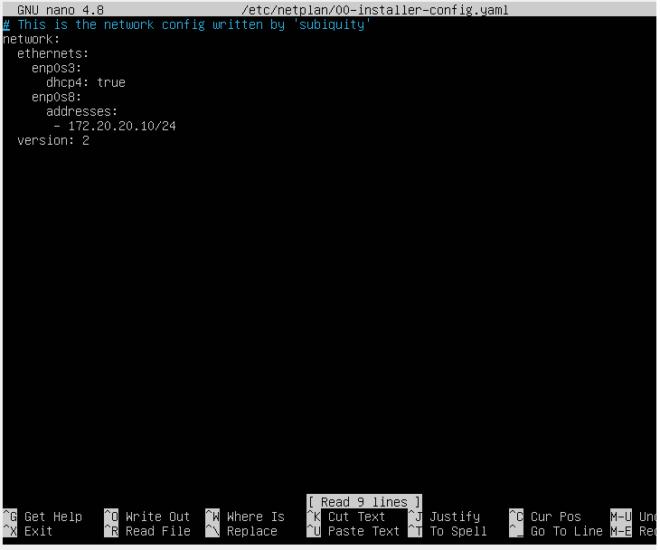

VM2:

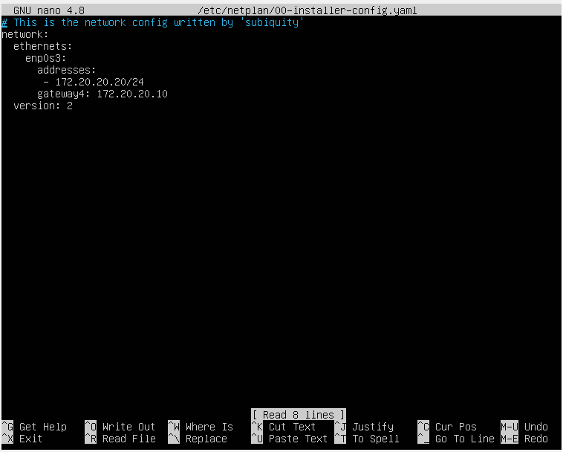

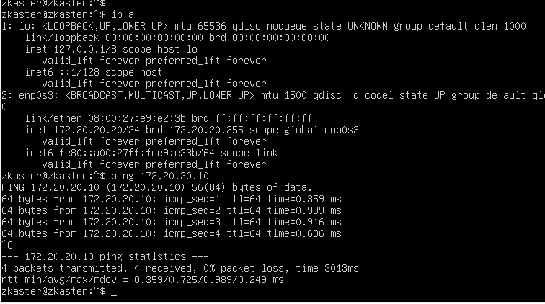

sudo nano /proc/sys/net/ipv4/ip_forward записать 1

sysctl -w net.ipv4.ip_forward=1

//if iptables is present

sudo iptables -t nat -A POSTROUTING -o enp0s3 -j MASQUERADE

There is no route to HOST (192.168.88.254).

The route to Internet works

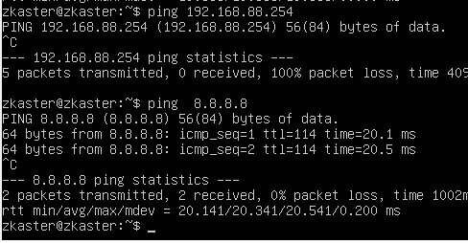

8.8.8.8 – public Google DNS

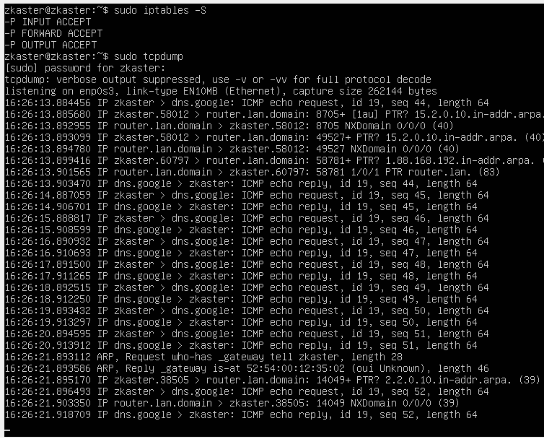

Epam.com

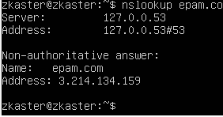

Default route for HOST is 192.168.88.1

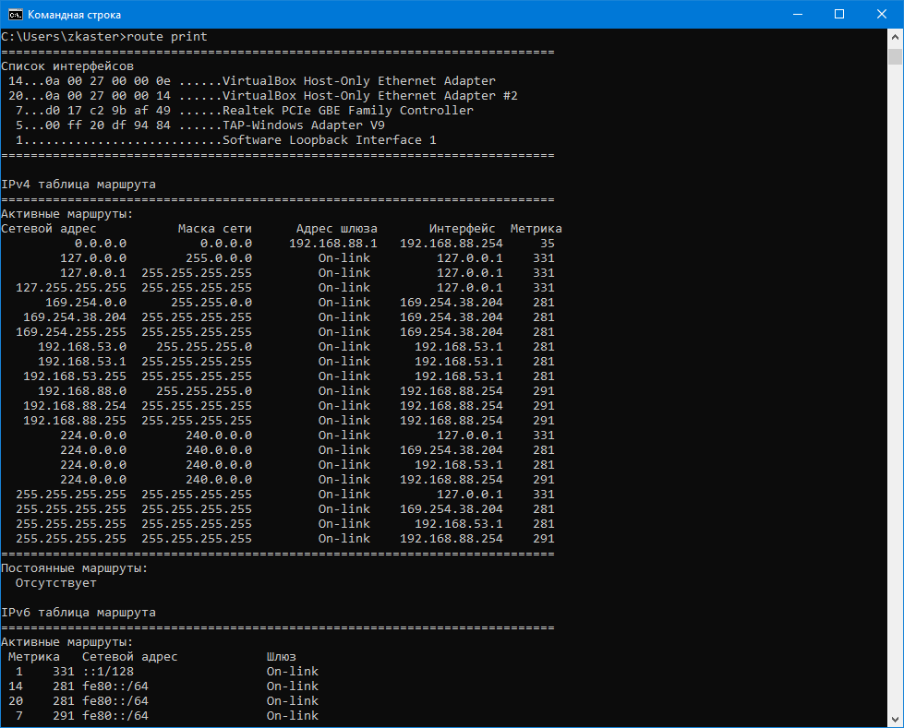

Traceroute to google.com

