1. Use already created internal-network for three VMs (VM1-VM3).

>>done

1. VM1 has NAT and internal, VM2, VM3 – internal only interfaces.

>>done

1. Install and configure DHCP server on VM1. (3 ways: using VBoxManage, DNSMASQ and ISC-DHSPSERVER). You should use at least 2 of them.

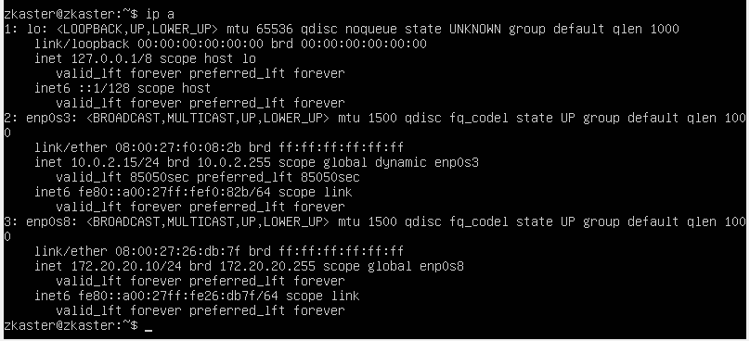

>>sudo apt install isc-dhcp-server

//check install

>>dpkg -s isc-dhcp-server

>> nano /etc/default/isc-dhcp-server

// set INTERFACESv4=”enp0s8”

//make backup

sudo mv /etc/dhcp/dhcpd.conf /etc/dhcp/dhcpd.conf.backup

>>sudo nano /etc/dhcp/dhcpd.conf

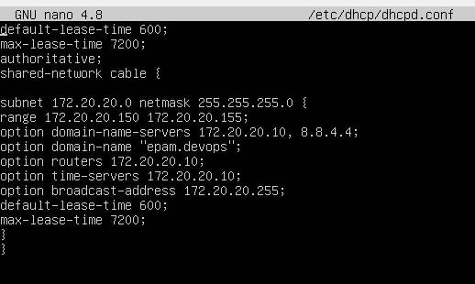

//start dhcpd

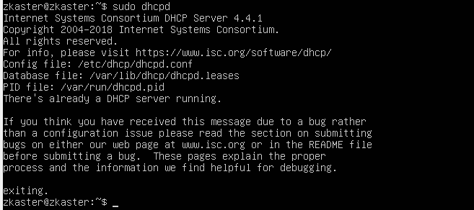

1. Check VM2 and VM3 for obtaining network addresses from DHCP server.

>>sudo nano /etc/netplan/00-installer-config.yaml

>>sudo netplan try

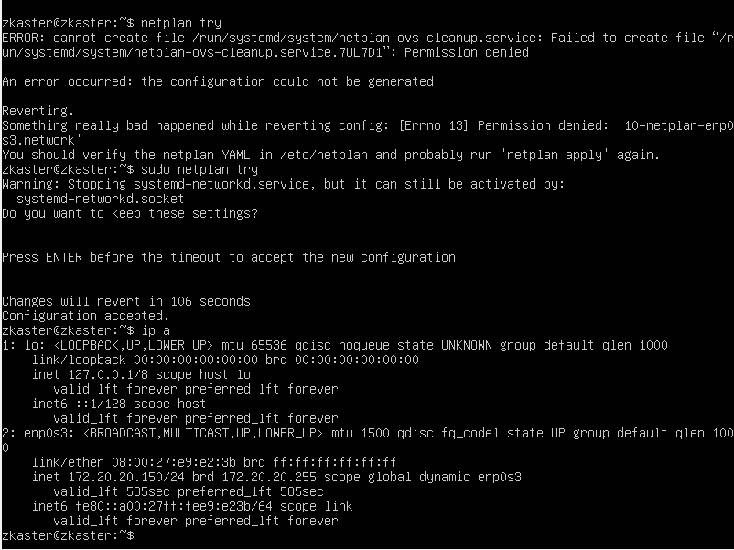

1. Using existed network for three VMs (from p.1) install and configure DNS server on VM1. (You can use DNSMASQ, BIND9 or something else).
2. Check VM2 and VM3 for gaining access to DNS server (naming services).

>> sudo systemctl disable systemd-resolved

>> sudo systemctl stop systemd-resolved

>> sudo apt install dnsmaq

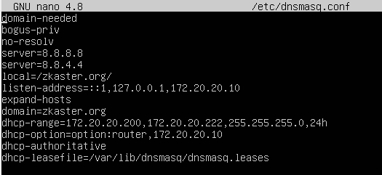

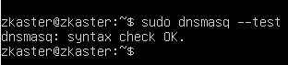

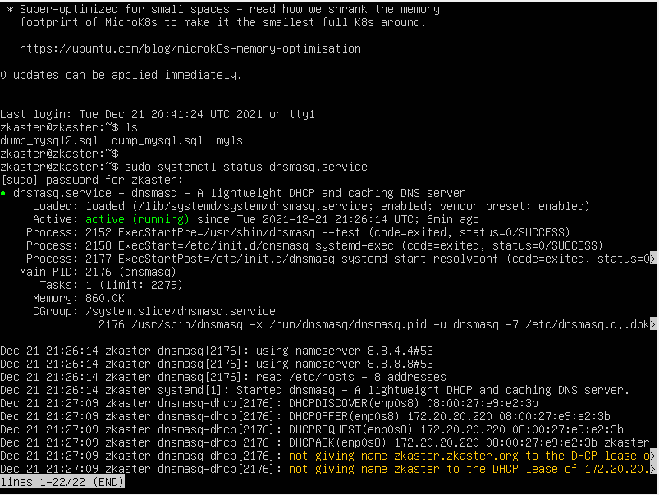

Check DHCP on VM2

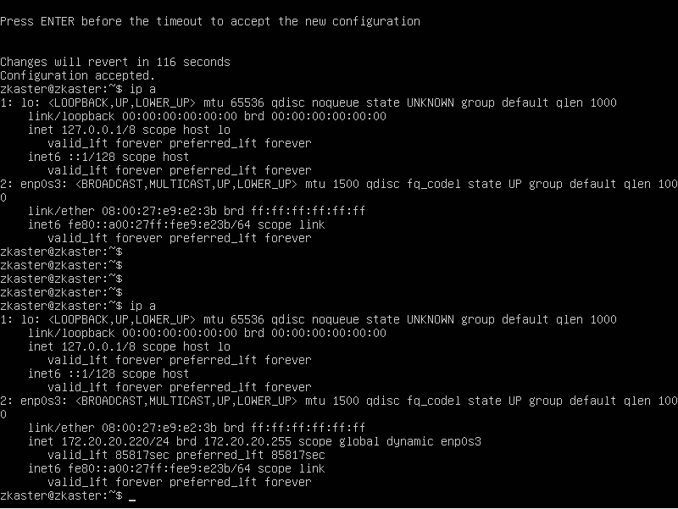

Check DNS on VM2

