|  |  |  |  |
| --- | --- | --- | --- |
|  | 2/2/2013 |  | |
|  | |  | |
| Managing People & Performance – Assignment 1  *Henley MBA, HB49 – MPP1 Assignment* | | | |
|  |  | |  |
|  |  | | Zsolt Kázsi |

Managing People & Performance – Assignment 1

Henley MBA, HB49 – MPP1 Assignment

Contents

Introduction 2

1. Section 1 – Identification 2

Bombardier Transportation and my organisation in Switzerland 2

Collapse, recovery – current organisation 3

Organisational Challenges in Light of Employee Survey 5

Strengths 6

Risks and Improvement Areas 6

Three-dimensional people strategy 6

2. Section 2 – Recommendations and Plan 7

Improving Horizontal Alignment 7

Work-Based Development 9

Other Recommendations 9

3. Section 3 - Benefits expected, measurements (30%) 10

Achieving high engagement through the psychological contract 10

Increasing enablement levels of employees 11

Measurements 11

Section 4 – Reflective Statement (10%) 12

References 13

# Introduction

When I joined my current place of work, it was a new experience for me: joining a project driven organisation requires a major change of mind-set, focus and priorities than my previous experience in other businesses.

On the following pages I will attempt to present the human resources system at my current place of work, attempting to present the local organisation, while focusing on and searching answers for managing workload in such an environment.

# Section 1 – Identification

The company I work for is Bombardier Transportation in Zurich, Switzerland. Bombardier is the world’s only manufacturer of both planes and trains. In this section I will present the company, based on the corporate website, and my division, as well as my organisation. The company’s global headquarters are located in Montréal, Canada, and its stock is traded on the Toronto Stock Exchange. In the fiscal year ended December 31, 2011, it posted revenues of $18.3 billion USD. (Bombardier, 2013)

The company is a sum of two business units (each consisting of several divisions), making it a global leader in transportation: Bombardier Aerospace designs, manufactures and supports innovative aviation products for the business, commercial, specialized and amphibious aircraft markets. The business unit I work for is Bombardier Transportation

## Bombardier Transportation and my organisation in Switzerland

The company has 62 production and engineering sites in 25 countries and more than 40 service centres at customer premises across the world, making it without doubt one of the global leaders in the rail industry. Bombardier Transportation’s headquarters are located in Berlin Germany, and has five divisions, with following areas of activity:

* Mainline and Metros: automated people movers, monorails, light rail vehicles, advanced rapid transit, metros, commuter/regional trains, intercity/high-speed trains and locomotives
* Locomotives and Equipment: complete product portfolio for applications ranging from trolley buses to freight locomotives, including propulsion equipment and bogies
* Services: fleet maintenance, operations and maintenance (O&M), vehicle refurbishment and modernization, and material management
* Transportation systems: customized “design-build-operate-maintain” transportation system solutions
* Rail control solutions: advanced signalling solutions for mass transit and mainline systems

Switzerland plays an important role in the organisation: all in all, Bombardier Switzerland employs about 900 people on four locations, two of which are relatively small production facilities (in Villeneuve and Oberwil), as well as the global headquarters for Locomotives and Propulsion & Controls divisions (in Zurich), and a major development office for bogies (in Winterthur). (Bombardier, 2012)

I work for the Services division: this part of the firm has over 60 employees in Switzerland, most of them located in Zurich, with a number of manufacturing colleagues in Oberwil, and 3 engineers based in Villeneuve.

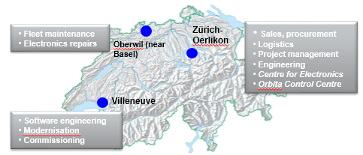

The company in general is a technology driven company, and Switzerland in particular is focused on engineering power. Nothing proves this more than the portion of engineers: our engineering department has about 20 people (one third of the local divisional team), and many persons in other departments (such as project management, sales, business development) have an engineering background.

On the other hand, in the Services division the traditional commercial activities also have a high role: in the so called Materials & Solutions department about 15 persons are dealing with buying and selling. Since most of my time has been spent with this organisation during my time with Bombardier, I will focus on them in the following, even though most recently I moved organisationally to the Centre for Electronics (due to my current divisional role and in order to further strengthen this relatively new department).

## Collapse, recovery – current organisation

When I joined Bombardier, in May 2009, the company was going through a rough patch: in a highly result oriented company Switzerland saw a serious drop of annual business volumes: mainly due to losing significant business on external markets (primarily in India), order intake numbers in 2009 dropped to about one third of those in the years before, as recently as 2008.

Even though it was not planned so (and I was not aware of the difficulties before), I came on board as Supplier Account Manager for Switzerland, being part of the local Procurement department. This team consisted at that time of 6 people: 3 long-time buyers, taking care of the operational activities, a department manager (also freshly appointed), an apprentice, and myself (taking care of bid & project procurement activities, as well as supplier management). Besides procurement there were also the commercial teams, responsible for back-office order handling both for spares, as well as for component repair & overhaul (CRO).

Because of the weakening results there were serious changes required, which resulted in overhauling the organisation profoundly. One of the most significant changes in our department was merging the commercial departments (M&S and CRO) with procurement, under one manager, though keeping a team structure. This has resulted in a more streamlined organisation, where the Parts and CRO teams are now responsible for the whole transactional cycle (including operational procurement).

Another change, very obvious on the surface, is the change in average age. When I joined, in each department several colleagues over 50 years of age have worked, and average age must have been at least 10-15 years older. For example, in procurement the 2 of the long-time buyers have started their retirement, and the 3rd colleague changed to a different role (closer to his home).

The table below shows the current distribution of the teams in the departmen, and highlights the number of young ones.

|  |  |  |  |  |  |
| --- | --- | --- | --- | --- | --- |
| **Materials & Solutions Organisation** | | | | | |
| **Team** | **Number of employees** | **Team Lead** | **Activity** | **Below Age 28** | **Apprentices (< 18)** |
| Procurement & Technical Clearance | 4 | 1 | bid & project procurement, technical clarifications | 2 | 1 |
| Customer Centre | 2 | (shared) | back-office: coordination of customer contact, reporting | 2 | 1 |
| Parts | 4 | 1 | parts order handling, full scope ("buying and selling") | 3 | 1 |
| CRO | 1 | (shared) | repair order handling, full scope + complex overhaul projects | 0 | 2 |

It is worth noting, that the Swiss education and labour system places high value on apprenticeships, the two-year vocational training for young ones below age 18. (Kammermann M., 2011) Most of the colleagues below 28 are actually closer to 20 than to 28, and they were previous apprentices with the company. We are also supported currently by 5 apprentices (younger than 18 years of age).

All these changes have resulted in a more streamlined and more cost effective organisation. Also, the in 2012 the order intake number was within a range of 10% compared to the high values back in 2008. Last year the small Swiss organisation delivered excellent business results both on EBIT and on free cash flow (ranked globally 5 and 4, respectively).

Of course, business realities keep changing, and the local senior management team is focusing on maintaining competitiveness and the good results for the coming years. In addition, the market has changed in the railway business: whereas much of the business had been “low-hanging fruit”, such as ad-hoc sales in the past, the focus on innovation and value added activities is increasing – however, this shall be discussed maybe in another assignment.

## Organisational Challenges in Light of Employee Survey

In October 2012 a global survey was administered to all internal employees in Bombardier. In light of the fact that we are dealing with a young organisation, it will be useful to use the results of the survey to identify development and improvement needs, to stabilise the team and help them grow.

The survey was managed by an independent external provider: Hay Group. The results were evaluated in detail, compared on overall company, divisional and country levels. As a follow-up, the results were then shared with managers broken down to the departmental level, in order to encourage development of detail discussions. During the discourse I present the results for the Switzerland M&S organisation, not going into detail on the overall Swiss results.

There were 16 persons invited to participate and 11 of these have filled in the questionnaire (consisting of 65 questions), which corresponds to a 69% participation rate. See below the dimension summary, indicating the scores by the various main categories.

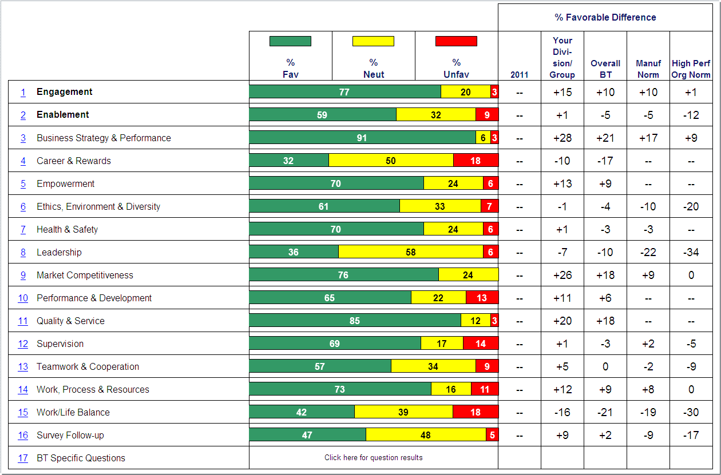

As demonstrated by the above table, in addition to comparisons within the company, the results were also measured against the “Manufacturing Norm” and to the “High Performing Organisations Norm”.

Manufacturing norm: Difference from companies around the world in the Manufacturing industry who have surveyed with the same question(s) within the previous five years

High Performing Organisations Norm: Difference from organizations with outstanding financial performance in their industry, who have surveyed with the same question(s) within the previous five years

Let’ go into the details, and investigate some areas of risk and in need of improvement.

### Strengths

There are a number of impressively strong areas, and going into more details on the questions, the answers show high engagement on behalf of the participants.

### Risks and Improvement Areas

Let’s move on now to the areas which can be considered as weaknesses, or risks.

Again, looking at the summary, it’s possible to select the few critical areas. In this case I will focus on “Career & Rewards”, on “Leadership” and finally on “Work/Life Balance”.

1. Careers and Rewards: for this sub-category the average is 32% favourable responses. We can see huge uncertainty in the answers given to the question “I have good idea of the possible career opportunities available to me”, with 9% positive, and 80% neutral (mostly displaying uncertainty). In comparison, this is 40% lower than Bombardier overall, and a shocking 54% lower compared to the High Performance norm. Other worrying answers are the ones for “Promotions and transfers are made fairly” with only 27% positive and 55% neutral answers, as well as to the question if the respondent is ‘Paid fairly for the work he does’, with 36% positive and the same amount of neutral answers. While the last answer could be explained by the fact that many of the respondents are young and thus on the lower end of the payment scale, this category clearly is an area in need of improvement.
2. Leadership: while we can see indications that the employees have high level of confidence and trust in their immediate supervisors, based on this category there are serious issues with communication. To the question “How would you rate Bombardier Transportation on being open and honest in communication to employees?”, only 9% answered favourably and 73% were undecided (neutral) – again, more than 50% lower than the High Performance norm. Also, when asked about “How you would rate the overall trust and confidence you have in Bombardier Transportation’s leadership team?”, only 36% answered favourably, the rest being neutral.
3. Work/Life Balance: this was the third worst category, with 42% positive answers, which is 30% below the High Performance norm. On the 2 questions whether the company and the direct supervisor supports and enables them to balance work and life responsibilities, in both cases only 36% answered favourably, and 27% negatively (the rest being neutral).

A common theme along these risk areas was the fact that many of the respondents were uncertain: this was most obvious in case of the question related to career opportunities (80% “neutral”), but similarly high on the topic of leadership communication (over 70%).

## Three-dimensional people strategy

This kind of scenario calls to mind one of two scenarios from the three-dimensional people strategy by Gratton & Truss. (Gratton, 2003)

In the Mere Rhetoric scenario business case of BT Payphones, “people were more confused than motivated”. Even though there was strong linkage both vertically (with business goals) and horizontally (on the level of individual HR policy areas), the “sheer number and complexity of initiatives and policies had overwhelmed line managers”. Based on the results of the employee survey, it appears that employees are indeed confused and uncertain, as far as careers and leadership communication is concerned.

And yet, I believe another scenario is applicable also: this would be the Strategy Driven scenario. The reason why I believe this is true should become apparent by looking into the positive results of the employee survey.

The strongest area overall is “Business Strategy & Performance”, as well as “Quality & Service”. Looking into the individual questions, this is supported further. Examples:

* “I have a good understanding of Bombardier Transportation’s business priorities” was answered favourably by 91%, a score 35% higher than Bombardier Services division overall
* High personal involvement is shown by 91% answering positively on “I understand how my team contributes to Bombardier Transportation’s performance”
* On the question “I feel proud of the products we produce” the answer was 100% positive (+13% higher in comparison to all of Bombardier)

After these examples, it’s not surprising that 81% answered favourably on the statement “I believe Bombardier Transportation has an outstanding future”. These answers support the conclusion that there exists a strong link to business strategy, and this link is also being put into action.

Also, coming back to the model, the business case refers to HP’s UK operations, where the company had a low-key HR department. This is strikingly familiar to me, since the Services division in Switzerland is currently supported by an HR business partner based in France, who is (for obvious reasons) not constantly present in the company, thus not very well-known by the people and not well-connected with them. The model explains that in the Strategy Driven scenario “the enactment of the business goals is primarily a line management responsibility”, and because of this “the subtleties of reinforcing HR practices are lost through weak horizontal alignment”.

Once again it becomes evident that the world is not black and white: our department is somewhere between the “Mere Rhetoric” and “Strategy Driven” scenarios, yet closer to being “Strategy Driven”.

In the following section I will attempt to make recommendations to improve on these areas.

# Section 2 – Recommendations and Plan

Let’s first see what recommendations can the department fares when investigated in the framework of the ‘Three-dimensional people strategy’, and how these findings can be used to . In the second half I will attempt to investigate what kind of psychological contract exists in this organisation.

## Improving Horizontal Alignment

Following up on the discussion earlier based on the three-dimensional strategy, it can be stated that the missing dimension is the horizontal one: according to the article, “the aim here is the achievement of a coherent and consistent approach to managing people that permeates the entire activities of the HR function and other organizational functional areas”.

Achieving this goal would enable us to move closer to the ultimate scenario, which is being “Strategy & Process Driven”. Again, the business case provides good reasons why it might be desirable for us to strive for. Earlier I mentioned the trend within the industry to be moving toward innovative and higher value add activities.

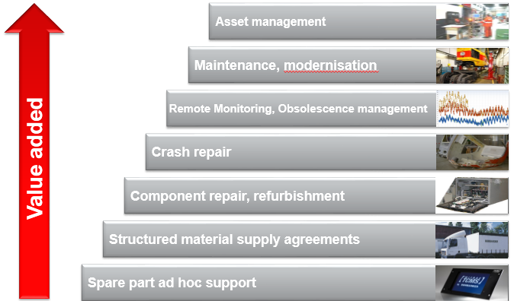

The business example for this scenario is Kraft Foods, which appears to have been in similar situation, as we are currently: the company experienced changed economic conditions, increased competition in their core brands, due to which developments their business strategy changed to one of growth through innovation.

The authors also make some practical suggestions for improving along each of the 3 axes. In the following I highlight a few of these suggestions for achieving stronger horizontal alignment and for increasing effectiveness in taking action:

* **Get the Balance Right:** this highlights the need to simplify, while at the same time also enforcing the message. Too many, and conflicting messages can be just as bad as no messages at all.
* **Think Systematically:** in Bombardier as in many multinational companies, there is no shortage of processes. However, it’s a challenge in HR (just like in other areas) to represent and communicate this complexity of the various HR interventions, their potential relationships, and intended and unintended consequences in an understandable system.
* **Keep the Best**: not surprisingly, the authors found that continuity of people and processes is crucial in order to ensure that actions are sustained over time. In Bombardier there have been several changes in the HR function and structure – there is a need for stability.

## Work-Based Development

In addition to attacking the strategic levels, as described above, another model I found applicable for our situation was the use of Work-Based Development Methods according to Woodall and Winstanley (1998), as represented in (McBain, 2010), pp 13-15.

Due to the well-functioning Swiss apprenticeship system, Bombardier is able to build on a supply of committed, enthusiastic young professionals, who already know the company and the organisation. It is only reasonable to build upon this talent pool, especially for entry level positions: as a matter of fact, the challenge is rather to provide sufficient job opportunities to those who finish their apprenticeship.

The methods referred to above provide useful tools to help these colleagues develop, and see what opportunities may be open for them within the company. In the list below I am only highlighting specific examples, most applicable to our situation.

* **Learning from another person:** 
  + Role models: already exists implicitly, former apprentices observing and following patterns of their mentor(s)
  + Coaching: needs to be developed, more formalized feedback and challenge
* **Learning from tasks**
  + Job rotation: rotate people within the larger department (e.g. Procurement to CRO), but also to other functions (e.g. Project Management, Sales), or temporarily to other locations (e.g. Oberwil)
  + Special projects: possible temporary assignments, even to other countries or divisions
  + Acting up / delegation: try people out in higher responsibilities temporarily (e.g. during vacation of supervisor)
* **Learning with others:**
  + Task forces / working parties: (short lived) High Performing Teams to be used more for projects, and encourage employees be part of communities of practice

The benefits expected, as well as some concrete application(s) shall be discussed in the next section.

## Other Recommendations

Finally, I want to discuss shortly a few other recommendations, still applicable to us. There is a need internally to clarify to each and every colleague their own responsibility in managing their career. McBain (2010), pp 7-9 discusses the stakeholders in the HR Development process, based on the work of Walton (1999). The fourth actor in this model (along with senior management, HRD specialists and line managers) is the individual employee. Some inexperienced employees might still pay little attention to their own role, whereas “a recent trend in many companies has been the significant devolvement of responsibility for training and development to both the line manager (often acting as the intermediary between the needs of the individual and the organisation) and individual employee”. This development has to be highlighted again and again in various forms.

One way of executing on this action will be the use of the newly introduced e-HR Portal

In closing, while managers might not realise the desire of employees to move on, this would be a mistake. The very fact that Career and Development appear to be the worst ranked category in the employee survey, show that this is not true: employees, old or young, are content with where they are: they very much have aspirations for a career, wanting to be more. This element of human behaviour is also discussed in the 50 Lessons video with Sir David Bell, entitled “Unlocking Potential”. Managers need this mind-set, and keep an open eye for talent among their “subordinates”, otherwise there is a risk that the organisation is not able to keep its best employees due to lack of opportunity and they will move on to another place, where they see better opportunities.

# Section 3 - Benefits expected, measurements (30%)

In this section I want to follow-up on some of the topics discussed in the previous section, and discuss what is to be expected based on the recommendation, and what measurements could be applied.

An overall outcome or benefit that would be expected from the recommendations above is a better alignment of expectations, both for employees as well as employer, or in other words, an improved psychological contract.

## Achieving high engagement through the psychological contract

One of the most unique concepts for me in this module was discovering the idea of the psychological contract that is established in a work relationship.

Companies have to realize that it is no longer possible “to motivate workers strictly through supervision or monetary incentives.” Instead, both parties have to agree on their respective contribution, thus creating another kind of contract. “Psychological contracts are beliefs, based upon promises expressed or implied, regarding an exchange agreement between an individual and, in organizations, the employing firm and its agents.” (Rousseau, 2004)

As we have seen, career management or awareness of the possible options is an area which is lacking in the company. However, career and talent management is a key area for companies, as explained also in the study material. “Career management is being highlighted as an essential component of psychological contracts and some organisations, have active alumni groups as key elements of their marketing activities.”

Bombardier in general has already been doing much in this area, and is already known in Switzerland as an attractive employer. The company has strong cooperation with educational partners, such as libs (apprenticeship centre), and encourages young engineers by offering internships to students and graduates. (Bombardier, 2012)

These activities have been successful to a large extent, as illustrated by some very positive answers in the employee survey, showing an already high level of employee engagement and trust toward the company. A few examples:

* + 91% answered positively on the question “I feel proud to work for Bombardier Transportation”
  + 82% answered positively on “I believe Bombardier Transportation has an outstanding future”, and similarly on “How would you rate Bombardier Transportation on being innovative in developing new products and technologies”

This shows there is a very good basis on engagement and commitment: however, this is something to nurture and to hold unto. The risks due to uncertainty and not knowing where to progress have been highlighted in section 1, or in other questions like “My job makes good use of my skills and abilities” was only answered positively by 36%.

This duality and possible mental conflict in employees is illustrated very well by the fact that only 45% answered positively when being asked if they would “like to continue working for Bombardier Transportation”, whereas an impressive 91% said, they “would recommend Bombardier as a place of work to family or friends as a place of work”.

Performing the strategic actions to attain higher level of horizontal alignment, that is improving the HR’s process focus and increasing action focus is expected to show these employees that they have opportunities within Bombardier and are counted upon.

The values of such move toward the highest level scenario in the three dimensional strategy is illustrated by Kraft, whose “capacity to create a Strategy and Process Driven people strategy was reflected in extremely high levels of corporate performance in comparison with their peer group of companies in the food sector throughout the period of the study.” (Gratton, 2003)

## Increasing enablement levels of employees

Another critical outcome expected and required from these actions are employees who have a higher sense of enablement and capability. This is important, as enablement, along with engagement, is another critical element to highly effective employees.

Enablement is described (in the survey follow-up) as supportive environment with optimized roles. It exists where work is performed in a structured and process oriented way, where employees feel they have authority and the power to perform.

The situation in this area should be improved primarily by the actions recommended in the Work-Based Development section.

* Expand job responsibilities
* Create high performance teams (short lived, project specific) +> young ones gaining broader viewpoint
* Job rotation… international assignments (1 case.. do more)

## Measurements

Retention rates, employee turnover

Already used:

Control point: next year’s employee survey

Current plan: annual surveys (past: 2-3 years)

How many have moved into different position within the company (country, other div?) – simple

# Section 4 – Reflective Statement (10%)

Going through this module and this assignment has taught me to open my mind, be willing to go

Reflection on High-Performing Team model

Opportunity to talk to HR manager, understand his role vision. Much of what we have studied about is being performed in BT

Been able to think about my psychological contract: relational on my end, something hybrid, maybe transactional on company’s part

# References

Bombardier, 2013. *About Us: Bombardier.* [Online]   
Available at: http://bombardier.com/en/corporate/about-us  
[Accessed January 2013].

Gratton, L. &. T. C., 2003. The three-dimensional people strategy: putting human resource policies into action. *Academy of Management Executive,* 17(3), p. 74–86.

Kammermann M., S. B. H. A., 2011. Two-year apprenticeships – a successful model of training?. *Journal of Vocational Education Training,* pp. 377-396.

McBain, R., 2010. *Human resource development,* s.l.: Henley Business School.

Rousseau, D. M., 2004. *Psychological contracts in the workplace: understanding the ties that motivate,* s.l.: Academy of Management Executive.