|  |  |  |  |
| --- | --- | --- | --- |
|  | 8/10/2012 |  | |
|  | |  | |
| Reflection and Stage 1 Plan  *Henley MBA, HB49 – PD1 Assignment* | | | |
|  |  | |  |
|  |  | | Zsolt Kázsi |

Reflection and Stage 1 Plan

Henley MBA, HB49 – PD1 Assignment

Contents

Introduction 2

1. Self-Awareness Reflection – Who am I 2

Keirsey Temperament Sorter II 2

Learning Styles (LSQ) 3

2. Self-Awareness Reflection – Me and My Organisation 3

Belbin team roles and My Contribution 4

3. Development Plan 4

Henley Star - Proactivity 5

Conclusion 6

# Introduction

Personal Development – this is one of the distinguishing qualities of this MBA programme, and also one of the factors, making me decide to come to Henley. I am aware of the need to improve my skills as a manager, so I was looking forward to this a lot.

On the other hand, this process is also challenging for me: it’s not enough to learn facts, collect and recite knowledge, but I will have to deal with myself. And not only that, I will have to write down what I find, open up to others and share.

# Self-Awareness Reflection – Who am I

Where do I come from, how did I turn into the person I am today? These are some questions I am challenged to ask in the process of self-reflection. I consider myself to be mostly a “self-made man”: Coming from a single-parent family with no earlier history of higher education, I have learned to rely mostly on myself.

One early influencing force was definitely my mother: starting from a losing situation (being put on the street with a young child and no money) she has been able to turn the situation around, build up a flourishing environment around herself, and has successfully taken care of her family. Much later, I have been able to stand up from a slightly similar situation, having rebooted my life after a divorce: that’s when I quit my fairly convenient work in Hungary, moved to Switzerland 4 years ago, at the age of 36: and I believe, I have been able to build a relatively successful life here, at least in the professional sense.

What do various professional evaluations tell about me? Do I recognize myself in these? We have been encouraged to have ourselves evaluated via various methods.

### Keirsey Temperament Sorter II

While I have been previously familiar with the Myers-Briggs personality types (MBTI), I have not known about Keirsey’s method, so this seemed like a good way to get a second opinion.

Based on the evaluation I can be classified in the category of Guardian Protector (ISFJ). Many characteristics fit me: I like to think that I am indeed dependable, helpful and hard-working. I certainly do have respect for authority and believe in following the rules. As a Protector, I do offer a high level of commitment and loyalty, ensuring stability, and always willing to roll up my sleeves to help the team and follow through to completion. (Keirsey, 2012)

On the other hand, there are certain facets of the description that do not seem to fit.

* Protectors dislike procrastination, whereas I tend to perform better under last minute pressure. Nothing demonstrates this better than the fact that I’m writing these lines on the day before submission deadline
* While Guardians (and Protectors) are cautious about change, I find that in many cases I am the person pushing for change, for improving established ways of doing things

It should be noted that I have also done an MBTI evaluation of myself for comparison, and was classified 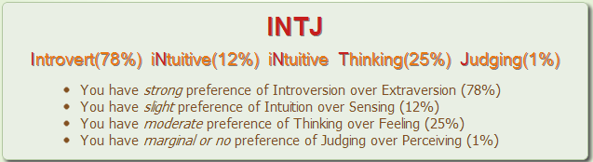as INTJ.

While I don’t think of myself as a Mastermind (Keirsey classification), I believe, I am being constantly formed, and might have been picking up some INTJ traits more recently.

### Learning Styles (LSQ)

Interested to find out more about the best way to learn, I participated in another evaluation, by filling in the Learning Styles Questionnaire. (Honey) 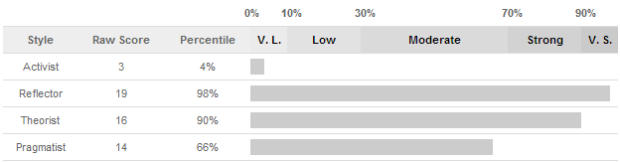

The strongest characteristic as Reflector is fully in line with my self-awareness. I am more of an observer in most activities, taking the back seat, and reaching conclusions by thinking over events. One of the greatest fears is indeed having to talk about something without preparation: I am quite weak at giving “elevator pitches”.

While I am convinced that I can think outside the box if necessary, I do realise the need to strengthen my Activist side. I would need to go more outside of my comfort zone, and take more calculated risks. Suspending judgment and being more ready to rely on intuition sometimes will contribute to being better to produce ideas in brainstorming sessions. Perhaps most difficult for me would be to participate more in conversations, speak my mind more often.

# Self-Awareness Reflection – Me and My Organisation

Reflecting on my personality and learning was interesting, but let’s take the next step: how do I fit into my organisation?

One thing I realized, as regards career: I do not perform well when participating in a traditional interview process. All three of my last successful company changes have involved evaluation in an assessment centre: Go figure!

### Belbin team roles and My Contribution

The Belbin Team Role Report helps to identify preferences. For me, it presents a fairly balanced picture: two preferred roles (as Monitor Evaluator and Teamworker), two fairly highly-ranked manageable roles (Implementer and Specialist), and only one least preferred role (as Resource Investigator). The paragraph, that struck a chord with me most in the narrative, was the following:

“You would do better to become the second fish in a large lake than the big fish in the small pond. You would do well to attach yourself to a powerful and charismatic boss who would welcome trying ideas out on you as a sounding board and seeking your assistance when difficult problems crop up.” (Belbin, 2012)

During my initial interviews with Bombardier, the would-be manager was a calm, polite, typical Swiss person. However things changed, and in the last interview I was confronted with his successor: a hasty, emotional, loud man of Italian origin.

To my surprise we had worked out quite well: the Swiss organisation has been turned around and is now one of the best performing organisations in terms of profitability (despite the size of the market), being ranked consistently in the top 5 globally in the division. I always appreciate when I’m told, how this turn-around couldn’t have been done without my help.

In those years I have been able to apply my past experiences, implement important changes. Also, I have gained valuable experience in project work and managing a team. As a result, I am now in a global strategic sourcing role, as Lead Buyer.

# Development Plan

The new job comes with significantly higher top management exposure than in my earlier strategic role (at IBM). Here I have to work frequently with our VP Procurement, who’s a calm, yet firm and authoritative guy (much the opposite of the initial manager, with whom I have worked well), and whom, as I feel, have yet failed to truly impress.

What can I do to manage this situation and improve my management skills? This last section has helped to put it all together, identify some of the most important qualities for managers, and put together a priority list and an action plan. There are many definitions of management and of a good manager, but I could clearly see the value of the 11 qualities of successful managers, as explained in the textbook. (Pedler, 2007, pp. 21-26)

Based on this, and following the method, I have evaluated my current abilities and priorities:

|  |  |  |
| --- | --- | --- |
| **The 11 Qualities of the  Effective Manager** | **2. TOTAL SCORES Min = 0, Max = 14** | **3. PRIORITY RANKINGS High (3), Medium (2) or Low (1)** |
| A. Command of Basic Facts | 6 | 2 |
| B. Relevant Professional Knowledge | 6 | 2 |
| C. Continuing Sensitivity to Events | 8 | 1 |
| D. Analytical, problem-solving and decision/ judgement-making skill | 5 | 2 |
| E. Social skills and abilities | 6 | 3 |
| F. Emotional resilience | 7 | 1 |
| G. Proactivity - an inclination to respond purposefully to events | 9 | 3 |
| H. Creativity | 7 | 3 |
| I. Mental agility | 4 | 3 |
| J. Balanced learning habits and skills | 5 | 1 |
| K. Self-knowledge | 6 | 2 |

Based on this assessment it was easy to identify the main development areas for an action plan:

* Proactivity
* Creativity
* Social skills

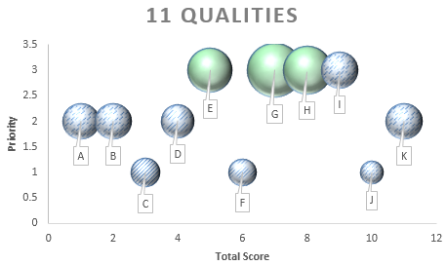As the final step (at least for this assignment), I need to create a specific action for the first critical quality.

### Henley Star - Proactivity

It has become clear in the opening workshop, that the Henley Star is considered an essential tool for personal development at the school:

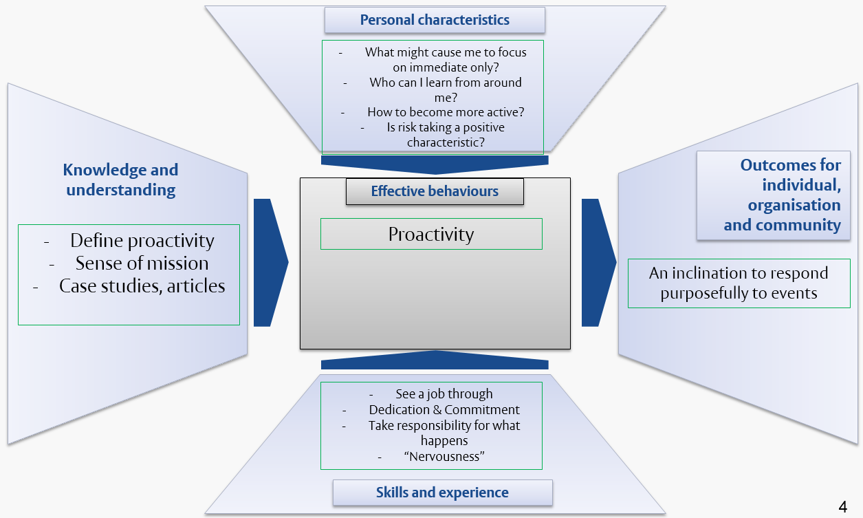For now, my thinking about this method is mostly neutral: let’s give it a try to see where this leads:

This looks like a starting point, and will need to be improved over time. Also, I’ll have to put together something similar for my other two focus characteristics.

# Conclusion

Having to go through this process of reflection, and primarily having to put the results into writing, has not been easy for me: I haven’t been as open to many people, as in this document. However, having gone through the process, this forced reflection has been very helpful.

Now I feel like I have a better overall view of the qualities, expected of managers, have a clearer view of my weaknesses and my strengths, and most importantly, I have a plan (a recipe) to develop my skills in areas of weakness: the programme has already helped me. I can’t wait to see, where the journey will take me next.

# References

Belbin, 2012. *Belbin Team Role Report for Zsolt Kazsi,* s.l.: Belbin Associates.

Honey, P. a. M. A., n.d. *Honey & Mumford Learning Styles Questionnaire (LSQ).* [Online]   
Available at: http://henleybusinessschool.peterhoney.com/module_results.aspx?mid=LS80&rid=48509  
[Accessed 6 October 2012].

Keirsey, D., 2012. *Keirsey Temperament Website - Portrait of the Guardian&reg; Protector (ISFJ).* [Online]   
Available at: http://www.keirsey.com/4temps/protector.asp  
[Accessed 7 October 2012].

Keirsey, D., 2012. *Personality Test - Keirsey Temperament Website.* [Online]   
Available at: http://www.keirsey.com/sorter/personal_page.aspx  
[Accessed 6 October 2012].

Pedler, M. B. J. &. B. T., 2007. *A Manager’s Guide to Self-Development.* 5th ed. s.l.:McGraw-Hill.