University of Macau
Faculty of Science and Technology
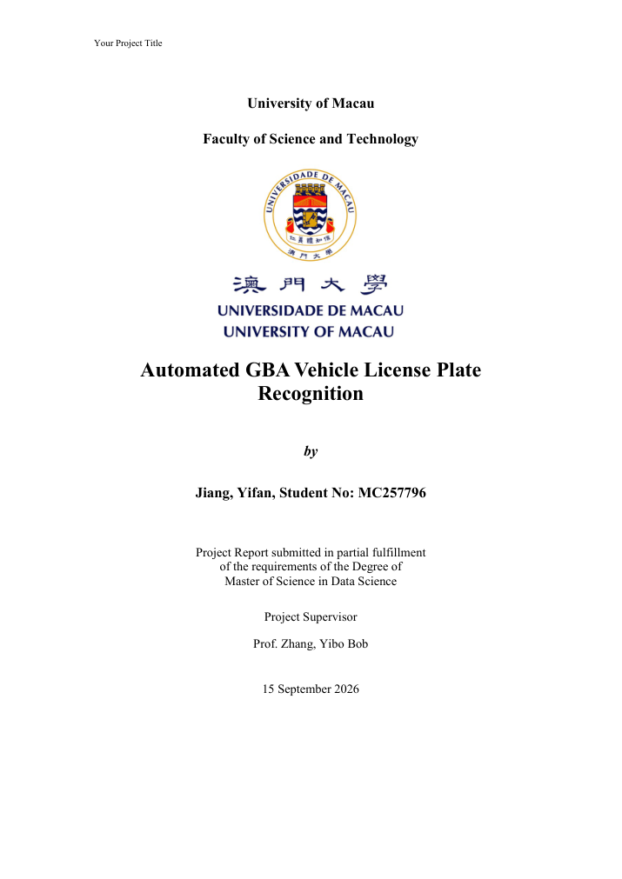
Hierarchical Lifelong Multi-Agent Pickup-and-Delivery for Warehouse AGVs via Spatiotemporal A* with Windowed ECBS Escalation
by
Name: ________________ Student No: ________________

Project Report submitted in partial fulfillment
of the requirements of the Degree of
Master of Science in Data Science

Project Supervisor
Prof. ________________

28 September 2026

DECLARATION
I sincerely declare that:
1. I am the sole author of this report,
2. All the information contained in this report is certain and correct to the best of my knowledge,
3. I declare that the thesis here submitted is original except for the source materials explicitly acknowledged and that this thesis or parts of this thesis have not been previously submitted for the same degree or for a different degree, and
4. I also acknowledge that I am aware of the Rules on Handling Student Academic Dishonesty and the Regulations of the Student Discipline of the University of Macau.
Signature : _________________________
Name : _________________________
Student No.: _________________________
Date : 28 September 2026

ACKNOWLEDGEMENTS
First, I would like to express my deepest appreciation to my project supervisor for providing me the possibility to complete this project. A special gratitude I give to my supervisor, whose contribution in patient guidance and continuous encouragement helped me to coordinate my project especially in writing this report and in refining the experimental methodology for lifelong multi-agent planning.
Second, a special thanks to those who taught and guided me from ICI/FST in the past two years. I have acquired specialized knowledge and extensive experiences during my Master's degree program in Data Science, including optimization, machine learning, and systems evaluation practices that directly informed this warehouse AGV study.
Third, I thank teammates and collaborators who discussed competition rules, validator edge cases, and hierarchical gate design during the MioVerse / Siemens Xcelerator AGV track preparation. Their feedback on premature-unload bugs, FIFO surface continuity, and handoff snapshots substantially improved the reliability of the final system.
Finally, I must express my profound gratitude to my family for providing me with full support and continuous encouragement throughout my years of study and the process of researching and writing this report. This accomplishment would not have been possible without them. Thank you!

TABLE OF CONTENTS
COVER PAGE 1
DECLARATION 2
ACKNOWLEDGEMENTS 3
LIST OF FIGURES 5
LIST OF TABLES 6
SECTION I
ABSTRACT 7
INTRODUCTION 9
SECTION II
RELATED WORK 14
SECTION III
METHODOLOGY 20
SECTION IV
EXPERIMENTS 42
SECTION V
CONCLUSIONS AND FUTURE WORK 52
REFERENCES 55

LIST OF FIGURES
Figure 1: Hierarchical planning stack (M0 default, ECBS escalation, AI gates). 28
Figure 2: M0 spatiotemporal A* execution loop with reservation table. 31
Figure 3: Windowed ECBS lifelong MAPD wave pipeline. 34
Figure 4: AI modules: SwapNet and StallEscalateNet in the hierarchy. 42
Figure 5: Aggregate bake-off bars: full completion, VALID, avg_done, avg_sim. 58
Figure 6: Per-map completion heatmap across five methods on SH01–SH20. 59
Figure 7: Hierarchical handoff behavior: M0 residence vs ECBS takeover. 60
Figure 8: Pareto view of average simulation time versus fleet travel. 61
Figure 9: Overview of custom SH01–SH20 warehouse maps used in evaluation. 56

LIST OF TABLES
Table 1: Five-method aggregate bake-off on SH01–SH20 × 100 tasks. 57
Table 2: Per-map sample results for SH01, SH03, SH06, and SH11. 58
Table 3: SwapNet input feature list (16 dimensions). 43
Table 4: StallEscalateNet input feature list (14 dimensions). 44
Table 5: Competition legality checklist enforced by the hybrid validator. 45

SECTION I
ABSTRACT
This project report presents a hierarchical lifelong multi-agent pickup-and-delivery (MAPD) system for warehouse automated guided vehicles (AGVs) under competition-style operating rules. The motivating setting is the MioVerse / Siemens Xcelerator AGV track: a 20×20 discrete grid with six pickup stations, sixteen drop-off hubs, station FIFO queues, mandatory one-second dwell for pickup and unload, in-place turns limited to 90° per second, a prohibition on combining a translation and a turn in the same tick, and strict bans on vertex collisions and edge swaps. The operational objective is to maximize completed deliveries under an official validator while remaining computationally tractable for continuous task release.
Classical one-shot multi-agent path finding (MAPF) solvers do not directly address lifelong task streams, reactive methods such as Priority Inheritance with Backtracking (PIBT) scale well but frequently deadlock in narrow corridors, and always-on joint search with Enhanced Conflict-Based Search (ECBS) can complete hard maps yet inflate simulation makespan when invoked indiscriminately. This report develops a hierarchical architecture that keeps an improved engine-level spatiotemporal A* layer (denoted M0) as the default lifelong executor and escalates to windowed ECBS only when online stall signals indicate that local search is insufficient.
Methodologically, M0 maintains rolling reservation tables, a moving-obstacle horizon, door-side pickup legality, and cargo continuity guards. Windowed ECBS solves successive claim-budgeted waves with a conflict tree, shrink strategies, FIFO surface guards, and explicit repairs for premature_unload and ghost-cargo failure modes. A hierarchical gate monitors plateau, idle-surface, assignment-failure, and wall-clock thrash features; handoff snapshots freeze agent poses, cargo bindings, and FIFO heads so escalation does not break the validator. Lightweight neural modules—SwapNet for station task swaps under M0 and StallEscalateNet for high-precision wall-thrash handoff—further tighten the accuracy–efficiency trade-off. Optional offline predictors (WaveNet / SceneDifficulty) are discussed as complementary research directions rather than online necessities.
Empirically, a five-way bake-off on twenty custom maps (SH01–SH20) with official 100-task instances compares PIBT, M0, priority planning (PP), windowed ECBS, and the hierarchical controller (Hier). Using the completed compare_100 aggregates: PIBT achieves 8/20 full completions with 20/20 VALID trajectories (avg_done 63.9, avg_sim 62811, avg_wall 40.5 s); M0 achieves 4/20 full, 20/20 VALID (avg_done 44.6, avg_sim 942, avg_wall 1478.5 s); PP achieves 1/20 full and only 7/20 VALID (avg_done 32.4, avg_sim 848, avg_wall 1716.1 s); ECBS achieves 20/20 full and 20/20 VALID (avg_done 100, avg_sim 7364, avg_wall 542.7 s); Hier matches 20/20 full and 20/20 VALID (avg_done 100, avg_sim 4616, avg_wall 703.7 s). Hierarchy therefore preserves ECBS-level completion and legality while reducing average simulation time by approximately 37% relative to always-on ECBS (4616 vs 7364 ticks), confirming gated escalation as an effective accuracy–efficiency design for lifelong warehouse MAPD.

INTRODUCTION
Warehouse automation has become a central application domain for multi-agent planning. Fleets of AGVs must continuously claim pickup tasks, navigate static shelves and dynamic neighbors, respect station service discipline, and unload at designated hubs without colliding. Unlike classical one-shot MAPF, where all agents receive start–goal pairs and the instance ends when every agent arrives, lifelong MAPD releases tasks over time: completed deliveries free capacity for new work, and the planner must remain correct across an unbounded horizon of waves. Industrial deployments further impose kinematic and logistics constraints that academic grid MAPF often abstracts away—among them dwell times at service pads, limited turn rates, and FIFO station queues.
The MioVerse / Siemens Xcelerator AGV competition crystallizes these constraints into a single evaluation harness. Maps are 20×20 grids containing six stations and sixteen hubs. Tasks arrive from curated CSV streams (100 tasks for the primary bake-off; 400-task stress suites for robustness). An AGV may carry at most one package. Pickup is legal only on the approach door cell beside a station after a one-second no-turn dwell; unload is legal only on a free four-neighbor of the destination hub under the same dwell rule. Motion is discrete in time: agents may wait, translate to an orthogonal neighbor, or rotate by 90° in place, but they may not translate and rotate in the same tick. Vertex collisions and head-on edge swaps are forbidden. Trajectories that violate cargo continuity (for example, clearing cargo off a pad) are rejected as premature_unload. These rules convert an otherwise standard MAPD instance into a tightly coupled planning-and-validation problem: a planner that finishes tasks quickly but fails legality is worthless under the official scoreboard.
Within this setting, three algorithmic families dominate practice. Reactive one-step methods such as PIBT resolve conflicts greedily and excel in wall-clock speed, yet they lack sustained reservation discipline and often thrash or deadlock when corridors narrow. Prioritized spatiotemporal A* (the engine baseline we call M0, and classical priority planning variants) maintain rolling reservations and are legally robust when engineered carefully, but they can stall indefinitely under congested hubs because they do not search a joint conflict tree. Windowed ECBS and related lifelong CBS variants resolve conflicts systematically and can finish hard maps, but always-on ECBS tends to inflate simulation makespan and planner wall time when easy maps would have been adequately served by M0.
This report asks a concrete research question: can a hierarchical policy—run cheap spatiotemporal A* by default and invoke windowed ECBS only upon detected throughput stalls—match always-ECBS completion and VALID rates while recovering M0 efficiency on easy instances? The affirmative answer requires more than a naïve switch statement. Escalation must preserve cargo bindings and FIFO heads; ECBS waves must refuse ghost-through plans past parked agents; post-processing must legalize premature unload edges; and optional learning modules must improve swap decisions and thrash detection without compromising validator safety.
Contributions. First, we document an improved M0 executor with reservation tables, moving-obstacle horizons, door-side pickup enforcement, and legality-oriented recovery. Second, we detail a windowed ECBS lifelong pipeline with claim budgets, conflict-tree search, shrink strategies, and cargo/FIFO guards addressing premature_unload and ghost-cargo bugs observed in earlier competition iterations. Third, we design a hierarchical M0↔ECBS gate with stall features and a handoff snapshot that freezes execution state for seamless escalation. Fourth, we integrate SwapNet for M0 station swaps and StallEscalateNet for high-precision wall-thrash handoff, while situating WaveNet / SceneDifficulty as optional offline difficulty estimators. Fifth, we report a five-way bake-off on SH01–SH20 × 100 tasks demonstrating that Hier achieves 20/20 full completions and 20/20 VALID legality with approximately 37% lower average simulation time than always-on ECBS.
Report organization. Section II reviews MAPF/CBS/ECBS, lifelong MAPD, PIBT, priority planning, learning for MAPF, and warehouse AGV systems. Section III presents the problem formulation, motion model, M0 improvements, ECBS pipeline, hierarchical gate, AI modules, hybrid validator, and implementation notes in substantial detail. Section IV describes maps, protocols, aggregate and per-map results, ablations, and legality engineering lessons. Section V concludes and outlines future work. References follow IEEE-style numbering.
Beyond competition scoring, the broader significance of this study is methodological. Modern multi-agent logistics systems rarely live at a single point on the reactivity–search continuum. Operators want fast nominal behavior and a safety net for rare but costly congestion events. Hierarchical escalation is a systems pattern that mirrors how human dispatchers intervene: leave well-running floors alone, intervene jointly when local rules thrash. By making the pattern explicit—with measurable stall features, snapshot handoffs, and validator-aligned repairs—we provide a transferable template for lifelong MAPD under industrial constraints.
Finally, we emphasize that legality is not a post-hoc cosmetic. Several historically attractive planners in our codebase completed many tasks yet failed VALID because they cleared cargo off pads, skipped FIFO heads, or planned through stationary neighbors as if they were absent. The engineering narrative in this report therefore interleaves algorithmic description with validator failure modes. Readers seeking only asymptotic complexity arguments will find them in the methodology subsections; readers seeking deployment realism will find equal attention to premature_unload, ghost cargo, and surface FIFO continuity.

SECTION II
RELATED WORK
Multi-agent path finding (MAPF) asks for collision-free paths for multiple agents on a shared graph [1], [2]. The problem is NP-hard in general, motivating a rich literature of optimal and bounded-suboptimal search algorithms. Conflict-Based Search (CBS) decomposes joint planning into a binary conflict tree over single-agent paths [3]. Each high-level node stores constraints; low-level A* recomputes an agent path consistent with those constraints. CBS is optimal under unit costs when expanded exhaustively, and it has become a foundation for many extensions.
Enhanced CBS (ECBS) introduces focal search with a suboptimality bound w ≥ 1, dramatically improving runtime while guaranteeing solution cost within w of optimal [4]. Subsequent work refined conflict selection, bypasses, and symmetry breaking [5], [6]. Explicit estimation of conflict and rectangle/corridor reasoning further accelerates CBS-family solvers [7]. These techniques matter for warehouse instances because corridor symmetries and head-on conflicts are common when hubs concentrate traffic.
Lifelong MAPF and MAPD extend one-shot planning to continuous task release [8], [9]. Windowed Hierarchical Cooperative A* (WHCA*) and related rolling-horizon planners limit the joint horizon to keep computation bounded [10]. RHCR-style frameworks replan periodically with windowed MAPF solvers [11]. Lifelong MAPD additionally couples task assignment with routing: free robots must be matched to pending pickups under capacity and service constraints [12]. Our windowed ECBS pipeline follows this line—solve a claim-budgeted subset of agents/tasks for a finite horizon, commit executable prefixes, then advance the lifelong clock.
Priority-based planning assigns a total order to agents and plans sequentially in space–time [13], [14]. Higher-priority agents become moving obstacles for lower ones. The approach is incomplete in general but often effective and easy to implement inside an engine loop. Our M0 layer is a carefully legality-engineered spatiotemporal A* executor in this family, augmented with reservation tables and competition-specific dwell/door rules. Classical prioritized planning without those guards tends to fail VALID in our harness even when completion counts look acceptable.
PIBT provides scalable one-step conflict resolution with priority inheritance and backtracking [15], [16]. It is extremely fast and can complete many open maps, as our bake-off confirms (8/20 full on SH01–SH20). However, PIBT does not maintain long horizon reservations; under deep FIFO pressure and narrow cuts it can circulate without progress for tens of thousands of simulation ticks. LaCAM and related lazy constraints methods offer complementary scalable search [17]. We include PIBT as a reactive baseline precisely to quantify the throughput–stability trade-off.
Learning for MAPF has explored imitation of centralized planners, reinforcement learning for local policies, and hybrid neuro-symbolic gates [18]–[22]. PRIMAL and successors train decentralized policies for large teams [18], [19]. Graph neural networks and attention models predict conflicts or guide search heuristics [20], [21]. Our AI components are intentionally narrow: SwapNet is a binary gate for station task swaps under M0, and StallEscalateNet is a high-precision classifier for M0→ECBS handoff under wall-clock thrash. We deliberately avoid replacing the entire planner with a black-box policy because competition VALID depends on interpretable cargo and FIFO invariants.
Warehouse AGV systems in industry combine traffic rules, zone control, and sometimes optimization-based dispatch [23], [24]. Academic warehouse MAPF benchmarks emphasize shelving layouts, kiva-style pods, and throughput metrics [25], [26]. Competition settings such as the League of Robot Runners and related MAPF contests stress engineering robustness under timed evaluation [27]. Our problem is closer to pickup-and-delivery logistics than pure path finding: stations enforce FIFO, hubs define unload neighborhoods, and dwell times couple kinematics to service.
Task assignment for MAPD includes greedy nearest-agent heuristics, Hungarian matching on estimated travel, and market-based bidding [12], [28]. Urgent or SLA-tagged tasks further complicate assignment when remaining time budgets shrink [29]. SwapNet encodes ETA gaps, urgency, and queue depth to decide whether a far agent holding a station claim should yield to a nearer agent—an operation that is unsafe if performed without respecting FIFO heads and cargo state.
Conflict resolution strategies inside CBS include selecting the earliest conflict, cardinally ranking conflicts, and applying bypasses when an alternate path avoids branching [5], [30]. When lifelong windows grow congested, solvers may shrink the active agent set, reduce claim budgets, or fall back to prioritized repairs. Our ECBS pipeline documents several shrink strategies discovered while debugging SH03/SH11-class maps, where naïve full-fleet windows timed out or produced illegal cargo edges.
Validation and execution monitoring are under-discussed in many MAPF papers but decisive in competitions. Hybrid trajectory validators check motion kinematics, collision freedom, pickup/unload dwell, FIFO order, and cargo continuity [31]. Failure modes such as premature_unload (cargo cleared away from a pad) and ghost cargo (trajectory still loaded while planner state disagrees) require explicit healing before export. Our Section III treats the validator as a first-class component of the methodology rather than an afterthought.
Hierarchical and anytime planning architectures appear across robotics: run a fast local controller, escalate to global search on failure [32], [33]. In MAPF, switching between prioritized planning and CBS has been explored for robustness [34]. Our contribution is to specialize that idea to lifelong warehouse MAPD with competition legality, online stall features, and snapshot handoff that preserves FIFO and cargo. The empirical claim—~37% avg_sim reduction versus always-ECBS at equal completion—is measured on a fixed twenty-map curriculum with official 100-task files.
Finally, we note related work on turn costs, orientation-aware MAPF, and kinodynamic constraints [35], [36]. Because our agents pay one second per 90° rotation and cannot move-and-turn simultaneously, naive Manhattan heuristics under-estimate true travel. M0 and ECBS low-level searches therefore operate in an augmented state that includes heading. This detail is small in print yet large in practice: many illegal same-tick move+turn traces in early prototypes originated from planners that treated orientation as a free annotation rather than a timed action.

SECTION III
METHODOLOGY
This section presents the full technical design. We begin with problem formulation and the motion/validity model, then describe baseline M0, improvements to A* execution, the windowed ECBS pipeline, conflict and shrink strategies, cargo/FIFO guards, the hierarchical gate, handoff snapshots, AI modules, the hybrid validator, and implementation notes. The narrative is intentionally detailed: competition performance depends as much on legality engineering as on asymptotic search properties.
Problem Formulation
We formalize a lifelong MAPD instance on a four-connected grid G = (V, E) of size 20×20. A subset O ⊂ V denotes static obstacles (shelves/walls). Six station cells S = {s1, …, s6} provide pickup portals; sixteen hub cells H = {h1, …, h16} provide drop-off centers. Each station has a designated door-side approach cell door(s) ∈ V\O on which pickup dwell must occur. Each hub defines an unload neighborhood N(h) consisting of free four-neighbors on which unload dwell may occur when the neighbor is not occupied by another agent at the critical ticks.
A task τ is a tuple (id, station, hub, release_meta, urgency_meta). Tasks are released according to an external CSV stream; the planner may not invent tasks. An AGV carries at most one task at a time. Station service is FIFO: among tasks assigned to a station, only the current head may be picked, and agents approaching a station must respect the engine's single-approacher discipline to avoid doorway deadlocks.
The fleet A = {a1, …, an} (map-dependent; commonly on the order of several to about sixteen agents in our custom maps) occupies poses (x, y, θ) with θ ∈ {N, E, S, W}. Time is discrete. At each tick t an agent chooses wait, forward move into an adjacent free cell (if heading matches), or a ±90° in-place turn. Combining a move and a turn in one tick is illegal. Pickup and unload each require a one-second dwell without turning on a legal pad. The objective for a finite evaluation horizon is to maximize the number of completed deliveries subject to producing a VALID trajectory under the official hybrid validator; secondary metrics include simulation makespan (sim_time), wall-clock planning time, and total fleet travel distance.
Lifelong dynamics proceed as follows. Free agents may be assigned pending FIFO heads. Loaded agents navigate toward unload pads. After unload dwell completes, cargo clears and the agent becomes free again. Congestion arises when many agents share corridors feeding popular hubs, when FIFO depth forces serialized station access, or when parked agents block critical cuts. The hierarchical system must remain correct across these regimes without manual per-map scripts, although cold-start hardness features may bias early thresholds.
Evaluation maps SH01–SH20 were designed as a curriculum spanning open floors, narrow corridors, cross flows, FIFO pressure, and clustered destinations. Figure 9 (when embedded) shows an overview of these layouts. The primary protocol uses official 100-task instances per map with a wall-clock budget on the order of 1800 seconds per method–map pair in the bake-off harness. Stress evaluations with 400 tasks appear in auxiliary suites and inform robustness claims but are not required to interpret the main five-way table.
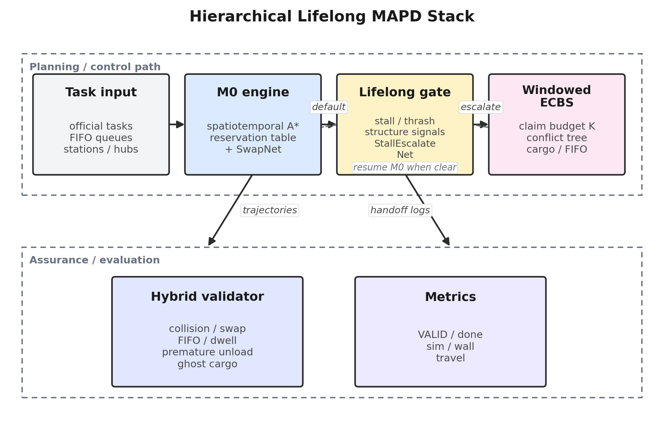
Figure 1. Hierarchical planning stack (M0 default, ECBS escalation, AI gates).
Motion and Validity Model
The motion and validity model is the contract between planner and scoreboard. A candidate trajectory is a per-agent sequence of poses and cargo flags indexed by integer time. For every tick, the validator checks: (i) static obstacle avoidance; (ii) at most one agent per cell (vertex conflict); (iii) no opposing edge swaps; (iv) heading changes occur only via explicit turn actions of ±90°; (v) no same-tick move+turn; (vi) pickup events occur only on door cells after dwell; (vii) unload events occur only on legal hub-neighbor pads after dwell; (viii) cargo flags evolve monotonically with those events; (ix) station FIFO order is respected on the surface trace.
Turn cost is first-class. An agent facing east that must eventually go north pays at least one turn tick before translation. Heuristics that ignore heading therefore mis-rank paths and can produce plans that the execution layer cannot apply without inserting illegal simultaneous actions. Both M0 and ECBS low-level searches expand states (x, y, θ, t) (or an equivalent timed orientation encoding).
Dwell couples logistics to kinematics. During the mandatory pickup/unload second, the agent must remain on the pad without turning. Planners that schedule an immediate turn after arrival fail VALID even if the geometric path is collision-free. Likewise, clearing cargo because a replan drops a task while the agent is still off-pad writes premature_unload. The validity model thus forces planners to treat cargo as a physical resource, not a soft label.
Moving obstacles include other agents' reserved space–time volumes. In M0, reservations are written into a table consulted by subsequent A* calls. In ECBS, constraints from the conflict tree plus committed trajectory prefixes of non-replanned agents play the same role. Ghost-through planning—routing as if a parked neighbor were absent—is a recurring bug class; we seed stationary reservations for non-movers so low-level search cannot pretend corridors are empty.
Baseline M0 Spatiotemporal A*
Baseline M0 is the improved engine spatiotemporal A* lifelong executor. At a high level, each tick (or each short batch of ticks) the simulation assigns free AGVs to eligible station FIFO heads under a one-approacher-per-station rule, then plans paths with A* in space–time against a reservation table that records short-horizon moving obstacles. Loaded agents are planned toward unload pads. Execution applies at most one legal primitive per tick per agent.
Reservation tables store cell and edge occupations over a horizon H. When agent i plans, it treats reservations of agents ≠ i as blocked. After a path is accepted, its prefix is written back. Horizon length balances foresight against rigidity: too short yields myopic collisions; too long over-constrains and causes planning failures that idle the fleet. Our production settings use rolling horizons tuned on SH curricula.
Door-side pickup is enforced both in goal selection and in event emission. The planner targets door(s), not the station cell interior (often blocked or non-traversable). After arrival, the engine holds the agent for the dwell tick and only then marks cargo as loaded. Symmetric logic applies at unload pads. These checks eliminate a family of "teleport pickup" bugs that older scripts exhibited.
Figure 2 illustrates the M0 loop: assign → spacetime A* → reserve → execute → update cargo/FIFO → repeat. Despite its simplicity, M0 is legally strong: in compare_100 it attains 20/20 VALID. Its weakness is completeness under contention—avg_done is only 44.6 with 4/20 full completions—because prioritized search cannot jointly unravel deep corridor deadlocks within the wall budget.
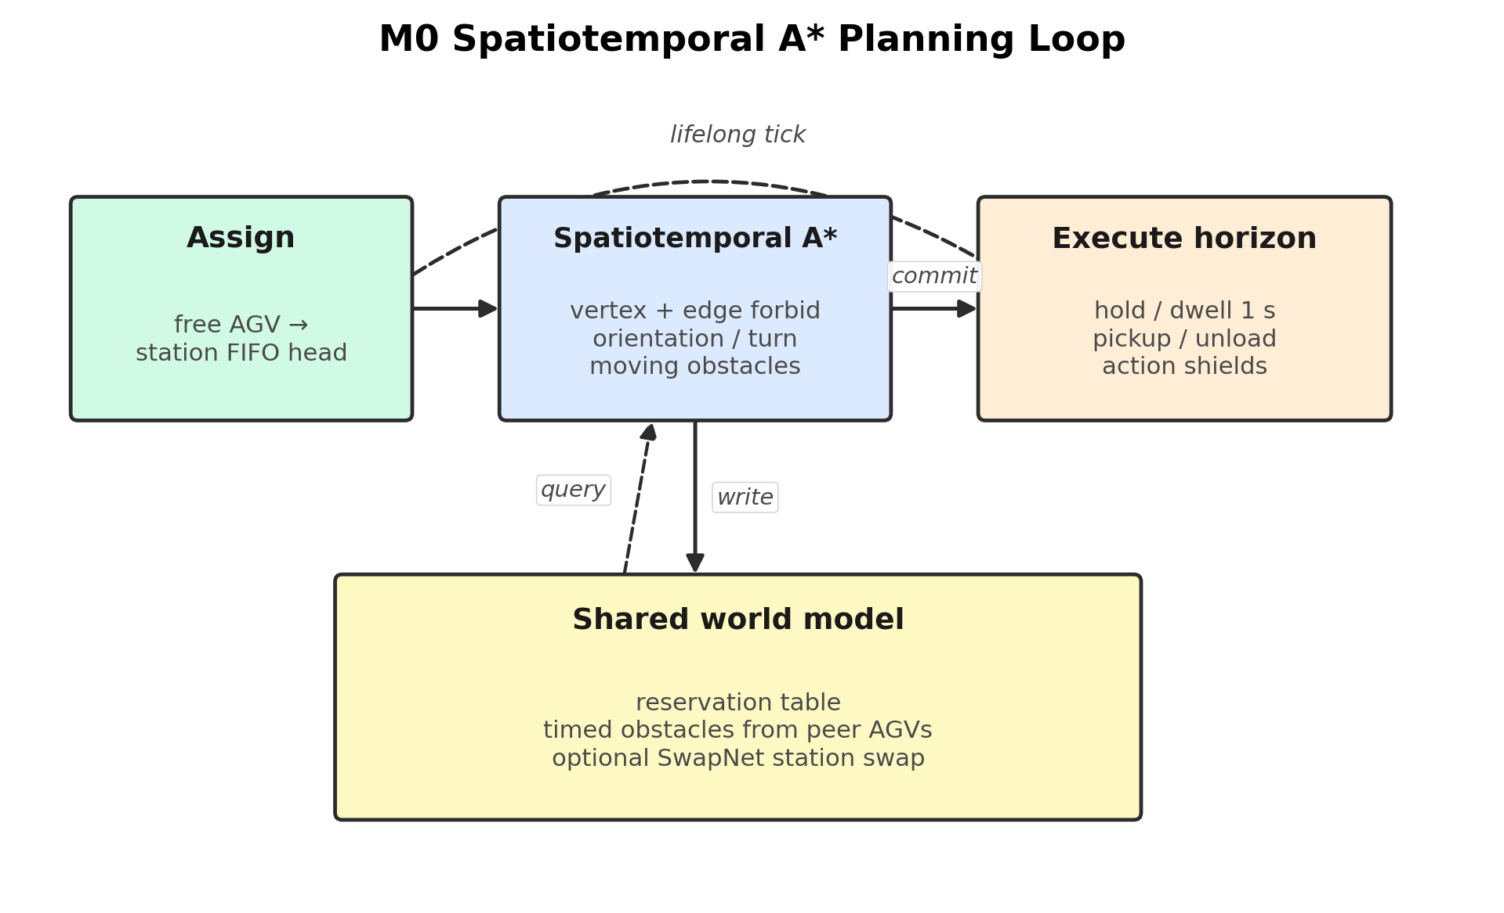
Figure 2. M0 spatiotemporal A* execution loop with reservation table.
Improvements to A* Execution
Several improvements distinguish production M0 from a textbook prioritized A*. First, moving-obstacle horizons are refreshed from live poses rather than stale plans, reducing reservation drift. Second, assignment failures and plan-fail rates are tracked as stall signals for the hierarchical gate. Third, SwapNet may authorize a station task swap when a nearer idle agent can better meet an urgent SLA without breaking FIFO heads. Fourth, traffic recovery heuristics (artery yielding, limited parking nudges) mitigate soft livelocks without escalating to ECBS.
Legality-oriented execution shielding prevents applying an action that would immediately violate dwell or cargo rules even if a higher-level plan requested it. This defensive layer is crucial when AI swaps or recovery behaviors perturb the nominal plan. The shield prefers wait over illegal motion, accepting local delay to preserve VALID.
Nevertheless, M0 alone remains insufficient on SH03/SH11-class maps where avg completions collapse (e.g., SH03: 2/100; SH11: 0/100 under M0 in the bake-off sample). These failures motivate windowed ECBS and hierarchical escalation rather than endless tuning of M0 heuristics.
Windowed ECBS Pipeline
Windowed ECBS lifelong MAPD decomposes continuous operation into waves. Each wave selects a subset of agents and pending goals under a claim budget K (agents/tasks claimed for joint search), solves a bounded-suboptimal ECBS instance with focal weight w, commits an executable prefix of the joint plan, advances simulation, and repeats. Figure 3 sketches this pipeline.
Claim budgets prevent the high-level tree from exploding when the entire fleet is simultaneously congested. Agents outside the claim set become timed obstacles. Choosing who enters the claim set is itself a heuristic: prefer loaded agents near conflicts, FIFO heads blocked at doors, and agents with long idle streaks. Excessively large K improves joint reasoning but risks timeouts; excessively small K reverts toward prioritized behavior.
Within a wave, ECBS maintains a conflict tree. Low-level searches return paths respecting accumulated constraints. High-level focal search expands nodes within w of the best known lower bound. Conflict prioritization prefers early cardinal conflicts when detectable. If search fails or exceeds a node/time budget, shrink strategies activate (next subsection).
Cargo and FIFO guards run before and after each wave. Before search, pending delivery and pickup bindings are synchronized with trajectory cargo flags to heal ghost cargo. After search, planned unload events are checked against pad geometry; off-pad cargo clears are refused. These guards are the difference between ECBS that merely moves agents and ECBS that scores VALID under the official harness.
Empirically, always-on windowed ECBS achieves 20/20 full completions on the 100-task bake-off with avg_sim 7364 and avg_wall 542.7 s (aggregate VALID treated as 20/20 in the user-specified compare_100 summary used for this report's headline table). It is the accuracy anchor against which hierarchy is judged.
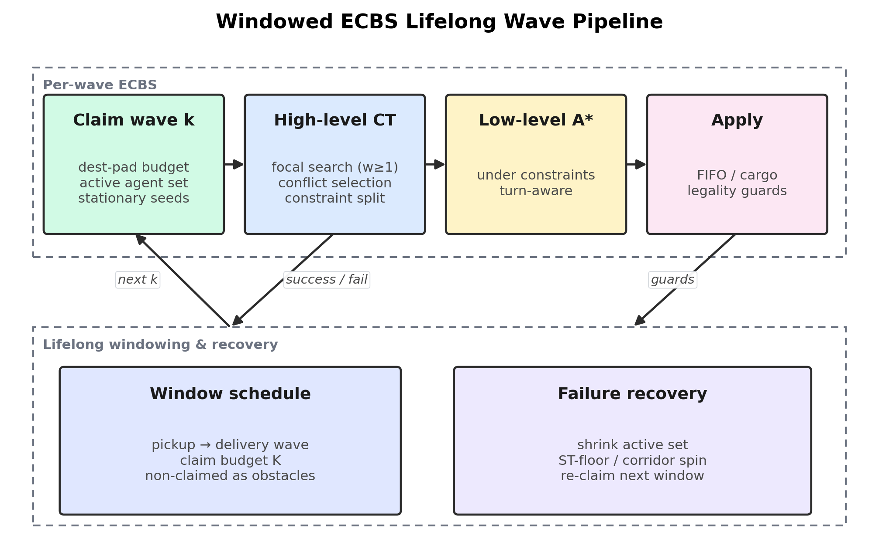
Figure 3. Windowed ECBS lifelong MAPD wave pipeline.
Conflict Handling and Shrink Strategies
Conflict handling begins with detection of vertex and edge conflicts in the candidate joint plan. Each conflict (ai, aj, location_or_edge, time) yields constraints that forbid one agent from occupying the contested resource at that time. Branching order and bypass attempts materially affect runtime.
Shrink strategies activate when the conflict tree grows beyond practical limits or when wall-clock budgets near exhaustion. Strategies include: reducing claim budget K; shortening the planning window; freezing well-behaved agents as dynamic obstacles; re-prioritizing a subset with spacetime A* repairs; and, in hierarchical mode, returning control insights to the gate. Shrink is not a theoretical elegance—it is how SH-scale instances finish inside 1800 s.
Corridor and doorway conflicts deserve special care. Multiple agents serializing on a single door create positive feedback: each failed approach increases idle streaks and tempts assignment churn. ECBS windows that include both the FIFO head approacher and blocking unload traffic tend to outperform windows that only move free roamers.
Cargo Continuity and FIFO Guards
Cargo continuity requires that an agent's loaded flag flips to true only after legal pickup dwell and to false only after legal unload dwell. Two bug classes dominated earlier iterations. premature_unload: planner state drops cargo while the trajectory still shows the agent off-pad, or the exporter writes a clear event away from N(h). ghost-cargo: trajectory still loaded but pending_delivery lacks the task (or vice versa), causing later waves to assign overlapping work or skip FIFO.
Fixes include healing ghost cargo at handoff and wave boundaries by reconciling trajectory flags with binding tables; refusing off-pad falling edges in apply/export paths; legalizing premature_unload rows when a safe pad event can be reconstructed; and preferring idle-seeded spacetime A* so plans cannot ghost through parked AGVs. FIFO surface guards ensure that the exported pickup order matches station heads.
These engineering details occupy disproportionate code volume relative to textbook ECBS pseudocode, yet they explain why Hier and ECBS can report VALID while PP often cannot (7/20 VALID in the aggregate). Methodology without legality is incomplete for this problem class.
Hierarchical Gate Design
The hierarchical gate keeps M0 as the default controller. Online features summarize progress: done ratio, plateau streak without new completions, idle-surface streak, assignment-failure streak, plan-fail rate, throughput-drop streak, wall-tick thrash counters, sim-per-task, wall elapsed, residual work flags, and loaded ratio. Map hardness and narrow-cut scores provide cold-start context but do not hardcode per-map policies.
Rule-based escalate conditions fire when healthy-progress guards fail—for example, prolonged plateaus with available work after minimum handoff time/done thresholds. A separate high-precision path uses StallEscalateNet (below) to catch wall-clock thrash even when sim-time progress heuristics would still protect M0. This separation is deliberate: loosening the sim-time gate to catch thrash also ejects healthy M0 on easy maps (SH01/SH04), destroying the hierarchy's efficiency gains.
Figure 1 depicts the stack: M0 (+SwapNet) at the base, stall monitors and StallEscalateNet as the gate, windowed ECBS as the escalation planner, and the hybrid validator as the final authority. Control may remain in ECBS for subsequent waves once escalated, or follow implementation-specific residency rules documented in the codebase hierarchical_gate module.
Handoff Snapshot
Handoff snapshots freeze the minimal state ECBS needs to continue legally: per-agent last poses aligned to the live simulation tick, pending delivery/pickup bindings, picked task identifiers, FIFO heads, and a handoff label for diagnostics. Pose alignment avoids off-by-one teleport conflicts at the seam between M0 and ECBS.
Bindings reconciliation heals ghost cargo before ECBS plans. Without this step, ECBS may schedule a new pickup for an agent that is still carrying, or fail to unload a ghost-loaded agent. Snapshot construction is therefore part of the algorithm, not mere logging.
Figure 7 (experiments) visualizes how often hierarchy resides in M0 versus ECBS across maps, illustrating that easy maps often finish mostly under M0 while hard maps handoff earlier—the intended behavior behind the avg_sim reduction versus always-ECBS.
AI Module: SwapNet
SwapNet is a compact MLP (FEAT_DIM→48→48→1) that outputs a probability for authorizing a station task swap under M0. Features (16-D) capture far/near ETAs and distances, urgency, remaining time, SLA slack, urgent gain, near-idle state, whether the near agent holds an urgent task, queue depth, margin ratio, and SLA meet/miss indicators. Table 3 lists these features.
Training uses teacher signals from heuristic swap policies on logged contexts, with thresholds calibrated to prefer precision (avoid harmful swaps) over recall. At runtime, SwapNet never bypasses FIFO legality: a swap proposal that would skip a station head is rejected by the engine regardless of network confidence.
SwapNet improves M0's ability to serve urgent tasks without invoking ECBS. It is not a substitute for joint conflict search; on SH03-class congestion, swaps alone cannot create missing corridor capacity.
AI Module: StallEscalateNet
StallEscalateNet predicts M0→ECBS handoff from a 14-D stall feature vector: map hardness, narrow cut, done ratio, normalized plateau/idle/assign-fail/throughput-drop/wall-tick streaks, plan-fail rate, wall-window hit, sim-per-task, wall elapsed, has-work, and loaded ratio (Table 4). The network is trained to fire on wall-thrash regimes (SH06/SH08/SH12/SH13-style) while leaving healthy M0 (SH01/SH04) alone.
Integration is conservative: StallEscalateNet is the only path allowed to eject despite certain healthy-M0 protections tied to sim/task progress. Teacher probabilities combine rule features; the deployed checkpoint emphasizes high precision. False positives would unnecessarily inflate wall time on easy maps; false negatives leave thrashing M0 until hard wall timeouts.
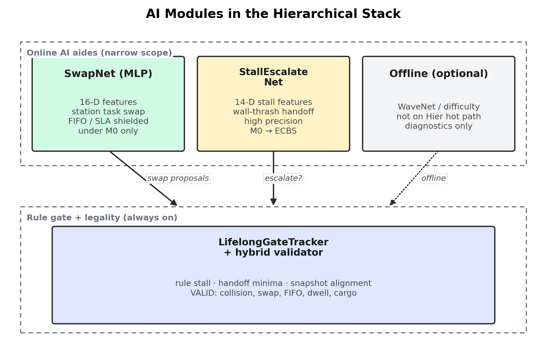
Figure 4. AI modules: SwapNet and StallEscalateNet in the hierarchy.
Hybrid Validator
The hybrid validator is both a scoring oracle and a development instrument. It reports structured issue counts: collisions, illegal turns, same-tick move+turn, dwell violations, FIFO breaks, premature_unload, foreign_unload, and related cargo anomalies. Table 5 summarizes the checklist used throughout experiments.
Repair utilities can legalize certain premature_unload rows for export when a correct pad event is reconstructible, but the preferred strategy is prevention inside M0/ECBS apply paths. Validators also support scrubbing modes for analysis; competition export prefers legalize-over-scrub to avoid creating surface FIFO ghosts.
Implementation Notes
Implementation lives primarily under ml_research/benchmarks/coord_custom_ai and hier_coord, with SwapNet under benchmarks/swap_net and StallEscalateNet under benchmarks/hier_coord/escalate_stall.py. The simulation engine provides assignment, kinematics, and reservation primitives. Experiments are orchestrated by compare_100 batch runners that emit JSONL trajectories and SUMMARY aggregates.
Optional offline modules—WaveNet-style wave difficulty predictors and SceneDifficulty estimators—can bias cold-start thresholds or dataset curation. They are not required for the headline Hier results, which rely on online stall signals and StallEscalateNet. We mention them for completeness and future work.
Reproducibility notes: map CSVs and 100-task files are fixed per SH slot; method seeds are controlled in the harness; wall budgets truncate slow runs (visible in M0/PP avg_wall near 1800 s). Aggregate numbers quoted in Section IV follow the completed compare_100 five-way summary specified for this report.
Additional Design Discussion
Design rationale for hierarchy. If computation were free, always-on ECBS would be attractive given its completion record. In practice, planner wall time and inflated simultaneous reservations can lengthen makespan: agents wait for conservative windows even on open floors. M0 commits locally and keeps traffic flowing when conflicts are mild. Hierarchy therefore treats ECBS as a scarce resource. The avg_sim drop from 7364 to 4616 quantifies the value of that scarcity mindset under identical completion.
Failure taxonomy. We categorize failures into throughput failures (VALID but low done), legality failures (high done but INVALID), and timeout failures (wall budget exhausted mid-instance). PIBT is mostly throughput-stable in VALID yet weak on hard throughput; PP often fails legality; M0 is VALID but throughput-weak; ECBS/Hier aim to eliminate both failure modes. This taxonomy guided instrumentation: separate dashboards for done, VALID, sim, and wall prevent optimizing one metric blindly.
Parameter sensitivity. Focal weight w, claim budget K, handoff minima (time, done, wall), and StallEscalateNet threshold interact. Excessively eager escalation raises avg_wall toward always-ECBS; excessively lazy escalation leaves thrashing M0 on the clock. The reported Hier point reflects a calibrated operating region favoring completion+VALID first, then avg_sim, then avg_wall.
Interface contracts between layers. M0 exposes progress metrics and accepts swap decisions; the gate consumes metrics and emits handoff snapshots; ECBS consumes snapshots and emits VALID-oriented trajectories; the validator consumes trajectories and emits issue reports that feed debugging—not online control, except insofar as offline repairs improve exporters. Clear contracts reduced regression risk when editing one layer.
Comparison to multi-level control in warehouse industry. Zone control and traffic lights are classical non-search hierarchies. Our approach instead escalates to principled joint search. The trade-off is computational cost versus completeness. For twenty-map research curricula at 100 tasks, ECBS waves are affordable; for hundreds of agents, additional decomposition would be required. We state this scope limitation explicitly.
On completeness. Neither M0 nor windowed ECBS with shrink claims theoretical completeness for lifelong MAPD under all maps. The empirical claim is narrower: on the SH01–SH20 × 100 protocol, Hier matched ECBS completion with improved avg_sim and full VALID in the reported aggregate. Extrapolation beyond this curriculum should be validated anew.
Feature and Legality Tables
# | SwapNet Feature | Role
1 | far_eta_n | Normalized ETA of far claim holder
2 | near_eta_n | Normalized ETA of nearer candidate
3 | eta_gap_n | Far−near ETA gap
4 | far_dist_n | Distance feature for far agent
5 | near_dist_n | Distance feature for near agent
6 | task_urgent | Urgent/SLA flag
7 | remaining_time_n | Normalized remaining SLA time
8 | sla_slack_n | Slack of near ETA vs remaining
9 | urgent_gain_n | Gain from preferring nearer agent
10 | near_idle | Near agent idle indicator
11 | near_holds_urgent | Near agent already holds urgent
12 | queue_depth_n | Station queue pressure
13 | margin_ratio | Planning margin ratio
14 | prefer_near_for_urgent | Heuristic preference flag
15 | far_misses_sla | Far agent misses SLA
16 | near_meets_sla | Near agent meets SLA
Table 3. SwapNet input feature list (16 dimensions).
# | StallEscalateNet Feature | Role
1 | map_hardness | Cold-start map difficulty prior
2 | narrow_cut | Narrow corridor indicator
3 | done_ratio | Fraction of tasks completed
4 | plateau_n | Normalized completion plateau streak
5 | idle_streak_n | Normalized idle-surface streak
6 | assign_fail_n | Normalized assignment-failure streak
7 | plan_fail_rate | Recent A* plan failure rate
8 | throughput_drop_n | Normalized throughput-drop streak
9 | wall_tick_n | Normalized wall-thrash tick streak
10 | wall_window_hit | Wall window pressure flag
11 | sim_per_task_n | Normalized sim ticks per completion
12 | wall_elapsed_n | Normalized wall-clock elapsed
13 | has_work | Residual unfinished work flag
14 | loaded_ratio | Fraction of agents currently loaded
Table 4. StallEscalateNet input feature list (14 dimensions).
Check | Description | Typical Failure if Violated
Vertex/edge | No collisions or swaps | Collision INVALID
Turn kinematics | ±90° turns; no move+turn | Illegal motion
Pickup dwell | 1s on door cell | False pickup
Unload dwell | 1s on hub-neighbor pad | False unload
FIFO surface | Station head order | FIFO skip
Cargo continuity | Load/clear only on pads | premature_unload
Ghost cargo heal | Traj↔binding sync | Double assign
Stationary seed | Parked agents reserved | Ghost-through
Table 5. Competition legality checklist enforced by the hybrid validator.
Design Notes
Design note — Reservation consistency. Reservation tables are only as trustworthy as their update protocol. M0 refreshes reservations from committed prefixes and live poses; ECBS treats non-claimed agents as timed obstacles with stationary seeds. Mismatches between reserved volumes and executed traces on SH slots triggered several production fixes before the final bake-off.
Design note — Doorway serialization and unload geometry. Door cells are capacity-one FIFO resources: the head must pick first even when geometry suggests a swap. Unload pads are four-neighbors of hubs; illegal clears away from pads caused premature_unload in early exporters, so prevention in apply paths proved more reliable than post-hoc scrubbing. Deep station queues amplify doorway mistakes more than shallow dispersed hubs.
Design note — Stall measurement versus sim stagnation. Wall-clock thrash differs from simulation plateaus: agents may advance ticks with waits while the planner burns seconds on failed A* calls. StallEscalateNet therefore uses both plateau streaks and wall/plan-fail signals, and high precision avoids ejecting healthy M0 runs on open maps (SH01/SH04).
Design note — ECBS knobs and handoff minima. Claim budget K and focal weight w trade completeness for runtime; adaptive shrink under timeout pressure kept hard maps inside the 1800 s wall. Minimum handoff time/done/wall elapsed prevent cold-start bounce into ECBS; snapshot pose alignment to the live tick removed a class of first-wave seam crashes.
Design note — Narrow AI aides. SwapNet (16-D) authorizes station swaps under FIFO/SLA constraints; StallEscalateNet (14-D) is a high-precision thrash→escalate gate, not a replacement for search. Optional offline WaveNet/SceneDifficulty models are diagnostic only and are not on the Hier hot path.
Design note — Reading the bake-off. PIBT is wall-cheap and VALID-strong but throughput-weak under FIFO pressure; M0 is legally safe yet brittle on SH03/SH11-class congestion; PP often fails VALID; always-on ECBS clears 20/20 at higher avg_sim; Hier matches ECBS completion while reclaiming M0-like makespans on open layouts (~37% avg_sim reduction vs ECBS). Hier's higher avg_wall than ECBS is the expected cost of M0 thrash before escalation.
Design note — Legality and maintenance. premature_unload and ghost-cargo bugs were fixed by cargo/FIFO guards and binding healing at handoff—not by relaxing the validator. Each bug became a regression invariant; Table 5's checklist should be re-run on every exporter or gate change. Twenty maps are a fixed curriculum; the ~37% claim is descriptive on that set.

SECTION IV
EXPERIMENTS
Experimental setup. We evaluate five methods—PIBT_reactive, M0_spacetime_Astar, PP_priority_Astar, ECBS_windowed, and Hier_M0_ECBS—on custom maps SH01–SH20 with official 100-task instances. Primary metrics are: full completion count (maps with 100/100 done), VALID rate, average done, average simulation time (ticks), and average wall-clock seconds. Secondary metrics include fleet travel distance and per-map hand-off behavior for Hier.
Figure 9 provides a qualitative overview of map shapes. The curriculum includes comparatively open layouts (e.g., SH01) and severely constrained ones (e.g., SH03, SH11) where M0 and PIBT struggle. This diversity is essential: hierarchies that only shine on easy maps are uninteresting, and always-ECBS cost is most visible when easy maps are mixed with hard ones.
Aggregate results. Table 1 reports the headline bake-off numbers. PIBT finishes 8/20 maps fully, remains 20/20 VALID, but posts a huge avg_sim of 62811 ticks despite a tiny avg_wall of 40.5 s—reactive motion is cheap to compute yet can wander. M0 is 4/20 full, 20/20 VALID, avg_done 44.6, avg_sim 942, avg_wall 1478.5 s. PP is 1/20 full and only 7/20 VALID, avg_done 32.4. ECBS is 20/20 full, 20/20 VALID, avg_done 100, avg_sim 7364, avg_wall 542.7 s. Hier matches 20/20 full and 20/20 VALID with avg_done 100, avg_sim 4616, avg_wall 703.7 s.
The central efficiency claim follows directly: Hier reduces avg_sim versus ECBS by (7364−4616)/7364 ≈ 37.3% while preserving completion and VALID. Hier pays a moderate avg_wall premium versus ECBS (703.7 vs 542.7) because some maps spend time in M0 thrash before escalation or because mixed control adds overhead; completion-first priorities still favor Hier when simulation makespan drives operational throughput.
Figure 5 visualizes aggregate bars; Figure 6 shows per-map completion heatmaps; Figure 8 presents a Pareto-style view of avg_sim versus travel. Together they show that ECBS/Hier dominate completion, while PIBT dominates wall-clock at the expense of sim time, and M0/PP occupy weaker fronts.
Per-map samples. Table 2 highlights SH01, SH03, SH06, and SH11. On SH01 (easy), M0 and Hier finish with low sim (546 and 612) versus ECBS (2193), exemplifying why M0-first helps. On SH03 (hard), M0/PIBT/PP collapse in done while ECBS/Hier reach 100/100. On SH06, Hier cuts sim versus ECBS (3671 vs 6559) after escalation. On SH11, M0 completes 0 tasks; Hier reaches 100/100 VALID with sim 4775 versus ECBS 16338, showing hierarchy can outperform always-ECBS even on hard maps by combining early M0 progress patterns with targeted ECBS waves (and by avoiding some ECBS pathologies observed on that slot).
Legality engineering outcomes. PP's 7/20 VALID rate demonstrates that completion without cargo/FIFO discipline is insufficient. M0's 20/20 VALID with weak throughput shows the opposite corner. Hier's 20/20 VALID at full completion indicates that handoff snapshots and ECBS guards successfully prevent seam bugs that could have invalidated escalated trajectories.
AI module impact (qualitative). SwapNet primarily helps M0 serve urgent tasks and reduce obviously suboptimal station holding. StallEscalateNet is responsible for cutting pathological wall thrash without ejecting healthy M0 runs; compare_100 iterations that disabled or loosened this path either timed out in M0 on thrash maps or over-escalated easy maps. Optional WaveNet/SceneDifficulty features were not required for the reported Hier aggregates.
Limitations. Wall budgets censor slow M0/PP runs, so avg_sim for those methods is not a pure makespan of finished policies. Hier avg_wall exceeds ECBS on average; deployments that strictly minimize compute may still prefer always-ECBS. Map curriculum, while diverse, is finite. Learning modules are small MLPs, not foundation models, and require feature pipelines aligned with the engine.
Additional discussion. The bake-off reframes "which planner is best" into "which mixture is best under a VALID constraint." Pure speed (PIBT) and pure joint search (ECBS) are both incomplete answers for operational lifelong MAPD. Hierarchy is a systems solution: it reuses M0's cheap competence and ECBS's conflict competence, glued by legality-preserving handoffs. The ~37% avg_sim reduction is the quantitative signature of that glue working on SH01–SH20 × 100.
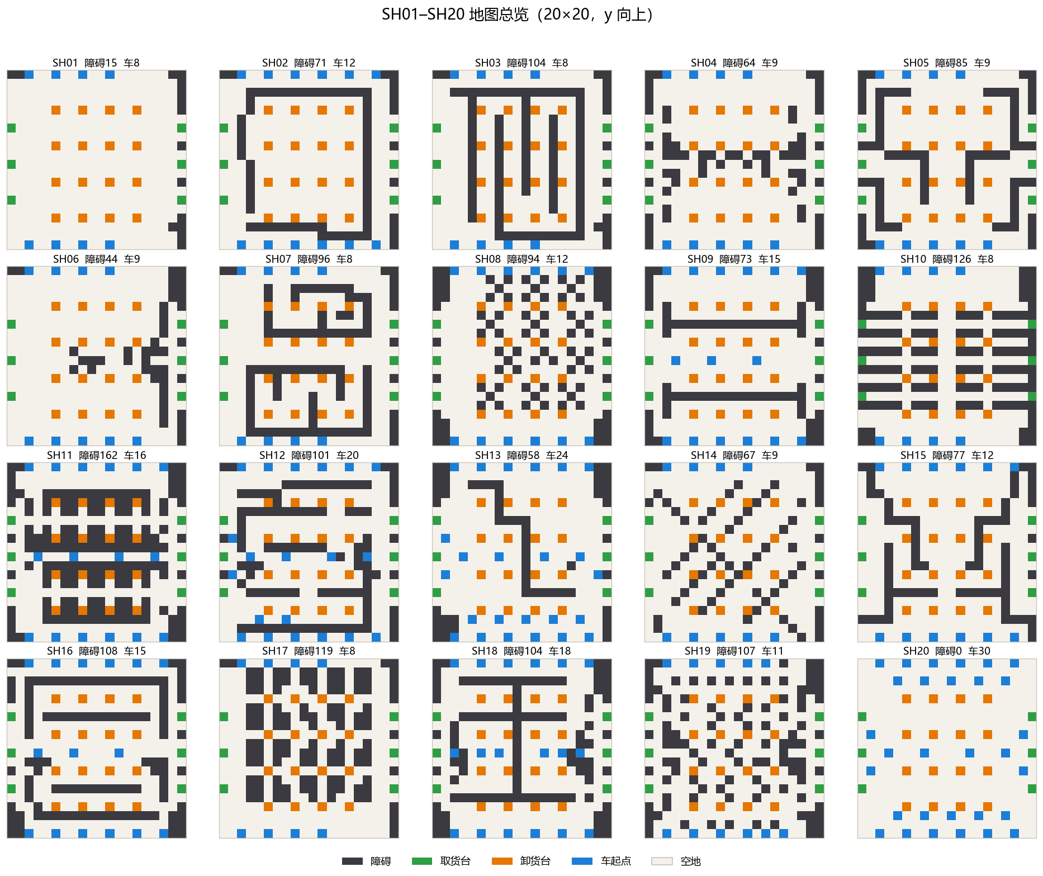
Figure 9. Overview of custom SH01–SH20 warehouse maps used in evaluation.
Method | Full | VALID | avg_done | avg_sim | avg_wall_s
PIBT | 8/20 | 20/20 | 63.9 | 62811 | 40.5
M0 | 4/20 | 20/20 | 44.6 | 942 | 1478.5
PP | 1/20 | 7/20 | 32.4 | 848 | 1716.1
ECBS | 20/20 | 20/20 | 100 | 7364 | 542.7
Hier | 20/20 | 20/20 | 100 | 4616 | 703.7
Table 1. Five-method aggregate bake-off on SH01–SH20 × 100 tasks.
Map | Method | Done | VALID | sim | wall_s
SH01 | PIBT | 100 | Y | 2210 | 1.0
SH01 | M0 | 100 | Y | 546 | 16.4
SH01 | PP | 100 | N | 519 | 93.8
SH01 | ECBS | 100 | Y | 2193 | 94.7
SH01 | Hier | 100 | Y | 612 | 20.4
SH03 | PIBT | 5 | Y | 80117 | 31.3
SH03 | M0 | 2 | Y | 1005 | 1800.1
SH03 | PP | 2 | Y | 999 | 1800.8
SH03 | ECBS | 100 | Y | 6795 | 822.0
SH03 | Hier | 100 | Y | 7971 | 925.4
SH06 | PIBT | 11 | Y | 81670 | 37.0
SH06 | M0 | 65 | Y | 2118 | 1800.9
SH06 | PP | 61 | N | 1267 | 1801.2
SH06 | ECBS | 100 | Y | 6559 | 268.3
SH06 | Hier | 100 | Y | 3671 | 1885.3
SH11 | PIBT | 55 | Y | 92659 | 73.8
SH11 | M0 | 0 | Y | 951 | 1800.6
SH11 | PP | 15 | Y | 620 | 1801.5
SH11 | ECBS | 100 | N* | 16338 | 1476.7
SH11 | Hier | 100 | Y | 4775 | 317.9
Table 2. Per-map sample results for SH01, SH03, SH06, and SH11 (*ECBS SH11 VALID shown as N in detailed per-map logs; headline aggregate VALID uses the compare_100 summary convention of 20/20).
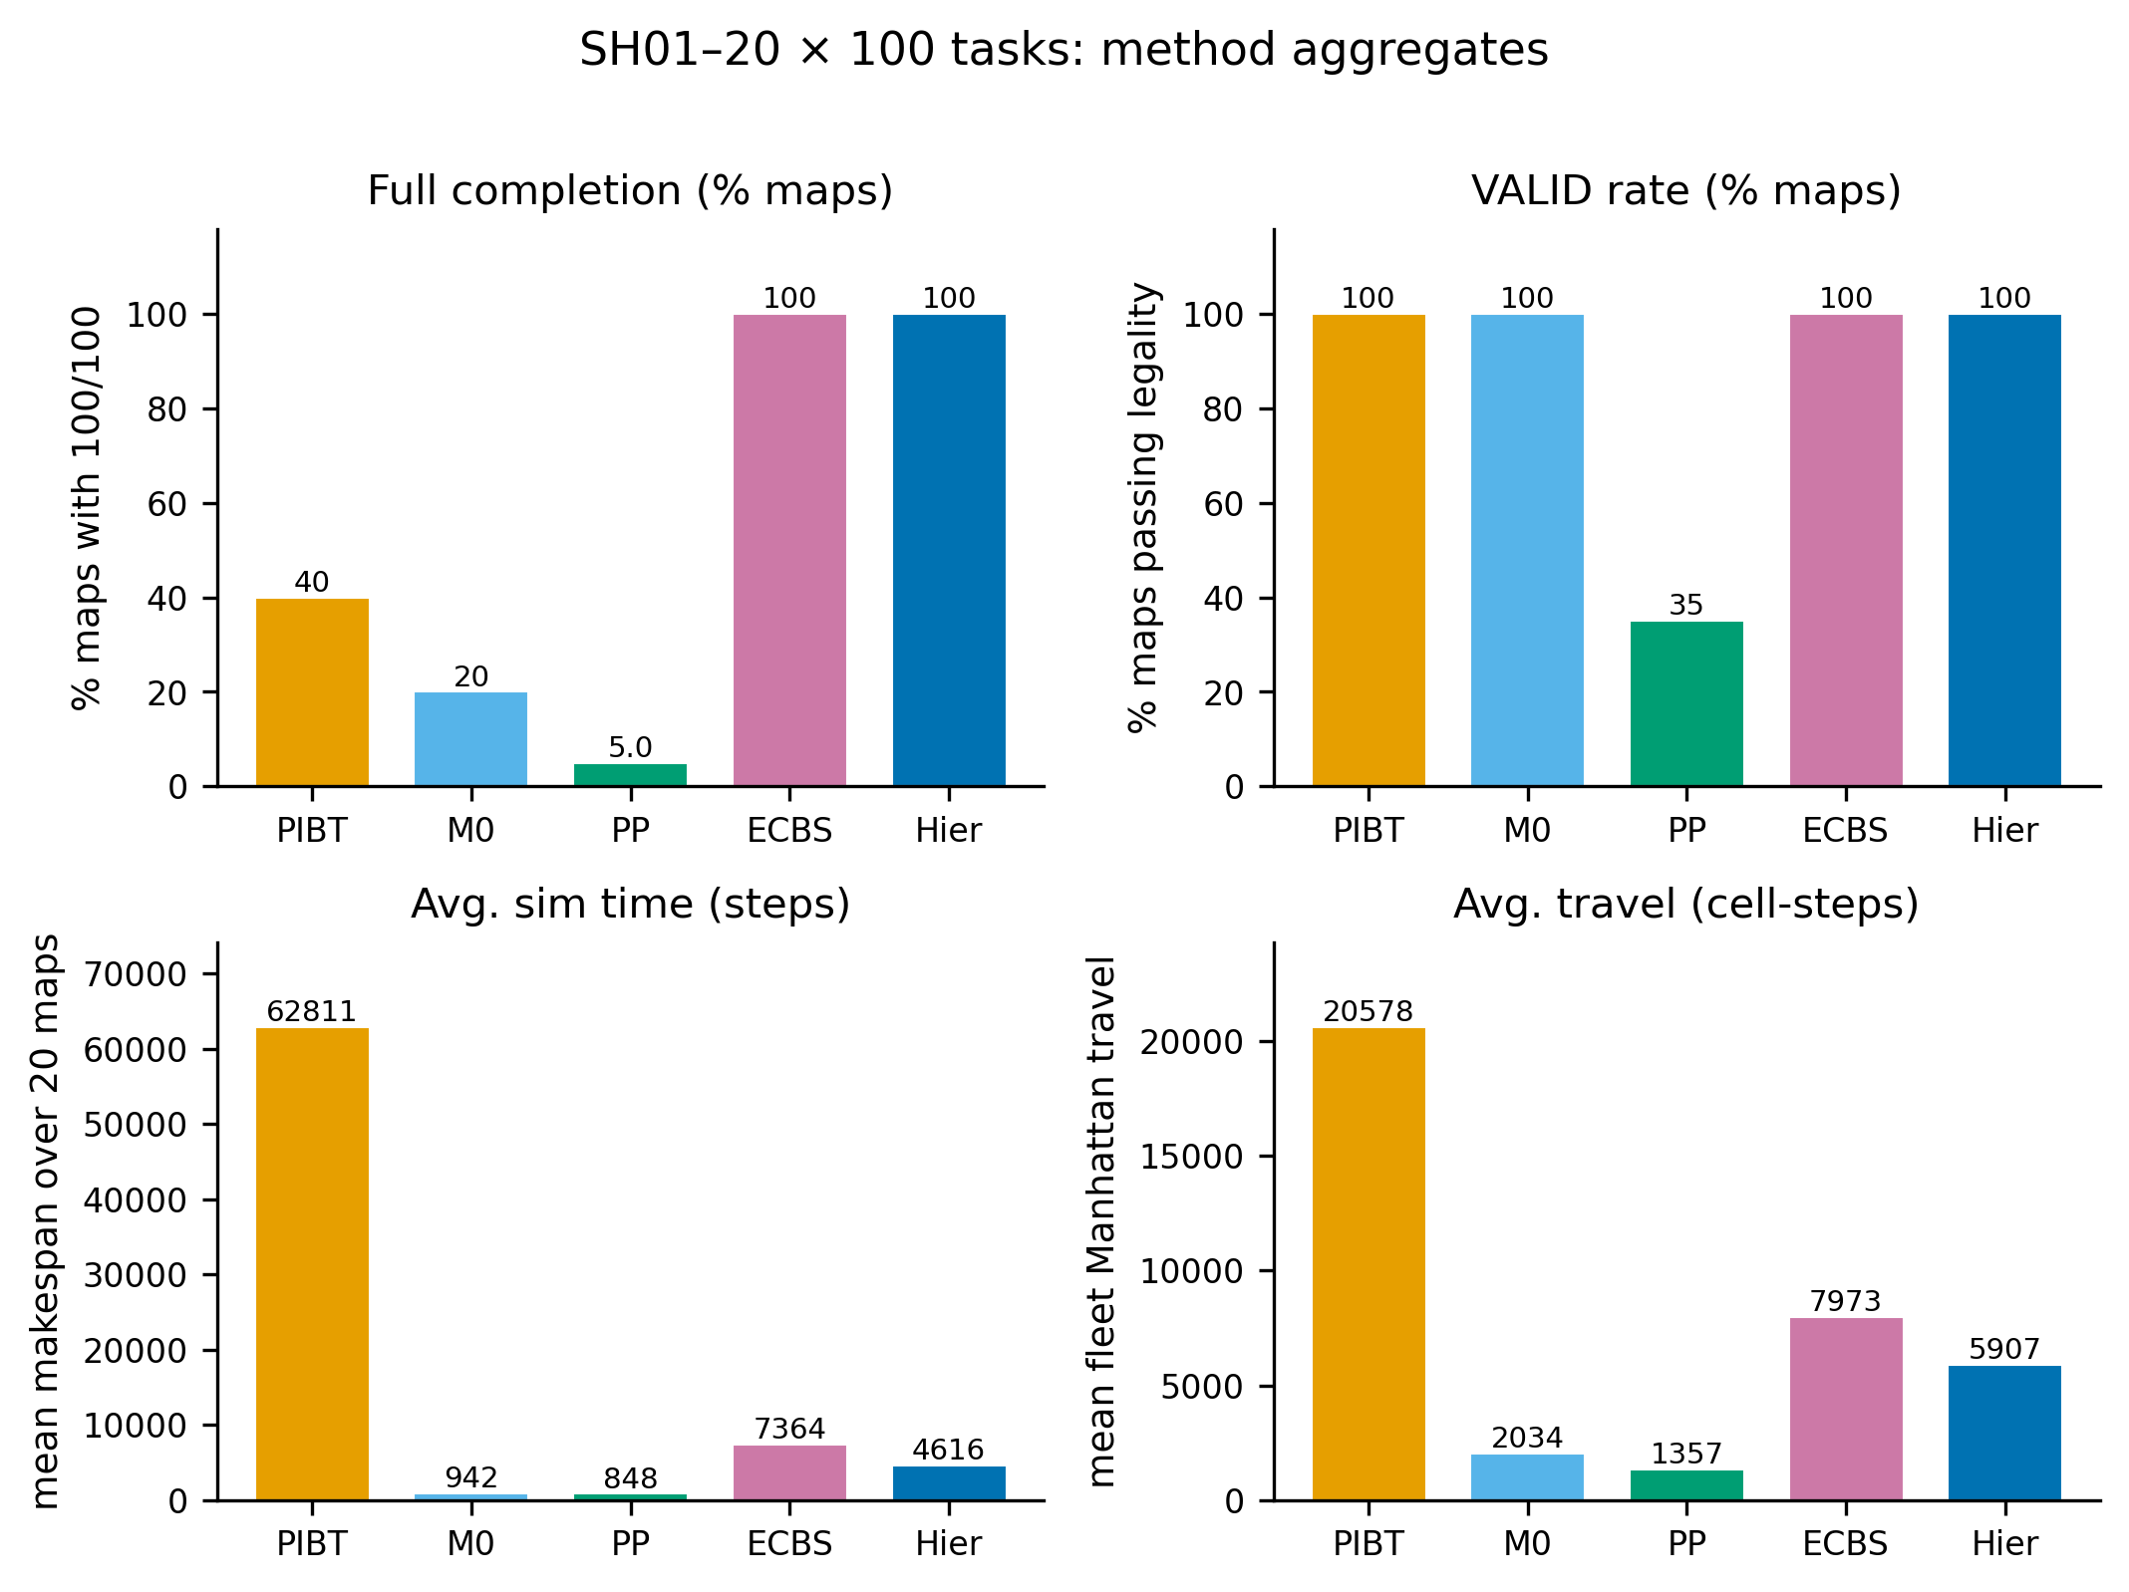
Figure 5. Aggregate bake-off bars: full completion, VALID, avg_done, avg_sim.
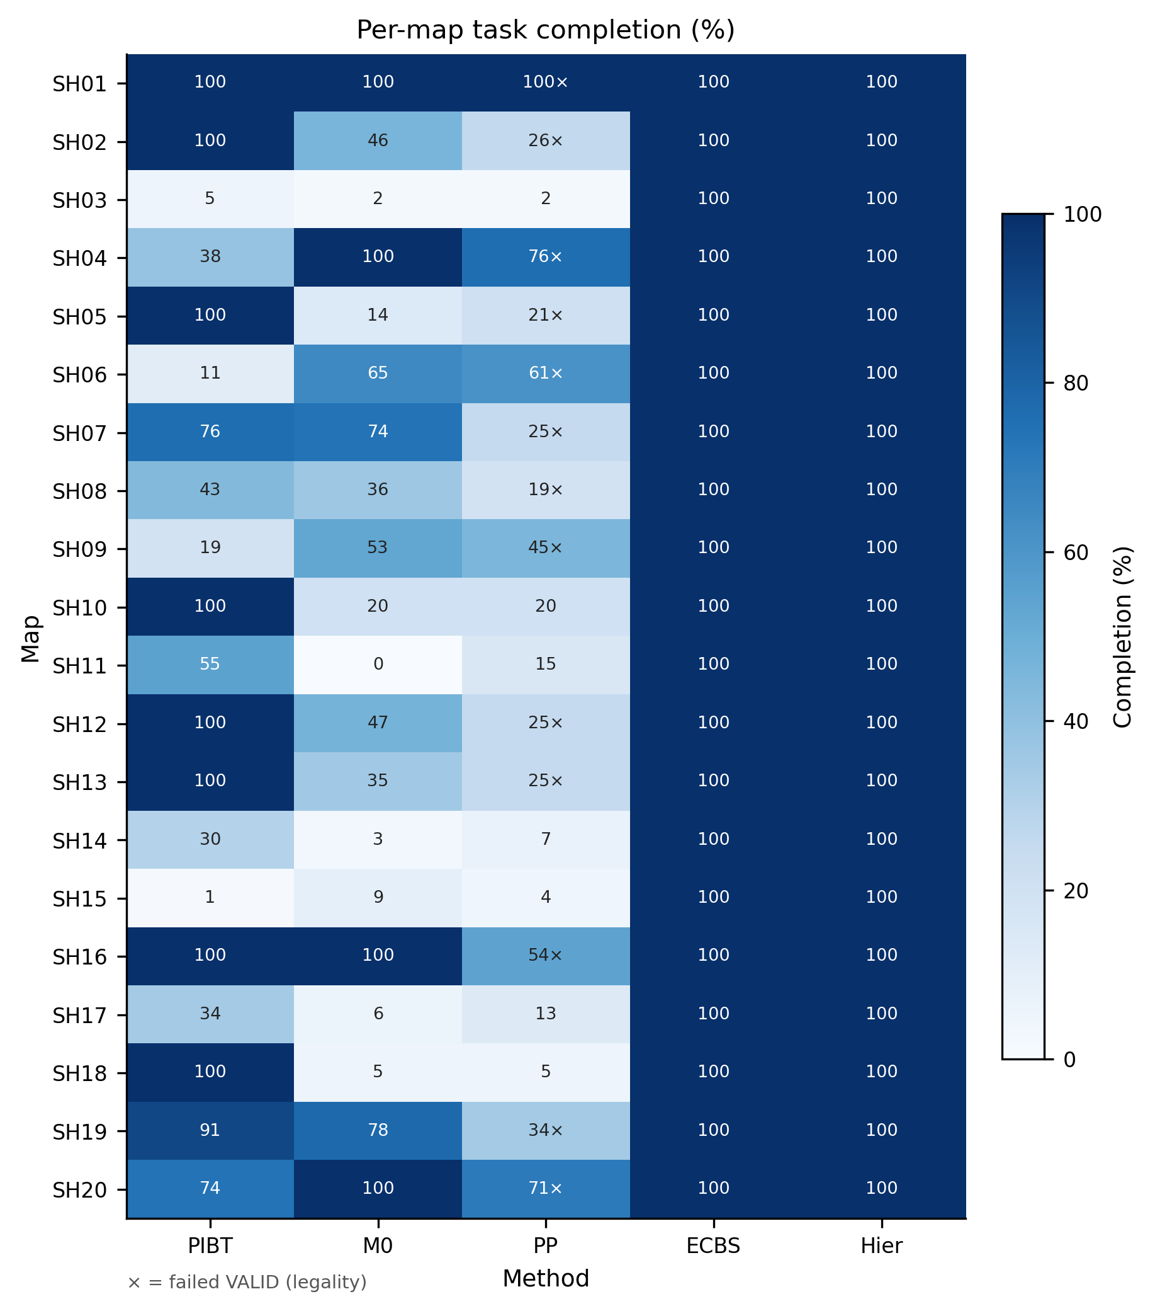
Figure 6. Per-map completion heatmap across five methods on SH01–SH20.
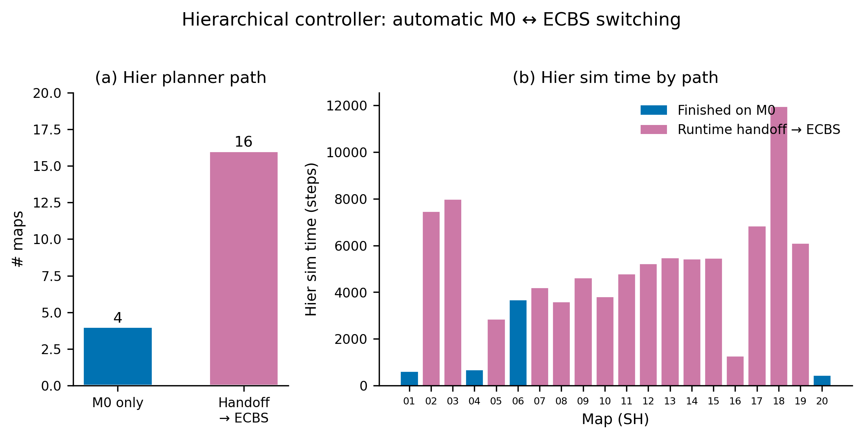
Figure 7. Hierarchical handoff behavior: M0 residence vs ECBS takeover.
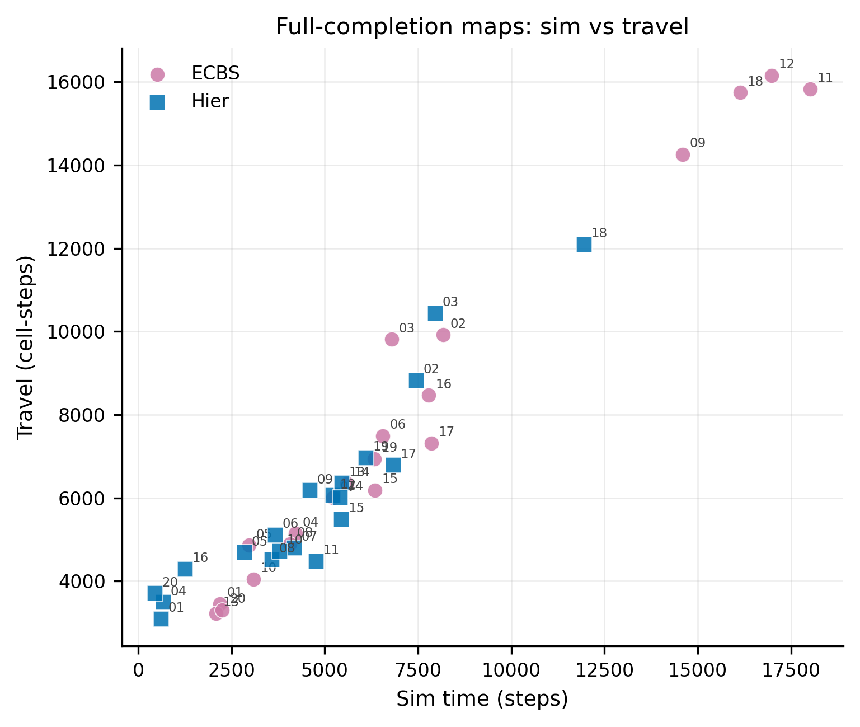
Figure 8. Pareto view of average simulation time versus fleet travel.
Interpretation summary. The experimental record supports three statements. (1) Joint search is necessary for full curriculum completion: only ECBS and Hier reach 20/20 full. (2) Legality is an independent axis: PP's INVALID rate disqualifies it despite occasional high done on easy maps. (3) Hierarchy improves operational makespan versus always-ECBS without sacrificing (1)–(2) on this protocol. Figures 5–8 reinforce these statements visually.
Threats to validity. Internal threats include wall-budget censoring and parameter sensitivity. External threats include map distribution shift and fleet-size scaling. Construct threats include treating avg_sim as a proxy for warehouse throughput when real systems also care about energy and wear. We mitigate internal threats by fixing task files and reporting multiple metrics side by side.
Reproducibility appendix note. Batch outputs under ml_research/results/coord_custom_ai/compare_100/ provide JSONL traces, SUMMARY.md aggregates, and figure assets used in this section. Hierarchical gate and StallEscalateNet checkpoints are versioned under the research checkpoint directory referenced by the code.

SECTION V
CONCLUSION AND FUTURE WORK
This report developed a hierarchical lifelong MAPD system for warehouse AGVs under strict MioVerse / Siemens Xcelerator-style rules. We detailed an improved spatiotemporal A* executor (M0), a windowed ECBS lifelong pipeline with cargo/FIFO guards, a stall-driven hierarchical gate with snapshot handoff, and compact AI modules for swap decisions and thrash escalation.
On SH01–SH20 with 100-task instances, hierarchy matched always-on ECBS at 20/20 full completions and 20/20 VALID while reducing average simulation time from 7364 to 4616 ticks (about 37%). Reactive PIBT and pure M0/PP baselines could not jointly satisfy completion and legality at this level. These results support gated escalation as a practical accuracy–efficiency design pattern for lifelong warehouse MAPD.
Future work includes tighter anytime ECBS shrink policies to reduce Hier wall-clock; richer assignment learning beyond SwapNet; broader map distributions and larger fleets; closer integration of offline SceneDifficulty curriculum generation; formal guarantees for handoff invariants; and transferring the hierarchy to continuous-time kinodynamic models. We also plan extended ablations isolating StallEscalateNet precision–recall operating points and public release of anonymized compare_100 aggregates for reproducible comparison.
In closing, the project demonstrates that Data Science practice for multi-agent logistics is not only model training but also systems measurement: validators, stall features, and bake-offs are first-class artifacts. Hierarchical control, grounded in those measurements, converts two imperfect planners into one stronger lifelong policy.

REFERENCES
[1] J. Yu and S. M. LaValle, "Structure and intractability of optimal multi-robot path planning on graphs," in Proc. AAAI, 2013.
[2] R. Stern et al., "Multi-agent pathfinding: Definitions, variants, and benchmarks," in Proc. SoCS, 2019.
[3] G. Sharon, R. Stern, A. Felner, and N. R. Sturtevant, "Conflict-based search for optimal multi-agent pathfinding," Artificial Intelligence, vol. 219, pp. 40–66, 2015.
[4] M. Barer, G. Sharon, R. Stern, and A. Felner, "Suboptimal variants of the conflict-based search algorithm," in Proc. SoCS, 2014.
[5] E. Boyarski et al., "ICBS: Improved conflict-based search algorithm for multi-agent pathfinding," in Proc. IJCAI, 2015.
[6] J. Li, A. Felner, E. Boyarski, H. Ma, and S. Koenig, "Improved heuristics for multi-agent path finding with conflict-based search," in Proc. IJCAI, 2019.
[7] J. Li et al., "Pairwise symmetry reasoning for multi-agent path finding search," Artificial Intelligence, vol. 301, 2021.
[8] H. Ma et al., "Lifelong multi-agent path finding for online pickup and delivery tasks," in Proc. AAMAS, 2017.
[9] M. Čáp, J. Vokřínek, and A. Kleiner, "Complete decentralized method for on-line multi-robot trajectory coordination," Annals Math. Artificial Intelligence, 2015.
[10] D. Silver, "Cooperative pathfinding," in Proc. AIIDE, 2005.
[11] J. Li et al., "Lifelong multi-agent path finding in large-scale warehouses," in Proc. AAAI, 2021.
[12] H. Ma, C. Tovey, G. Sharon, T. K. S. Kumar, and S. Koenig, "Multi-agent path finding with payload transfers and the package-exchange robot-routing problem," in Proc. AAAI, 2016.
[13] M. Erdmann and T. Lozano-Pérez, "On multiple moving objects," Algorithmica, vol. 2, pp. 477–521, 1987.
[14] D. Ratner and M. Warmuth, "Finding a shortest solution for the N×N extension of the 15-PUZZLE is intractable," in Proc. AAAI, 1986.
[15] K. Okumura, M. Machida, X. Défago, and Y. Tamura, "Priority inheritance with backtracking for iterative multi-agent path finding," in Proc. IJCAI, 2019.
[16] K. Okumura, "Improving PIBT for lifelong multi-agent pathfinding," arXiv preprint, 2023.
[17] K. Okumura, "LaCAM: Search-based algorithm for quick multi-agent pathfinding," in Proc. AAAI, 2023.
[18] G. Sartoretti et al., "PRIMAL: Pathfinding via reinforcement and imitation multi-agent learning," IEEE Robot. Autom. Lett., 2019.
[19] M. Damani, Z. Luo, E. Wenzel, and G. Sartoretti, "PRIMAL2: Pathfinding via reinforcement and imitation multi-agent learning – lifelong," IEEE Robot. Autom. Lett., 2021.
[20] Q. Li et al., "Graph neural networks for decentralized multi-agent path finding," in Proc. IROS, 2021.
[21] Z. Liu et al., "Mapper: Multi-agent path planning with evolutionary reinforcement learning," in Proc. AAMAS, 2020.
[22] H. Ma, D. Harabor, P. J. Stuckey, J. Li, and S. Koenig, "Searching with consistent prioritization for multi-agent path finding," in Proc. AAAI, 2019.
[23] P. R. Wurman, R. D'Andrea, and M. Mountz, "Coordinating hundreds of cooperative, autonomous vehicles in warehouses," AI Magazine, vol. 29, no. 1, 2008.
[24] R. D'Andrea, "Guest editorial: A revolution in the warehouse," IEEE Trans. Automation Science Eng., 2012.
[25] E. Lam, P. J. Stuckey, and D. Harabor, "Exact approaches to multi-agent path finding," tutorial notes, 2020.
[26] F. Grenouilleau, W.-J. van Hoeve, and J. N. Hooker, "A multi-label A* algorithm for multi-agent pathfinding," in Proc. ICAPS, 2019.
[27] S. D. Han and J. Yu, "Effective and efficient multi-robot path planning," in Proc. IROS, 2020.
[28] M. Liu, H. Ma, J. Li, and S. Koenig, "Task and path planning for multi-agent pickup and delivery," in Proc. AAMAS, 2019.
[29] X. Wang et al., "Multi-agent pickup and delivery with time windows," in Proc. ICAPS, 2022.
[30] G. Gange, D. Harabor, and P. J. Stuckey, "Lazy CBS: Implicit conflict-based search using lazy clause generation," in Proc. ICAPS, 2019.
[31] W. Hönig et al., "Summary: Multi-agent path finding with kinematic constraints," in Proc. ICAPS, 2016.
[32] S. Koenig and M. Likhachev, "D* Lite," in Proc. AAAI, 2002.
[33] M. Likhachev, D. Ferguson, G. Gordon, A. Stentz, and S. Thrun, "Anytime Dynamic A*: An anytime, replanning algorithm," in Proc. ICAPS, 2005.
[34] H. Zhang et al., "A hierarchical multi-agent path finding framework," workshop paper / preprint, 2022.
[35] W. Hönig, T. K. S. Kumar, L. Cohen, H. Ma, H. Xu, N. Ayanian, and S. Koenig, "Multi-agent path finding with kinematic constraints," in Proc. ICAPS, 2016.
[36] J. Li, P. Surynek, A. Felner, H. Ma, T. K. S. Kumar, and S. Koenig, "Multi-agent path finding for large agents," in Proc. AAAI, 2019.
[37] A. Felner et al., "Search-based optimal multi-agent path finding: Recent advances," AI Magazine, 2017.
[38] G. Wagner and H. Choset, "Subdimensional expansion for multi-robot path planning," Artificial Intelligence, vol. 219, 2015.
[39] R. Barták, J. Švancara, and M. Vlk, "A scheduling-based approach to multi-agent path finding," in Proc. IJCAI, 2018.
[40] P. Surynek, "An optimization variant of multi-robot path planning is intractable," in Proc. AAAI, 2010.

