Research Plan: Lifelong Multi-AGV Task Allocation and Path Finding(MAPF)

1. Problem Setting
Lifelong multi-AGV pickup-and-delivery on a grid warehouse: parcels move from induction stations to destination chutes. Goals: high throughput / short makespan, collision-free motion, and operational constraints.

1.1 Environment
- Map: 20 m x 20 m grid (scale may increase in experiments), 1 m cells; axis-aligned moves, one cell per second.
- Induction stations (6) with one pickup cell each; destination chutes (16) with four adjacent unload cells each.
- Baseline fleet: 12 homogeneous AGVs (larger fleets in scaling studies).

1.2 AGV Model
- Speed 1 m/s; ignore acceleration.
- In-place turns only (+/-90 / 180 deg), each 1 s.
- Load and unload each 1 s; waiting in integer seconds; one parcel per AGV.

1.3 Tasks and Constraints
- Task: station, chute, priority (normal/urgent), optional remaining time.
- FIFO per induction station; at most one pickup per station per second.
- Unload only at a valid unload cell; no diagonal moves.
- Conflicts: same cell at the same time, or head-on swap.
- No turn in the same timestep as load/unload.

1.4 Scope: Allocator vs Path Planner
- Learning target: task allocator only — choose pairs (AGV, task).
- Path layer: space-time reserved A* (and/or scalable space A* + execution shield). This is prioritized / reserved search: useful and scalable, but not complete multi-agent search (unlike CBS).
- Do not claim: completeness, optimality, or guaranteed deadlock elimination. Deadlocks and plan failures are measured and analyzed as failure modes.

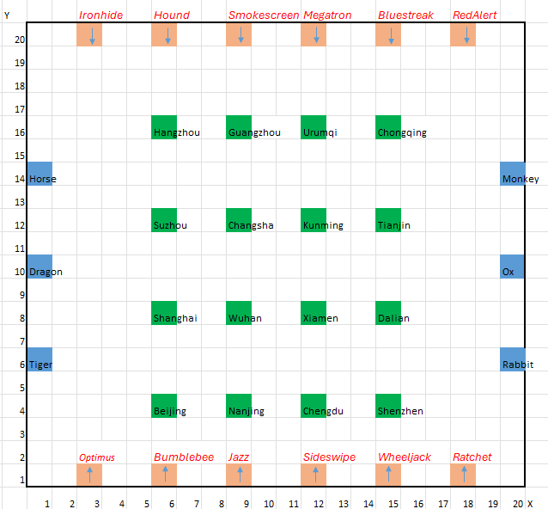

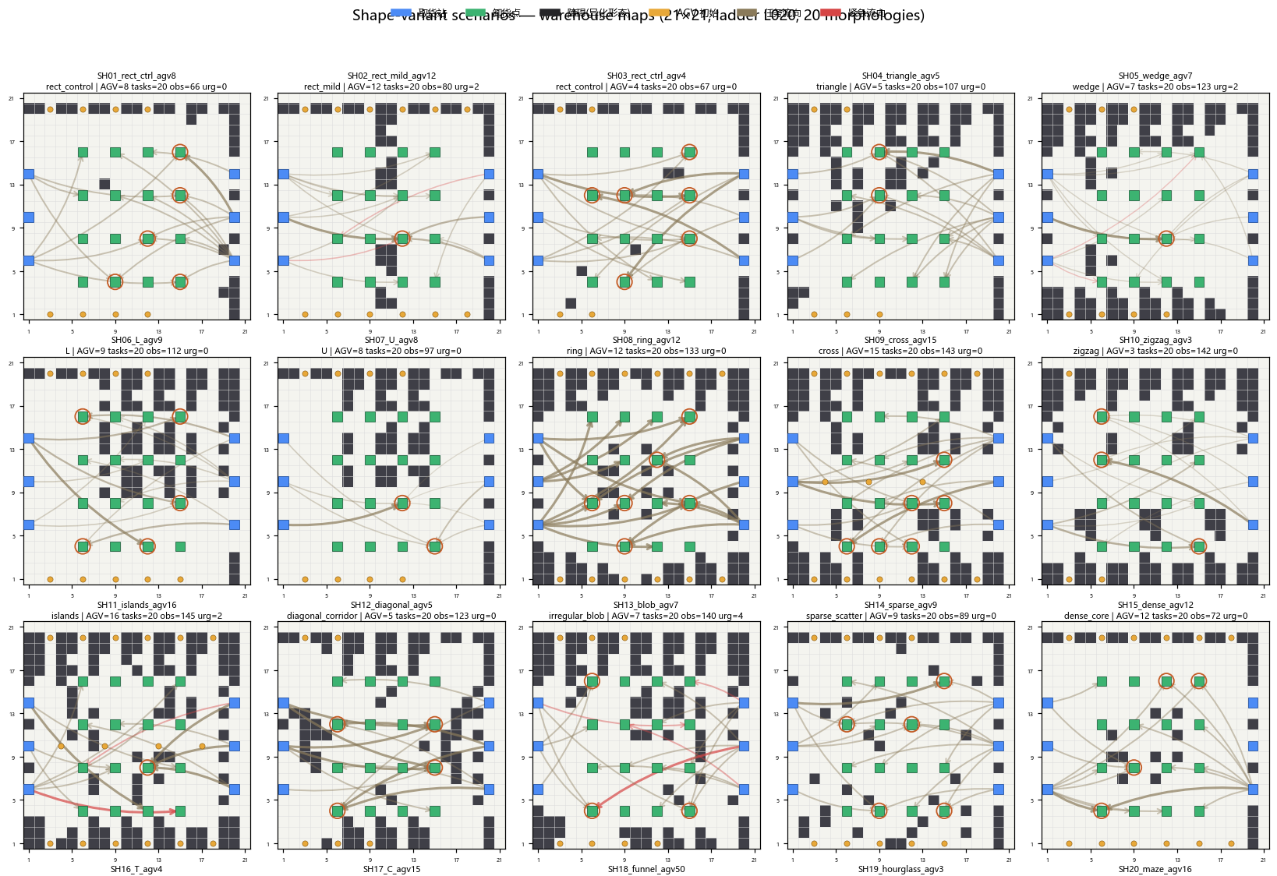

2. Positioning and Intended Novelty
BC/RL for assignment already exists in the literature. Novelty is problem- and system-centered, not the slogan of BC+RL:
- Problem: lifelong MAPD with industrial constraints (FIFO induction, urgency deadlines, load/unload and turn times, multi-cell chutes).
- Method: learn only the task allocator (dispatcher); paths stay with space-time reserved search (safety shield).
- Evidence: compare against cost-matrix / matching baselines under scale, dynamics, and execution noise; report when learning helps and when it fails.
One-line contribution: a constraint-aware learned allocator for lifelong industrial multi-AGV dispatch, evaluated against classical cost-based dispatch under engineering stress—not a claim of inventing BC+RL.
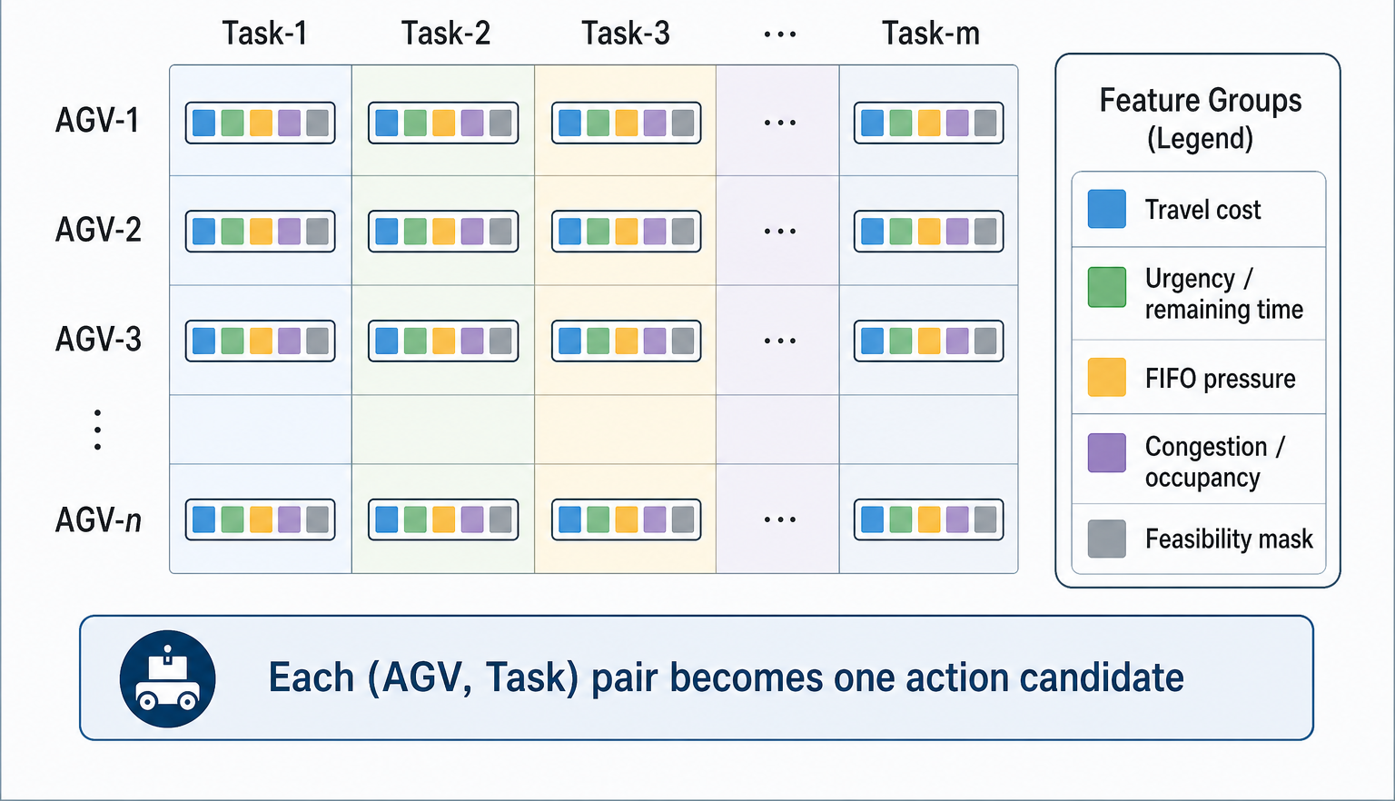

3. Method: BC Warm-Start + RL Fine-Tuning
Pipeline: BC imitates expert assignments -> RL fine-tunes for operational metrics -> search shield produces executable paths.

3.2 Behavior Cloning
- Record (features, legal mask, expert pair index) while experts run.
- Train a masked pair-scoring network with cross-entropy.
- Use pi_BC only as a short warm start for RL.

3.3 RL Fine-Tuning (to beat cost-matrix baselines)
Current risk: if RL uses step rewards dominated by -cost, it rediscovers the cost matrix and rarely beats it. Planned fixes:
- Episode-level rewards: throughput, makespan, urgent lateness, plan failure, idle/deadlock proxies—not primarily -Manhattan cost.
- True on-policy rollouts with the learned allocator + search shield.
- Train on hard scenes (hub congestion, urgent bursts, dynamics); require only near-parity on light load.
- Features beyond cost: queue pressure, endpoint occupancy, recent conflicts, plan-failure history, time-to-deadline slack.
- Optional relative reward vs a frozen M0 cost-matrix baseline on the same scene.
- Keep BC short; align train/eval checkpoints (no silent fallback to cost-softmax).

3.4 Baselines
Greedy cost matrix (M0), Hungarian (M1), priority planning (M2), token-passing (M3), rolling matching (M5). Proposed: BC+RL allocator + search shield (M4). Expectation: gains mainly under congestion/dynamics/urgency; light load should not regress much.

4. Expected Problems and Risks

4.1 Learning / Allocator
- May not beat a well-tuned cost matrix on easy scenes; must show selective gains.
- Reward misspecification: cost-shaped RL collapses to M0-like behavior.
- Sample efficiency and wall-clock cost of episode-level PPO.
- Partial observability / feature gaps: network cannot beat heuristics if inputs carry no extra information.
- Checkpoint / feature mismatch between training and evaluation.

4.2 Path Planning / Execution
- Space-time reserved A* is incomplete for multi-AGV; solvable instances may fail.
- Deadlocks, endpoint blocking, and cascading plan failures under high density.
- Execution noise breaks reserved trajectories; shield reduces collisions but does not guarantee liveness.
- Complete solvers (e.g. CBS) are too slow for large lifelong instances; at most small-scale references or windowed variants.

4.3 System / Thesis Risks
- Scope creep: rewriting a complete planner distracts from the allocator thesis.
- Weak novelty if results only show marginal ties with M0 on the default map.
- Reproducibility: seed, scene generation, and fair wall-time budgets.
- Industrial constraints (FIFO, urgency) complicate fair comparison if baselines are not constrained identically.

4.4 Mitigation
- Fix episode rewards and on-policy training before claiming superiority.
- Report failure cases and deadlock/plan-failure metrics explicitly.
- Use complete planners only as optional small baselines, not as the main shield.
- Keep contribution wording problem/system-focused; avoid overclaiming optimality.

5. Expected Contributions and Timeline
- Contributions: (1) industrial lifelong MAPD setting for learned allocation; (2) BC->RL allocator with search safety layer and constraint-aware features/rewards; (3) stress evaluation and failure analysis vs cost-based dispatch.
- Months 1-2: simulator, metrics, baselines.
- Months 2-4: expert demos and BC.
- Months 4-7: episode-level RL and main comparisons.
- Months 6-9: scale / dynamics / noise studies.
- Months 8-12: analysis, writing, revision.

6. Working Title
Lifelong Multi-AGV Task Allocation under Industrial Warehouse Constraints: Behavior Cloning, Reinforcement Learning, and Search-Based Safety

