May, 28, 2021

BSCS- 2 Act. 3

Write a Python program to construct the following pattern, using a nested for loop.

             1

          2 1 2

      3 2  1 2 3

   4 3 2 1 2 3  4

5 4 3 2 1 2 3 4 5

   4 3 2 1 2 3 4

      3 2 1 2 3

          2 1 2

              1

***Answer:***

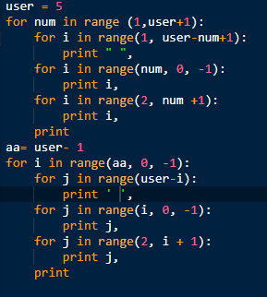 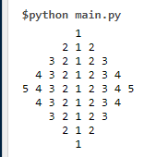

***Code:***

user = 5

for num in range (1,user+1):

for i in range(1, user-num+1):

print " ",

for i in range(num, 0, -1):

print i,

for i in range(2, num +1):

print i,

print

aa= user- 1

for i in range(aa, 0, -1):

for j in range(user-i):

print ' ',

for j in range(i, 0, -1):

print j,

for j in range(2, i + 1):

print j,

print