CPSC 405 DATA MINING

Decision Tree GUI User Manual

Table of Contents

Overview 1

Connecting to a Robot 1

Connect Panel 2

Awareness Panel 3

Text to Speech Panel 5

Posture Panel 6

Motion Panel 7

Application Panel 9

Camera and Diagnostics 10

Section

1

Overview

The Decision Tree GUI allows a user to open a csv file, perform Decision Tree operations on it, and export the results.

Opening a Csv File

By default, upon opening the GUI, it is empty. The first step is to open a csv file.

**Step 1:** Select File -> Open Csv in the top left corner of the GUI.

**Step 2:** Navigate to the desired csv file, and press open. The GUI will import the data and display it in an easily readable format.

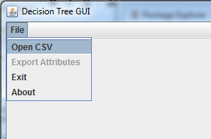

Section

2

Initialization

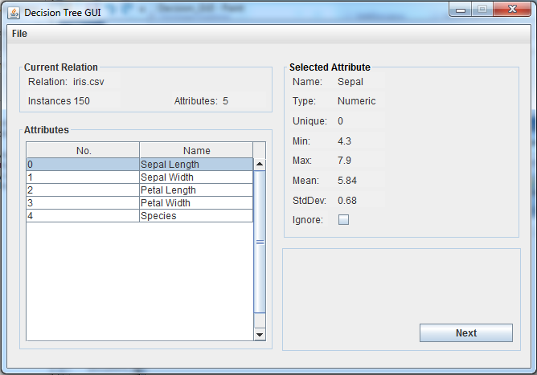

After opening a Csv file, the GUI will display the following information.

**Current Relation:**

* Relation: The opened file.
* Instances: The number of rows contained within the file.
* Attributes: The number of columns contained within the file.

**Attributes:** The Attributes pane displays a table listing all of the Attributes. Selecting a new Attribute will update the Selected Attribute pane.

**Selected Attribute:**

* Name: The name of the attribute
* Type: The type of the attribute as “Numeric” or “Categorical”
* Unique: If the attribute is Categorical, it will display the number of unique values associated with the attribute.
* Min: The minimum value of the attribute.
* Max: The maximum value of the attribute.
* Mean: The mean of the attribute.
* StdDev: The standard deviation of the attribute.
* Ignore: Selecting this checkbox will cause the program to ignore this attribute at runtime.

From this window you can also export the attributes as a csv file.

**Step 1:** Select File -> Export Attributes in the top left corner of the GUI.

**Step 2:** Navigate to where you wish the file to be saved, enter a name, and press export.

Section

3

Running the Algorithm

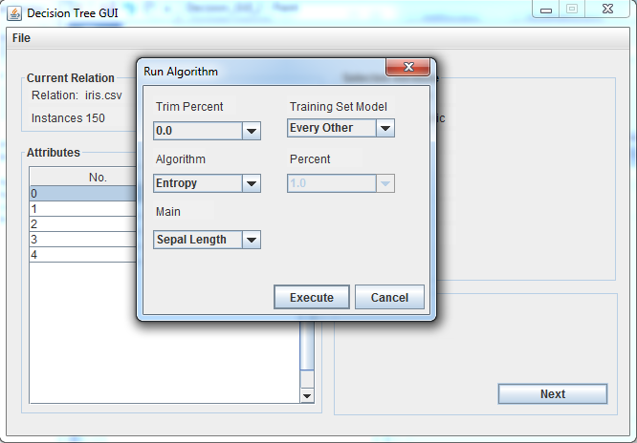

To run the algorithm, press the Next button to display a new Dialog. This Dialog contains the following selections.

**Trim:** Trims the data by a set percentage. 0 will cause no trim. 90 will cause 90% of the data to be trimmed.

**Training Set Model:**

* Every Other: The Test Set and Training Set will be of equal size, selecting alternating rows to assign to each.
* Percentage: The Training Set will consist of a percentage of the data, with the Test set consisting of the rest. The percent combo box allows you to specifiy the percentage.

**Algorithm:**

* Entropy: The Entropy algorithm will be used to calculate the decision tree.
* Gini: The Gini algorithm will be used to calculate the decision tree.

**Main:** Allows you to set the main class of the data. This is what the data will be sorted into.

Section

4

Results

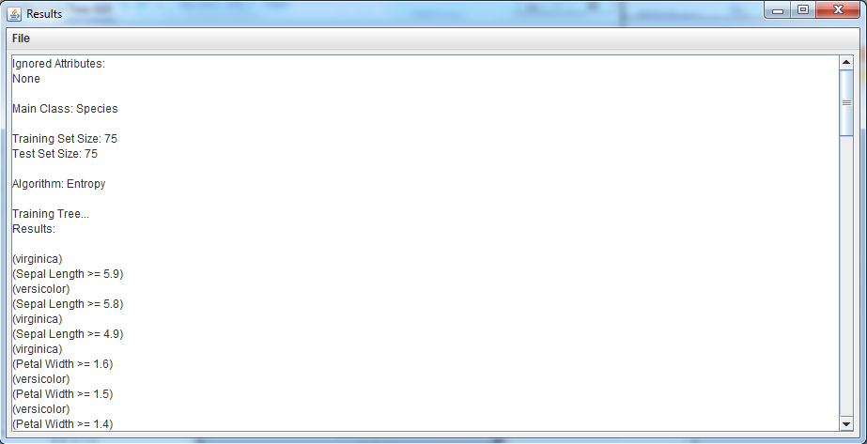

Pressing execute will cause the program to train the tree and classify the test set. The results window will display the tree and the resulting sets. From this window, selecting File -> Save will allow you to save the result console. You can also export the training set and test set as csv files.

.