ANA500 Micro-Project 4: Can Recurrent Neural Networks Forecast Tomorrow's Electricity Demand?
Dataset: Hourly Energy Consumption, PJM East region, Kaggle (https://www.kaggle.com/datasets/robikscube/hourly-energy-consumption)
Tools: Python, NumPy, pandas, statsmodels, scikit-learn, TensorFlow/Keras, Matplotlib, Seaborn
Author: Zeena Keshwji | Date: November 6, 2026

Problem statement
Electricity cannot be stored cheaply at grid scale, so generation has to match demand hour by hour. PJM East demand in this data swings between about 14,500 MW and 62,000 MW. Under-forecasting risks shortages and expensive last-minute generation; over-forecasting wastes committed capacity. We want to predict each of the next 24 hourly load values (in megawatts) from the past load history and the calendar.

Hypothesis
Demand is a repeating pattern with memory, so a model that reads the recent load as a sequence should forecast it best:
- H1 (cycles): Load has strong daily, weekly and annual cycles.
- H2 (deep learning vs. baselines): A recurrent network beats the seasonal-naive forecast and linear (ridge) regression.
- H3 (recurrence and gating): Gated recurrent networks (LSTM, GRU) beat a plain RNN and a feed-forward network given the same inputs.
- H4 (memory length): A one-week input window beats a one-day window.
- H5 (error structure): The largest errors fall in summer peaks and on holidays, because the data has no weather variable.
Models are compared on a chronological hold-out test set (2017 to August 2018). Differences in error are tested with a paired block bootstrap at alpha = 0.05.

Step 0. Set up the environment
# Quiet TensorFlow's start-up logging; must be set before TensorFlow is imported
import os
os.environ["TF_CPP_MIN_LOG_LEVEL"] = "3"
# Core data handling
import numpy as np
import pandas as pd
# Visualization (Matplotlib + Seaborn)
import matplotlib.pyplot as plt
import matplotlib.dates as mdates
import seaborn as sns
# Time-series diagnostics and the U.S. federal holiday calendar
from statsmodels.tsa.stattools import acf
from scipy.stats import mannwhitneyu
from pandas.tseries.holiday import USFederalHolidayCalendar
# Machine-learning baselines from Micro-Project 3
from sklearn.linear_model import Ridge
from sklearn.ensemble import HistGradientBoostingRegressor
from sklearn.metrics import r2_score
# Deep learning
import tensorflow as tf
import keras
from keras import layers
import time
import urllib.request
import zipfile
import warnings
warnings.filterwarnings("ignore")
# One consistent look: teal = the data / best model, coral = highlights, gray = baselines
sns.set_theme(style="whitegrid", context="notebook")
TEAL, CORAL, GRAY = "#17877B", "#E4572E", "#8A9099"
os.makedirs("figures", exist_ok=True) # every chart is also saved for the slide deck
pd.set_option("display.width", 130)
pd.set_option("display.max_columns", 20)
# Deterministic TensorFlow ops, so that re-running this notebook gives the same numbers
tf.config.experimental.enable_op_determinism()
SEEDS = [42, 7, 2026] # every neural network is trained once per seed
print("TensorFlow", tf.__version__, "| Keras", keras.__version__)
TensorFlow 2.20.0 | Keras 3.10.0

Step 1. Acquire
Identify: the Kaggle "Hourly Energy Consumption" dataset (user robikscube), which holds hourly load published by PJM Interconnection, the grid operator for much of the eastern U.S. We use the PJM East region file, the longest series.
Retrieve: if the CSV is not on disk, the cell downloads the ZIP from Kaggle's public endpoint and extracts it.
Query: the file is read into a pandas DataFrame.
DATA_PATH = "data/PJME_hourly.csv"
DATA_URL = "https://www.kaggle.com/api/v1/datasets/download/robikscube/hourly-energy-consumption"
# Retrieve the file only if it is not already on disk, so the notebook is reproducible
if not os.path.exists(DATA_PATH):
os.makedirs("data", exist_ok=True)
urllib.request.urlretrieve(DATA_URL, "data/hourly-energy-consumption.zip")
with zipfile.ZipFile("data/hourly-energy-consumption.zip") as z:
z.extract("PJME_hourly.csv", "data")
# Query: load the file and parse the timestamp column
raw = pd.read_csv(DATA_PATH, parse_dates=["Datetime"])
print("Shape:", raw.shape)
print("Range:", raw["Datetime"].min(), "to", raw["Datetime"].max())
print("Already in time order?", raw["Datetime"].is_monotonic_increasing)
raw.head()
Shape: (145366, 2)
Range: 2002-01-01 01:00:00 to 2018-08-03 00:00:00
Already in time order? False
Datetime PJME_MW
0 2002-12-31 01:00:00 26498.0
1 2002-12-31 02:00:00 25147.0
2 2002-12-31 03:00:00 24574.0
3 2002-12-31 04:00:00 24393.0
4 2002-12-31 05:00:00 24860.0

Step 2. Prepare

2a. Clean the time index
A recurrent network assumes evenly spaced steps, so the index must be a perfect hourly grid. We check for missing values, duplicate timestamps and gaps.
# Quality checks on the raw file
n_null = int(raw["PJME_MW"].isna().sum())
dups = raw[raw["Datetime"].duplicated(keep=False)].sort_values("Datetime")
print("Missing load values:", n_null)
print("Rows sharing a timestamp:", len(dups), "on", dups["Datetime"].dt.date.nunique(), "dates (fall daylight-saving hour)")
# Sort by time; the two readings in a repeated daylight-saving hour are averaged
load = raw.groupby("Datetime")["PJME_MW"].mean().sort_index()
# Reindex onto a complete hourly grid to expose gaps
load = load.asfreq("H")
gaps = load[load.isna()].index
print("Hours missing from the grid:", len(gaps), "| by month:", gaps.month.value_counts().sort_index().to_dict())
# Gaps are isolated single hours (mostly the spring daylight-saving hour), so time interpolation is safe
longest_gap = load.isna().astype(int).groupby(load.notna().cumsum()).sum().max()
print("Longest gap (hours):", longest_gap)
load = load.interpolate("time")
print("Clean series:", len(load), "hours, missing now:", int(load.isna().sum()))
print(load.describe().round(0).to_string())
print("Lowest reading:", load.idxmin(), "(Hurricane Sandy) =", int(load.min()), "MW")
print("Highest reading:", load.idxmax(), "=", int(load.max()), "MW")
Missing load values: 0
Rows sharing a timestamp: 8 on 4 dates (fall daylight-saving hour)
Hours missing from the grid: 30 | by month: {3: 12, 4: 5, 10: 5, 11: 7, 12: 1}
Longest gap (hours): 1
Clean series: 145392 hours, missing now: 0
count 145392.0
mean 32079.0
std 6464.0
min 14544.0
25% 27571.0
50% 31420.0
75% 35647.0
max 62009.0
Lowest reading: 2012-10-30 04:00:00 (Hurricane Sandy) = 14544 MW
Highest reading: 2006-08-02 17:00:00 = 62009 MW

2b. Explore: testing H1
We look at the long-run series, the typical shape by hour and month, and the autocorrelation function.
# Figure 1: the full series as daily peaks, with one sample week below it
fig, axes = plt.subplots(2, 1, figsize=(11, 5.4), gridspec_kw={"height_ratios": [1.3, 1]})
daily_peak = load.resample("D").max()
axes[0].plot(daily_peak.index, daily_peak / 1000, color=TEAL, lw=0.6)
axes[0].set(title="Daily peak load, PJM East, 2002-2018", ylabel="GW")
week = load["2017-07-17":"2017-07-23"]
axes[1].plot(week.index, week / 1000, color=TEAL, lw=2)
axes[1].set(title="One week of hourly load, July 17-23, 2017", ylabel="GW")
axes[1].xaxis.set_major_formatter(mdates.DateFormatter("%a"))
axes[1].xaxis.set_major_locator(mdates.DayLocator())
plt.tight_layout(); plt.savefig("figures/01_load_overview.png", dpi=200); plt.show()
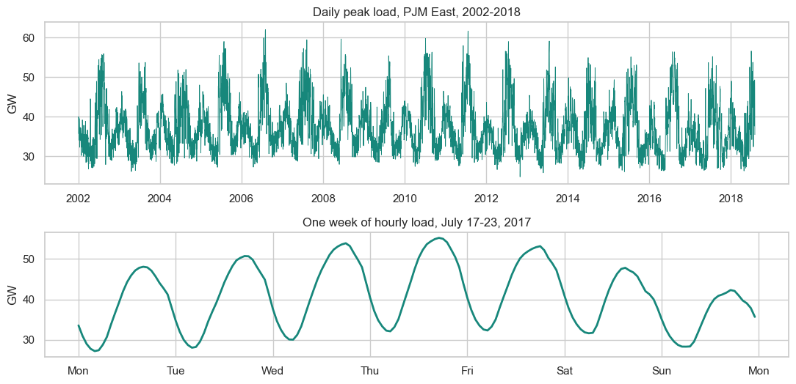
# Calendar view: average load by hour and month, and by hour for weekdays vs. weekends
profile = load.groupby([load.index.month, load.index.hour]).mean().unstack() / 1000
fig, axes = plt.subplots(1, 2, figsize=(11, 4), gridspec_kw={"width_ratios": [1.25, 1]})
sns.heatmap(profile, cmap="YlGnBu", ax=axes[0], cbar_kws={"label": "Average GW"},
yticklabels=["Jan", "Feb", "Mar", "Apr", "May", "Jun", "Jul", "Aug", "Sep", "Oct", "Nov", "Dec"])
axes[0].set(title="Average load by month and hour", xlabel="Hour of day", ylabel="")
axes[0].tick_params(axis="y", rotation=0)
is_weekend = load.index.dayofweek >= 5
for mask, label, color in [(~is_weekend, "Weekday", TEAL), (is_weekend, "Weekend", CORAL)]:
prof = load[mask].groupby(load[mask].index.hour).mean() / 1000
axes[1].plot(prof.index, prof.values, color=color, lw=2, label=label)
axes[1].set(title="Average daily shape", xlabel="Hour of day", ylabel="GW")
axes[1].legend(frameon=False)
plt.tight_layout(); plt.savefig("figures/02_calendar_patterns.png", dpi=200); plt.show()
# Size of each cycle in plain numbers
hour_mean = load.groupby(load.index.hour).mean()
month_mean = load.groupby(load.index.month).mean()
print(f"Daily cycle: lowest hour {hour_mean.idxmin()}:00 = {hour_mean.min():,.0f} MW, highest hour {hour_mean.idxmax()}:00 = {hour_mean.max():,.0f} MW")
print(f"Annual cycle: lowest month {month_mean.idxmin()} = {month_mean.min():,.0f} MW, highest month {month_mean.idxmax()} = {month_mean.max():,.0f} MW")
print(f"Weekday mean {load[~is_weekend].mean():,.0f} MW vs. weekend mean {load[is_weekend].mean():,.0f} MW")
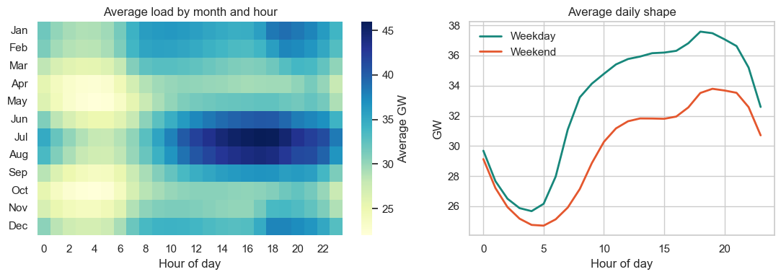
Daily cycle: lowest hour 4:00 = 25,415 MW, highest hour 19:00 = 36,427 MW
Annual cycle: lowest month 4 = 27,861 MW, highest month 7 = 37,882 MW
Weekday mean 32,996 MW vs. weekend mean 29,784 MW
# Autocorrelation out to two weeks: peaks at multiples of 24 and at 168 show the cycles
lags = 24 * 14
ac = acf(load, nlags=lags, fft=True)
fig, ax = plt.subplots(figsize=(9, 3.6))
ax.plot(range(lags + 1), ac, color=TEAL, lw=1.6)
for lag, text in [(24, "24 h"), (168, "168 h (1 week)")]:
ax.scatter([lag], [ac[lag]], color=CORAL, zorder=3, s=40)
ax.annotate(f"{text}: {ac[lag]:.2f}", (lag, ac[lag]), xytext=(6, 8), textcoords="offset points", fontsize=10)
ax.set(title="Autocorrelation of hourly load", xlabel="Lag (hours)", ylabel="Correlation", ylim=(0, 1.08))
plt.tight_layout(); plt.savefig("figures/03_autocorrelation.png", dpi=200); plt.show()
print(f"ACF: lag 1 = {ac[1]:.3f}, lag 12 = {ac[12]:.3f}, lag 24 = {ac[24]:.3f}, lag 168 = {ac[168]:.3f}")
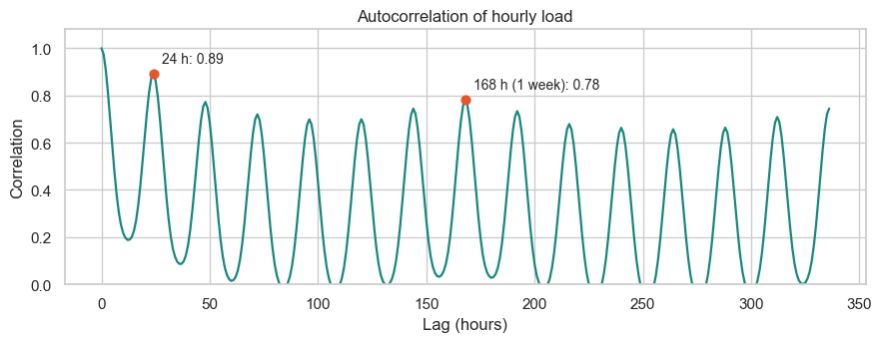
ACF: lag 1 = 0.975, lag 12 = 0.189, lag 24 = 0.891, lag 168 = 0.782

2c. Features and supervised windows
Each sample is one forecast. The model sees the last 168 hours of load with calendar features and the calendar of the next 24 hours (known in advance), and predicts the next 24 hourly loads. The calendar uses sine and cosine pairs so that hour 23 sits next to hour 0 and December next to January, plus a flag for weekends and federal holidays.
The split is chronological, because a random split would leak the future into training:
Set | Forecast target dates | Use
Train | 2002 to 2014 | Fit parameters and scalers
Validation | 2015 to 2016 | Early stopping, tuning, choosing the final model, calibrating intervals
Test | Jan 2017 to Aug 2, 2018 | Final results only

Training windows start every 6 hours to give the networks more examples. Validation and test forecasts are all issued at midnight, one per day, so every day is scored once.
# Calendar features for every hour in the series
idx = load.index
holidays = USFederalHolidayCalendar().holidays(start=idx.min(), end=idx.max())
is_off = ((idx.dayofweek >= 5) | idx.normalize().isin(holidays)).astype("float32")
calendar = np.column_stack([
np.sin(2 * np.pi * idx.hour / 24), np.cos(2 * np.pi * idx.hour / 24),
np.sin(2 * np.pi * idx.dayofweek / 7), np.cos(2 * np.pi * idx.dayofweek / 7),
np.sin(2 * np.pi * idx.dayofyear / 365.25), np.cos(2 * np.pi * idx.dayofyear / 365.25),
is_off,
]).astype("float32")
# Split boundaries, as positions in the hourly array
HORIZON, WINDOW = 24, 168
VAL_START, TEST_START = idx.get_loc(pd.Timestamp("2015-01-01 00:00")), idx.get_loc(pd.Timestamp("2017-01-01 00:00"))
# Standardize load with TRAINING statistics only, so nothing is learned from later data
mu, sigma = load.iloc[:VAL_START].mean(), load.iloc[:VAL_START].std()
z = ((load.values - mu) / sigma).astype("float32")
past_features = np.column_stack([z, calendar]) # 8 features per past hour
print(f"Training mean {mu:,.0f} MW, std {sigma:,.0f} MW")
# Forecast origins: position t means "forecast hours t to t+23 using hours before t"
positions = np.arange(WINDOW, len(load) - HORIZON + 1)
hours = idx.hour[positions]
train_o = positions[(positions + HORIZON <= VAL_START) & (hours % 6 == 0)]
val_o = positions[(positions >= VAL_START) & (positions + HORIZON <= TEST_START) & (hours == 0)]
test_o = positions[(positions >= TEST_START) & (hours == 0)]
def make_windows(origins, window=WINDOW):
"""Returns past inputs (n, window, 8), future calendar (n, 24, 7) and targets (n, 24)."""
past = past_features[origins[:, None] + np.arange(-window, 0)]
future = calendar[origins[:, None] + np.arange(HORIZON)]
target = z[origins[:, None] + np.arange(HORIZON)]
return past, future, target
Xp_tr, Xf_tr, y_tr = make_windows(train_o)
Xp_va, Xf_va, y_va = make_windows(val_o)
Xp_te, Xf_te, y_te = make_windows(test_o)
print("Train:", Xp_tr.shape, "| Validation:", Xp_va.shape, "| Test:", Xp_te.shape, "| Targets:", y_te.shape)
print("Test days:", idx[test_o[0]].date(), "to", idx[test_o[-1]].date())
# Leakage check: no training target reaches the validation period, no validation target reaches test
assert train_o.max() + HORIZON <= VAL_START and val_o.max() + HORIZON <= TEST_START
to_mw = lambda a: a * sigma + mu # converts standardized values back to megawatts
actual_val, actual_test = to_mw(y_va), to_mw(y_te)
Training mean 32,288 MW, std 6,453 MW
Train: (18960, 168, 8) | Validation: (731, 168, 8) | Test: (579, 168, 8) | Targets: (579, 24)
Test days: 2017-01-01 to 2018-08-02

Step 3. Analyze data

3a. Technique and evaluation
This is multi-output regression: 24 continuous targets per forecast. Every trained model is fitted with both a 24-hour and a 168-hour input window, and keeps the window that scores better on validation, so no model gets an information advantage.
Model | Type | Why it is here
Same hour yesterday | Baseline | The simplest daily-cycle forecast
Seasonal naive | Baseline | "Same hour last week"; any useful model must beat it
Ridge regression | Linear ML | The linear baseline carried over from Micro-Project 3
Gradient boosting | Tree ML | A strong non-neural benchmark, one model per horizon hour
Dense network (MLP) | Deep learning | Same inputs, flattened, so it has no notion of order
Simple RNN | Deep learning | Recurrence without gates
LSTM | Deep learning | Gated memory
GRU | Deep learning | Lighter gated memory
Seq2Seq LSTM | Deep learning | An encoder reads the past, a decoder steps through the next 24 hours

Metrics: MAE in MW (the main metric), RMSE, MAPE, R², and the peak error, the percent error on each day's highest hour, which is the number that matters most for capacity planning.
def metrics(actual, pred):
"""Accuracy on (days, 24) arrays in MW, including error on each day's peak load."""
err = pred - actual
peak_err = np.abs(pred.max(axis=1) - actual.max(axis=1)) / actual.max(axis=1)
return {"MAE": np.abs(err).mean(), "RMSE": np.sqrt((err ** 2).mean()),
"MAPE %": 100 * np.abs(err / actual).mean(), "R2": r2_score(actual.ravel(), pred.ravel()),
"Peak MAPE %": 100 * peak_err.mean()}
forecasts_val, forecasts_test = {}, {} # (model, window) -> (days, 24) forecast in MW
WINDOWS = [24, 168]
# Naive baselines: each hour repeats its value from one day or one week earlier
naive = lambda origins, lag: load.values[origins[:, None] + np.arange(HORIZON) - lag]
for name, lag in [("Same hour yesterday", 24), ("Seasonal naive", 168)]:
forecasts_val[(name, lag)], forecasts_test[(name, lag)] = naive(val_o, lag), naive(test_o, lag)
# Flattened inputs for models with no notion of sequence: past loads + the next 24 hours' calendar
flat = lambda Xp, Xf, w: np.column_stack([Xp[:, -w:, 0], Xf.reshape(len(Xf), -1)])
for w in WINDOWS:
F_tr, F_va, F_te = flat(Xp_tr, Xf_tr, w), flat(Xp_va, Xf_va, w), flat(Xp_te, Xf_te, w)
# Ridge regression: the penalty is chosen on the validation set
scores = {a: metrics(actual_val, to_mw(Ridge(alpha=a).fit(F_tr, y_tr).predict(F_va)))["MAE"]
for a in [0.01, 0.1, 1, 10, 100, 1000]}
best_alpha = min(scores, key=scores.get)
ridge = Ridge(alpha=best_alpha).fit(F_tr, y_tr)
forecasts_val[("Ridge", w)], forecasts_test[("Ridge", w)] = to_mw(ridge.predict(F_va)), to_mw(ridge.predict(F_te))
print(f"Ridge, {w} h window: alpha = {best_alpha}, validation MAE = {scores[best_alpha]:,.0f} MW")
# Gradient boosting: one model per horizon hour, on the past loads plus that hour's calendar
t0 = time.time()
gb_val, gb_test = np.zeros_like(y_va), np.zeros_like(y_te)
for h in range(HORIZON):
rows = lambda Xp, Xf: np.column_stack([Xp[:, -w:, 0], Xf[:, h, :]])
gb = HistGradientBoostingRegressor(max_iter=200, learning_rate=0.08, random_state=42)
gb.fit(rows(Xp_tr, Xf_tr), y_tr[:, h])
gb_val[:, h], gb_test[:, h] = gb.predict(rows(Xp_va, Xf_va)), gb.predict(rows(Xp_te, Xf_te))
forecasts_val[("Gradient boosting", w)], forecasts_test[("Gradient boosting", w)] = to_mw(gb_val), to_mw(gb_test)
print(f"Gradient boosting, {w} h window: validation MAE = {metrics(actual_val, to_mw(gb_val))['MAE']:,.0f} MW ({time.time() - t0:.0f} s)")
Ridge, 24 h window: alpha = 0.01, validation MAE = 1,332 MW
Gradient boosting, 24 h window: validation MAE = 1,248 MW (36 s)
Ridge, 168 h window: alpha = 0.01, validation MAE = 1,245 MW
Gradient boosting, 168 h window: validation MAE = 1,257 MW (66 s)

3b. Build the neural networks
Each architecture is a small Keras functional model with two inputs, the past window and the future calendar. Training uses Adam, mean squared error on the standardized load, early stopping on validation loss (best weights restored), and a learning-rate cut when validation loss stalls.
def build_model(kind, window=WINDOW, units=64):
"""Builds one of the five network types. Output: the next 24 hourly loads (standardized)."""
past = keras.Input((window, 8), name="past")
future = keras.Input((HORIZON, 7), name="future_calendar")
future_flat = layers.Flatten()(future)
if kind == "MLP": # order-blind: the window is flattened
x = layers.Concatenate()([layers.Flatten()(past), future_flat])
x = layers.Dense(256, activation="relu")(x)
x = layers.Dropout(0.1)(x)
x = layers.Dense(128, activation="relu")(x)
out = layers.Dense(HORIZON)(x)
elif kind == "Seq2Seq LSTM": # encoder summarizes the past, decoder walks the next 24 hours
_, h, c = layers.LSTM(units, return_state=True)(past)
x = layers.LSTM(units, return_sequences=True)(future, initial_state=[h, c])
out = layers.Reshape((HORIZON,))(layers.TimeDistributed(layers.Dense(1))(x))
else: # single recurrent layer, then a dense head with the future calendar
rnn = {"Simple RNN": layers.SimpleRNN, "LSTM": layers.LSTM, "GRU": layers.GRU}[kind]
x = layers.Concatenate()([rnn(units)(past), future_flat])
x = layers.Dense(64, activation="relu")(x)
out = layers.Dense(HORIZON)(x)
return keras.Model([past, future], out, name=kind.replace(" ", "_"))
def train(kind, seed, window=WINDOW, units=64, max_epochs=60):
"""Trains one network with a fixed seed and returns the model and its history."""
keras.utils.set_random_seed(seed)
model = build_model(kind, window, units)
model.compile(optimizer=keras.optimizers.Adam(1e-3), loss="mse")
callbacks = [keras.callbacks.EarlyStopping(monitor="val_loss", patience=8, restore_best_weights=True),
keras.callbacks.ReduceLROnPlateau(monitor="val_loss", factor=0.5, patience=3, min_lr=1e-5)]
hist = model.fit([Xp_tr[:, -window:], Xf_tr], y_tr, validation_data=([Xp_va[:, -window:], Xf_va], y_va),
epochs=max_epochs, batch_size=256, callbacks=callbacks, verbose=0)
return model, hist
build_model("LSTM").summary()
Model: "LSTM"
┏━━━━━━━━━━━━━━━━━━━━━┳━━━━━━━━━━━━━━━━━━━┳━━━━━━━━━━━━┳━━━━━━━━━━━━━━━━━━━┓
┃ Layer (type) ┃ Output Shape ┃ Param # ┃ Connected to ┃
┡━━━━━━━━━━━━━━━━━━━━━╇━━━━━━━━━━━━━━━━━━━╇━━━━━━━━━━━━╇━━━━━━━━━━━━━━━━━━━┩
│ past (InputLayer) │ (None, 168, 8) │ 0 │ - │
├─────────────────────┼───────────────────┼────────────┼───────────────────┤
│ future_calendar │ (None, 24, 7) │ 0 │ - │
│ (InputLayer) │ │ │ │
├─────────────────────┼───────────────────┼────────────┼───────────────────┤
│ lstm (LSTM) │ (None, 64) │ 18,688 │ past[0][0] │
├─────────────────────┼───────────────────┼────────────┼───────────────────┤
│ flatten (Flatten) │ (None, 168) │ 0 │ future_calendar[… │
├─────────────────────┼───────────────────┼────────────┼───────────────────┤
│ concatenate │ (None, 232) │ 0 │ lstm[0][0], │
│ (Concatenate) │ │ │ flatten[0][0] │
├─────────────────────┼───────────────────┼────────────┼───────────────────┤
│ dense (Dense) │ (None, 64) │ 14,912 │ concatenate[0][0] │
├─────────────────────┼───────────────────┼────────────┼───────────────────┤
│ dense_1 (Dense) │ (None, 24) │ 1,560 │ dense[0][0] │
└─────────────────────┴───────────────────┴────────────┴───────────────────┘
Total params: 35,160 (137.34 KB)
Trainable params: 35,160 (137.34 KB)
Non-trainable params: 0 (0.00 B)

3c. Tune the layer width
A small grid on the validation set only, using the LSTM with the fast 24-hour window. The chosen width is used by all recurrent networks. Single-seed differences this small are close to noise, so the point is only to rule out a poor size.
grid = []
for units in [32, 64, 128]:
t0 = time.time()
m, h = train("LSTM", SEEDS[0], 24, units)
val_pred = to_mw(m.predict([Xp_va[:, -24:], Xf_va], verbose=0))
grid.append({"Units": units, "Parameters": m.count_params(), "Val MAE": metrics(actual_val, val_pred)["MAE"],
"Epochs": len(h.history["loss"]), "Seconds": round(time.time() - t0)})
grid = pd.DataFrame(grid)
print(grid.round(1).to_string(index=False))
UNITS = int(grid.loc[grid["Val MAE"].idxmin(), "Units"])
print("Chosen width:", UNITS)
Units Parameters Val MAE Epochs Seconds
32 19672 1225.300049 60 31
64 35160 1221.199951 57 63
128 90712 1234.699951 42 93
Chosen width: 64

3d. Train every network: 5 architectures x 2 windows x 3 seeds
Neural networks vary from run to run, so a single run is weak evidence. Each network and window is trained with three seeds. The forecast used is the average of the three (a small ensemble), and the spread of single-seed MAE shows how stable it is.
Iteration note: a first run used one window for the networks, picked from a single seed, and stopped at a 40-epoch cap. Those two design flaws were fixed here. Model selection still uses validation data only, but because that first run did show test scores, the test set is not perfectly untouched.
DEEP = ["MLP", "Simple RNN", "LSTM", "GRU", "Seq2Seq LSTM"]
seed_rows, histories = [], {}
for kind in DEEP:
for w in WINDOWS:
val_runs, test_runs = [], []
for seed in SEEDS:
t0 = time.time()
m, h = train(kind, seed, w, UNITS)
val_runs.append(to_mw(m.predict([Xp_va[:, -w:], Xf_va], verbose=0)))
test_runs.append(to_mw(m.predict([Xp_te[:, -w:], Xf_te], verbose=0)))
histories.setdefault((kind, w), h.history) # keep the first seed's learning curve
seed_rows.append({"Model": kind, "Window": w, "Seed": seed, "Parameters": m.count_params(),
"Epochs": len(h.history["loss"]), "Val MAE": metrics(actual_val, val_runs[-1])["MAE"],
"Test MAE": metrics(actual_test, test_runs[-1])["MAE"], "Seconds": round(time.time() - t0)})
forecasts_val[(kind, w)], forecasts_test[(kind, w)] = np.mean(val_runs, axis=0), np.mean(test_runs, axis=0)
print(kind, w, "done")
seeds = pd.DataFrame(seed_rows)
print(seeds.round(1).to_string(index=False))
MLP 24 done
MLP 168 done
Simple RNN 24 done
Simple RNN 168 done
LSTM 24 done
LSTM 168 done
GRU 24 done
GRU 168 done
Seq2Seq LSTM 24 done
Seq2Seq LSTM 168 done
Model Window Seed Parameters Epochs Val MAE Test MAE Seconds
MLP 24 42 128408 60 1180.099976 1345.699951 12
MLP 24 7 128408 60 1186.199951 1352.800049 11
MLP 24 2026 128408 48 1163.800049 1336.800049 9
MLP 168 42 423320 51 1209.300049 1368.099976 17
MLP 168 7 423320 55 1225.300049 1389.900024 17
MLP 168 2026 423320 60 1194.000000 1352.699951 18
Simple RNN 24 42 21144 60 1188.699951 1390.699951 21
Simple RNN 24 7 21144 60 1205.199951 1373.500000 21
Simple RNN 24 2026 21144 60 1185.900024 1397.800049 21
Simple RNN 168 42 21144 60 1178.000000 1376.699951 120
Simple RNN 168 7 21144 60 1187.800049 1352.099976 122
Simple RNN 168 2026 21144 54 1215.099976 1400.199951 110
LSTM 24 42 35160 57 1221.199951 1417.199951 56
LSTM 24 7 35160 54 1233.400024 1435.900024 54
LSTM 24 2026 35160 42 1244.099976 1456.400024 42
LSTM 168 42 35160 47 1252.800049 1416.900024 323
LSTM 168 7 35160 41 1262.500000 1459.599976 283
LSTM 168 2026 35160 56 1250.199951 1453.000000 421
GRU 24 42 30680 53 1209.699951 1428.199951 63
GRU 24 7 30680 60 1198.300049 1406.300049 73
GRU 24 2026 30680 60 1189.400024 1405.300049 69
GRU 168 42 30680 60 1210.699951 1383.900024 1367
GRU 168 7 30680 60 1195.900024 1385.699951 433
GRU 168 2026 30680 60 1185.199951 1392.900024 426
Seq2Seq LSTM 24 42 37185 60 1195.599976 1363.800049 151
Seq2Seq LSTM 24 7 37185 60 1222.900024 1412.599976 151
Seq2Seq LSTM 24 2026 37185 59 1221.099976 1406.599976 149
Seq2Seq LSTM 168 42 37185 47 1220.599976 1391.900024 408
Seq2Seq LSTM 168 7 37185 46 1228.800049 1411.300049 402
Seq2Seq LSTM 168 2026 37185 50 1214.500000 1406.699951 442
# Each model keeps the window with the lower VALIDATION error
val_mae = pd.Series({k: metrics(actual_val, v)["MAE"] for k, v in forecasts_val.items()})
best_window = val_mae.groupby(level=0).idxmin().map(lambda k: k[1]).to_dict()
print(val_mae.unstack().round(0).to_string())
print("Chosen windows:", best_window)
# Learning curves at each network's chosen window: loss should settle with no runaway gap
fig, axes = plt.subplots(1, 5, figsize=(13, 2.9), sharey=True)
for ax, kind in zip(axes, DEEP):
hist = histories[(kind, best_window[kind])]
ax.plot(hist["loss"], color=GRAY, lw=1.8, label="Training")
ax.plot(hist["val_loss"], color=TEAL, lw=1.8, label="Validation")
ax.set(title=f"{kind} ({best_window[kind]} h)", xlabel="Epoch", yscale="log")
axes[0].set_ylabel("MSE (standardized)")
axes[0].legend(frameon=False, fontsize=9)
plt.tight_layout(); plt.savefig("figures/04_learning_curves.png", dpi=200); plt.show()
24 168
GRU 1171.0 1165.0
Gradient boosting 1248.0 1257.0
LSTM 1203.0 1211.0
MLP 1160.0 1190.0
Ridge 1332.0 1245.0
Same hour yesterday 2137.0 NaN
Seasonal naive NaN 3312.0
Seq2Seq LSTM 1190.0 1191.0
Simple RNN 1154.0 1151.0
Chosen windows: {'GRU': 168, 'Gradient boosting': 24, 'LSTM': 24, 'MLP': 24, 'Ridge': 168, 'Same hour yesterday': 24, 'Seasonal naive': 168, 'Seq2Seq LSTM': 24, 'Simple RNN': 168}
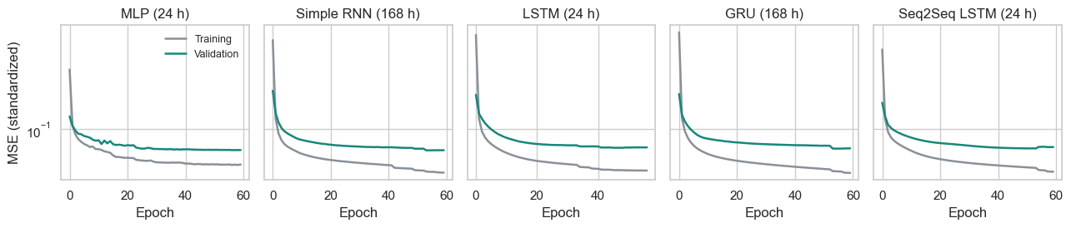

3e. Choose the final model on validation, then open the test set
The final model is the one with the lowest validation MAE. Test results are reported for every model, but they played no part in that choice.
# All windows are kept for the H4 test; the tables below use each model's chosen window
all_val, all_test = dict(forecasts_val), dict(forecasts_test)
forecasts_val = {m: all_val[(m, w)] for m, w in best_window.items()}
forecasts_test = {m: all_test[(m, w)] for m, w in best_window.items()}
val_table = pd.DataFrame({k: metrics(actual_val, v) for k, v in forecasts_val.items()}).T
test_table = pd.DataFrame({k: metrics(actual_test, v) for k, v in forecasts_test.items()}).T
chosen = seeds[seeds.apply(lambda r: best_window[r["Model"]] == r["Window"], axis=1)]
test_table["Seed SD of MAE"] = chosen.groupby("Model")["Test MAE"].std().reindex(test_table.index)
test_table["Parameters"] = chosen.groupby("Model")["Parameters"].first().reindex(test_table.index)
test_table.insert(0, "Window", pd.Series(best_window))
test_table.insert(1, "Val MAE", val_table["MAE"])
FINAL = val_table["MAE"].idxmin()
print("Final model (lowest validation MAE):", FINAL)
print(test_table.sort_values("Val MAE").round(3).to_string())
Final model (lowest validation MAE): Simple RNN
Window Val MAE MAE RMSE MAPE % R2 Peak MAPE % Seed SD of MAE Parameters
Simple RNN 168 1151.372 1337.233 1921.176 4.131 0.902 5.074 24.058 21144.0
MLP 24 1160.116 1330.911 1934.734 4.109 0.900 5.062 8.015 128408.0
GRU 168 1165.265 1359.359 1940.475 4.230 0.900 5.019 4.782 30680.0
Seq2Seq LSTM 24 1189.947 1374.111 1959.883 4.264 0.898 5.097 26.574 37185.0
LSTM 24 1203.498 1412.346 1998.894 4.401 0.893 5.172 19.629 35160.0
Ridge 168 1244.888 1377.561 2013.073 4.214 0.892 5.519 NaN NaN
Gradient boosting 24 1248.036 1415.986 2045.564 4.405 0.888 5.444 NaN NaN
Same hour yesterday 24 2136.861 2300.121 3134.259 7.322 0.738 7.162 NaN NaN
Seasonal naive 168 3312.272 3511.414 4794.154 10.993 0.387 11.790 NaN NaN
# H2 and H3: paired block bootstrap on daily MAE. Days are resampled in 14-day blocks, which keeps
# the autocorrelation in errors that a plain t-test would ignore.
daily_mae = {k: np.abs(v - actual_test).mean(axis=1) for k, v in forecasts_test.items()}
def block_bootstrap(diff, block=14, reps=10000, seed=42):
"""Returns the mean difference, its 95% CI and a two-sided p-value."""
rng = np.random.default_rng(seed)
n = len(diff)
starts = rng.integers(0, n - block + 1, size=(reps, int(np.ceil(n / block))))
samples = diff[(starts[:, :, None] + np.arange(block)).reshape(reps, -1)[:, :n]].mean(axis=1)
p = min(1.0, 2 * min((samples <= 0).mean(), (samples >= 0).mean()))
return diff.mean(), *np.percentile(samples, [2.5, 97.5]), p
def compare(a, b):
mean, lo, hi, p = block_bootstrap(daily_mae[b] - daily_mae[a])
return {"Comparison": f"{a} vs. {b}", "MAE gain (MW)": mean, "CI low": lo, "CI high": hi, "p": p}
BEST_RNN = val_table.loc[["Simple RNN", "LSTM", "GRU", "Seq2Seq LSTM"], "MAE"].idxmin()
print("Best recurrent network on validation:", BEST_RNN)
pairs = [(FINAL, m) for m in forecasts_test if m != FINAL]
pairs += [(BEST_RNN, m) for m in ["Seasonal naive", "Ridge", "Gradient boosting", "MLP"] if m != BEST_RNN]
pairs += [("LSTM", "Simple RNN"), ("GRU", "Simple RNN"), ("LSTM", "MLP"), ("GRU", "MLP")]
tests = pd.DataFrame([compare(a, b) for a, b in dict.fromkeys(p for p in pairs if p[0] != p[1])])
print("Positive gain = the first model has lower error than the second")
print(tests.round(3).to_string(index=False))
# H4: does a week of history beat a day? Same model, 168 h vs. 24 h window, on the test set
h4 = []
for m in ["Ridge", "Gradient boosting"] + DEEP:
d24, d168 = (np.abs(all_test[(m, w)] - actual_test).mean(axis=1) for w in WINDOWS)
mean, lo, hi, p = block_bootstrap(d24 - d168)
h4.append({"Model": m, "Val MAE 24h": val_mae[(m, 24)], "Val MAE 168h": val_mae[(m, 168)],
"Test MAE 24h": d24.mean(), "Test MAE 168h": d168.mean(), "Gain from 168h": mean, "CI low": lo, "CI high": hi, "p": p})
h4 = pd.DataFrame(h4)
print("\nPositive gain = the one-week window has lower test error")
print(h4.round(3).to_string(index=False))
Best recurrent network on validation: Simple RNN
Positive gain = the first model has lower error than the second
Comparison MAE gain (MW) CI low CI high p
Simple RNN vs. GRU 22.126 4.148 41.898 0.014
Simple RNN vs. Gradient boosting 78.752 38.091 123.783 0.000
Simple RNN vs. LSTM 75.112 56.520 95.276 0.000
Simple RNN vs. MLP -6.323 -23.258 12.204 0.533
Simple RNN vs. Ridge 40.328 -10.654 96.203 0.120
Simple RNN vs. Same hour yesterday 962.887 847.054 1085.732 0.000
Simple RNN vs. Seasonal naive 2174.181 1779.619 2617.747 0.000
Simple RNN vs. Seq2Seq LSTM 36.877 14.605 62.266 0.001
LSTM vs. Simple RNN -75.112 -95.276 -56.520 0.000
GRU vs. Simple RNN -22.126 -41.898 -4.148 0.014
LSTM vs. MLP -81.435 -97.368 -64.910 0.000
GRU vs. MLP -28.449 -47.650 -9.332 0.003
Positive gain = the one-week window has lower test error
Model Val MAE 24h Val MAE 168h Test MAE 24h Test MAE 168h Gain from 168h CI low CI high p
Ridge 1332.348 1244.888 1426.568970 1377.561035 49.007999 16.393 78.896 0.002
Gradient boosting 1248.036 1256.567 1415.985962 1423.218994 -7.233000 -40.097 20.803 0.582
MLP 1160.116 1189.858 1330.911011 1352.553955 -21.643000 -48.945 5.169 0.119
Simple RNN 1154.439 1151.372 1353.098022 1337.234009 15.865000 -1.334 34.651 0.072
LSTM 1203.498 1210.865 1412.345947 1408.552002 3.794000 -13.837 20.183 0.659
GRU 1170.633 1165.265 1389.864990 1359.359009 30.506001 15.461 45.920 0.000
Seq2Seq LSTM 1189.947 1191.272 1374.109985 1374.687988 -0.577000 -18.467 18.476 0.957
# Model comparison chart, sorted by test MAE
order = test_table.sort_values("MAE", ascending=False).index
order = [m for m in order if m != "Same hour yesterday"] # far off the scale; its value is in the table
colors = [TEAL if m == FINAL else (GRAY if m not in DEEP else "#7FBDB5") for m in order]
fig, ax = plt.subplots(figsize=(8, 4.2))
bars = ax.barh(order, test_table.loc[order, "MAE"], color=colors, height=0.68)
ax.bar_label(bars, labels=[f"{v:,.0f} MW ({p:.1f}%)" for v, p in zip(test_table.loc[order, "MAE"], test_table.loc[order, "MAPE %"])],
padding=4, fontsize=10)
ax.set(title="Test-set error by model, Jan 2017 to Aug 2018", xlabel="Mean absolute error (MW)")
ax.set_xlim(0, test_table.loc[order, "MAE"].max() * 1.28); ax.grid(axis="y", visible=False)
plt.tight_layout(); plt.savefig("figures/05_model_comparison.png", dpi=200); plt.show()
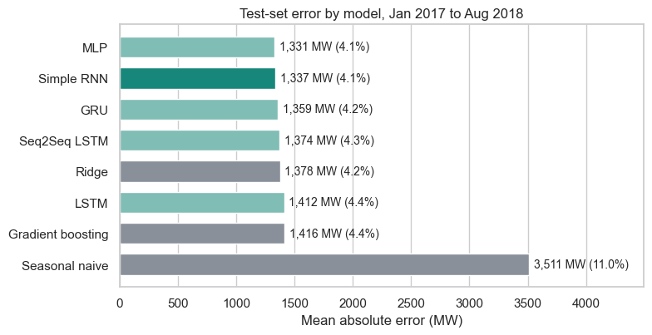

Step 4. Report

4a. What the forecasts look like
We plot the final model against the seasonal-naive baseline on a summer and a winter week from the test set.
pred = forecasts_test[FINAL]
test_days = idx[test_o]
hourly = pd.DataFrame({"actual": actual_test.ravel(), "final": pred.ravel(),
"naive": forecasts_test["Seasonal naive"].ravel()},
index=pd.DatetimeIndex(np.concatenate([idx[o:o + HORIZON] for o in test_o])))
fig, axes = plt.subplots(2, 1, figsize=(11, 5.6))
for ax, (start, end, name) in zip(axes, [("2017-07-17", "2017-07-23", "Summer week"), ("2018-01-01", "2018-01-07", "Winter week")]):
w = hourly[start:end] / 1000
ax.plot(w.index, w["actual"], color="#262B33", lw=2, label="Actual")
ax.plot(w.index, w["final"], color=TEAL, lw=2, label=FINAL)
ax.plot(w.index, w["naive"], color=GRAY, lw=1.4, ls="--", label="Seasonal naive")
ax.set(title=name, ylabel="GW")
ax.xaxis.set_major_formatter(mdates.DateFormatter("%a %b %d")); ax.xaxis.set_major_locator(mdates.DayLocator())
axes[0].legend(frameon=False, ncol=3, loc="upper right")
plt.tight_layout(); plt.savefig("figures/06_forecast_examples.png", dpi=200); plt.show()
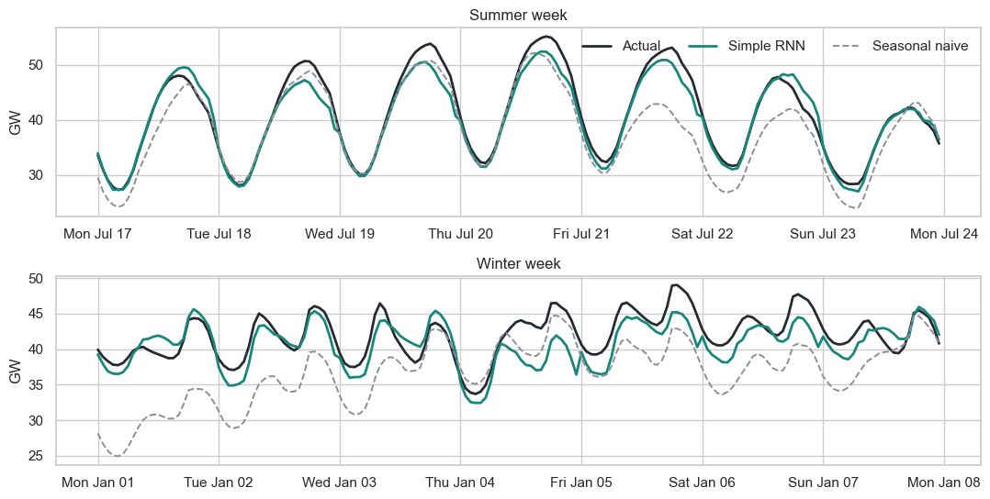

4b. Where the errors fall: testing H5
hourly["abs_err"] = (hourly["final"] - hourly["actual"]).abs()
hourly["ape"] = 100 * hourly["abs_err"] / hourly["actual"]
by_month = hourly.groupby(hourly.index.month)["abs_err"].mean()
by_hour = hourly.groupby(hourly.index.hour)["abs_err"].mean()
by_horizon = pd.Series(np.abs(pred - actual_test).mean(axis=0))
fig, axes = plt.subplots(1, 2, figsize=(11, 3.7), sharey=True)
month_names = ["J", "F", "M", "A", "M", "J", "J", "A", "S", "O", "N", "D"]
top = by_month.nlargest(3).index
axes[0].bar(range(12), by_month.values, color=[CORAL if m in top else TEAL for m in by_month.index])
axes[0].set_xticks(range(12)); axes[0].set_xticklabels(month_names)
axes[0].set(title="Error by month", ylabel="MAE (MW)"); axes[0].grid(axis="x", visible=False)
axes[1].plot(by_hour.index, by_hour.values, color=TEAL, lw=2)
axes[1].set(title="Error by hour of day", xlabel="Hour"); axes[1].set_xticks(range(0, 24, 4))
plt.tight_layout(); plt.savefig("figures/07_error_structure.png", dpi=200); plt.show()
# Compare day types: holidays and the top 5% of days by peak against all other days
day_err = pd.DataFrame({"mae": daily_mae[FINAL], "peak": actual_test.max(axis=1)}, index=test_days)
day_err["group"] = "Normal day"
day_err.loc[day_err["peak"] >= day_err["peak"].quantile(0.95), "group"] = "Top 5% peak day"
day_err.loc[day_err.index.isin(holidays), "group"] = "Federal holiday"
print(day_err.groupby("group")["mae"].agg(["count", "mean", "median"]).round(0).to_string())
# Mann-Whitney tests: are each group's daily errors higher than normal days?
normal = day_err.loc[day_err["group"] == "Normal day", "mae"]
for g in ["Federal holiday", "Top 5% peak day"]:
print(g, "vs. normal days: p =", round(mannwhitneyu(day_err.loc[day_err["group"] == g, "mae"], normal, alternative="greater").pvalue, 4))
summer_day = day_err.index.month.isin([6, 7, 8])
print("Summer vs. other days: p =", round(mannwhitneyu(day_err.loc[summer_day, "mae"], day_err.loc[~summer_day, "mae"], alternative="greater").pvalue, 5))
print("\nMAE by season:")
season = hourly.index.month.map(lambda m: {12: "Winter", 1: "Winter", 2: "Winter", 3: "Spring", 4: "Spring", 5: "Spring",
6: "Summer", 7: "Summer", 8: "Summer"}.get(m, "Fall"))
print(hourly.groupby(season)[["abs_err", "ape"]].mean().round(2).to_string())
print(f"\nMAE at 1 hour ahead {by_horizon.iloc[0]:,.0f} MW, at 24 hours ahead {by_horizon.iloc[-1]:,.0f} MW")
print("\nFive worst test days:")
day_err["bias"] = (pred - actual_test).mean(axis=1) # positive = forecast too high
day_err["weekday"] = day_err.index.day_name()
day_err["peak change vs. prior day"] = day_err["peak"].diff()
print(day_err.nlargest(5, "mae")[["mae", "peak", "bias", "weekday", "peak change vs. prior day"]].round(0).to_string())
print("\nCorrelation of daily error with absolute day-over-day peak change:",
round(day_err["mae"].corr(day_err["peak change vs. prior day"].abs()), 2))
# Share of total error that falls on the worst 10% of days
worst = day_err["mae"].nlargest(int(len(day_err) * 0.1)).sum() / day_err["mae"].sum()
print(f"\nWorst 10% of days carry {100 * worst:.0f}% of total error")
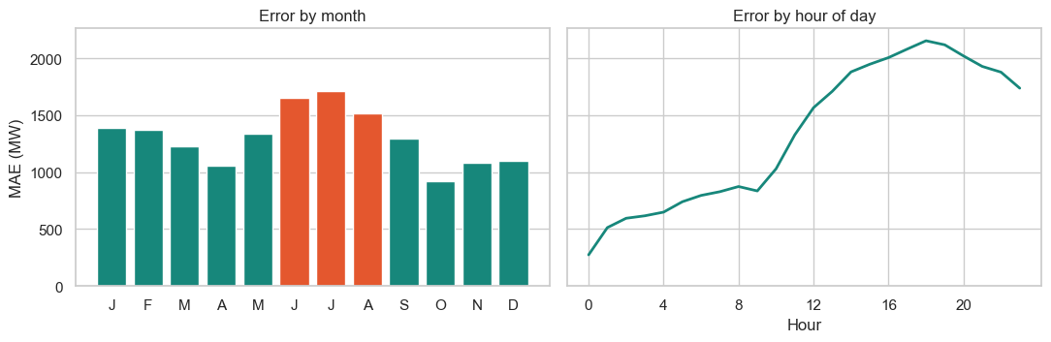
count mean median
group
Federal holiday 15 1422.0 1191.0
Normal day 535 1311.0 1121.0
Top 5% peak day 29 1777.0 1661.0
Federal holiday vs. normal days: p = 0.1786
Top 5% peak day vs. normal days: p = 0.0001
Summer vs. other days: p = 0.0
MAE by season:
abs_err ape
Fall 1099.180054 3.65
Spring 1209.119995 4.13
Summer 1645.630005 4.54
Winter 1320.010010 4.00
MAE at 1 hour ahead 274 MW, at 24 hours ahead 1,737 MW
Five worst test days:
mae peak bias weekday peak change vs. prior day
Datetime
2017-05-20 6002.0 32175.0 5992.0 Saturday -15024.0
2018-06-22 4525.0 34629.0 4213.0 Friday -8377.0
2018-05-05 4460.0 30118.0 4460.0 Saturday -9384.0
2018-05-30 4361.0 37888.0 4361.0 Wednesday -4801.0
2018-07-06 4302.0 43890.0 3144.0 Friday -8613.0
Correlation of daily error with absolute day-over-day peak change: 0.53
Worst 10% of days carry 24% of total error

4c. Prediction intervals
Operators need a range, not just a point. We use split conformal calibration: for each horizon hour, the 5th and 95th percentiles of the validation errors become a 90% band around the forecast. The test set then shows whether the band really covers 90% of outcomes.
val_resid = actual_val - forecasts_val[FINAL]
q_lo, q_hi = np.percentile(val_resid, 5, axis=0), np.percentile(val_resid, 95, axis=0)
lower, upper = pred + q_lo, pred + q_hi
inside = (actual_test >= lower) & (actual_test <= upper)
print(f"90% band: average width {np.mean(upper - lower):,.0f} MW, test coverage {100 * inside.mean():.1f}%")
cov = pd.Series(inside.ravel(), index=hourly.index)
print("Coverage by season (%):", (100 * cov.groupby(season).mean()).round(1).to_dict())
# Refinement: calibrate separately per season, still using validation errors only
season_of = lambda days: np.array([{12: "Winter", 1: "Winter", 2: "Winter", 3: "Spring", 4: "Spring", 5: "Spring",
6: "Summer", 7: "Summer", 8: "Summer"}.get(m, "Fall") for m in days.month])
val_season, test_season = season_of(idx[val_o]), season_of(idx[test_o])
lower, upper = pred.copy(), pred.copy()
for s_name in np.unique(val_season):
rows = test_season == s_name
lower[rows] += np.percentile(val_resid[val_season == s_name], 5, axis=0)
upper[rows] += np.percentile(val_resid[val_season == s_name], 95, axis=0)
inside = (actual_test >= lower) & (actual_test <= upper)
cov = pd.Series(inside.ravel(), index=hourly.index)
print(f"Season-calibrated band: average width {np.mean(upper - lower):,.0f} MW, test coverage {100 * inside.mean():.1f}%")
print("Coverage by season (%):", (100 * cov.groupby(season).mean()).round(1).to_dict())
print("Width by season (MW):", pd.Series((upper - lower).mean(axis=1)).groupby(test_season).mean().round(0).to_dict())
90% band: average width 4,787 MW, test coverage 86.6%
Coverage by season (%): {'Fall': 91.0, 'Spring': 89.9, 'Summer': 81.0, 'Winter': 85.5}
Season-calibrated band: average width 4,717 MW, test coverage 86.2%
Coverage by season (%): {'Fall': 87.6, 'Spring': 83.3, 'Summer': 85.4, 'Winter': 89.6}
Width by season (MW): {'Fall': 4228.0, 'Spring': 3888.0, 'Summer': 5692.0, 'Winter': 5026.0}

Step 5. Act: apply the results
The operating question is how much capacity to hold above the forecast. For each day we measure how far the true peak landed above the forecast peak. The 95th percentile of that shortfall is the buffer needed to cover 95% of daily peaks. The buffer is set on the validation years and checked on the test set.
def peak_buffer(actual, forecast, q=95):
"""MW above the forecast peak needed to cover q% of daily peaks."""
return np.percentile(actual.max(axis=1) - forecast.max(axis=1), q)
buffers = pd.DataFrame({
m: {"Buffer from validation (MW)": peak_buffer(actual_val, forecasts_val[m]),
"Test peaks covered %": 100 * np.mean(actual_test.max(axis=1) <= forecasts_test[m].max(axis=1) + peak_buffer(actual_val, forecasts_val[m]))}
for m in dict.fromkeys(["Seasonal naive", "Ridge", BEST_RNN, FINAL])}).T
print(buffers.round(1).to_string())
saved = buffers.loc["Seasonal naive"].iloc[0] - buffers.loc[FINAL].iloc[0]
print(f"\nBuffer reduction vs. seasonal naive: {saved:,.0f} MW")
# Example day-ahead view: the highest-demand day in the test set, with its 90% band
k = int(np.argmax(actual_test.max(axis=1)))
fig, ax = plt.subplots(figsize=(8, 3.9))
ax.fill_between(range(24), lower[k] / 1000, upper[k] / 1000, color=TEAL, alpha=0.18, label="90% band")
ax.plot(range(24), pred[k] / 1000, color=TEAL, lw=2.2, label="Forecast")
ax.plot(range(24), actual_test[k] / 1000, color="#262B33", lw=2, label="Actual")
ax.set(title=f"Next-day forecast for the highest-demand test day, {test_days[k]:%B %d, %Y}", xlabel="Hour of day", ylabel="GW")
ax.set_xticks(range(0, 24, 4)); ax.legend(frameon=False, loc="upper left")
plt.tight_layout(); plt.savefig("figures/08_peak_day_band.png", dpi=200); plt.show()
print(f"{test_days[k]:%Y-%m-%d}: actual peak {actual_test[k].max():,.0f} MW, forecast peak {pred[k].max():,.0f} MW")
Buffer from validation (MW) Test peaks covered %
Seasonal naive 9362.5 93.6
Ridge 4585.7 92.7
Simple RNN 4514.1 94.5
Buffer reduction vs. seasonal naive: 4,848 MW
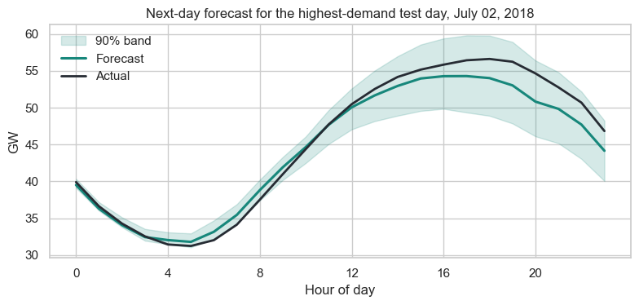
2018-07-02: actual peak 56,609 MW, forecast peak 54,286 MW

Hypothesis verdicts
Hypothesis | Evidence | Verdict
H1 Strong cycles | Autocorrelation 0.89 at 24 h and 0.78 at 168 h; July averages 36% above April | Supported
H2 RNN beats baselines | Simple RNN beats seasonal naive by 2,174 MW and gradient boosting by 79 MW (both p < 0.001); its 40 MW lead over ridge is not significant (p = 0.12) | Partly supported
H3 Gated RNNs win | LSTM and GRU were significantly worse than the Simple RNN (by 75 and 22 MW) and the MLP (by 81 and 28 MW) | Not supported
H4 One week beats one day | Helped ridge (49 MW) and GRU (31 MW); no significant change for the other five models | Partly supported
H5 Errors at peaks and holidays | Summer and top-5% peak days have higher MW error (p < 0.001); holidays do not differ detectably (p = 0.18, 15 days) | Partly supported

Recommendations
- Use the Simple RNN with a one-week window as the working forecast. It had the lowest validation error, is the smallest network (21,144 parameters) and trains in about 2 minutes. Its test MAE is 1,337 MW (4.1%), 62% below the seasonal-naive forecast.
- Keep ridge regression as the transparent backup. Extra model complexity bought little here: the Simple RNN and the MLP are tied (p = 0.53), and the lead over ridge is within noise on MAE. The RNN's lower peak error (5.1% vs. 5.5%) was not formally tested.
- Set reserves from measured error. About 4,500 MW above the forecast peak covered 94.5% of test-day peaks. The seasonal-naive forecast would need about 9,400 MW. Ridge needs nearly the same as the RNN (4,586 MW), so this gain comes from moving beyond naive forecasts, not from the RNN specifically.
- Recalibrate the bands often. The 90% band covered only 86.6% of test hours (81.0% in summer), because test errors ran about 16% above validation errors. Per-season calibration raised summer to 85.4% but lowered spring to 83.3%, so overall coverage did not improve. A rolling recalibration on recent errors is the next thing to try.
- Add weather next. The five worst days were all over-forecasts on days when the peak fell sharply from the day before, and daily error correlates with the size of that day-to-day change (r = 0.53). That pattern is consistent with sudden weather changes, but this dataset has no weather variable, so the cause is not confirmed.

Limitations
- Forecasts are issued at midnight using load through 23:00. A real day-ahead market closes earlier, so a live system would be less accurate.
- The results cover one region and end in August 2018. Models were not refitted on the validation years before testing.
- Three seeds per network is a small sample, and many pairwise tests were run without correcting for multiple comparisons.
- The test set was seen once during the first design iteration (see Step 3d), so test scores may be slightly optimistic.
- Peak-day error is higher in MW, but those days also have higher load, so the percent error was not compared.

