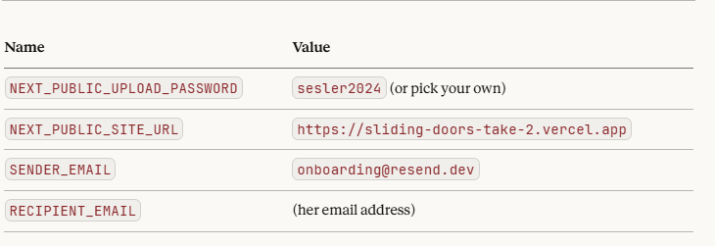

Resend.com
Api:

re_XseZy3VF_HbmXkQCHbybRBiuE64REMyqv
https://sliding-doors-take-2.vercel.app/sesler

