System.DirectoryServices.AccountManagement.PrincipalExistsException: The object already exists. ---> System.DirectoryServices.DirectoryServicesCOMException: The object already exists

at System.DirectoryServices.DirectoryEntry.CommitChanges()
at System.DirectoryServices.AccountManagement.SDSUtils.ApplyChangesToDirectory(Principal p, StoreCtx storeCtx, GroupMembershipUpdater updateGroupMembership, NetCred credentials, AuthenticationTypes authTypes)
--- End of inner exception stack trace ---
at System.DirectoryServices.AccountManagement.SDSUtils.ApplyChangesToDirectory(Principal p, StoreCtx storeCtx, GroupMembershipUpdater updateGroupMembership, NetCred credentials, AuthenticationTypes authTypes)
at System.DirectoryServices.AccountManagement.SDSUtils.InsertPrincipal(Principal p, StoreCtx storeCtx, GroupMembershipUpdater updateGroupMembership, NetCred credentials, AuthenticationTypes authTypes, Boolean needToSetPassword)
at System.DirectoryServices.AccountManagement.ADStoreCtx.Insert(Principal p)
at System.DirectoryServices.AccountManagement.Principal.Save()
at Cssd.IT.ActiveDirectoryIntegration.ActiveDirectory.Sinks.UserSinkAndCacheFeed.Create(User user)
in C:\IT_Portal\Dev\Source\ActiveDirectoryIntegration\Cssd.IT.ActiveDirectoryIntegration\ActiveDirectory\Sinks\UserSinkAndCacheFeed.cs:line 53
at Synnduit.SinkGateway`1.<>c__DisplayClass8_0.<Create>b__0() in D:\TEMP\Synnduit\src\Synnduit\Gateway.cs:line 112
at Synnduit.SinkGateway`1.Execute[T](Func`1 method) in D:\TEMP\Synnduit\src\Synnduit\Gateway.cs:line 162

Tired to see if user existed somewhere in TestAD
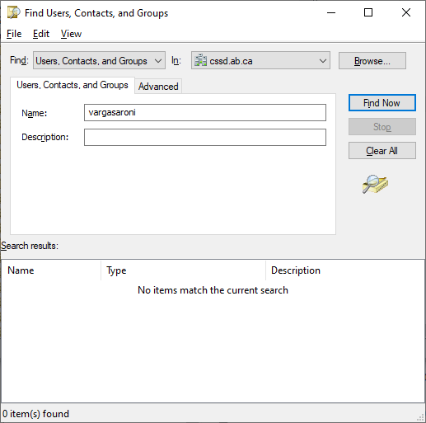
Used the employeeId, Sur
jessica.vargasaroni
name, Partial lastname: ‘Vargas’, 'Aroni’, nothing found.
In production the account exists.

Looked up Exception class for error:
https://docs.microsoft.com/en-us/dotnet/api/system.directoryservices.accountmanagement.principalexistsexception?view=netframework-4.8
Stuck wondering why it finds an existing entry and I can’t find it using the tool.

