**实验一**

**程序代码**

#include<iostream>

using namespace std;

class coordinate{

public:

coordinate()

{

times = 2;

cout << "coordinate construction1 called!" << endl;

}

coordinate(int times1)

{

times = times1;

cout << "coordinaqte construction2 called!" << endl;

}

~coordinate()

{

cout << "coordinate derstruction called!" << endl;

}

void inputcoord()

{

for (int i = 0; i < times; i++)

{

cout << "please input x:" << endl;

cin >> coord[i][1];

cout << "please input y:" << endl;

cin >> coord[i][2];

}

}

void showcoord()

{

cout << "the coord is:" << endl;

for (int i = 0; i < times; i++)

{

cout << "("<<coord[i][1]<<","<<coord[i][2]<<")"<<endl;

}

}

void showavgcoord()

{

float avgx = 0;

float avgy = 0;

for (int i = 0; i < times; i++)

{

avgx = avgx + coord[i][1];

avgy = avgy + coord[i][2];

}

avgx = avgx / times;

avgy = avgy / times;

cout << "the avg coord is:" << endl;

cout << "("<<avgx << "," << avgy << ")" << endl;

}

private:

float coord[100][100];

int times;

};

int main()

{

coordinate y(5);

y.inputcoord();

y.showcoord();

y.showavgcoord();

return 0;

}

**代码结果**

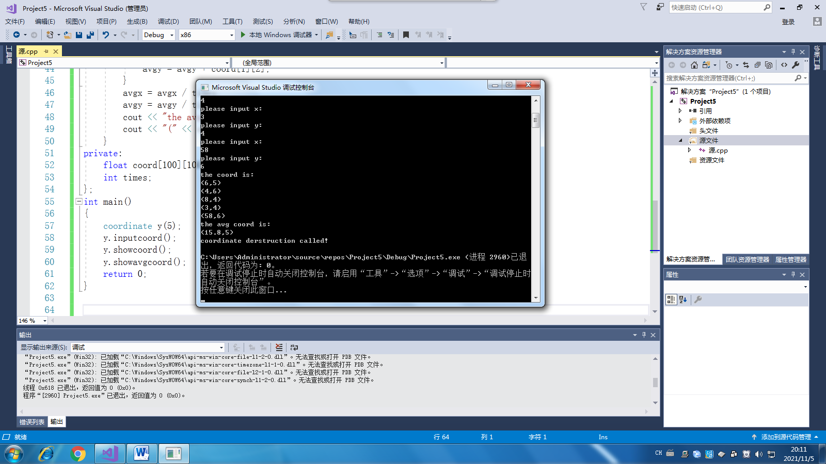

**实验二**

**程序代码**

#include<iostream>

#include<string>

using namespace std;

class score {

public:

score()

{

times = 2;

cout << "score construction1 called!" << endl;

}

score(int times1)

{

times = times1;

cout << "score construction2 called!" << endl;

}

~score()

{

cout << "score derstruction called!" << endl;

}

void input()

{

for (int i = 0; i < times; i++)

{

cout << " 请输入学生姓名:" << endl;

cin >> name[i];

cout << "请输入科目A成绩:" << endl;

cin >> grade[i][1];

cout << "请输入科目B成绩:" << endl;

cin >> grade[i][2];

cout << "请输入科目C成绩:" << endl;

cin >> grade[i][3];

}

}

void showgrade()

{

float avg[100];

int sum;

for (int i = 0; i < times; i++)

{

sum = grade[i][1] + grade[i][2] + grade[i][3];

avg[i] = sum / 3;

}

for (int i = 0; i < times; i++)

{

cout << "姓名："<< name[i] << " 科目A成绩:"<< grade[i][1] << " 科目B成绩:"<< grade[i][2] << " 科目C成绩:"<< grade[i][3] << endl;

}

for (int i = 0; i < times; i++)

{

cout << "姓名：" << name[i] << " 平均成绩:" << avg[i] << endl;

}

}

void showavggrade()

{

float avgA = 0;

float avgB = 0;

float avgC = 0;

for (int i = 0; i < times; i++)

{

avgA = avgA + grade[i][1];

avgB = avgB + grade[i][2];

avgC = avgC + grade[i][3];

}

avgA = avgA / times;

avgB = avgB / times;

avgC = avgC / times;

cout << "课程名称：A平均成绩：" << endl;

cout << avgA << endl;

cout << "课程名称：B平均成绩：" << endl;

cout << avgB << endl;

cout << "课程名称：C平均成绩：" << endl;

cout << avgC << endl;

}

private:

string name[100];

float grade[100][100];

int times;

};

int main()

{

score a(2);

a.input();

a.showgrade();

a.showavggrade();

return 0;

}

**代码结果**

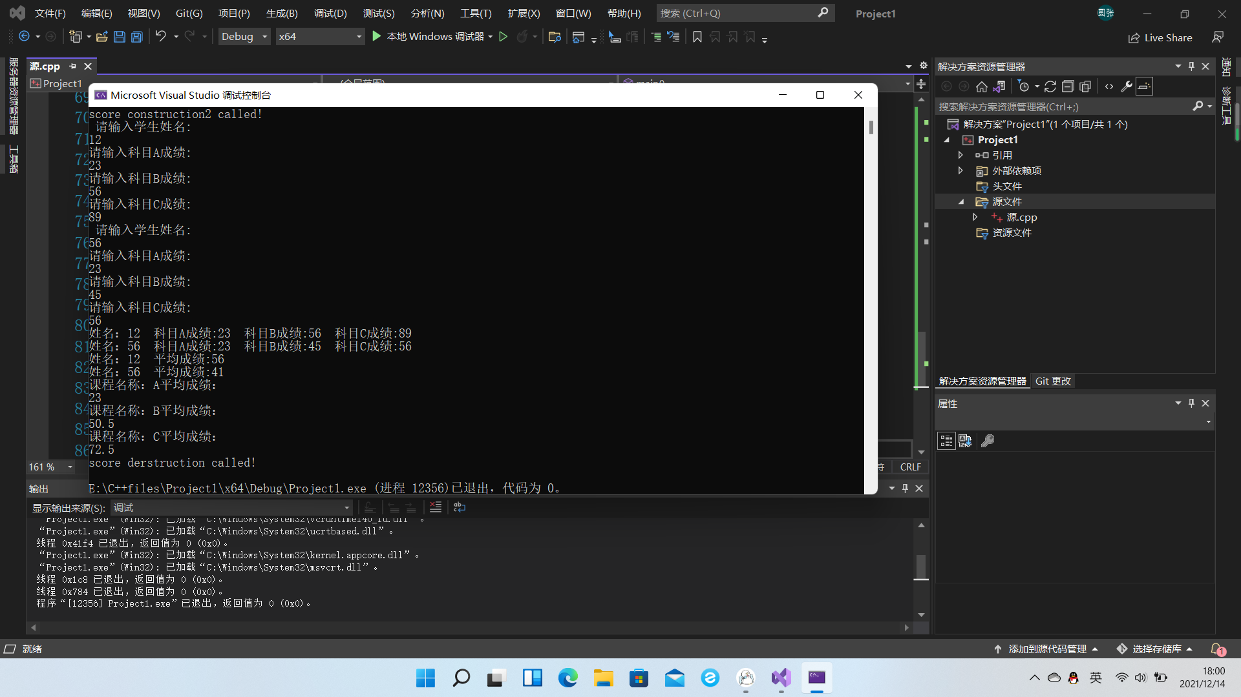

**感想心得**  
这次上机实验非常困难，需要涉及的方面太多，虽然已经有了一个例子在前面，我们可以借鉴着来，但工程量还是很大。

本次上机遇到最大的问题就是对待C++的一些基本语法掌握不熟练，整体编程下来就花费了许多时间。

Copyright ©2021-2099 ZhangKangNian. All rights reserved