**1.程序代码**

#include<iostream>

using namespace std;

class complex {

public:

double real;

double imag;

complex(double r = 0, double i = 0)

{

real = r;

imag = i;

}

};

complex operator*(complex co1, complex co2)

{

complex temp;

temp.real = co1.real * co2.real - co1.imag * co2.imag;

temp.imag = co1.real * co2.imag + co1.imag * co2.real;

return temp;

}

int main()

{

complex com1(2, 2), com2(3, 3), total;

total = com1 * com2;

cout << "imag1: " << com1.imag << " " << "real1: " << com1.real << endl;

cout << "imag2: " << com2.imag << " " << "real2: " << com2.real << endl;

cout << "imag= " << total.imag << endl;

cout << "real= " << total.real;

}

**2.代码结果**

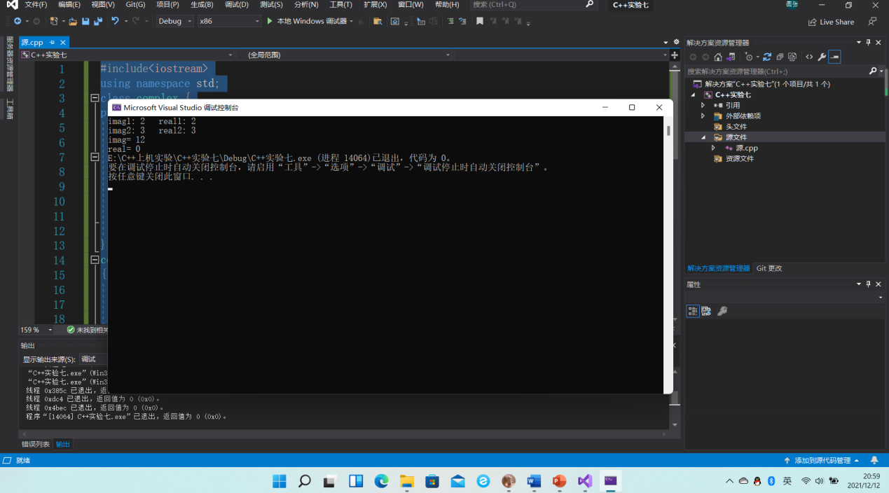

3.实验心得

本次上机实验学习了C++最后一个基本特征——多态，多态其实就是用一个名字定义不同的函数，这些函数执行不同但又类似的操作，这样就可以用同一个函数名调用不同内容的函数。

Copyright ©2021-2099 ZhangKangNian. All rights reserved