Menu
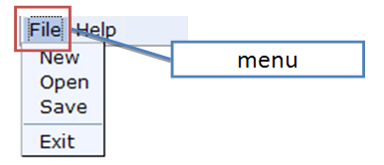
Menu is used to contain menupopup, it self is very simple.

Input Box

CSS Definition | Description | Default Values
div.menubar td | The html tag to represent menu | white-space: nowrap;
div.menubar a | The label of menu button | color: black; text-decoration: none;
div.menubar a:visited | The label of menu button after visited | color: black; text-decoration: none;
div.menubar a:hover | The label of menu button when mouse hover | color: black; text-decoration: none;

Menu
Customize the Menu Background, Menu label while hovering.
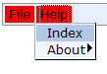
The way to customize the background color of menu is to change the background attribute of div.menubar td.
div.menubar td
{
background: red;
}
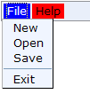
The way to customize the menu while hovering is to change the hover attribute of div.menubar td and div.menubar a, for example:
div.menubar td:hover
{
background: blue;
}

div.menubar a:hover
{
color:white;
}

