Auxhead
Auxhead and Auxheader.
Note:
- The CSS source of Auxhead from SVN
- The CSS source of Auxhead with Grid from SVN
- The CSS source of Auxhead with Listbox from SVN
- The CSS source of Auxhead with Tree from SVN

Mold: Default
Structure:
Overview
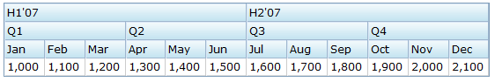
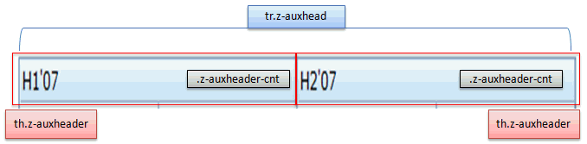
Events:
Action: | Normal (Open) | Hover | Click, Select, and Drag. | Focus | Focus and Hover | Disable
CSS naming: | z-auxhead  z-auxheader
Supported | V

CSS Specification:
Class Name | Description | Default Values
div.z-grid-header tr.z-auxhead | Background image | background-image: url(${c:encodeURL('~./zul/img/grid/s_hd.gif')}); background-color: #C7E5F1; background-repeat: repeat-x;
div.z-grid-header th.z-auxheader | Font size | overflow: hidden; border: 1px solid; border-color: #DAE7F6 #9EB6CE #9EB6CE #DAE7F6; white-space: nowrap; padding: 2px; font-size: ${fontSizeM}; font-weight: normal;
.z-auxheader-cnt | Font size of the content | font-size: ${fontSizeM}; font-weight: normal; font-family: ${fontFamilyT}; border: 0; margin: 0; padding: 0; overflow: hidden;

