SIMPLY REACH
ZKTM Mobile
The Quick Start Guide
Version 0.8.6
September 2007
Potix Corporation

Copyright © Potix Corporation. All rights reserved.
The material in this document is for information only and is subject to change without notice. While reasonable efforts have been made to assure its accuracy, Potix Corporation assumes no liability resulting from errors or omissions in this document, or from the use of the information contained herein.
Potix Corporation may have patents, patent applications, copyright or other intellectual property rights covering the subject matter of this document. The furnishing of this document does not give you any license to these patents, copyrights or other intellectual property.
Potix Corporation reserves the right to make changes in the product design without reservation and without notification to its users.
The Potix logo and ZK are trademarks of Potix Corporation.
All other product names are trademarks, registered trademarks, or trade names of their respective owners.
Table of Contents
Before You Start 4
New to ZK Framework 4
New to Sun Java Wireless Toolkit 4
New to Java Integrated Development Environment (IDE) 4
1. What to Download 5
2. Run the Demo 6
Deploy zkmob-demo-all 6
Setup Security Domain 6
Start the ZK Mobile Client 6
3. Installation 8
Install ZK Mobile Computing on Tomcat 8
Install ZK on Jetty 8
Deploy your Application as a WAR file or an EAR file 9
Working with MySQL 9
4. The Content of Distribution 10
client 10
doc 10
dist/lib 10
dist/src 10
dist/WEB-INF 10
5. The Content of Demo Distribution 11
/ 11
/zkmob-demo 11
/MyMobileApp 11
6. My First ZK Mobile Application 12
My First Hello World 12

Before You Start

New to ZK Framework
Before developing ZK Mobile applications in Java (and running ZK Mobile demo in your machine), you have to install a ZK Framework first. Refer to the ZK's Quick Start Guide for more details.
Download | ZK Standard Distribution and ZK Documentation  http://www.zkoss.org/download/
Note: zkmob 0.8.6 works with ZK 3.0 and later only

New to Sun Java Wireless Toolkit
The Sun Java Wireless Toolkit is a toolbox for developing wireless applications that are based on JavaME's Connected Limited Device Configuration (CLDC) and Mobile Information Device Profile (MIDP). The toolkit includes an emulation environments that you can emulate different mobile devices and test driving your ZK Mobile applications. Note that you don't have to learn JavaME to write ZK Mobile applications.
Download | Installer for Windows:  sun_java_wireless_toolkit-2_5_1-windows.exe  A list of all available versions:  http://java.sun.com/products/sjwtoolkit/

New to Java Integrated Development Environment (IDE)
Eclipse is one of the most popular Java IDEs. With IDE, it is easier to develop and debug your ZK Mobile applications. Moreover, you can understand ZK Mobile better by debugging through ZK's source codes.
The step-by-step setup guide can be found in one of our small talks:
http://www.zkoss.org/smalltalks/eclipse/ek.html

1. What to Download
File | Description
zkmob-0.8.6.tar.gz  zkmob-0.8.6.zip | The binary distribution of ZK Mobile, including ZK Mobile libraries.  In addition to the ZK Framework, it is all you need to enable reach of your Web applications to mobile devices.
zkmob-demo-0.8.6.zip | Standalone zkmob-demo application in WAR and EAR format, and the source codes of zkmob-demo.  It is the fastest way to test drive the features of ZK Mobile without configuring your Web server.
zkmob-javadoc-0.8.6.zip | The Java API document of ZK Mobile framework.
zkmob-src-0.8.6.tar.gz | The source codes of ZK Mobile framework, including the third-party libraries to build the source codes.

2. Run the Demo

Deploy zkmob-demo-all
The simplest way to run the demo is to download zkmob-demo-0.8.6.zip from http://sourceforge.net/project/showfiles.php?group_id=152762. Unzip it to a folder (we will call it $ZKMOB later in this article). You can deploy zkmob-demo-all.war or zkmob-demo-all.ear to your Web or application server. Most Web or application servers have a management console that allows you to deploy an application painlessly.
For Tomcat server, you can copy it directly to the $TOMCAT_DIR/webapps directory, and then Tomcat will start the deployment automatically.

Setup Security Domain
Start Preferences program from Sun Java(TM) Wireless Toolkit for CLDC. The Preferences window shall pop out. Select Security in Category list, MSA in Security Policy, and maximum in Security domain. Press OK button.

Start the ZK Mobile Client
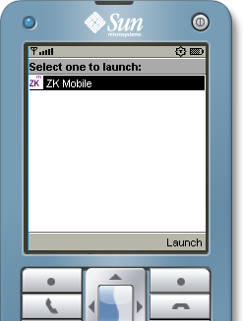
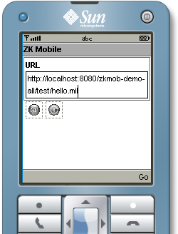
Start Run MIDP Application .... In Select a JAD file to Run navigation dialog find and select the $ZKMOB/client/zkmob.jad and press Run button. A mobile device emulator shall appear with the ZK Mobile option. Press the Launch button and appear the ZK Mobile's URL Entry page. Now press the Go button and you should see the Hello World!.
You can then click the Home button and it brings you back to ZK Mobile's URL Entry page again. You can move focus to the @ history icon and click the History button. There you will see the pre-bookmarked demo program URL list. Select what you want to try and click the Go button and ZK Mobile client will bring you there.
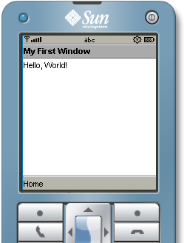
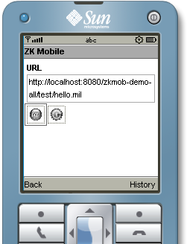
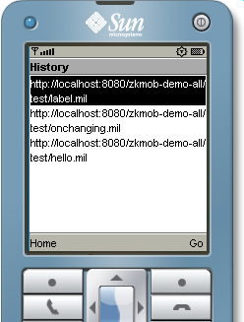
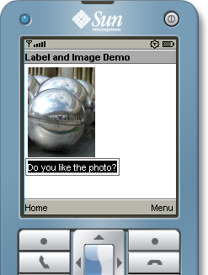

3. Installation
ZK Mobile consists of a set of libraries. There are two ways to install them to Tomcat Web server. First, copy them to the shared directory (for Tomcat, it is shared/lib), so all Web applications can use them. Second, copy them to the WEB-INF/lib directory of the Web application, such that you can deploy your Web application to any Web server you want.
Here we illustrate first how to install ZK Mobile libraries to the shared directory. It varies from one Web server to another.

Install ZK Mobile Computing on Tomcat
- Before install ZK Mobile Computing on Tomcat, you have to install ZK Framework first. Refer to the ZK's Quick Start Guide/Install ZK on Tomcat for details.
- Stop Tomcat.
- Uncompress zkmob-0.8.6.zip or zkmob-0.8.6.tar.gz
- Copy dist/lib/*.jar to $TOMCAT_HOME/shared/lib
- Re-start Tomcat.
- Deploy demo/bin/zkmob-demo.war to Tomcat. It can be done by use of the Tomcat manager, or by copying it to $TOMCAT_HOME/webapps directly. If you prefer copying directly, you have to stop Tomcat first.
- Start the ZK Mobile client as described in previous section. In client's URL Entry page browse to http://localhost/zkmob-demo/test/hello.mil or http://localhost:8080/zkmob-demo/test/hello.mil, depending on your configuration.

Install ZK on Jetty
- Before install ZK Mobile on Jetty, you have to install ZK framework first. Refer to the ZK's Quick Start Guide/Install ZK on Jetty for details.
- Stop Jetty.
- Uncompress zkmob-0.8.6.zip or zkmob-0.8.6.tar.gz
- Copy dist/lib/*.jar to $JETTY_HOME/ext
- Deploy demo/bin/zkmob-demo.war to Jetty by copying it to $JETTY_HOME/webapps directly.
- Start Jetty.
- Start the ZK Mobile client as described in previous section. In client's URL Entry page browse to http://localhost/zkmob-demo/test/hello.mil or http://localhost:8080/zkmob-demo/test/hello.mil, depending on your configuration.

Deploy your Application as a WAR file or an EAR file
In additions to installing ZK Mobile libraries to the Web server, you can put them into your Web application such that you can deploy your Web application to any Web server.

To bundle ZK Mobile libraries with the WAR file
Copy dist/lib/*.jar, and dist/lib/ext/*.jar from zkmob-0.8.6.zip to the /WEB-INF/lib directory in your WAR file.

To bundle ZK libraries with the EAR file
Copy dist/lib/*.jar, and dist/lib/ext/*.jar from zkmob-0.8.6.zip to the root directory of your EAR file, such that all your Web applications (in the same EAR file) can share them.

Working with MySQL
To open the connection under zscript, you have to put MySQL JDBC driver (mysql-connector-*.jar) under the $TOMCAT_DIR/common/lib directory.

4. The Content of Distribution
This chapter describes the content of zkmob-0.8.6.zip.

client
This directory holds the ZK Mobile client jar and a client deployment JAD file.

doc
This directory holds the documents including Quick Start Guide and User Guide.

dist/lib
This directory holds the binary libraries required to run ZK Mobile.

dist/src
This directory holds the source codes in JAR format. These JAR files are used for debugging in IDE, such as Eclipse. You cannot build the binary libraries from these. Rather, download and uncompress zkmob-src-0.8.6.tar.gz.

dist/WEB-INF
This directory holds the TLD and XSD files that might be useful to develop ZK Mobile applications.

5. The Content of Demo Distribution
This chapter describes the content of zkmob-demo-0.8.6.zip.

/
This directory holds the executable: zkmob-demo.war, zkmob-demo-all.war, zkmob-demos.ear and zkmob-demos-all.ear. Refer to the Installation chapter for details.

/zkmob-demo
This directory holds the source codes of the ZK Mobile demo.

/MyMobileApp
This directory holds an empty ZK Mobile application which you can start your new ZK Mobile application from.

6. My First ZK Mobile Application

Prepare WEB-INF/web.xml
ZK Mobile Computing is an extension to the ZK Framework so you have to prepare first the web.xml that can be used to run ZK application. Then add one more zkLoader servlet mapping specific for the ZK Mobile applications. Then, what you need to do is to copy files with .mil extension to the proper directories in your Web applications.
<servlet-mapping>
<servlet-name>zkLoader</servlet-name>
<url-pattern>*.mil</url-pattern>
</servlet-mapping>
<mime-mapping>
<extension>jad</extension>
<mime-type>text/vnd.sun.j2me.app-descriptor</mime-type>
</mime-mapping>
<welcome-file-list>
<welcome-file>index.mil</welcome-file>
</welcome-file-list>

My First Hello World
Create a file called hello.mil with the following content. Then, start the ZK Mobile client to see the result, say http://localhost:8080/zkdemo/hello.mil.
<frame title="My First window" visible="true">
Hello, World!
</frame>
Then, the result is depicted as follow.

$TOMCAT_HOME is where you installed Tomcat.
$JETTY_HOME is where you installed Jetty.
http://ww.mysql.com

