Home Scene

**Purpose**

The purpose of this scene is to serve as a starting point for the application from where players can navigate to the different primary areas of the game.

**Setting and Story**

Within this scene, players will see the title of the game and buttons for the primary functionality of the game. Buttons are yellow, and the background is reminiscent of a forest, either with tree silhouettes or evergreen-like colours. Tim the lumberjack may also appear in this scene, either in silhouette or next to the menu buttons. The title should appear at the top of the screen in block lettering, optionally with an outline.

**Concept artwork**

**Primary Action**

Player selects Play from the menu.

**Exit Action**

Player selects Exit from the menu or closes the application through the mobile device OS close function.

**Flow Diagram**

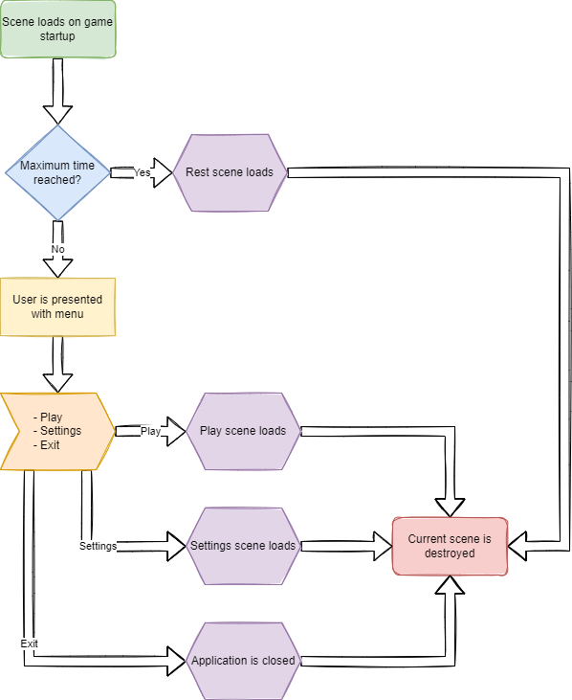

**UI Prototype**

