**一：**

import java.io.*;

import java.awt.*;

import javax.swing.*;

import java.awt.event.*;

import jxl.*;

import jxl.write.*;

import jxl.write.Label;

public class MyFX {

public static void main(String[] args) throws Exception {

new Text();

}

}

class Text implements ActionListener {

String f1;

String f2;

String f3;

JFrame frame=new JFrame("答案校对");

Container con=new Container();//布局

JLabel label1=new JLabel("学生答案:");

JLabel label2=new JLabel("标准答案:");

JLabel label3=new JLabel("保存地址:");

JTextField text1=new JTextField();

JTextField text2=new JTextField();

JTextField text3=new JTextField();

JButton button=new JButton("确定");

JButton button1=new JButton("浏览本地文件");

JButton button2=new JButton("浏览本地文件");

JButton button3=new JButton("浏览本地文件");

JFileChooser jfc=new JFileChooser();//文件选择器

Text(){

jfc.setCurrentDirectory(new File("d:\\"));//文件选择器的初始目录定为d盘

//取屏幕的高度和宽度

double lx=Toolkit.getDefaultToolkit().getScreenSize().getWidth();

double ly=Toolkit.getDefaultToolkit().getScreenSize().getHeight();

frame.setLocation(new Point((int)(lx/2)-150,(int)(ly/2)-150));//窗口出现位置

frame.setSize(400,260);//窗口大小

label1.setBounds(20,50,100,20);

label2.setBounds(20,90,100,20);

label3.setBounds(20,130,100,20);

text1.setBounds(90,50,160,20);

text2.setBounds(90,90,160,20);

text3.setBounds(90,130,160,20);

button1.setBounds(260,50,100,20);

button2.setBounds(260,90,100,20);

button3.setBounds(260,130,100,20);

button.setBounds(175,170,70,20);

button1.addActionListener(this);//添加事件处理

button2.addActionListener(this);

button3.addActionListener(this);

button.addActionListener(this);

con.add(label1);

con.add(text1);

con.add(button1);

con.add(label2);

con.add(text2);

con.add(button2);

con.add(label3);

con.add(text3);

con.add(button3);

con.add(button);

con.add(jfc);

frame.add(con);

frame.setVisible(true);//窗口可见

frame.setDefaultCloseOperation(JFrame.EXIT_ON_CLOSE);//使能关闭窗口，结束程序

}

@Override

public void actionPerformed(ActionEvent e){//事件处理

if(e.getSource().equals(button1)){

jfc.setFileSelectionMode(0);//设定只能选择到文件

int state=jfc.showOpenDialog(null);//此句是打开文件选择器界面的触发语句

if(state==1){

return;//撤销则返回

}

else{

File f=jfc.getSelectedFile();//f为选择到的文件

text1.setText(f.getAbsolutePath());

f1=f.getAbsolutePath();

}

}

if(e.getSource().equals(button2)){

jfc.setFileSelectionMode(0);//设定只能选择到文件

int state=jfc.showOpenDialog(null);//此句是打开文件选择器界面的触发语句

if(state==1){

return;//撤销则返回

}

else{

File f=jfc.getSelectedFile();//f为选择到的文件

text2.setText(f.getAbsolutePath());

f2=f.getAbsolutePath();

}

}

if(e.getSource().equals(button3)) {

jfc.setFileSelectionMode(1);

int state=jfc.showSaveDialog(null);

if(state==1){

return;//撤销则返回

}

else{

File f=jfc.getSelectedFile();//f为选择到的文件

text3.setText(f.getAbsolutePath());

f3=f.getAbsolutePath();

}

}

if(e.getSource().equals(button)) {

try {

ReadExcel(f1,f3);

Answer(f2,f3);

JFrame res=new JFrame("提示");

JLabel label=new JLabel("校对完成！");

JLabel lab=new JLabel("最终文件已存入指定地点");

Container container=new Container();

double lx=Toolkit.getDefaultToolkit().getScreenSize().getWidth();

double ly=Toolkit.getDefaultToolkit().getScreenSize().getHeight();

res.setLocation(new Point((int)(lx/2)-60,(int)(ly/2)-95));

res.setSize(200,100);

label.setBounds(70,20,80,20);

lab.setBounds(30,40,150,20);

container.add(label);

container.add(lab);

res.add(container);

res.setVisible(true);

res.setDefaultCloseOperation(JFrame.EXIT_ON_CLOSE);

} catch (Exception e1) {

e1.printStackTrace();

}

}

}

public static void ReadExcel(String f,String result) throws Exception {

Workbook readBook = Workbook.getWorkbook(new File(f));

WritableWorkbook writeBook = Workbook.createWorkbook(new File(result));

Sheet sheet_r = readBook.getSheet(0); //sheet.getCell(args0,args1) args0为列，args1为行

WritableSheet sheet_w = writeBook.createSheet("Sheet1",0);

sheet_w.addCell(new Label(0,0,"no"));

sheet_w.addCell(new Label(1,0,"key"));

for(int i=1;i<sheet_r.getRows();i++) {

Cell cell1 = sheet_r.getCell(0,i);

Cell cell2 = sheet_r.getCell(1,i);

jxl.write.Number num = new jxl.write.Number(0,i,Integer.valueOf(cell1.getContents()));

sheet_w.addCell(num);

String str = cell2.getContents();

for(int j=0;j<str.length();j++) {

String s = Character.toString(str.charAt(j));

sheet_w.addCell(new Label(j+1,i,s));

}

}

writeBook.write();

writeBook.close();

readBook.close();

}

public static void Answer(String f,String result) throws Exception {

Workbook readBook = Workbook.getWorkbook(new File(f));

Workbook book = Workbook.getWorkbook(new File(result)); //修改

WritableWorkbook writeBook = Workbook.createWorkbook(new File (result), book);

Sheet sheet_r = readBook.getSheet(1); //sheet.getCell(args0,args1) args0为列，args1为行

WritableSheet sheet_w = writeBook.createSheet("Sheet2",1);

Sheet sheet = book.getSheet(0);

sheet_w.addCell(new Label(0,0,"no"));

sheet_w.addCell(new Label(1,0,"score"));

for(int j=1;j<sheet.getRows();j++) {

jxl.write.Number num = new jxl.write.Number(0,j,j);

sheet_w.addCell(num);

}

for(int i=1;i<sheet_r.getColumns();i++) {//列

Cell cell1 = sheet_r.getCell(i,1);

Cell cell2 = sheet_r.getCell(i,2);

String res = cell1.getContents();

int score = Integer.valueOf(cell2.getContents());

for(int j=1;j<sheet.getRows();j++) {//行

cell1 = sheet.getCell(i,j);

if((cell1.getContents()).equals(res)) {

jxl.write.Number num = new jxl.write.Number(i,j,score);

sheet_w.addCell(num);

}

else {

jxl.write.Number num = new jxl.write.Number(i,j,0);

sheet_w.addCell(num);

}

}

}

writeBook.write();

writeBook.close();

readBook.close();

}

}

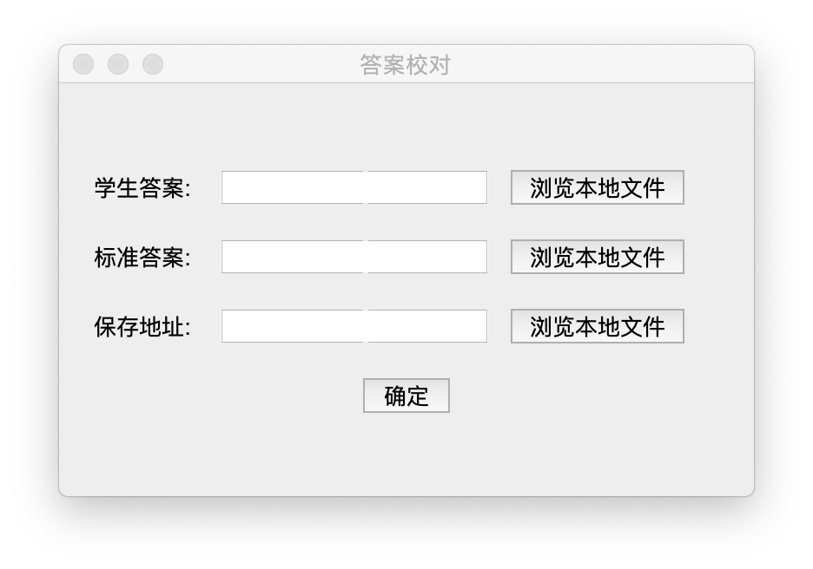

理由：

1、运用Java对Excel表格进行读取和分解并创建新的表格文件，对于自己来说是新的东西

2、融合了图形界面选取文件，学习了一些图形界面相关的内容

**二：**

from wordcloud import WordCloud, STOPWORDS, ImageColorGenerator

import matplotlib.pyplot as plt

from scipy.misc import imread

path_txt='/Users/zky/Desktop/The Adventures of Sherlock Holmes - Arthur Conan Doyle.txt'

f = open(path_txt,'r').read()

pic = imread('/Users/zky/Desktop/sherlock1.png')

#coloring = imread('/Users/zky/Desktop/red.jpeg')

stopwords = set(STOPWORDS)

stopwords.add("said")

stopwords.add("one")

stopwords.add("upon")

stopwords.add("will")

stopwords.add("well")

stopwords.add("may")

stopwords.add("must")

wordcloud = WordCloud(font_path='/Library/Fonts/Chalkduster.ttf',

mask=pic,

stopwords=stopwords,

background_color="black",

scale=1.5,

max_words=200).generate(f)

#image_colors = ImageColorGenerator(coloring)

plt.imshow(wordcloud,interpolation="bilinear")

plt.axis("off")

#plt.figure()

plt.show()

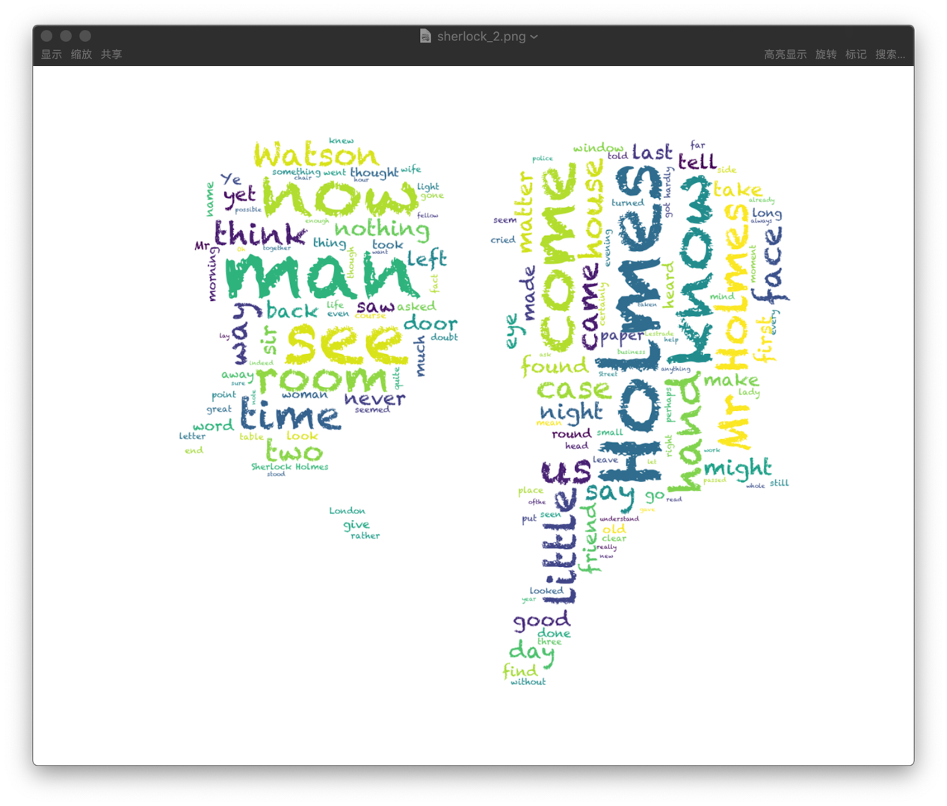

理由：

1、运用python词云库对The Adventures of Sherlock Holmes的内容做了一个带图片形状的词云，并去掉了一些高频出现但没有太大意义的词

2、觉得有趣