

**The Practical Training IV course design report**

**Training project name: music website and its background management system**

**classes and grades in school: 20 and in Computer Science and Technology**

**Student No.: 2050341071**

**Name: Zhang Ke**

**faculty adviser: yuan shuai**

School of Computer Science, Hubei Second Normal University

**catalogue**

1. Description of the practical training program 2

2. requirement analysis 2

(1) Business domain analysis 2

(2) Use-case analysis 2

1. Use case diagram 2

2. Use-case description 2

3. Use-case sequence Fig 2

3. system design 2

(I) Back-end system design 2

(2) Front-end system design 2

4. system implementation 3

(I) Back-end system implementation 3

(2) Front-end system implementation 3

5. Operation and testing 3

(I) Operation display of the back-end interface 3

(2) Front-end interactive interface and operation display 3

Sixth, summary and experience 3

# Description of practical training project

The theme of this training project is to create a music website and its background management system. The music website is designed to provide connections between users and singers and promote music creation, sharing and communication. The site will provide users to log in and search for songs, enabling users to maintain their music preferences and preferences.

Key features of the music site include song search, singer search, album search and style search features. Users are able to browse various kinds of music on the site and search for their favorite songs or singers.

The background management system will be used for the daily management and maintenance of the website. Administrators can log into the background management system to manage and monitor user accounts, content, and data. The system will provide user management functions, including viewing and editing user profiles, reset passwords, etc. In addition, managers can manage song and singer information, including adding, editing, and deleting music.

The technical stack of this project mainly includes front-end development, back-end development, and database management. Front-end development will build the user interface using HTML, CSS, JavaScript, Vue, axios, and restfull, and interact with the back-end API. The backend development will use j ava spring boot and mybatis to build the core functionality and logic of the website. Database Management will use a MySQL relational database to manage data for users, music, and singers.

In short, this training project aims to create a music website and its background management system, which will attract music lovers and creators to share and discover new music, while providing a convenient management interface to manage and maintain the website content.

# requirement analysis

## Business domain analysis

User management: Music websites need to provide user login and personal data management functions. Users can create personal accounts and be able to edit and update their personal information and passwords.

Music management: The website needs to support the management of songs and music information. This includes adding, editing, and removing music, including singers, albums, songs, styles, etc.

Music Search: The site should also provide powerful search capabilities that enable users to search for and discover the music they are interested in based on the song title, singer name, album title, or other keywords.

Background management: The background management system shall support the administrator to manage and monitor the user accounts, content and data. Administrators should be able to view and edit user profiles and reset passwords.

## Use case analysis

### use case diagram

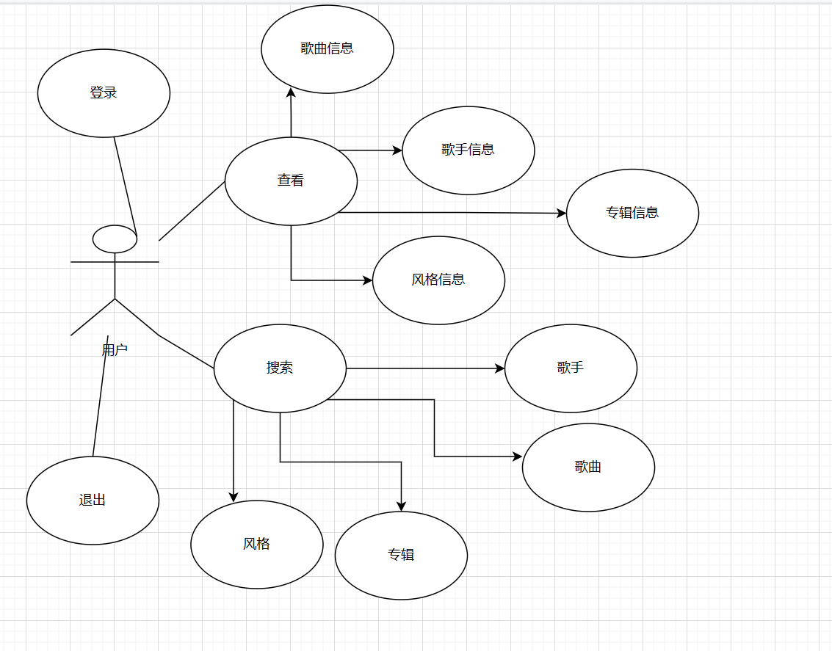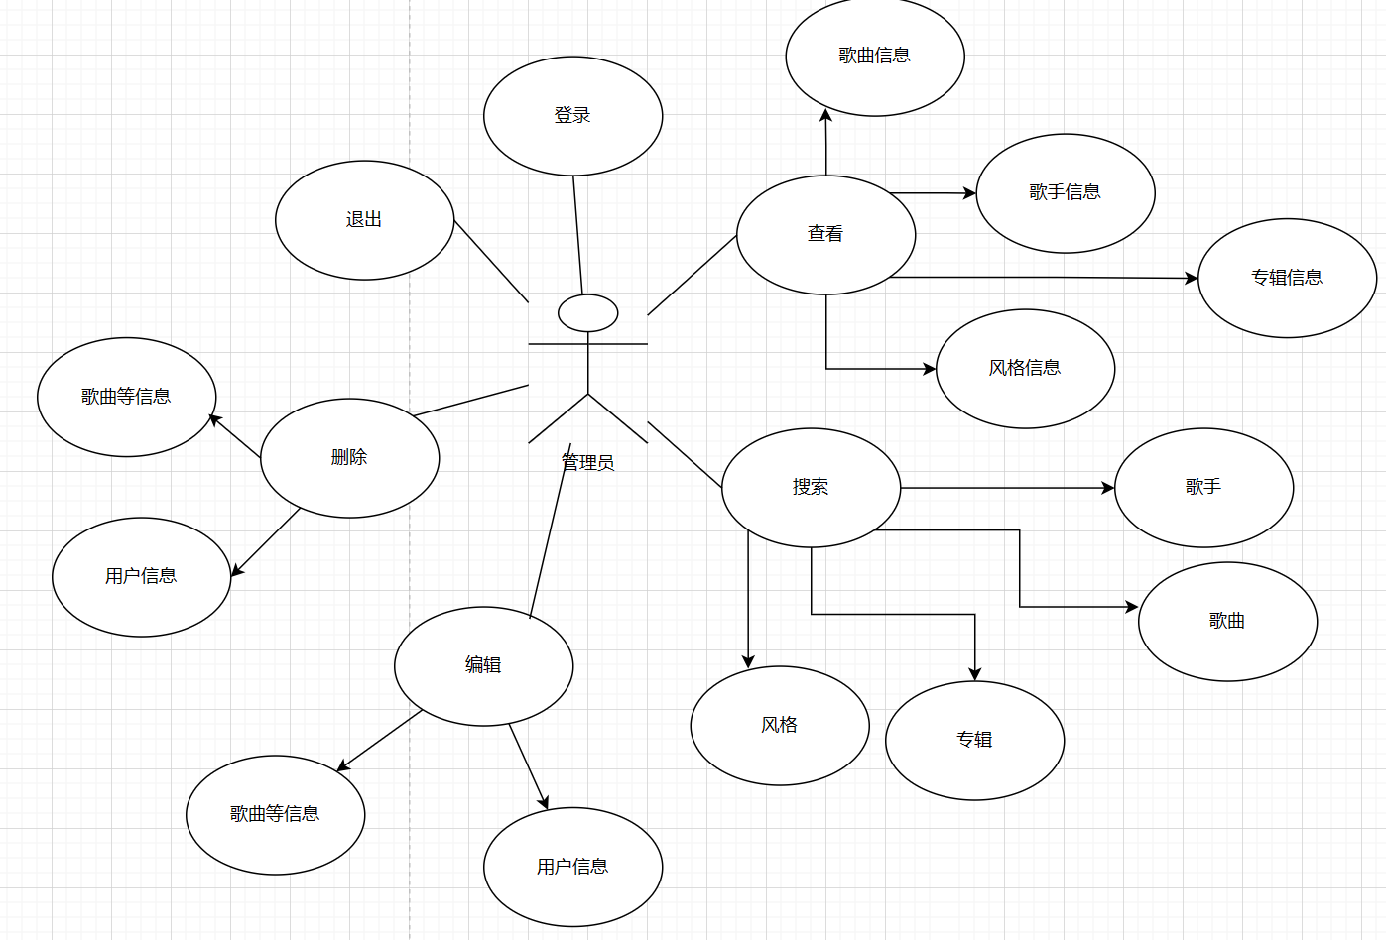

### Use case description

The use cases of the music website and its background management system involve two roles: user and administrator respectively.

User use cases:

entry:

Description: Users log in to the music website by providing valid credentials.

Main steps:

Open the music website.

Enter a user name and password.

Select the user option.

Click on the Login button.

View music:

Description: Users browse and view the available music.

Main steps:

Log in to the music web site.

Browse the music categories or recommended lists.

Click on Music to see the details.

Search for music:

Description: Users search for their favorite music based on their keywords.

Main steps:

Log in to the music web site.

Enter the keywords in the search box.

Click on the search button.

Displays a list of music results related to the keywords.

Alternative steps:

withdraw from:

Description: The user safely exits the session on the music site.

Main steps:

Click on the exit button.

Administrator's case:

entry:

Description: The administrator logs in to the background management system by providing a valid certificate.

Main steps:

Open the background management system.

Enter the administrator user name and password.

Select the Administrator option.

Click on the Login button.

View the user information:

Description: The administrator views and manages user profiles and information.

Main steps:

Log in to the background management system.

Browse the list of registered users.

Select a specific user to view its details.

Search users:

Description: The administrator searches for users based on the user name or other keywords.

Main steps:

Log in to the background management system.

Enter the keywords in the search box.

Click on the search button.

Displays a list of users related to the keywords.

Delete user:

Description: The administrator removes the inappropriate or offending users.

Main steps:

Log in to the background management system.

Search or browse for the users that you want to delete.

Select a specific user and perform the delete operation.

Edit the music information:

Description: Administrator edit information about music, such as singers, albums, songs and styles.

Main steps:

Log in to the background management system.

Search for or browse for the music that you want to edit.

Select a specific music to go into the edit mode.

Update the music information and save the changes.

### Sequence plots of use cases

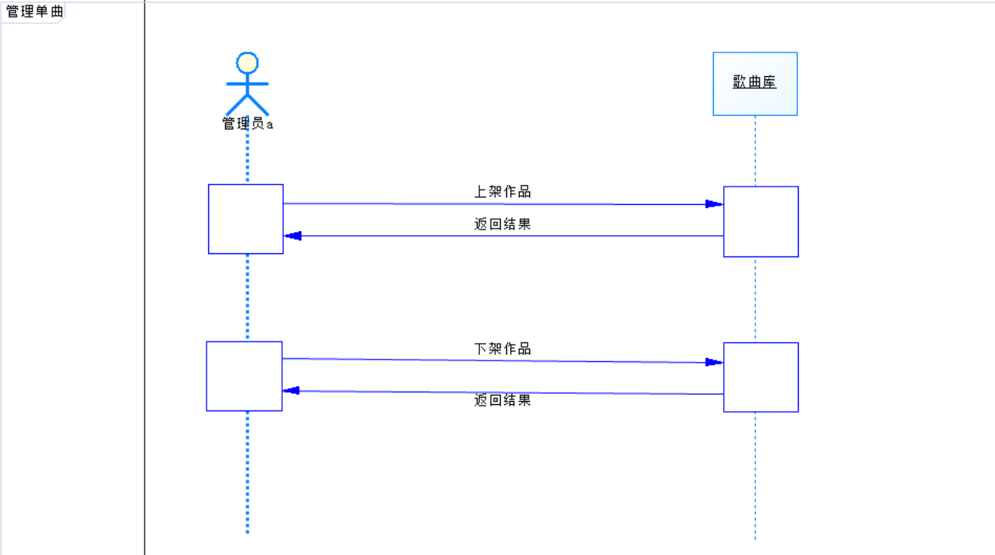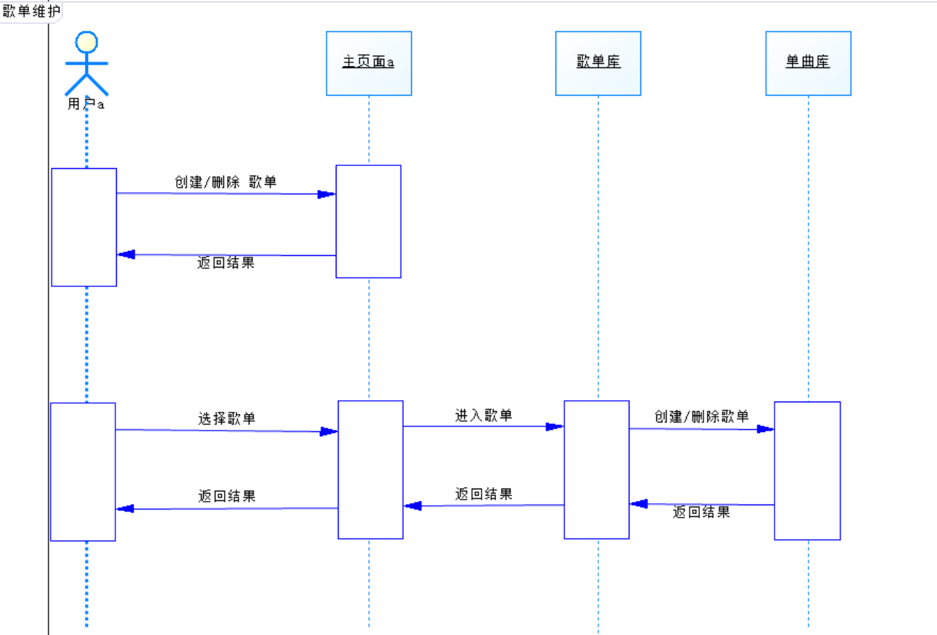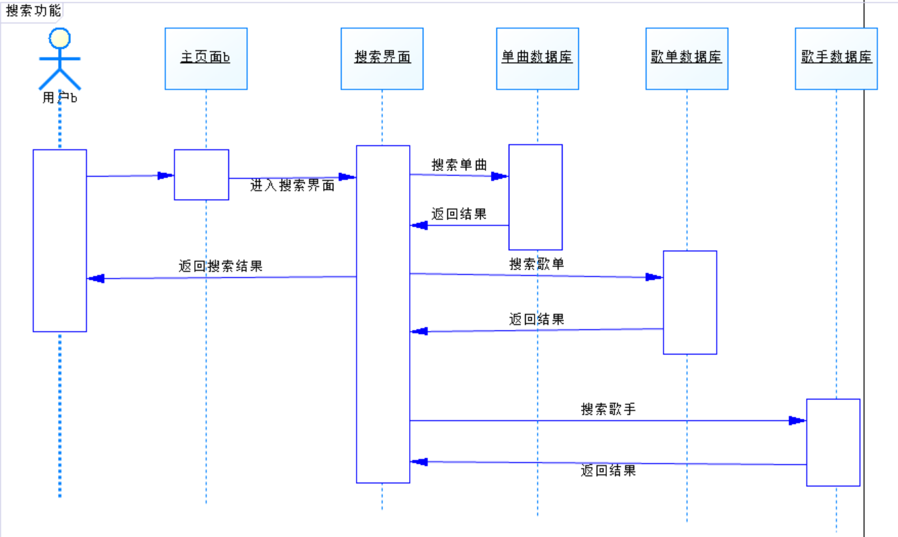

# system design

## system chart

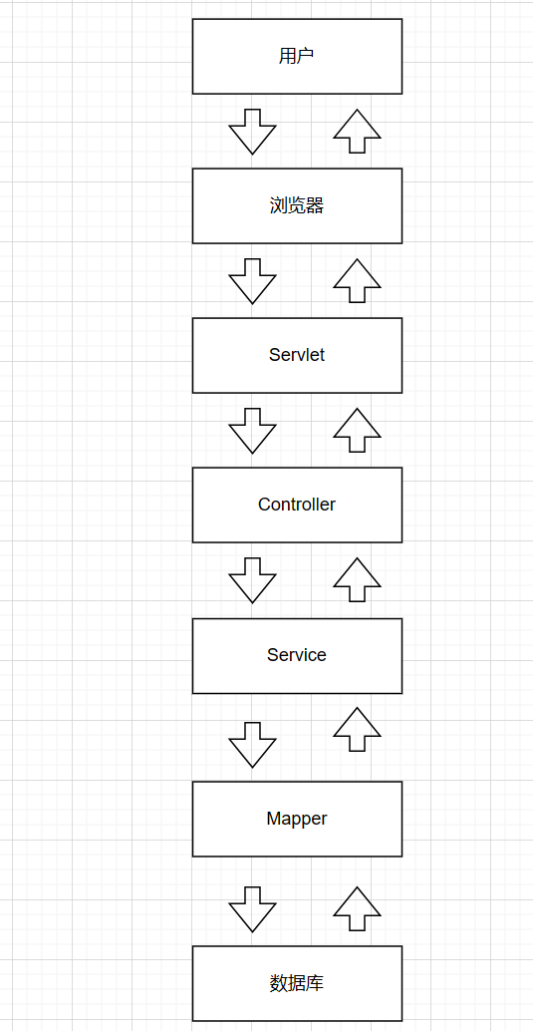

## Back end system design

Architecture design: the MVC (Model-View-Controller) architecture

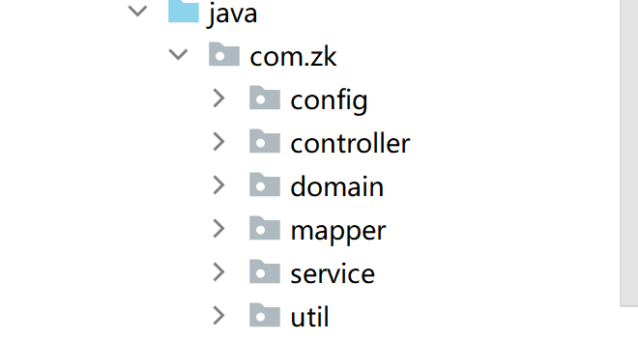

Database design: design the database mode and table structure, including user information, album information, song information, etc.

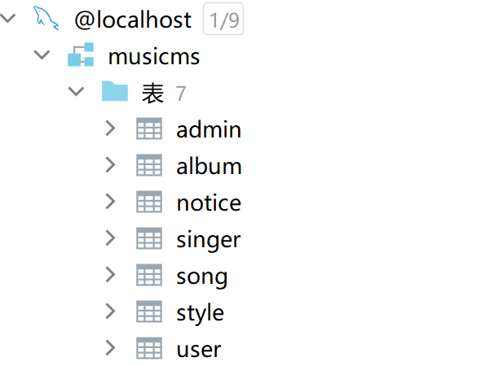

Business logic: Ensure the integrity and correctness of the system functions.

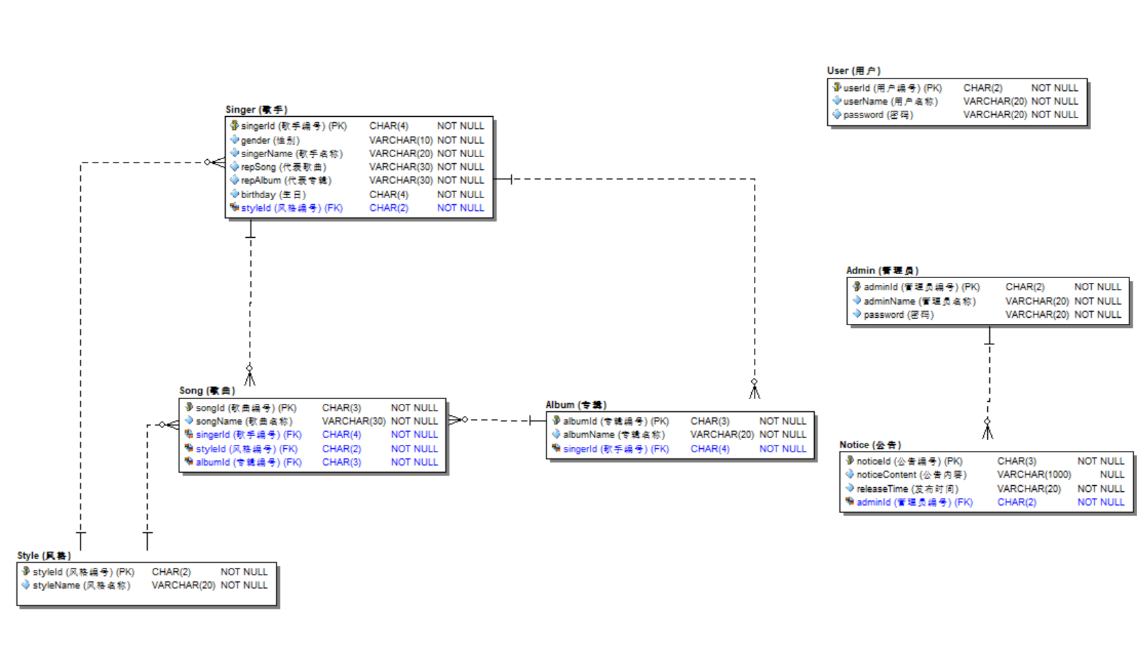

API design: design the back-end interface, including the API interface for user authentication, music search, music playback and other functions.

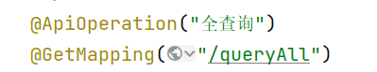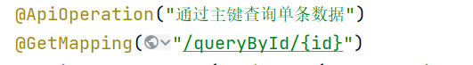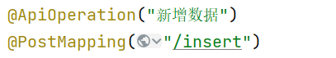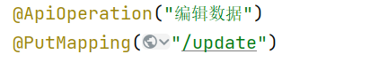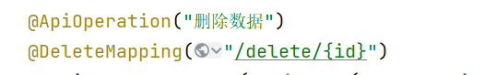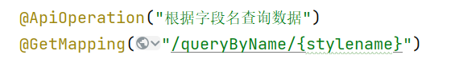

## Front end system design

User interface design (User Interface Design):

Layout design: determine the page structure and layout, including the location and arrangement of the navigation bar, sidebar, content area, etc.

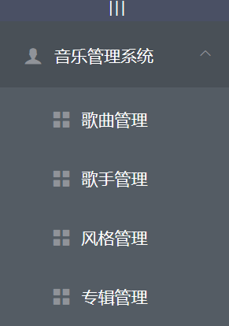

Color selection: select the color scheme suitable for the brand and demand, used for the background, text, buttons of the interface elements.

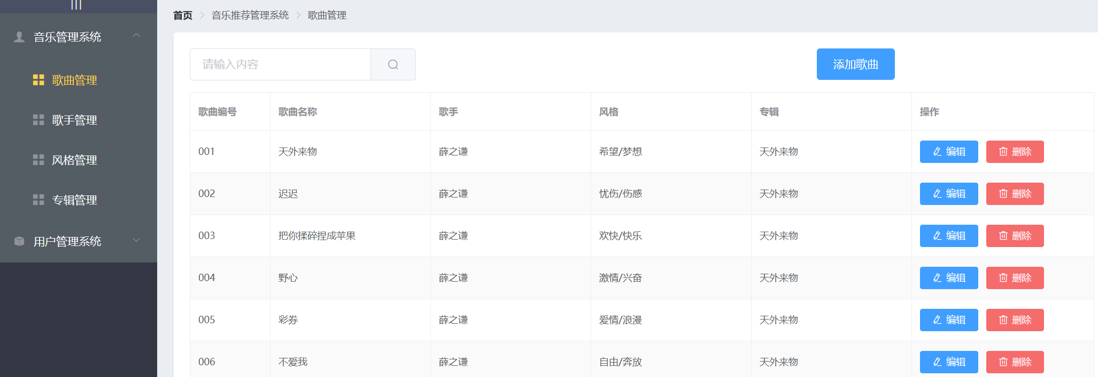

Icons and graphics design: Select the appropriate icons and graphics to improve the visualization effect and easy identification of the user interface.



Interaction Design (Interaction Design):

Navigation design: Design intuitive and easy-to-use navigation methods to ensure that users can easily browse and navigate the various pages of the website or application.

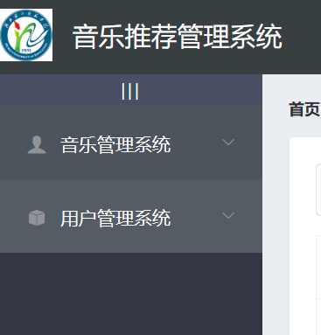

Form Design: Design forms that are easy to fill in and understand, including interactive elements such as input fields, options, validation, and submission.

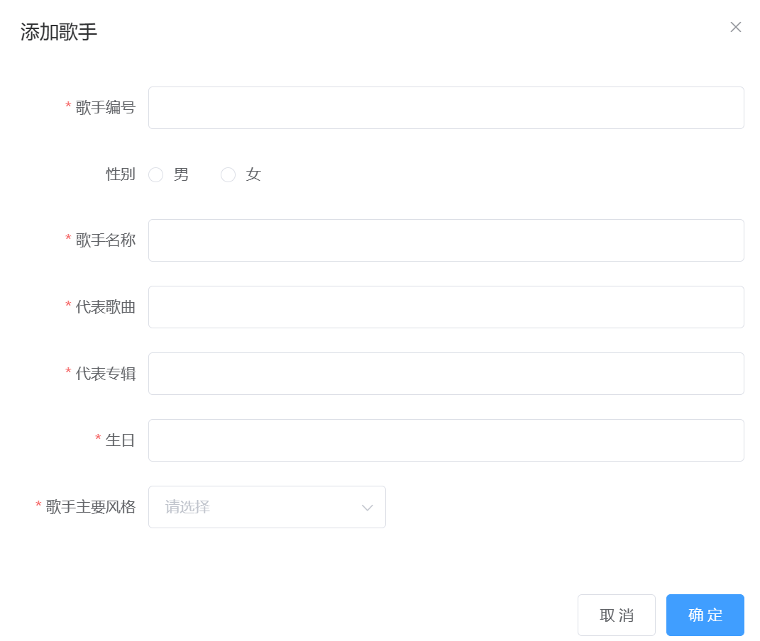

Dynamic design: Use appropriate animation effects and transitions to enhance user experience and guide users to pay attention to important information and operations.

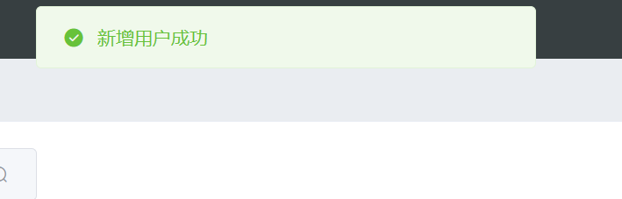

Feedback design: Provide immediate and clear feedback, such as button press effect, load indicator and error prompt, to let the user understand the operation status and results.

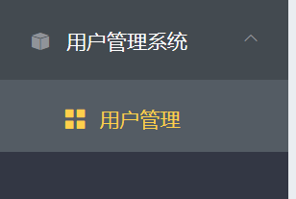

# system implementation

## Rear end system implementation

### Edit module

1. Flow chart (or activity chart)

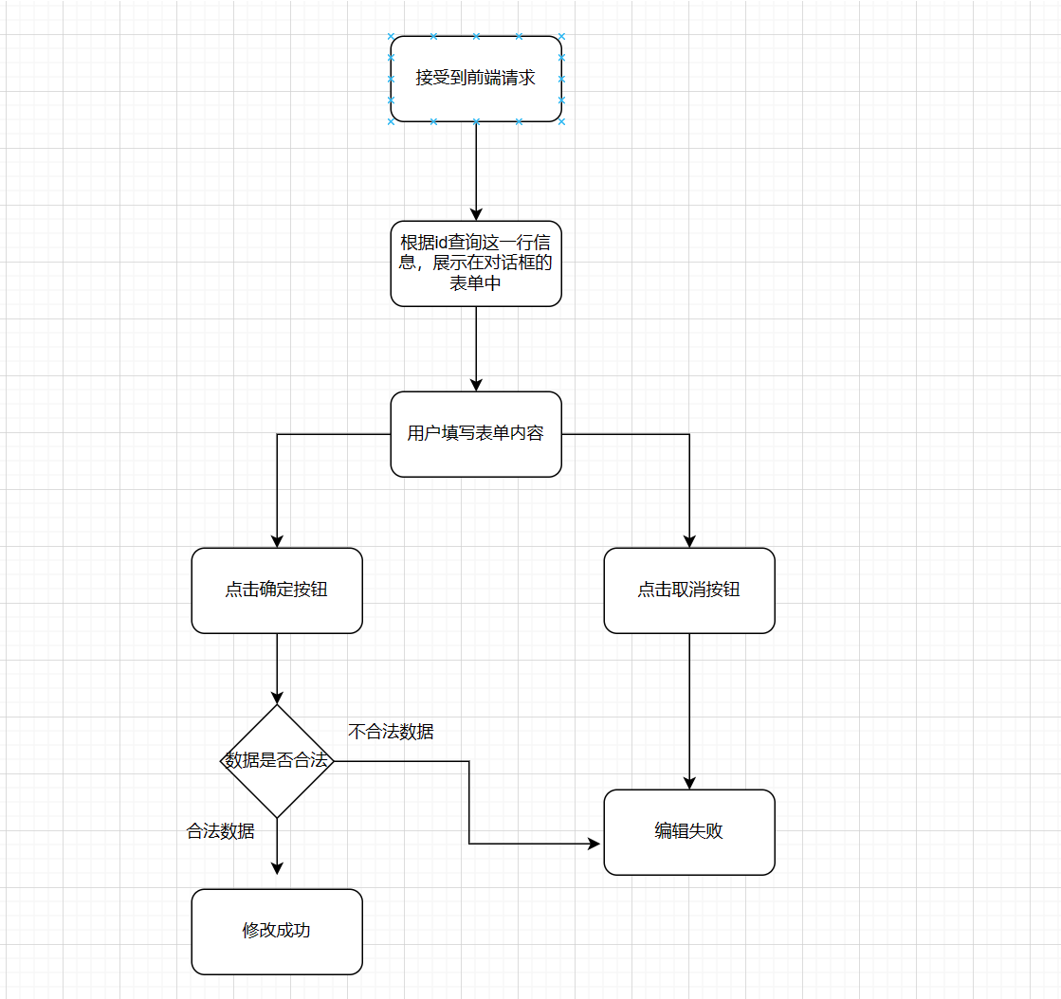

1. Core code and an introduction

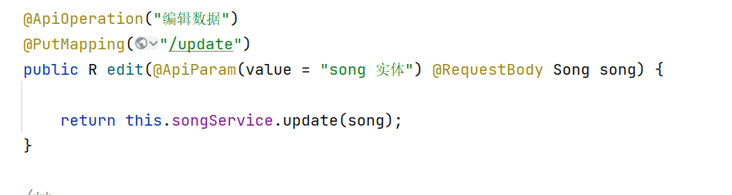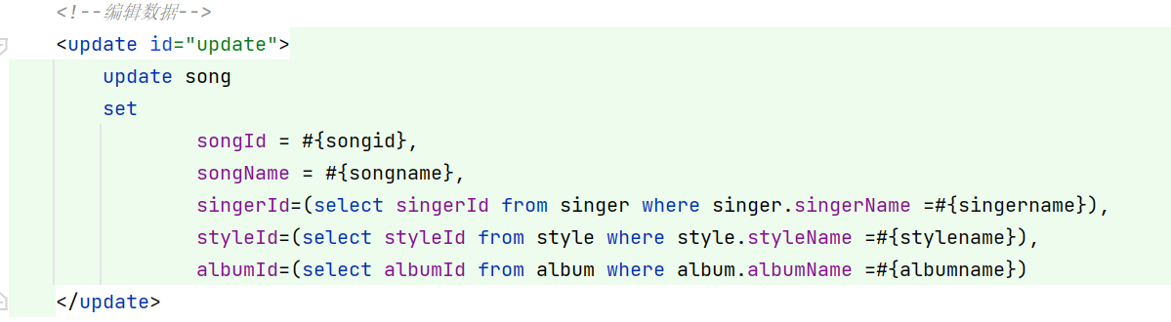

### Remove the module

1. Flow chart (or activity chart)

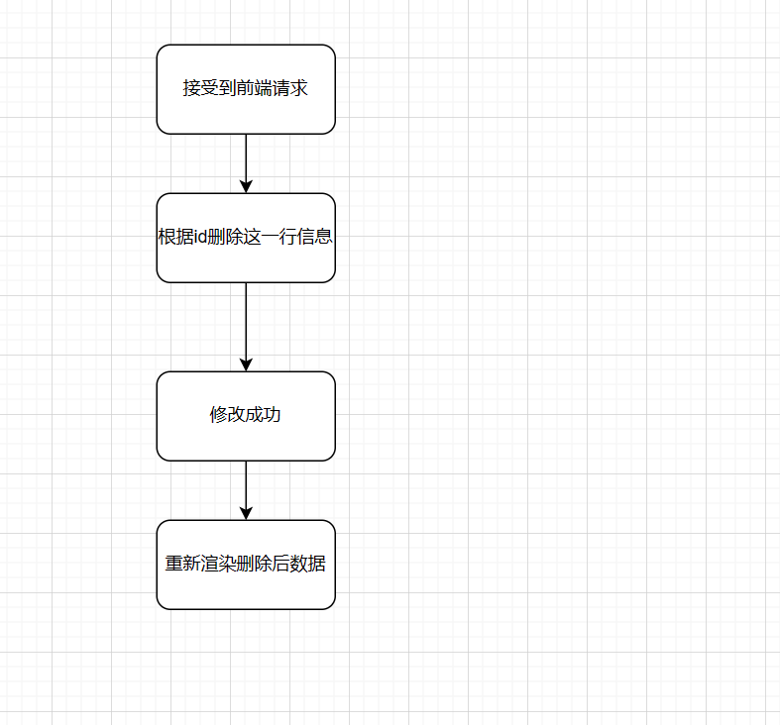

1. Core code and an introduction

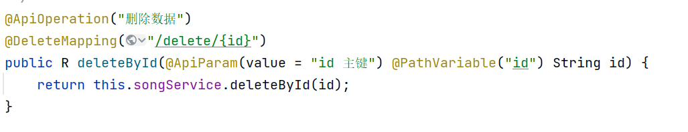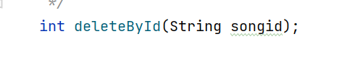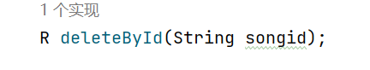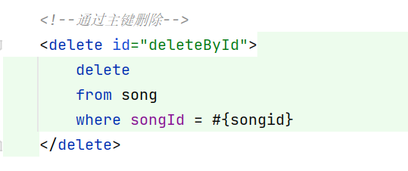

## Front end system implementation

### Edit module

1. Flow chart (or activity chart)

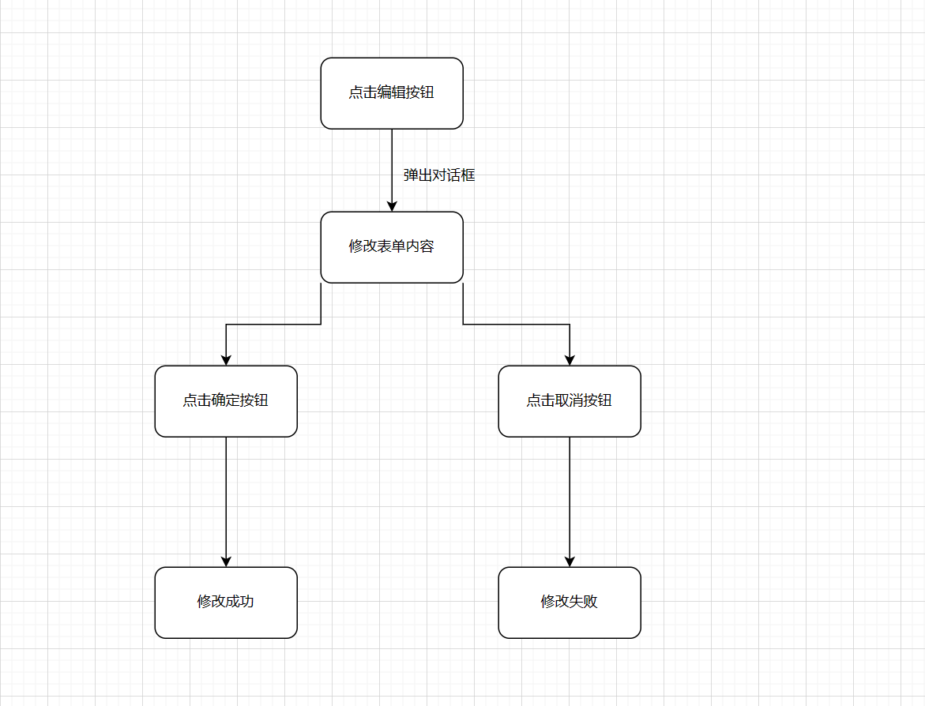

1. Core code and an introduction

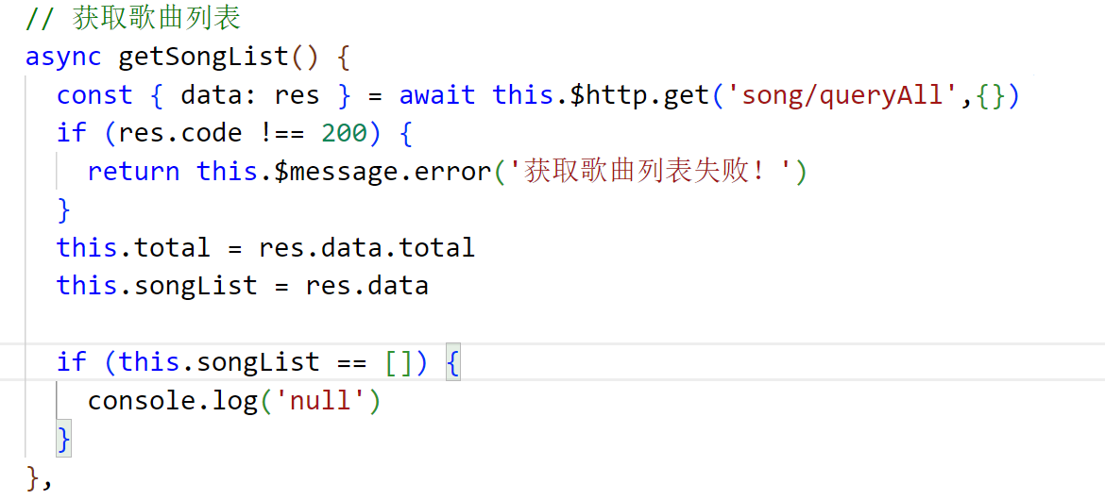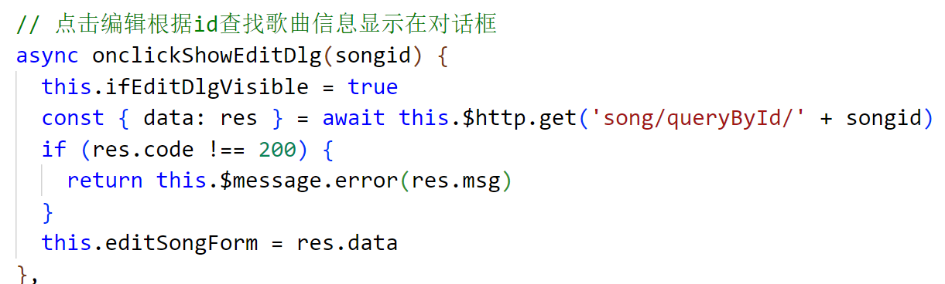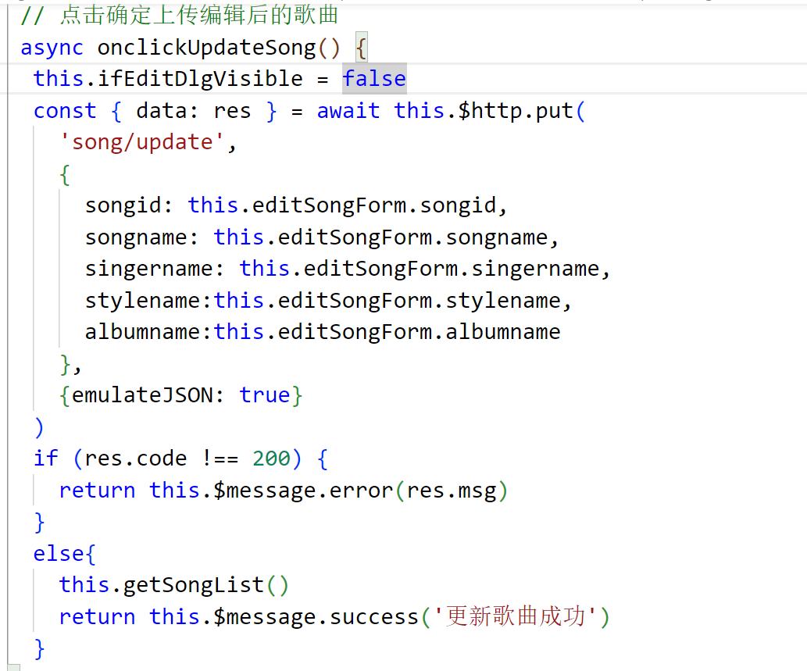

### Remove the module

1. Flow chart (or activity chart)

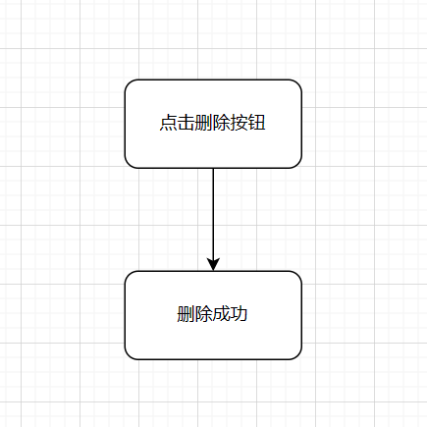

1. Core code and an introduction

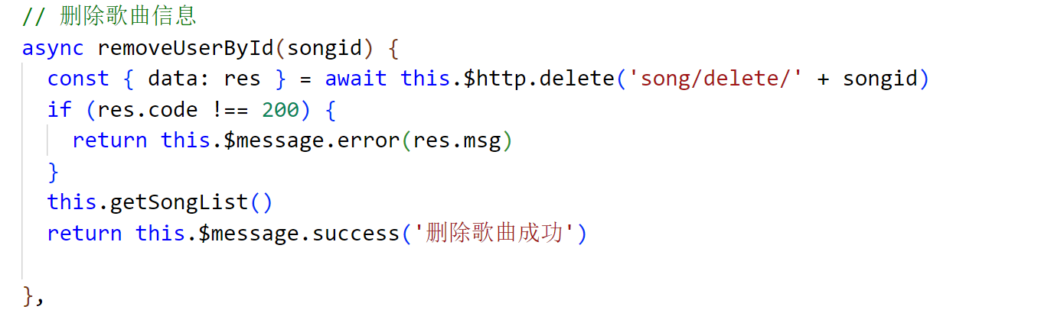

# Summary and experience

## Summary of practical training projects

.. The practical training project of the music website and its background management system is a substantial and interesting learning experience. Through this project, I successfully created a more functional music website, enabling users to browse and search for their favorite music. At the same time, the background management system also provides powerful management functions to help us monitor and manage user accounts, music content and data.

In this project, I learned a lot of knowledge and skills about front-end and back-end development. I used HTML, CSS and vue and element to build the user interface, enabling user login and profile management. I also learned how to handle user requests, design and manage databases, and implemented music adding, editing and deleting functions.

In the backend development aspect, I built the core functions and logic of the website using Java's springboot framework combined with mybatis. The construction of the background management system also makes us learn to manage users, deal with databases and other details.

Through this practical training project, I have further deepened my understanding of the whole website development process. I learned how to analyze the business needs, plan the architecture and functional modules of the project, and check the information on the Internet when I did not understand the problems, and ask my classmates and teachers to solve the problems. I am also familiar with the importance of the version control tools.

## Training experience

For me, the training project of music website and its background management system is the first project that the front and back end including the database is designed by myself. Through this project, I not only learned a lot of technical knowledge, but also had a deep understanding of the design and development process of music websites.

First, I learned how to effectively use HTML, CSS, and JavaScript to build the front-end interface of the website. Through practice, I got familiar with different HTML tags and CSS styles, and mastered the skills of responsive design and user interaction. At the same time, I also learned to use axios to interact with the back-end API, enabling user login and dynamic web page updates.

Secondly, I have a deeper understanding of the back-end development. I learned to use Java's springbo o t three-tier architecture to build the core functions and logic of the website, realizing user login, music management and other functions. At the same time, I also learned the design and management of databases, and how to handle user requests and ensure the security of the website.

In addition, the practical training program has also cultivated my problem-solving ability. In the process of the project, I kept encountering problems, constantly searching for information on the Internet and then solving technical problems and debugging errors. With my classmates and teachers, I constantly improve and optimize the functions and performance of the website through discussing and sharing our experiences.

In general, this training is a very rare learning opportunity. Through the project practice, I not only improved my technical ability, but also cultivated the ability of communication, cooperation and problem solving. This will be a positive boost to my future career development and a solid step forward in software development.

Finally, I would like to thank the instructor for supervising our work of the project during the training, and answering the problems for us seriously and responsibly when we encounter them.