Product Requirements
Team | CookieCodec

Brief problem statement
Denton locals need a way to utilize the artistic skills and abilities of University of North Texas art students. Our website seeks to connect Denton locals (including other UNT students), to local artists in order to purchase existing art work, or to commission new works. While artists are in pursuit of their degree and developing a personal portfolio of their work, an outlet for them to advertise and spread their work could be a major asset to both the artist, and the buyer.
Many people seek out affordable, quality art work and services, be it customized jewelry, digital graphics, decorative art and paintings, marketing and advertisement assets, etc. and student artists would be an ideal source of that content. Our website would provide artists with a range of motives, including financial incentive and the opportunity to build a customer base. Students often struggle with transitioning into a career after obtaining their degree, and the opportunity for valuable experience and the spreading of the artists’ artwork could aid in the success of local artists, both before and after graduation.

System requirements
To run our website, you will need a functioning computer with internet access and a web browser. Your web browser needs to be JavaScript compatible. The website will run on an external server with a SQL database as its main storage library.

Users profile
Who is the system intended for? What characteristics should the users have (this can also be a range of things such as reading level, etc.).
Artist:
Basic characteristics:
18 years of age or older.
UNT Art student or Alumni.
Has art to sell, is looking for art-related work, or is networking.
Multiple levels of experience.
Technical characteristics:
Has contact information available.
Is able to navigate a website on the Internet.
Has general to specific art-related knowledge.
Has access to digital files of example artwork.

Customer:
Basic characteristics:
18 years of age or older.
Is looking for art or for hiring for commission.
Technical characteristics:
Has contact information available.
Is able to navigate a website on the Internet.
Multiple levels of art-related knowledge.

Feature requirements (user stories)
List the Priority as 1 (High Priority - Critical) to 3 (Low Priority – Would be nice if we have time)
No. | User Story Name | Description | Priority
1 | Contact artist | A UNT Engineering student is working on a private project and needs help from a UNT art student to source digital art assets. | 1
2 | Registration | A UNT art student is looking to find commission based work and needs a place to host, and advertise their work, so they register at CookieCodec to find interested persons. | 1
3 | Registration | A Denton resident is looking to purchase some affordable artwork for their office and so they register to CookieCodec website to browse artists’ artwork and connect with compatible artists. | 1
4 | Search | As a buyer, I can search specifically by artistic medium in order to find artwork that interests me. | 2
5 | Contact artist | As a buyer interested in a particular artist, I can send a private message to their inbox in order to organize a transaction. | 1
6 | Security/Privacy | As a concerned artist, a watermark will be applied to all of my artwork to ensure the integrity of my art. | 1
7 | Login | Login to gain access to the main site. When correct credentials are entered in the login window, the login window will disappear and the restricted access to the website will be lifted. | 2
8 | Browse Gallery | Select “Browse Gallery” from the navigation bar at the top of the website to search for artwork. When clicked, a redirection to a new page is performed. The new page will display artworks with the optional filter buttons for a narrower search. | 1

Use Cases for the 2-3 Most Critical Tasks
Use Case ID: | 4
Use Case Name: | Browse artworks
Created By: | Alexander Ortegren | Last Updated By: | Alexander Ortegren
Date Created: | 09-23-2016 | Date Last Updated: | 12-04-2016

Actors: | Registered member
Description: | A signed in member will browse the artworks page for a particular artwork and when clicked “go to artist” be presented with that artwork’s sellers’ portfolio.
Preconditions: | - Both members need active accounts on the website  - The seller account need to be registered as a “seller”
Postconditions: | - The button click yields an artist’s page with corresponding artworks  - The buyer can now see and access the sellers portfolio
Normal Flow: | - The buyer navigates to the gallery page and finds desired artwork  - The buyer clicks to go to artist of that artwork  - Sellers profile with portfolio is displayed
Alternative Flows: | The buyer navigates to the seller through another way (ex: the messaging system)
Exceptions: | The buyer navigates to a sellers portfolio and it is empty or not visible for the buyer.
Includes: | Searching for a seller to exchange contact information
Priority: | high
Frequency of Use: | Often – Depending on frequency of site
Business Rules:
Special Requirements: | Search is exact and not keyword/letter based
Assumptions: | Users would want to search for artists by their artwork instead of artist.
Notes and Issues:

Use Case ID: | 1
Use Case Name: | Contact artist
Created By: | George Tipton | Last Updated By: | Alexander Ortegren
Date Created: | 09-21-2016 | Date Last Updated: | 12-04-2016

Actors: | Registered users (including artists)
Description: | Users (including artists) may contact artists in order to coordinate a sale or commission, or contact an artist with relevant questions/concerns about his or her work.
Preconditions: | - User has a verified registered account on the website.  - User must be logged in (user authentication).  - User has selected specific artist profile.
Postconditions: | - A message will be sent to artist through message service  - User will get a confirmation, indicating that their message has been properly sent.  - User will be notified of any error that has occurred.
Normal Flow: | - A user will navigate to specific artist profile  - The system will display a “contact” link to the user, which links to the messaging system.  - The user will enter their desired message to the artist.  - User will submit message.  - The system will display a confirmation message, indicating that the users message has been sent successfully.
Alternative Flows: | - The user is contacted by another artist  - User selects “reply” to artist message.  - User enters desired message.  - User will submit message.  - The system will display a confirmation message, indicating the users message has been sent successfully.
Exceptions: | - Internal website server error.  - Artist has deleted their profile.
Includes: | - User receives a message from artist, and can reply.
Priority: | High: all users must be able to contact other users and artists.
Frequency of Use: | Being that conversations will incorporate between one and three messages from both user and artist, the user will send between one and three messages on average each week.
Business Rules: | User must comply with websites specified terms and agreements.
Special Requirements:
Assumptions: | - Artist has an active account.  - User is interested in artists work or experience.
Notes and Issues: | N/A

Use Case ID: | 6
Use Case  Name: | Create Account
Created By: | Andrew Johnston | Last Updated By: | Andrew Johnston
Date Created: | 92116 | Date Last Updated: | 92316

Actors: | First time users, nonregistered users.
Description: | Creating a verified, registered account on the website. This includes choosing between user and Artist profiles.
Preconditions: | User has not created an account on the website.  User is of legal age to create an account on the website.  User has knowledge of his/her personal identifiable information.  User has access to an email address account to verify contact information.
Postconditions: | User has created an account.  User has verified their contact information via email.  User has ability to login to website to utilize additional features.
Normal Flow: | User navigates to CookieCodec website.  User selects that he/she wants to ‘Register’ an account.  The system will present options displaying the difference between a normal user and Artist profile.  The user will select which type of profile fits their needs.  The system will display a series of personal identifiable information questions.  The user fills out the provided form.  The user selects ‘Submit’.  The system sends out a confirmation email to user provided email address.

The system indicates to the user that the confirmation email has been sent to the provided email address.
The system will present the login page to the user.
Alternative Flows: | The user enters the website. The user does not login to the system. The user wishes or selects an option that is available to only logged in, registered users.  The system presents a message stating that the option the user is trying to reach is only available to logged in, registered users.  The system provides the ‘Login’ and ‘Register’ options. 3. User selects “Register’.  The user is logged into a normal account on the website. The user wishes or selects an option that is only available to logged in, registered Artist accounts.  The system presents a message stating that the option the user is trying to reach is only available to logged in, registered Artist accounts.  The system provides the ‘Login’ and ‘Register’ options.  User selects “Register’.
Exceptions: | User is underage and cannot legally create an account on the website.  User does not know or cannot provide all required personal identifiable information.  User does not utilize any functions or options on the system or website that do not require a logged in, registered account.
Includes: | Clicking on link provided by verifiable email sent by the system calls the finished register account page.  Selecting an option that is unavailable to a unlogged in, unregistered account will prompt the account page.
Priority: | Creating an account is a high priority as it is required to utilize many options and functionalities of the system. DIfferent functionalities are provided to the different types of accounts, so it is necessary to register the correct type.
Frequency of Use: | Creating an account will be accomplished by every user that wishes to utilize functionalities that are only offered to logged in, verified accounts. This function will only be utilized once per user, before logging in for the first time.
Business Rules: | User must be 18 years of age or older.  User must have knowledge of his/her personal identifiable information.  User must agree with the website’s terms and conditions.
Special Requirements: | ● System must not have provided email address or username not on file already.
Assumptions: | User wishes to utilize functionalities that are offered to logged in, verified accounts.  User is of legal age to create account and has knowledge of his/her personal identifiable information.  User has selected the option to ‘Register’ an account.
Notes and Issues: | Still to decide: What personally identifiable information must be provided between the difference of a normal user and Artist profile.

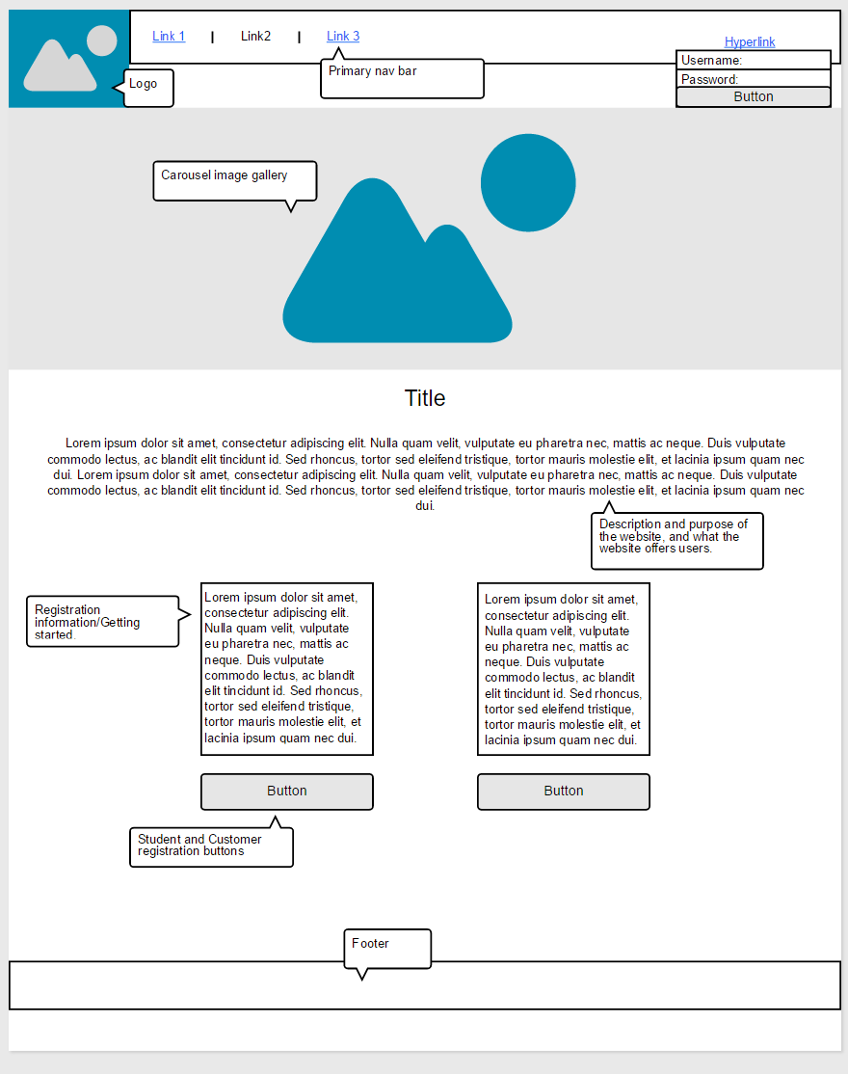

Non-Functional Requirements
- Security:
  - Creative assets will be protected from theft and unauthorized use.
  - User account information will be stored securely in a MySQL database.
- Usability:
  - Customers should be able to register and contact an artist within one hour of use.
  - System should be easy and efficient enough to use, so that user errors are minimal.
  - Artists should be notified of incoming messages from potential customers, and be able to send a received response within 30 minutes.
- Data Integrity
  - The system shall store its user’s data in a database on an external server.
  - The user’s data shall not be accessible to other users unless the user specifically agrees to have their information displayed.
  - A watermark shall be implemented on every user’s uploaded artwork pictures to ensure their art is not illegally copied.
- Privacy
  - The webpages, other than login screen and registration page, shall not be accessed by users unless they are logged in to a valid account.
  - Every user’s login information shall be stored using an encryption formula in order to prevent account theft.
  - Personal information about the user shall not be displayed on the website, unless user allows it.
- Accessibility
  - Accessible and usable only in authorized ways by registered and authorized users.
  - Simple and consistent navigation.
  - This site has been built using code compliant with W3C standards for HTML and CSS.
- Legal and licensing issues or patent-infringement-avoidability
  - Utilizing any 'Copy' functions, including highlighting images, will be disabled to all users.
  - All user profile information and images hosted on our website will be protected from unauthorized access.
  - All images will be protected via provided watermarking.

