Network Security

Introduction
The organization is in the software development industry. Internet and related services are significantly used by the employees such as Software Developers, Architects and Project Managers.
At the moment the company has only a traditional packet filtering firewall installed at the perimeter of the network. The CIO of the company has been informed that there are various malware and other malicious security breaches happening within the company.
One of the first considerations facing the enterprise that wants to deploy networking related security is which contain advanced technologies to adoption. This report examines the three prevalent standards, 802.11b, 802.11g, and 802.11a, with an eye toward the forthcoming 802.11n standard, which promises much higher throughput than is currently available.
I also look at two wireless LAN (WLAN) architectures – standalone access points and centrally controlled coordinated access points – and discuss implementation considerations that can help you decide which architectures to adopt in your environment.
To help decide which standards-based network security to implement, it wants to perform a site survey that identifies the most appropriate wireless technologies and architectures for your environment. Before delving into the more technical details, let’s examine what’s involved in planning and conducting a site survey.

Analysis of Current Network with Internet Perimeter Security
Segments in the network
An increased desire for the drive for heightened network security, and the need to accurately identify and segment workers, devices and networks are all being driven by the changes in the way businesses partner and work with other organizations.
The list of requirements and challenges that the current generation of Company networks must address is highly diverse and includes the following.
Global enterprise availability
Unified Communications, financial, medical, and other critical systems are driving requirement for five availability and improved convergence times necessary for real-time interactive applications.
Migration towards fewer centralized data repositories increases the need for network availability for all business processes. Network change windows are shrinking or being eliminated as businesses operations adjust to globalization and are operating 7x24x365.
Collaboration and real-time communication application use is growing
The user experience is becoming a top priority for business communication systems. As Unified Communications deployments increase, uptime becomes even more critical.
Continuing evolution of security threats
Security threats continue to grow in number and complexity. Distributed and dynamic application environments are bypassing traditional security chokepoints.

Security equipment’s performance and ranking

The need to adapt to change without forklift upgrades
IT purchases face longer time-in-service and must be able to adapt to adjust to future as well as present business requirements. Time and resources to implement new business applications are decreasing. New network protocols and features are starting to appear (Microsoft is introducing IPv6 into the enterprise network).
The need for partner and guest access is increasing as business partnerships are evolving. Increased use of portable devices (laptops and PDAs) is driving the demand for full featured and secure mobility services. An increasing need to support multiple device types in diverse locations.
Business risk mitigation requires validated system designs. Adoption of advanced technologies (voice, segmentation, and security, wireless) all introduces specific requirements and changes to the base switching design and capabilities.
This document is the first part of an overall systems design guide that addresses NSS Labs with the company architectures using the latest advanced services technologies from Cisco and is based on best-practice design principles that have been tested in an enterprise systems environment.
It introduces the key architectural components and services that are necessary to deploy a highly available, secure, and service-rich Company network. It also defines a reference design framework that provides the context for each of the specific design chapters helping the network engineer understand how specific design topics fit into the overall architecture.
Vlans and inter communication between departments
Network equipment required to head office location
The NSS Labs of company is usually understood as that portion of the computing infrastructure that provides access to network communication services and resources to end users and devices spread over above three geographic location. It might span a single floor, building or even a large group of buildings spread over an extended geographic area.
Some networks will have a single infrastructure that also acts as the core or backbone of the network and provide interconnectivity between other portions of the overall network.
The company core can often interconnect the company branch access, the data center and WAN portions of the network. In the largest enterprises, there might be multiple architecture sites distributed all branches with each providing both end user access and local backbone connectivity.
From a technical or network engineering perspective, the concept of a company has also been understood to mean the high-speed Layer-2 and Layer-3 Ethernet switching portions of the network outside of the data center.
Current Network Diagram
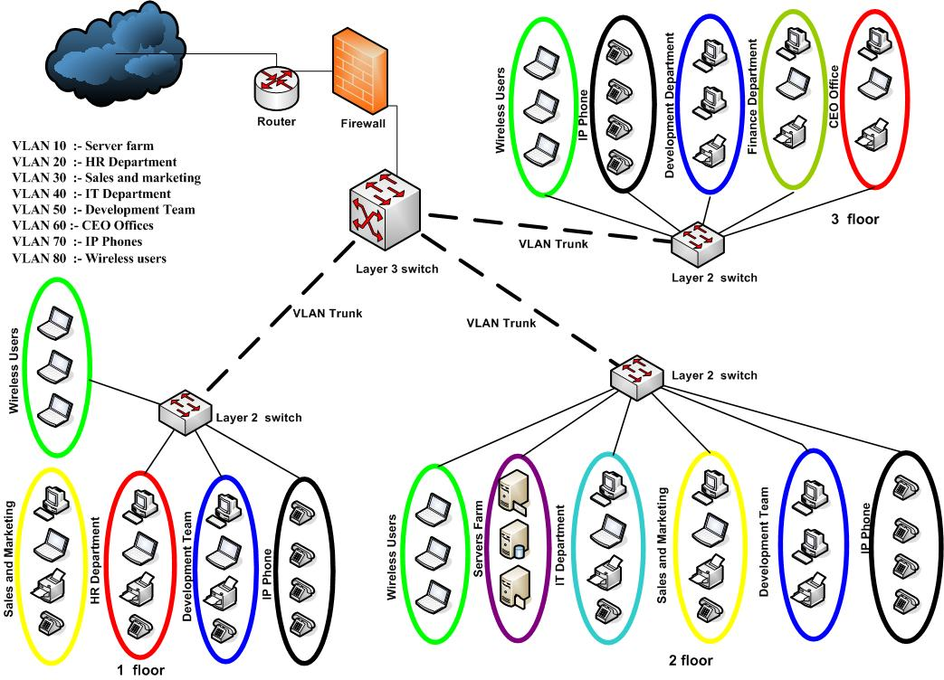
Figure 1

Network Requirements
- Use these guidelines to configure a network switch for a system running the Enterprise Manager Ops Center software.
- Use an 8-port or 16-port Virtual LAN (VLAN) switch.
- Discover and manage the switch.
- Create a separate VLAN for management and provisioning networks.
- Disable spanning-tree protocols on the switch.
- Packet filtering firewall
For Ethernet connectivity for current network
- The management network must be a 10/100 connection.
- The provisioning and data networks must be a 10/100/1000 (1 GB) connection.
- In Connected mode, the Enterprise Controller also needs to get access to company vendor Web sites to download updates or other system
Resources accessed via network
The servers provide computing power to facilitate transfer of data across a network to enable applications, operating systems, file transfer, email, printing and communications among client computers. Each particular type of server is generally defined by its configuration and software which enables it to communicate with intermediate client machines.
Whether you are powering business communications, web site access or distributing computing power across a variety of machines, servers provide the computing power at the core of any network. Each unique type of server is managed by a platform, which pairs specified hardware and software to power data transfer according to incoming requests.
Critical a proper or stable network to the company
As bandwidth rates have increased, modern servers can handle a larger number of requests, distributing data transfer across a series of servers through a cloud or cluster.
Modern IT department can work with a variety of computing configurations to get the very most out of their servers. According to the architecture of a server, defined communications roles improve the ability to secure data and ensure it’s only delivered to its intended recipients.
The ability to reliably scale computing power across client requests has been at the core of IT growth in recent years, and understanding server capabilities can provide insights into these trends for professionals, business owners and developers.

Product evaluation specification sheet for the above security device

- The holistic approach to network access security, It provides:
- Accurate identification of every user and device
- Easy provisioning of all devices
- Centralized, context-aware policy management to control user access: whoever, wherever, and from whatever device
- Rich contextual data about connected users and devices to rapidly detect, mitigate, and remediate threats
- Highly secure business and context-based access
- Business-policy enforcement
- Access control
- Highly secure supplicant-less network access
- Device administration access control and auditing
- Device profiling
- Device-profile feed service
- Extensive multiforest Active Directory support

Controls used in current network
Types of Server Hosting
While the core technology that powers many modern servers is based upon similar processors, the configuration and distribution of that computing power varies widely. When hosting your server in a data center, you’re able to harness resources to optimize the efficiency of data transfer. For both enterprise level companies as well as startups, selecting the right server configuration can mean substantial savings in terms of economic and computing efficiency.
Shared
As the single most economical form of hosting, server resources are shared across a wide variety of users. While users have the ability to access their own partition (even on a dedicated IP address), memory and transfer resources are shared across other sites.
Many entry level developers opt for a shared server for its low costs – the ability to easily migrate or upgrade from common shared operating systems such as cPanel has made it easier to scale up to dedicated or distributed servers based upon future needs.
Virtual
In recent years, virtual private servers (VPS) have become increasingly popular for users seeking an intermediate choice between shared and dedicated servers. With a virtual configuration, servers are portioned into sub-dedicated areas which provide users with root access and full computing power for their given segment of the server.
Moderately priced, these configurations allow for creation of development environments without a full investment in dedicated hardware.
Server Application Types
The application of server computing power to specific data needs has enabled hardware specialization to improve uptimes, efficiency and reliability of networks.
While a given hardware setup can often power multiple applications, many times data centers are organized around hardware for a specific purpose to make more efficiency use of the network.
Web Servers To power data transfer of hypertext protocol (http), web servers deliver images, text, rich media and data over the Internet. Modern web servers are optimized to deliver a variety of data sources including VOIP (voice over IP), streaming media as well as hosting files (FTP) and websites.
Web servers are optimized for data transfer speed, as well as security with extensive firewalls and incoming request filters to protect against denial of service attempts.
Application Servers
A subset of traditional data servers, application servers are designed to power frameworks which are involved in extensive processes related to a specific set of software. Application servers can power web-based apps, games, output from scripts and programs as well as serving data from an API (application protocol interface.)
Modern application servers are optimized for load balancing and are often located in a cloud, which enables them to distribute data more efficiently.
Specialized Servers
File, Printer and Database Servers While modern servers often are involved in multiple tasks, specialized servers provide dedicated support for file transfer, printer communications and database queries.
For specific types of uses, having a dedicated server for a specific purpose can speed up processing times and ensure sufficient resources are available during peak volumes.
Media Servers
With the growth of streaming audio and video, media servers provide an efficient way to transfer high bandwidth files online. For dedicated media firms, businesses and producers alike, investing in efficient hardware can lower operational costs from operating a server over time.
With the growth of high definition video and real-time gaming platforms, media servers are under increasing stress to meet growing consumer demands for quality.

Mail (Exchange) Servers
Mail servers serve as an outbound client and inbound retrieval server for electronic messages, commonly via the STMP (simple mail transfer) protocol. Serving as a transfer agent (TA),mail servers communicate with each other according to their set rules, including filters, checks and blacklists to determine whether a message is successfully delivered.
New Networking requirements of the organization
Implement layer 2 and 3 switches for redundancy manner
Here I use layer 2 and 3 switches which will be connected with all the access switches on redundant path. Depending on the distance of host location Access switch uplinks will be used either Gigabit Copper based Ethernet cable or Gigabit Fiber based cable.
All Access points distribute multiple SSID, all vlans in network it provides ,
- Mobility access to the users
- Wi-Fi roaming available implementing network
- Every floor implementing 2 access point for keep redundancy and availability
- Radius sever using for the central wifi authentication
Access switches will be manageable where we can segregate department wise user on different vlans, according to the requirement finance department have a vlan, accounts department have a vlan, and Customer service department vlan and each library section have separate user vlan
Through this vlan we can reduce broadcast domains and also subnet wise user management is easier. Inter vlan sub network will be communicating through Core switch. IDS is use to get unusual activity alarm when devices are affected.
New proposed network diagram
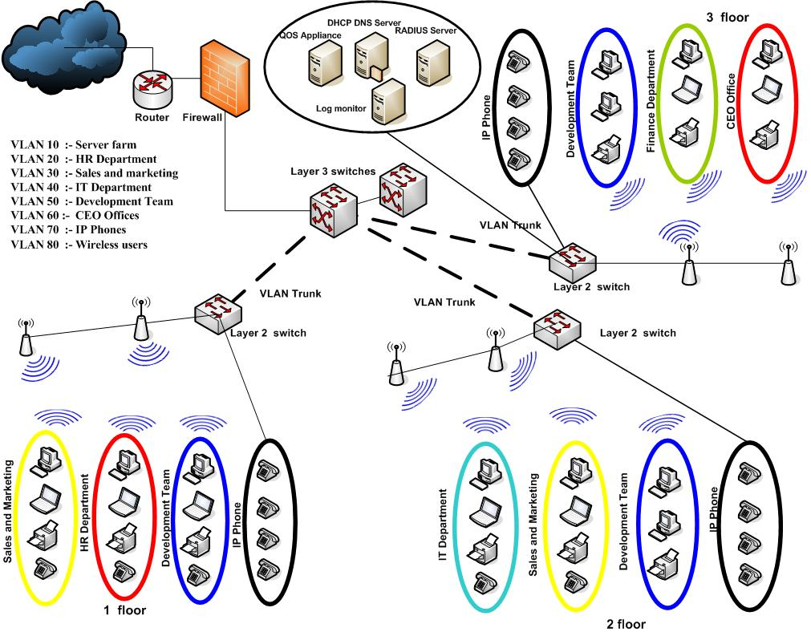
Figure 2

A copy of each dat transaction will send to IDS device to inspect and match with latest signature pattern to identify virus activity and generate notifications to the administrator over mail. Server Farm zone has been separated with different subnet work zone where a single server vlan or multiple vlans can be used with manageable server farm switch.
The Uplinks for layer 2 to layer 3 will be change with fiber in order to keep good connectivity in the new proposed solution of the network as well.
Vlan solution
- Voice VLAN (IP phones VLAN 70 ) will be keep in wired Network (LAN)
- Voice need big bandwidth
I am going deploying NMS servers to collect SNMP trapp from devices and IDS device alarm, which will give us insight on various events occur on each device and flexibility of management. On the upper side of Core switch we connect with Internet firewall where the entire user internet request is monitored and prefinished against corporate policies.
With this firewall a separate zone connects with a switch, this zone is for the servers which can receive not only local traffic but also from outsider. Here Mail, Web, Ftp servers will connect directly on switch ports and I am going to give Public IP directly on this server NIC.
Product brochures for three leading products
To protect against network-level attacks, Juniper Networks devices use a dynamic packet filtering method known as stateful inspection to unmask malicious traffic.
With this method, firewalls collect information on various components in a packet header, including source and destination IP addresses, source and destination port numbers, and packet sequence numbers.
When a responding packet arrives, the firewall will compare the information reported in its header with the state of its associated session. If they do not match, the firewall will execute the actions specified in the security policy, which typically involves dropping the packet and logging the action.
Stateful inspection provides more security than other firewall technologies such as packet filtering because the traffic is examined under the context of the connection and not as a collection of various packets.
By default, the Juniper Networks firewall denies all traffic in all directions. Then, by using centralized, policy-based management, enterprises can create security policies that define the parameters of traffic that is permitted to pass from specified sources to specified destinations.
Secure, reliable WAN connectivity also plays an important role in network-level protection. By deploying robust virtual private networks (VPNs), remote sites can be securely connected to other remote sites and to centralized data and applications using high-bandwidth shared media such as the Internet.
Features such as Auto VPN, can help ease the administration and management of VPNs, particularly in hub-and-spoke topologies, allowing secure connections to be automatically set up and taken down without manual configuration also.
With cloud computing and virtualization adoption on the rise, the evolution of the data center brings a new set of challenges to IT professionals.
While the need for physical network security will continue to exist in data centers, organizations will continue to adopt cloud computing in phases, resulting in hybrid environments essentially, a mix of physical and virtualized data center workloads.
This data center model will result in some workloads like those on physical servers being secured by physical firewalls, while others, such as those running on virtual machines (VMs), being at risk, because traditional security methods provide zero visibility into VM traffic.
To address this concern, Juniper Networks has integrated Juniper Networks Firefly Host with the Junos OS-based SRX Series platform to extend the protections of the SRX Series products into virtualized environment as well.
Product line Highlights
AppSecure is a suite of next-generation security capabilities that utilize advanced application identification and classification to deliver greater visibility, enforcement, control, and protection over the network.
Firefly Host is a purpose built firewall for virtualization that protects traffic to/from virtual machines (east/west traffic). Firefly Host also includes IPS, Virtualization
Specific AV, Introspection which allows you to scan the installation properties of a virtual machine (such as the OS, applications and hot fixes), Smart Groups which supports the use of attributes to create dynamic system associations for VMs) and a Compliance Module with pre-defined and custom rules engine alerts on virtual machine and host configuration changes.
- Firefly Host is tightly integrated into the VMware hypervisor and VMware management framework (VCenter)
- Integrates with other Juniper security products to deliver enterprise-wide unified access control (UAC) and adaptive threat management
- Centralized, policy-based management minimizes the chance of overlooking security holes by simplifying rollout and network-wide updates.
- Technologies make it easy for administrators to divide the network into secure segments
- Various high availability (HA) options offer the best redundant capabilities for any given network
- Rapid-deployment features, including AutoVPN and Dynamic VPN services, help minimize the administrative burden associated with widespread IPsec deployments
Product’s performances and weaknesses
A host-based Intrusion Detection System resides on the system being monitored and tracks changes made to important files and directories with ability to monitor events local to a host. One of the advantages of host-based IDS is that it does not have to look for patterns, only changes within a specify set of rules.
Host-based intrusion detection methodologies fall under Post-event audit trail analysis. For instance, products in this category perform automated audit trail analysis, reduction and management. Persistently the purchase of such a product can be justified on the cost savings achieved through the centralized and automation of audit trail management.
Other advantages are that investigators can go back in time and do historical analysis of events that have occurred in the past. Lastly, this is particular helpful in exploration of break-ins that have taken place over a period of time.
From the network-based security viewpoint, by the time it detects the security problem, 'it's normally too late to react and look after the data, and the resulting consequences of the attack go far deeper into the network without resistance.
In due course, the damage is already done by the time you find out. Also, given that most hackers learn how to cover up their tracks by tampering with audit trails, after-the-fact analysis often misses attacks.
Advantages and disadvantages of deploying IDS
Network Manager should request a proper guidance from vendors who specialize in IDS deployment and capable to provide detailed documentation and advice to select right features and capabilities Intrusion detection software where new flaws and vulnerabilities are discovering on a daily basis. There are many way of describing Intrusion detection systems.
The primary descriptors are the system monitoring approaches, the analysis strategy, and the timing of information sources and analysis. The most common commercial Intrusion detection systems are real-time network-based.
In order to select the best Intrusion detection systems and to integrate intrusion detection functions with the rest of the organization security infrastructure, governing factors. The most important that to prevent crisis behavior that can abuse the system by increasing the perceived risk of discovery, improved diagnosis and rectification of causative factors.
The first steps needed to illustration the characteristic of the threat from outside and inside the IT organization, assisting in making decisions regarding the network is likely to be attacked and allocation of computer security resources.
Additionally, understanding the frequency and features of attacks allows Network Manager drawing up the budget for network security resources whether the network currently under attack or likely to be attack.
In today's hacking environment and attack can be launched and completed in under a millisecond. So that, another consideration that Network Manager should understand the functional components of the IDS whether components are the Host on which the IDS software runs.
Most of the well-known desktop operating systems such as Windows 95-98 and Windows ME lack system logging facilities.
Accountability and response are two overarching goals that Network Manager should state for intrusion detection systems. It is extremely difficult to enforce accountability in any system with weak identification and authentication mechanisms.
To achieve the goals, Network Manager should understand and evaluate the control strategy of the input and output of the IDS then analyze which process model for Intrusion detection can help to determine what goals are best addressed by each intrusions detection system.
For instance, military or other organizations that deal with national security issues tend to manage with a high degree of regulation. Some Intrusion Detection systems offer features that support enforcement of formal use policies.
Advantages and disadvantages of deploying Network Intrusion Detection systems
There should be typical deployment of Network Intrusion detection systems for doing packet analysis. An intrusion detection system placed outside the firewall to detect attack attempts coming from Internet.
The advantages of Network-based IDS can be ready to protect against attack and even made undetectable to many attackers. To accomplish advantages of Network Intrusion detection system, well-placed network-based IDS can monitor a large network but it may have complicatedness processing all packets in a large or busy network and, consequently, may fail to distinguish an attack launched during periods of high traffic as well.
Other disadvantages of Network-based Intrusion detection system cannot analyze encrypted information. Location 1 of Network-based IDS sensors, placed behind the external firewall and Router has advantages to observe attacks, originating from the outside world, that break through the network's perimeter defences that may target the ftp server or web server.
Most network-based Intrusion detection system cannot tell whether or not an attack was successful. Location 2 of the Network-based IDS sensors placed outside an external firewall has advantages to document sort of attack originating on the Internet that target to attack the network.

For full enterprise coverage Network Intrusion detection system must be placed on each network segment and should be able to remotely manage the various Network Intrusion detection systems, collate the information gathered, and display the enterprise-wide information on a console.

References
[1] Laudon K.C, Laudon J.P, 2009, Management Information Systems, 11th Edition, Prentice Hall Inc
[2] Lucey T. 1997, Management Information Systems 8th Edition
[3] Davis, Gordon B, 1974, Management Information Systems: Conceptual foundations, Structure and Development: McGraw Hill Ltd, P-5-7
[4] Murdic R.C and Ross J. E., 1977, Information Systems for Modern Management, Second Edition, Eaglewood Cliffs, N.J., Prentice Hall Inc., P 5-6
[5] Henry C. Lucas (JR),1982, Information Systems; Concept for management, Second Edition, New York: McGraw Hill Books P-5
[6] Joseph F. Kelly,1970, Computerised Management Information Systems, New York, The McMillan Company, P-5
[7] Scott, George M.,1986, Principles of Management Information Systems, McGraw Hill Books Company, P-66
[8] Bagad V.S, 2009, Management Information System, Fourth Edition, Technical Publications Pune

