# The source files

The source files can be found here: <https://github.com/zl6977/KBE_chair>

The video demonstration can be found in the blackboard system.

# Product description and selected parameters.

The chair to be developed is a classic style wood chair, as shown in figure 1. The customer can adjust the parameters shown in figure 1 and table 1 to get their personalized product.

Table 1 Introduction for each parameter

|  |  |  |  |
| --- | --- | --- | --- |
| **Parameters /unit** | **Description** | **Default value** | **Allowable range** |
| leg_length /mm | The length of the 4 legs. From ground to the bottom of the seat. | 500 | [500.0, 900.0] |
| back_height /mm | The height of the back. From the top of the seat to the top. | 600 | [400.0, 1000.0] |
| seat_length /mm | The length of the seat as a rectangle. From the front of the seat to the back side of seat. | 600 | [200.0, 600.0] |
| seat_width /mm | The width of the seat as a rectangle. From the left to right side of seat. | 500 | [300.0, 600.0] |
| back_tilt_angle /degree | The tilt angle backward of the back. | 0 | [0.0, 20.0] |
| top_rail_added_length /mm | The added length of the top rail compared with the width of the seat. | 10 | [0.0, 400.0] |

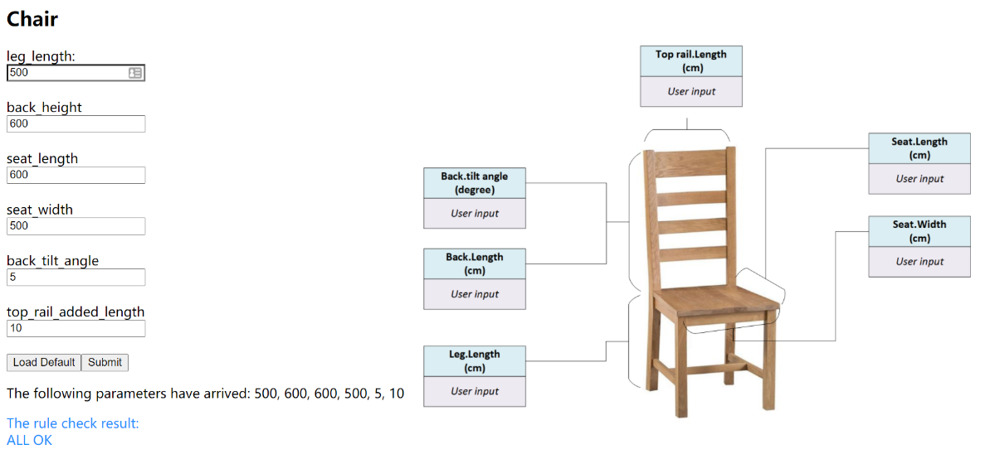

Figure 1 UI and parameters illustration of the product

# KBE application architecture

This KBE application consists of 3 parts, the interconnections of which are shown in figure 2:

1. The user interface server: server_chair_zzz.py
2. manufacturability check server: manufChecker.py
3. DFA template and file



Figure 2 the KBE application architecture

Usage:

1. Run server_chair_zzz.py and manufChecker.py.
2. Open <http://10.24.10.83:1234/orderChair> to check the UI. (see Figure 1)
3. Input the wanted value for each parameter or use *Load Default.*
4. Submit to see if the chair based on the parameter set can be manufactured. (see Figure 1)
5. The DFA file will be generated automatically, which can be visualized in Siemens NX.

For engineers, the allowable range of the parameter set can be adjusted via web.

1. Open <http://127.0.0.1:4321/setParamsIntervals> (see Figure 2).
2. Input the value for the allowable parameter set.
3. Submit to update the parameter set.
4. New rules come to be applied.

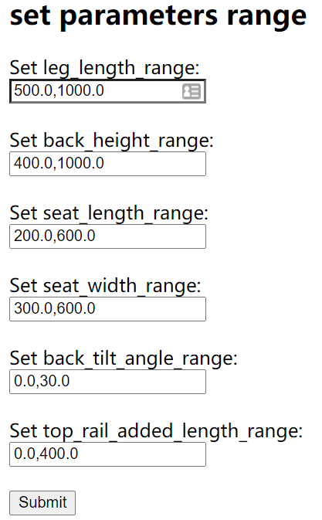

Figure 3 The UI to set allowable parameter range

# UML sequence diagrams showing how an order placed

The KBE application is developed in Client/server architecture. A typical order is placed in the sequence shown in figure 4.



Figure 4 The order making scenario

# Description of the modules

As mentioned above, this KBE application consists of 3 modules, see figure 5 and table 2.



Figure 5 The illustration of each module

Table 2 The introduction

|  |  |  |
| --- | --- | --- |
| Module | Purpose | Functions |
| server_chair_zzz.py | 1. To provide UI to the customer to change the parameters; 2. To generate the responding HTML; 3. To call the checker to check manufacturability; 4. To generate the DFA file of the customized product. | * My handler: the class to realize the purpose 1,2. * update_template(): the function to realize propose 4. * check_manufacutrable():the function to realize propose 3. |
| manufChecker.py | 1. To provide UI to the engineers to set the allowable range of parameters; 2. To check if the given parameter set meets the requirement and return the result. | * My handler: the class to realize the purpose 1. * RuleChecker: the class to realize the purpose 2. |
| chair_zzz.dfa | 1. To provide the template with the 6 modifiable parameters. |  |

# Result demonstration

3 examples of the product ordered with different and arbitrary values of the parameters, see table 3 and figure 5.

Table 3 The parameters of the 3 examples

|  |  |  |  |
| --- | --- | --- | --- |
| **Parameters /unit** | **Chair 1** | **Chair 2** | **Chair 3** |
| leg_length /mm | 500 | 500 | 600 |
| back_height /mm | 600 | 600 | 450 |
| seat_length /mm | 600 | 600 | 400 |
| seat_width /mm | 500 | 500 | 450 |
| back_tilt_angle /degree | 0 | 5 | 5 |
| top_rail_added_length /mm | 10 | 60 | 60 |

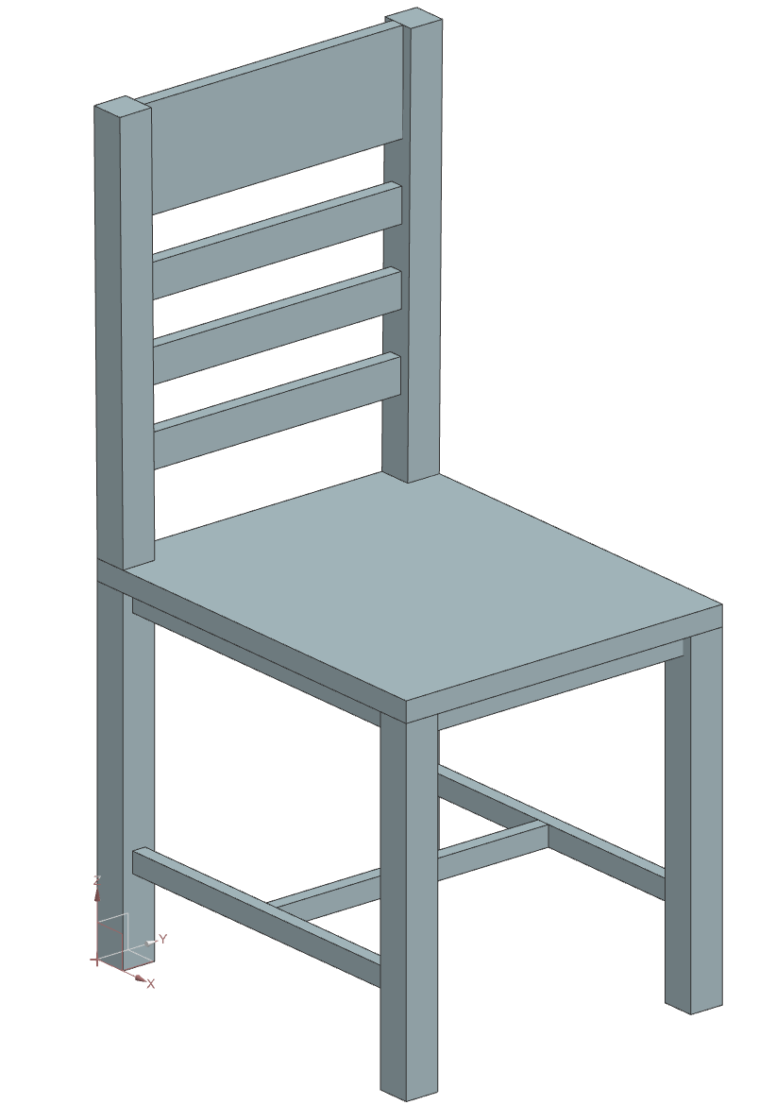 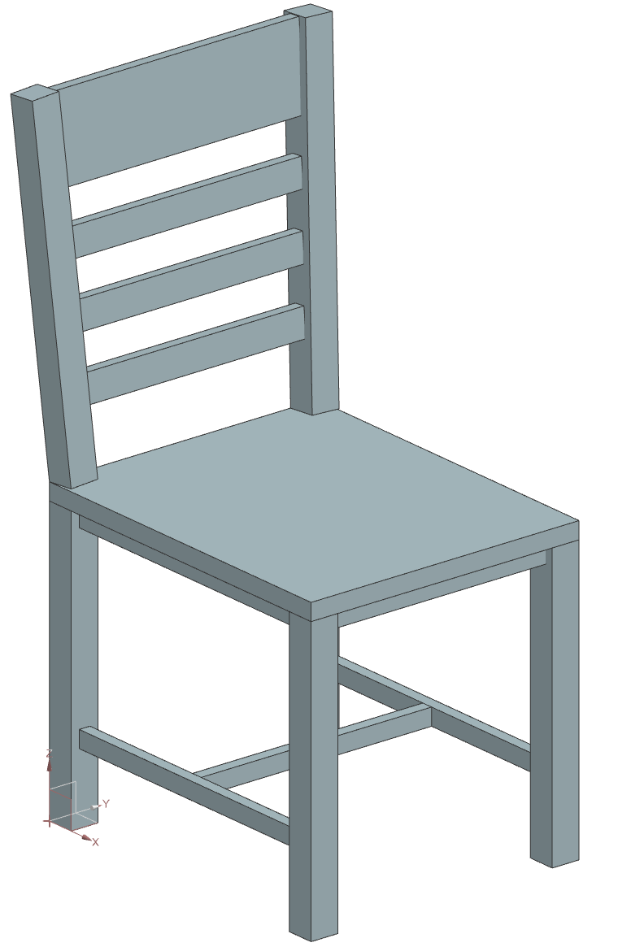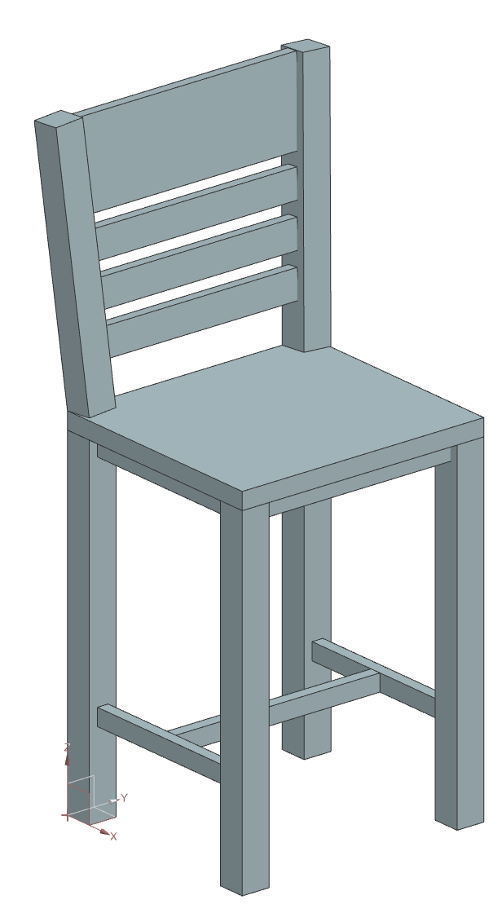

(a)chair 1 (b)chair 2 (c)chair 3

Figure 5 Result demonstration

# Discussion

This KBE application realizes the customer-involved parametric design. The app can check the manufacturability of the user input, and provide the DFA file of the customized product.

To further refinement, there are some aspects that are worth noticing.

1. Multi users: Current app can only process a single user’s request at same time. In the real environment, the refinement for multi users must be done. For example, to generate and save the DFA file for each user.
2. Real-time result demonstration: To provide a user friendly service, the real-time result demonstration is a must. It is a potential way to use the image exporting function to generate the image and show it in the webpage.