Description:

Three shapefiles: New York Counties, New York Streets and Address Points for New York.

New York Counties

1. Completeness

Total record count: 62.
Important columns that were considered: OBJECTID, NAME, COUNTYFP, STATEFP.
High quality file.

2. Dummy records

TBA

3. Validity checks

Invalid geometry
If an object has SHAPE field equals to null, or has no geometry info besides initial state,
or it's bounding rectangle has no geometry info, or it is not simple to process(wrong orientation, self-intersection, open polygon...)
Invalid geometry found: 0 (0%)
Multipart geometry
Multipart polygon features are polygons that contain more than one part or have a hole.
Multipart found: 6 (9.67 %):

Sample check records:
ID Name
19 Queens - valid
25 Erie - not valid
26 Bronx - valid
61 New York - valid
74 Kings - valid
80 Suffolk - valid
Sample check result: All found records were manually checked and some were valid and some not.
Status: Partially valid

Sliver polygon
The factors that define a sliver polygon are the thinness ratio and the polygon's area. If the polygon is below a specified thinness ratio and value, it is considered a sliver
Slivers found; 0 (0%)

4. Visual precision check

Visual precision quality is low, based on 10% manually checked records.
Examples:

Suffolk County screenshot from shapefile:

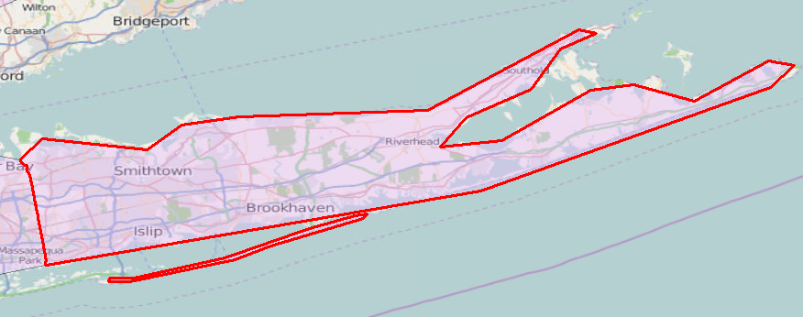
Suffolk County screenshot from Google Maps:
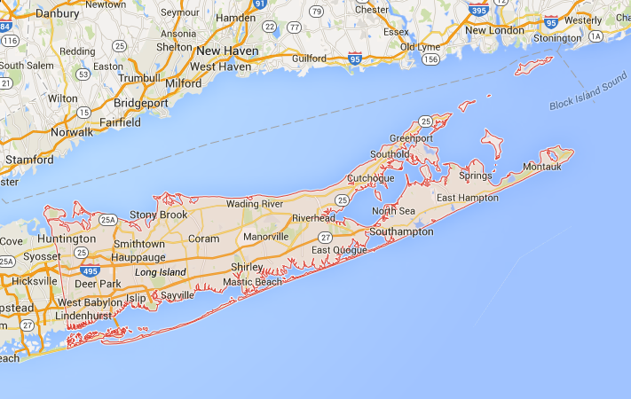

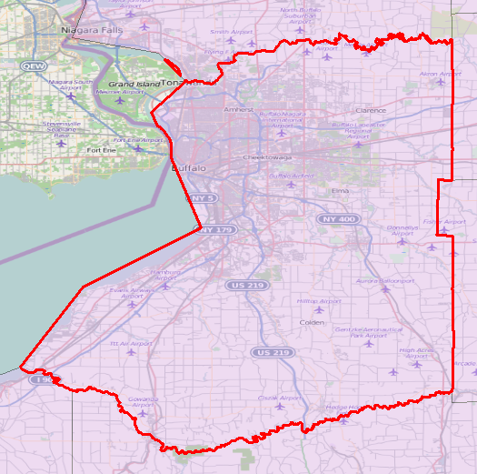
Erie County screenshot from shapefile:

Erie County screenshot from Google Maps:
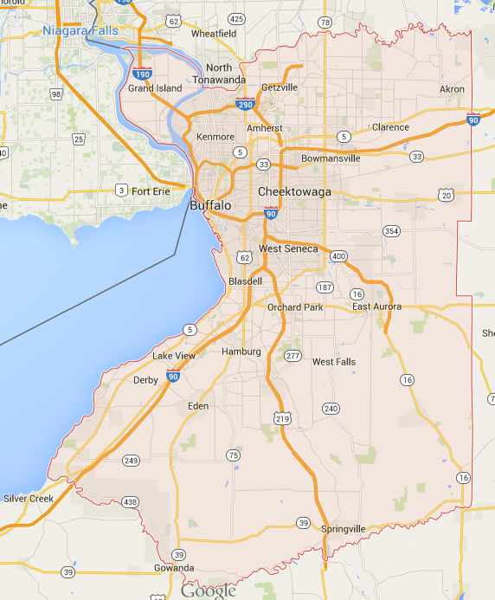
New York Streets:

1. Completeness

Total record count: 1,113,969.
Important columns that were considered: NYSStreetI, StreetName, PostType, PostDirect, LeftCounty, RightCount, LeftPostal, RightPosta.

Good quality file.

2. Dummy values

TBA

3. Validity checks

Invalid geometry
Invalid found: 0 (0%)

Multipart line
Multipart line features are those that have two or more separate paths
Multipart lines found: 0 (0%)

Polyline or path closes on self
Paths or lines in polyline features that either touch or cross themselves
Closes on self found: 3844 (0.34%):

Sample check records:
NYStreetl Name
505704945 Tammy Court - valid
505727600 Woodsedge Court - valid
442378820 Cemetery Road - valid
437996177 Heritage Circle - valid
437259549 Carpenter Road - valid
505853650 Hicks Lane - not valid
505886439 Trails End - valid
505893873 Milton Court - valid
505900507 North Island Drive - valid
505850029 Trotter Drive - not valid
505854209 Lower Salem Road - valid

Sample check result: 10 records of all found records were manually checked and some were valid and some not.
Status: Partially valid

Cutbacks (5% tolerance)
Cutbacks are high-angle turns that cause features to turn back toward themselves. These angles affect polyline and polygon features and can be caused during an editing session
Cutbacks found: 0 (0%)

4. Visual precision check

10 manually checked records came out partially invalid.

Examples:

Carpenter road screenshop from shapefile:
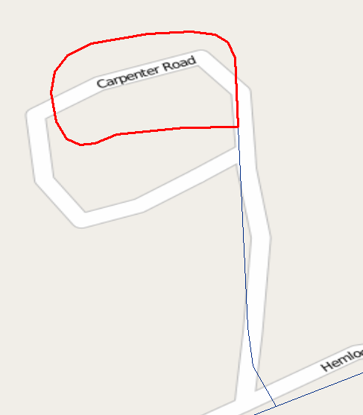
Carpenter road screenshot from Google Maps:
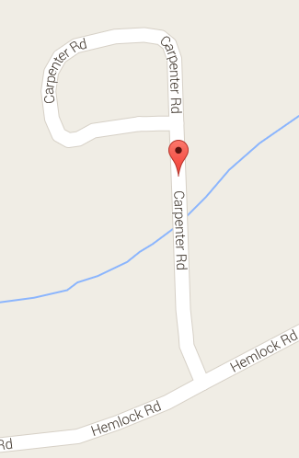

Hicks Lane screenshot from shapefile:
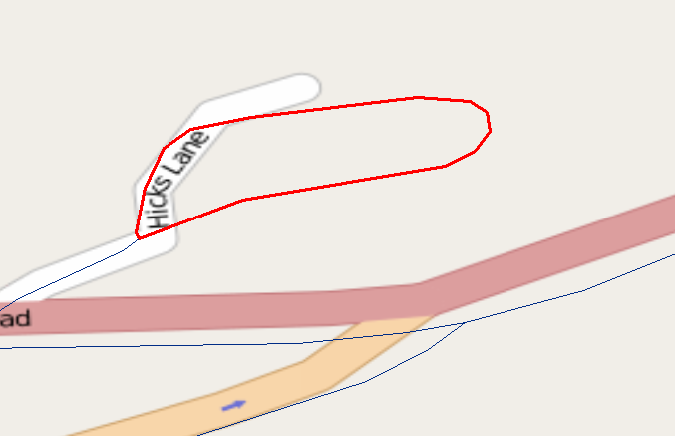
Hicks Lane screenshot from Google Maps:

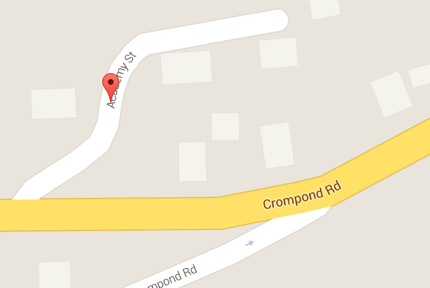
Address Points for New York

1. Completeness

Total record count: 4,229,542.
Important columns that were considered: NYSAddressPointID, CountyID, NYSStreetID, AddressNumber, StreetName, ZipCode, PointType, AddressSource

Good quality file.

2. Dummy values

TBA

3. Validity checks

Invalid geometry
Invalid found: 0 (0%)

