# Magnificent Things

**Upload the solution, without images!**

Create a Web page (HTML5 + CSS3) that looks like the screenshot below:

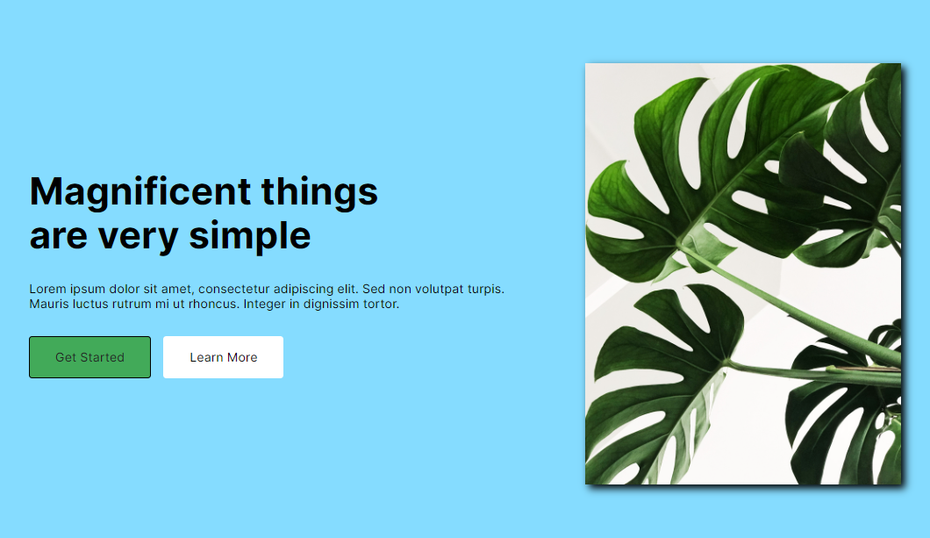

Use hover effect for **"Get Started"** button, like the picture below:

Картина, която съдържа текст, екранна снимка, растение, дизайн

Описанието е генерирано автоматично

## Output

The output should be valid **HTML5** + **CSS3** + **images** that implement the above web page.

## Constraints

* Use font: <https://fonts.googleapis.com/css2?family=Inter:wght@100;200;300;400;500;600;700;800;900&amp;display=swap>
* The site should open correctly in the latest version of Chrome