Assignment 03: Classes and Objects

Multiply

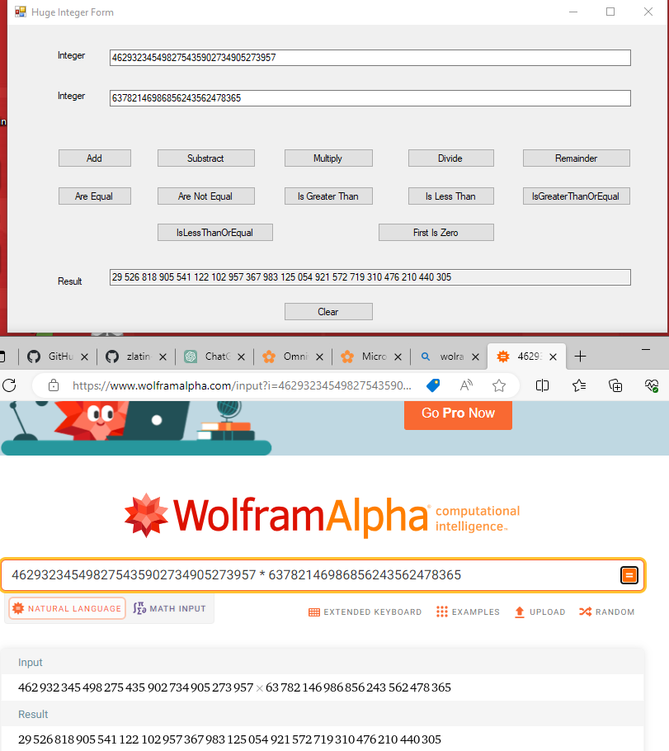

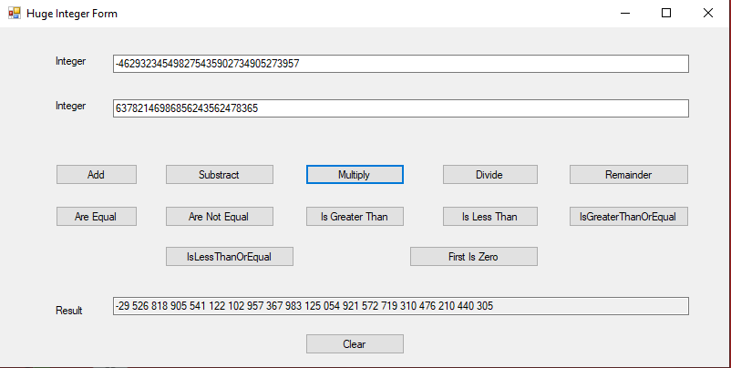

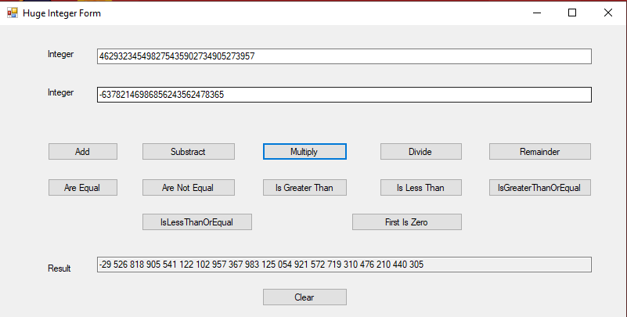

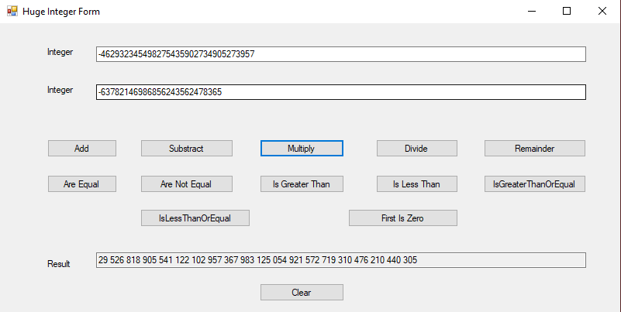

Divide

Remainder

Add

Subtract

Is Zero

Is Equal To

Is Not Equal To

Is Greater Than

Is Less Than

Is Greater Than or Equal To

Is Less Than or Equal To