As root, in the Desktop folder

# apt update

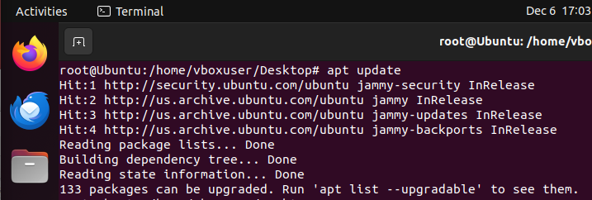

# apt-add-repository universe

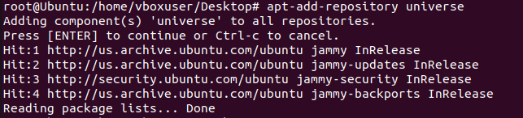

# apt-add-repository ppa:cubic-wizard/release

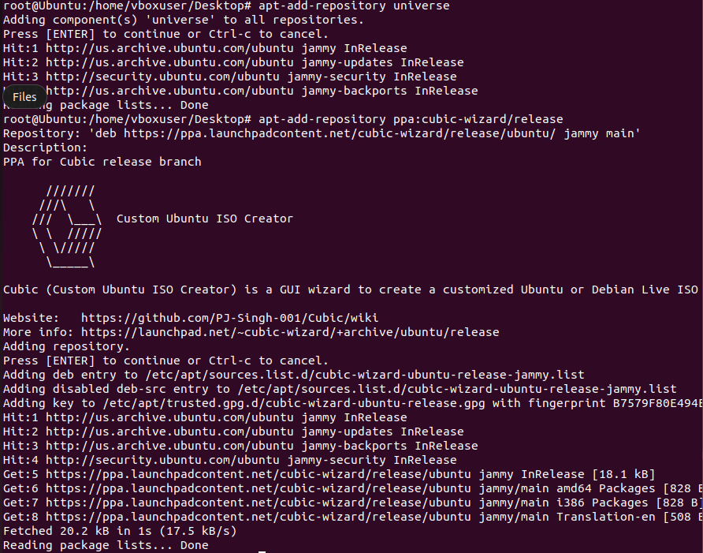

# apt update

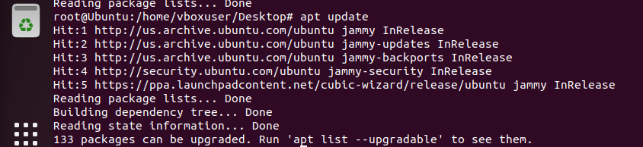

# apt install –no-install-recommends cubic

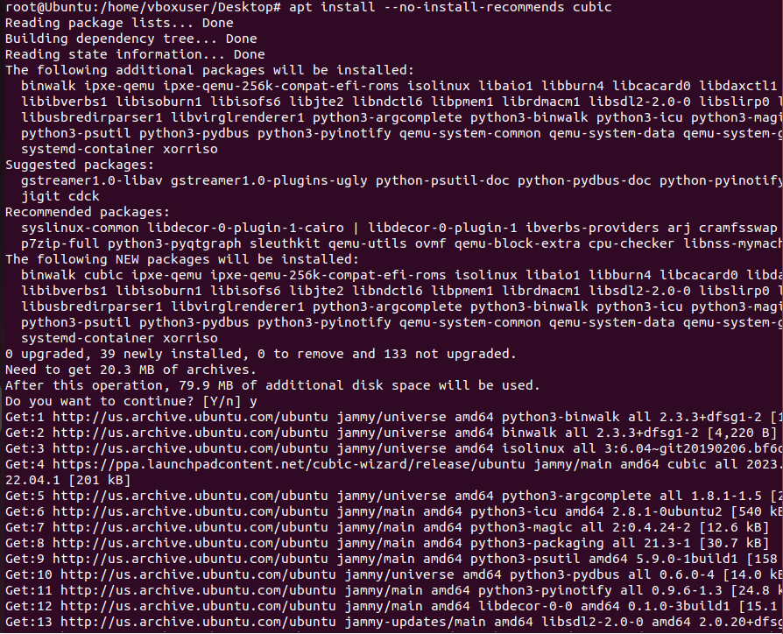

Open Cubic

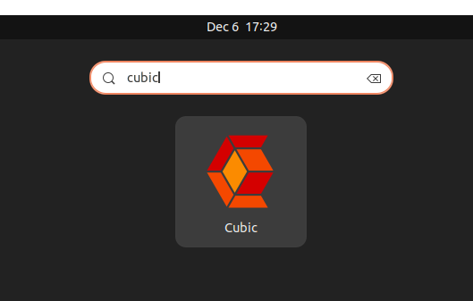

Pick a directory

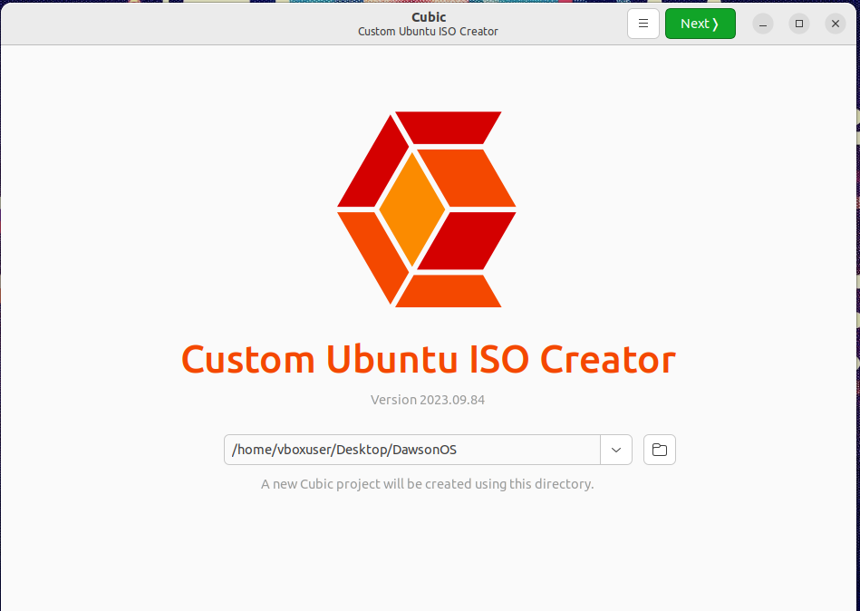

Select an iso of the OS you want (can be either Debian or Ubuntu.)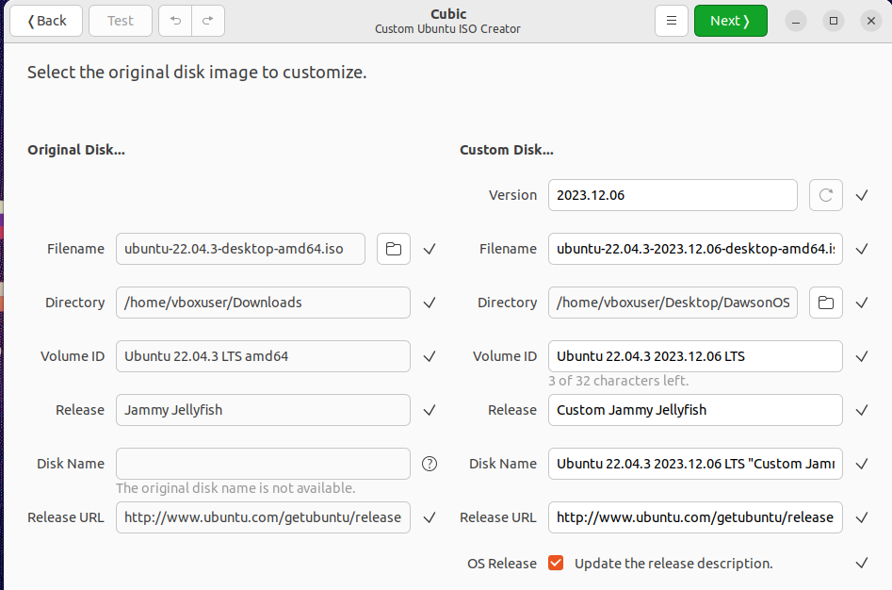

Customize the right side to your liking. 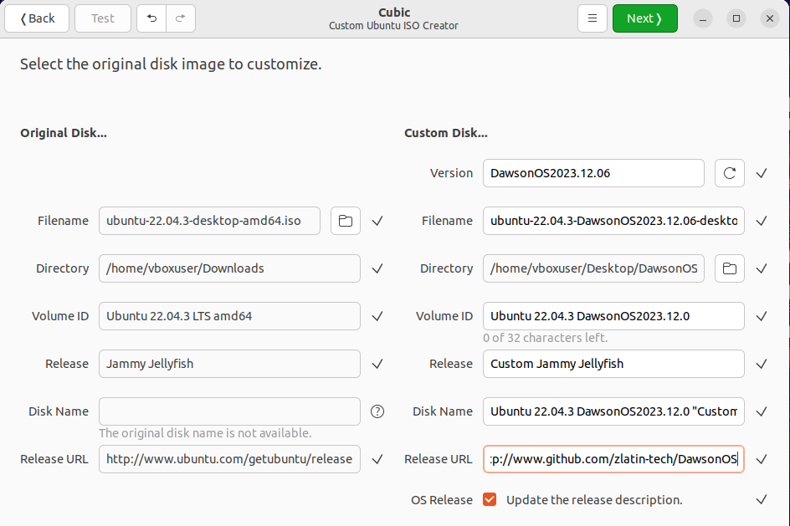

Once you press next, it will take a while to load . When it’s done, it automatically opens the virtual environment.

You’re by default as root

# apt update

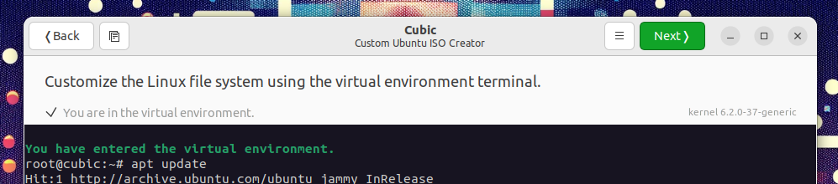

Now, you can add any packages you want to your iso and customize it to your liking.

# add-apt-repository universe

Install netbeans through ubuntu universe repository: # add-apt-repository “deb <http://archive.ubuntu.com/ubuntu> focal universe” ([How to install NetBeans IDE on Ubuntu 20.04 (howtoforge.com)](https://howtoforge.com/how-to-install-netbeans-ide-on-ubuntu-2004/))

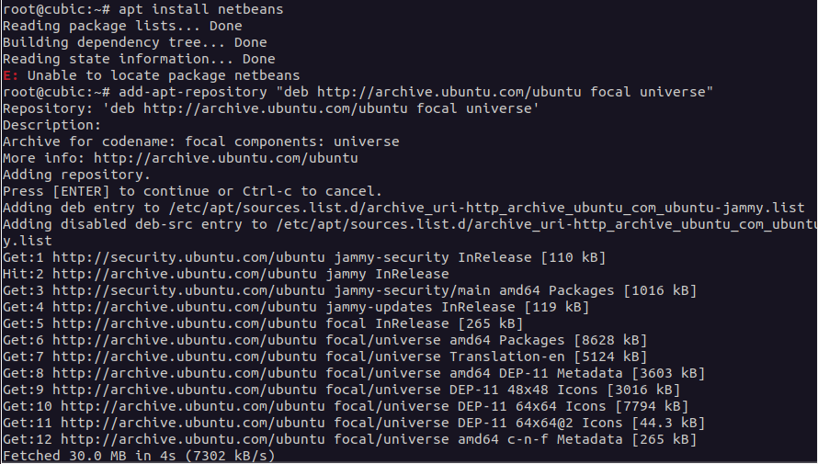

# apt update

#apt install netbeans

Run # apt upgrade

Press Next

It will take a bit of time to load and then it will show you a list of packages.Here, you can pick any packages that you want removed or kept. Note: the selected packages will be REMOVED; not kept. A lot of things can be removed for a minimal installation. Press next when satisfied.

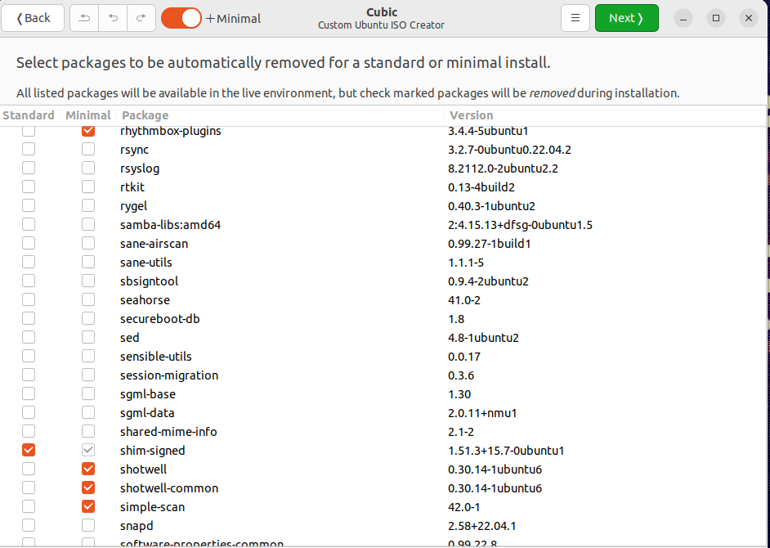

It gives you the option of kernel. Just picked the latest one. As for Preseeding and Boot, just leave them alone. You could look at the manual if you’re interested, but they’re not necessary for this. Press next.

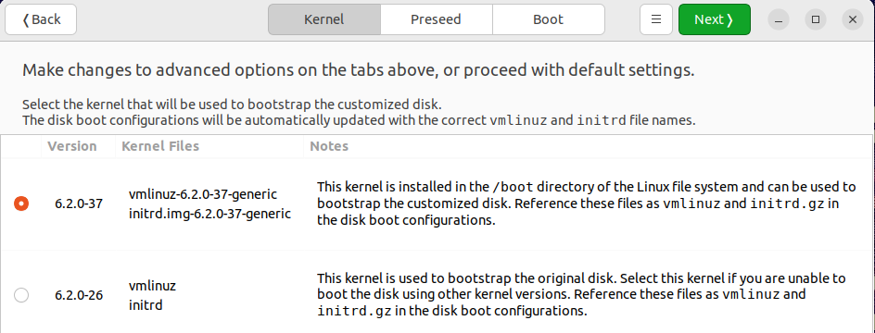

Then, it prompts you for the compression. SImply use the default gzip and it will lead you to a loading page. This can take a while.

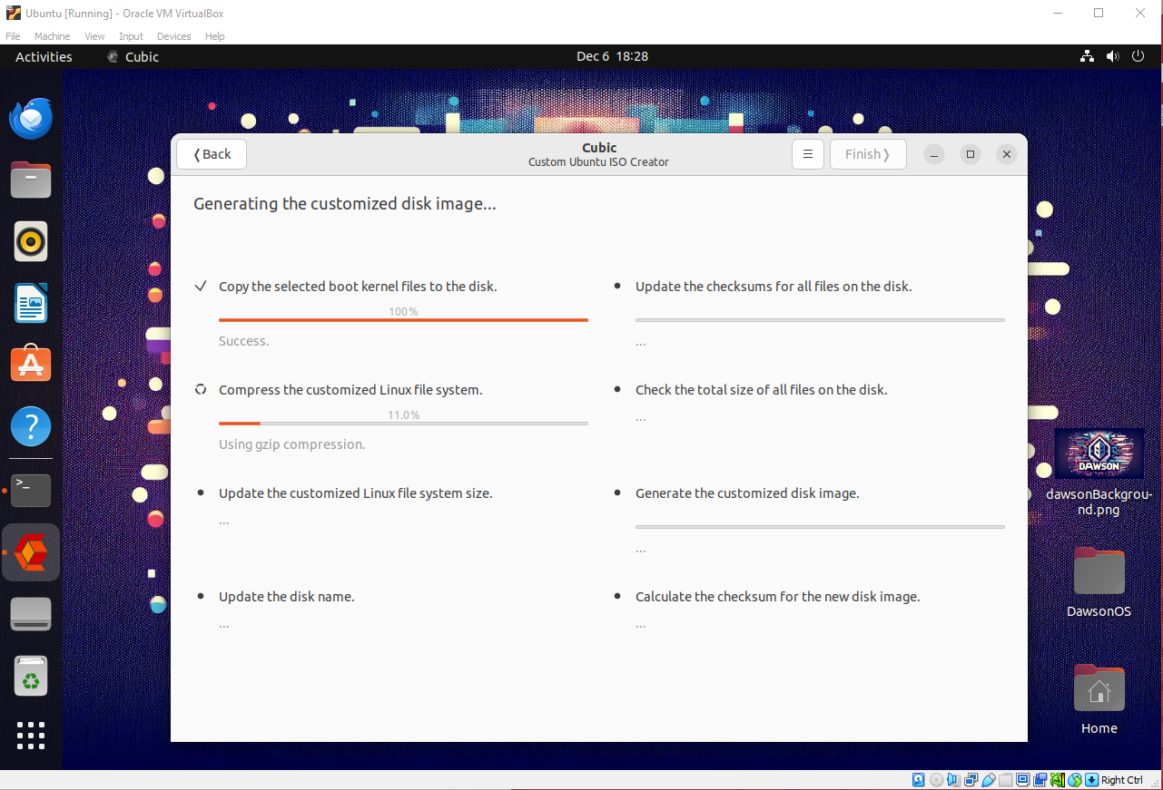

Once finished, it gives you a checksum and a checksum file in case you want to confirm you haven’t been hacked. You also have the option to Test the created image which will open it inside a new virtual machine.

Simply press Close.

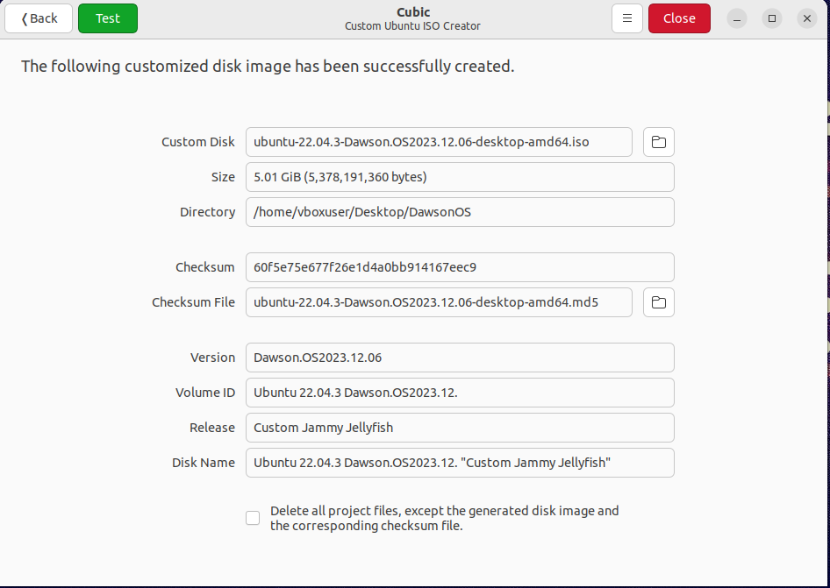Now you can open the folder in which you selected everything to happen, and you should have your iso file.

